UNITED STATES SECURITIES AND EXCHANGE COMMISSION

Washington, D.C. 20549

Form 10-K

(Mark One)

- ANNUAL REPORT PURSUANT TO SECTION 13 OR 15(d) OF THE SECURITIES EXCHANGE ACT OF 1934

For the fiscal year ended December 31, 2025

or

- TRANSITION REPORT PURSUANT TO SECTION 13 OR 15(d) OF THE SECURITIES EXCHANGE ACT OF 1934

 |  |  | For the transition period from |  |  | to
 |  |  | Commission File Number: 001-38047
 |  |  | Upbound Group, Inc.
 |  |  | (Exact name of registrant as specified in its charter)
 | Delaware |  |  |  |  | 45-0491516
(State or other jurisdiction of |  |  |  |  |  |  | (I.R.S. Employer
incorporation or organization) |  |  |  |  |  |  | Identification No.)
5501 Headquarters Drive, Plano, Texas |  |  |  |  |  | 75024
(Address of principal executive offices) |  |  |  |  |  |  | (Zip Code)
 |  |  | 972-801-1100
 |  |  | (Registrant's telephone number, including area code)
 |  |  | Securities registered pursuant to Section 12(b) of the Act:
 | Title of Each Class |  |  | Trading Symbol |  |  | Name of Exchange on Which Registered
Common Stock, par value $0.01 per share |  |  |  | UPBD |  |  | The Nasdaq Stock Market LLC

Securities registered pursuant to Section 12(g) of the Act: None

Indicate by check mark if the registrant is a well-known seasoned issuer, as defined in Rule 405 of the Securities Act. Yes ☒ No ☐

Indicate by check mark if the registrant is not required to file reports pursuant to Section 13 or Section 15(d) of the Exchange Act. Yes ☐ No ☒

Indicate by check mark whether the registrant (1) has filed all reports required to be filed by Section 13 or 15(d) of the Securities Exchange Act of 1934 during the preceding 12 months (or for such shorter period that the registrant was required to file such reports), and (2) has been subject to such filing requirements for the past 90 days. Yes ☒ No ☐

Indicate by check mark whether the registrant has submitted electronically every Interactive Data File required to be submitted pursuant to Rule 405 of Regulation S-T during the preceding 12 months (or for such shorter period that the registrant was required to submit such files). Yes ☒ No ☐

Indicate by check mark whether the registrant is a large accelerated filer, an accelerated filer, a non-accelerated filer, a smaller reporting company, or an emerging growth company. See the definitions of “large accelerated filer,” “accelerated filer,” “smaller reporting company,” and “emerging growth company” in Rule 12b-2 of the Exchange Act.

Large accelerated filer ☒ Accelerated filer ☐ Non-accelerated filer ☐

Smaller reporting company ☐ Emerging growth company ☐

If an emerging growth company, indicate by check mark if the registrant has elected not to use the extended transition period for complying with any new or revised financial accounting standards provided pursuant to Section 13(a) of the Exchange Act. ☐

Indicate by check mark whether the registrant has filed a report on and attestation to its management’s assessment of the effectiveness of its internal control over financial reporting under Section 404(b) of the Sarbanes-Oxley Act (15 U.S.C. 7262(b)) by the registered public accounting firm that prepared or issued its audit report. ☒

If securities are registered pursuant to Section 12(b) of the Act, indicate by check mark whether the financial statements of the registrant included in the filing reflect the correction of an error to previously issued financial statements. ☐

Indicate by check mark whether any of these error corrections are restatements that require a recovery analysis of incentive-based compensation received by any of the registrant's executive officers during the relevant recovery period pursuant to §240 10D-1(b). ☐

Indicate by check mark whether the registrant is a shell company (as defined in Rule 12b-2 of the Exchange Act). Yes ☐ No ☒

Aggregate market value of the 56,286,830 shares of Common Stock held by non-affiliates of the registrant at the closing sales price as reported on The Nasdaq Stock Market LLC, on June 30, 2025 | $ | 1,412,799,433
Number of shares of Common Stock outstanding as of the close of business on February 13, 2026: |  | 58,117,605

Documents incorporated by reference:

Portions of the definitive proxy statement relating to the 2026 Annual Meeting of Stockholders of Upbound Group, Inc. are incorporated by reference into Part III of this report.

 | TABLE OF CONTENTS
 |  | Page
 | PART I
Item 1. | Business | 4
Item 1A. | Risk Factors | 13
Item 1B. | Unresolved Staff Comments | 39
Item 1C. | Cybersecurity | 39
Item 2. | Properties | 40
Item 3. | Legal Proceedings | 40
Item 4. | Mine Safety Disclosures | 40
 | PART II
Item 5. | Market for Registrant’s Common Equity, Related Stockholder Matters and Issuer Purchases of Equity Securities | 41
Item 6. | Reserved | 41
Item 7. | Management’s Discussion and Analysis of Financial Condition and Results of Operations | 42
Item 7A. | Quantitative and Qualitative Disclosures about Market Risk | 55
Item 8. | Financial Statements and Supplementary Data | 56
Item 9. | Changes in and Disagreements with Accountants on Accounting and Financial Disclosure | 99
Item 9A. | Controls and Procedures | 100
Item 9B. | Other Information | 100
Item 9C. | Disclosure Regarding Foreign Jurisdictions that Prevent Inspections. | 100
 | PART III
Item 10. | Directors, Executive Officers and Corporate Governance | 100
Item 11. | Executive Compensation | 100
Item 12. | Security Ownership of Certain Beneficial Owners and Management and Related Stockholder Matters | 100
Item 13. | Certain Relationships and Related Transactions, and Director Independence | 100
Item 14. | Principal Accountant Fees and Services | 101
 | PART IV
Item 15. | Exhibits and Financial Statement Schedules | 102
Item 16. | Form 10-K Summary | 106
SIGNATURES |  | 107

i

CAUTIONARY NOTE REGARDING FORWARD-LOOKING STATEMENTS

This Annual Report on Form 10-K includes “forward-looking” statements within the meaning of the Private Securities Litigation Reform Act of 1995, Section 27A of the Securities Act of 1933, as amended (the “Securities Act”), and Section 21E of the Securities Exchange Act of 1934, as amended (the “Exchange Act”). Forward-looking statements can be identified by the fact that they do not relate strictly to historical or current facts. They often include words such as “believes,” “expects,” “anticipates,” “estimates,” “intends,” “plans,” “seeks” or words of similar meaning, or future or conditional verbs, such as “will,” “should,” “could,” “may,” “aims,” “intends,” or “projects.” These forward-looking statements, include, without limitation, those relating to the impact of ongoing challenging macroeconomic conditions on our business, operations, financial performance and prospects, the future business prospects and financial performance of our Company as a whole and our segments, our growth strategies, our expectations, plans and strategy relating to our capital structure and capital allocation, including any share repurchases under our share repurchase program, the potential impact of the matters discussed in Note M - “Contingencies” in this Annual Report on Form 10-K, and other statements that are not historical facts. Unless expressly indicated or the context requires otherwise, the terms “Upbound Group, Inc.,” “Company,” “we,” “us,” and “our” in this document refer to Upbound Group, Inc. and, where appropriate, its subsidiaries.

A forward-looking statement is neither a prediction nor a guarantee of future events or circumstances, and those future events or circumstances may not occur. You should not place undue reliance on forward-looking statements, which speak only as of the date of this Annual Report on Form 10-K. These forward-looking statements are based on currently available operating, financial and competitive information and are subject to various risks and uncertainties. Our actual future results and trends may differ materially and adversely depending on a variety of factors, including, but not limited to, the risks and uncertainties discussed under “Risk Factors” and “Management’s Discussion and Analysis of Financial Condition and Results of Operations” below. Given these risks and uncertainties, you should not rely on forward-looking statements as a prediction of actual results. Any or all of the forward-looking statements contained in this Annual Report on Form 10-K and any other public statement made by us, including by our management, may turn out to be incorrect. We are including this cautionary note to make applicable and take advantage of the safe harbor provisions of the Private Securities Litigation Reform Act of 1995 for forward-looking statements. Except as required by law, we expressly disclaim any obligation to update or revise any forward-looking statements, whether as a result of new information, future events, changes in assumptions or otherwise. Factors that could cause or contribute to these differences include, but are not limited to:

- difficulties encountered in managing the financial and operational performance of our multiple business segments;

- risks associated with pricing, value proposition and other changes to our consumer offerings and strategies being deployed in our businesses;

- our ability to continue to effectively execute our strategic initiatives, including mitigating risks associated with any potential additional mergers and acquisitions, or lease-to-own refranchising opportunities;
- our ability to effectively provide consumers with additional products and services beyond lease-to-own and products and services currently offered by our Brigit segment, including through third-party partnerships;
- the possibility that costs, difficulties or disruptions related to the integration of Brigit operations into our other operations will be greater than expected;

- the possibility that the anticipated benefits from the Brigit acquisition may not be fully realized or may take longer to realize than expected;

- the general strength of the economy and other economic conditions affecting consumer preferences, spending and payment behaviors, including the availability of credit to our target consumers and to other consumers, impacts from continued or renewed inflation, central bank monetary policy initiatives to address inflation concerns, and a possible recession or slowdown in economic growth;

- failure to effectively manage our operating labor and non-labor operating expenses, including failure to effectively optimize our proprietary algorithms and customer decisioning tools to limit merchandise losses for our lease-to-own offerings;
- our ability to retain the revenue associated with acquired lease-to-own customer accounts and enhance the performance of acquired stores;

- factors affecting the disposable income available to our current and potential customers;

- changes in the unemployment rate;

- capital market conditions, including changes in interest rates and availability of funding sources for us;

- changes in our credit ratings;

- our ability to identify potential acquisition candidates, complete acquisitions and successfully integrate acquired companies;

1

- disruptions caused by the operation of our information management systems or disruptions in the systems of our third-party retailers or other third parties with whom we do business;

- risks related to our virtual lease-to-own business, including our ability to continue to develop and successfully implement the necessary technologies;

- our ability to achieve the benefits expected from our integrated virtual and staffed third-party retailer offering and to successfully grow this business segment;

- exposure to potential operating margin degradation due to the higher cost of merchandise and higher merchandise losses in our Acima segment compared to our Rent-A-Center segment;

- additional risks associated with our Brigit segment and its consumer products and services, including managing losses, regulatory, licensing and other compliance risks, risks associated with our Brigit segment’s reliance on regulated banks and on providers of third-party data and technology and other third-party service providers; and other new risks for our Company;
- our ability to (i) effectively adjust to changes in the composition of our offerings and product mix as a result of acquiring Brigit and continue to maintain the quality of existing offerings and (ii) successfully introduce other new product or service offerings on a timely and cost-effective basis;
- changes in our future cash requirements as a result of the Brigit acquisition, whether caused by unanticipated increases in capital expenditures or working capital needs, unanticipated liabilities or otherwise;
- our ability to retain the talent and dedication of key employees of Brigit;

- litigation or administrative proceedings to which we are or may be a party to from time to time and changes in estimates relating to litigation reserves, including in each case in connection with the regulatory and litigation matters described in Note M to our consolidated financial statements included in this Annual Report on Form 10-K;
- our compliance with applicable statutes and regulations governing our businesses, impacts from the enforcement of existing laws and regulations and the enactment of new laws and regulations adversely affecting our business, including in connection with the regulatory matters described in Note M to our consolidated financial statements included in this Annual Report on Form 10-K, and any legislative or other regulatory enforcement efforts or private party litigation or arbitration that seeks to re-characterize store-based or virtual lease-to-own transactions as credit sales and to apply consumer credit laws and regulations to our lease-to-own business or to apply credit laws to our Brigit segment’s non-credit consumer offerings;

- our transition to more-readily scalable “cloud-based” solutions;

- our ability to continue to enhance digital or e-commerce capabilities, including mobile applications;

- our ability to protect our proprietary intellectual property and to defend against allegations by third parties that any of our products, services or business activities may infringe against their intellectual property rights;
- risks from development, deployment and governance of artificial intelligence (“AI”) and adjacent technologies, including technical failures or inaccuracies, rapid adoption by our competitors, and evolving regulatory requirements that may restrict certain AI uses or increase compliance costs;
- our ability or that of our third-party retailers or other third parties with whom we do business to protect the integrity and security of customer, employee, supplier and third-party retailer or other third-party information, which may be adversely affected by hacking, computer viruses, cybersecurity attacks or similar disruptions;
- impairment of our goodwill or other intangible assets;

- disruptions in our supply chain;

- limitations of, or disruptions in, our distribution network;

- rapid inflation or deflation in the prices of our lease-to-own products and other related costs;

- allegations of product safety and quality control issues, including recalls of goods we lease to customers;

- our ability to execute, as well as the effectiveness of, lease-to-own store consolidations, including our ability to retain the revenue from customer accounts merged into another store location as a result of a store consolidation;
- our available cash flow and our ability to generate sufficient cash flow to continue paying dividends;

- increased competition from traditional competitors, virtual lease-to-own competitors, online retailers, Buy-Now-Pay-Later, earned wage access and financial health technology competitors and other fintech companies and other competitors, including subprime lenders;

2

- our ability to identify and successfully market products and services that appeal to our current and future targeted customer segments and to accurately estimate the size of the total addressable market;
- consumer preferences and perceptions of our brands;

- our ability to enter into new rental or lease purchase agreements and collect on our existing rental or lease purchase agreements;

- ongoing changes in tariff policies, including impacts from tariffs proposed or imposed by the current U.S. Presidential Administration on the price of imported goods, or consumer prices overall or other financial impacts of such tariffs or proposed or imposed retaliatory tariffs enacted by U.S. trading partners on our costs or target consumers;
- adverse changes in the economic conditions of the industries, countries or markets that we serve;

- information technology and data security costs;

- the impact of breaches in data security or other disturbances to our information technology and other networks;

- changes in estimates relating to self-insurance liabilities and income tax reserves;

- changes in our effective tax rate;

- fluctuations in foreign currency exchange rates;

- our ability to maintain an effective system of internal controls; and

- the other risks detailed from time to time in our reports furnished or filed with the United States Securities and Exchange Commission (the “SEC”).

3

PART I

Item 1. Business.

Upbound Group, Inc.

Unless the context indicates otherwise, references to “we,” “us”, “our”, and the “Company” refer to the consolidated business operations of Upbound Group, Inc., the parent, and any or all of its direct and indirect subsidiaries. For any references in this document to Note A through Note U, refer to the Notes to consolidated financial statements in Item 8 included in this Annual Report on Form 10-K.

We are a technology and data-driven leader in accessible and inclusive financial solutions that address the evolving needs and aspirations of underserved consumers. Through our Acima and Rent-A-Center segments, we are a leading lease-to-own provider with operations in the United States, Puerto Rico and Mexico. We provide a critical service for underserved consumers by providing them with access to, and the opportunity to obtain ownership of, high-quality, name brand durable products under a flexible lease-purchase agreement with no long-term debt obligation. Our Acima segment offers lease-to-own solutions through retailers in stores and online enabling such retailers to grow sales by expanding their customer base utilizing our differentiated offering and allowing customers to access our flexible lease-to-own solutions at thousands of retailers and to lease a wide range of durable products. Through our Rent-A-Center segment, we provide a fully integrated customer experience through our e-commerce platform and brick and mortar presence.

On January 31, 2025, we completed the acquisition of Brigit, a holistic financial health technology company that has helped millions of customers improve their financial health and literacy, find ways to earn and save money, access their earned wages before their regularly scheduled payday, build their credit through savings and protect themselves from identity theft. Its mission is to help customers build a better financial future. See Note B in our consolidated financial statements included in this Annual Report on Form 10-K for additional information.

We were incorporated in the State of Delaware in 1986, and our common stock is traded on The Nasdaq Stock Market under the ticker symbol “UPBD.” Our principal executive offices are located at 5501 Headquarters Drive, Plano, Texas 75024. Our telephone number is (972) 801-1100 and our company website is www.upbound.com. Information contained on our website is not incorporated by reference into this Annual Report on Form 10-K.

The Lease Purchase Transaction

The lease purchase transaction is a flexible alternative that provides freedom for consumers who wish to obtain use and enjoyment of brand name merchandise with no long-term obligation and without having to pay the full price up front. Our customer has the right, but is not obligated, to acquire title to the merchandise either through an early purchase option or through payment of all lease renewals that would be required to obtain ownership.

The unit economics of the lease purchase transaction vary depending on the length of time customers take to obtain ownership of the product or whether the customer chooses to return the product without obtaining ownership. If a customer elects an early purchase option within a designated period of time following the initial lease, such as 90 or 120 days, a customer generally pays the retail price of the product plus a premium to the cost. Other lease-to-own transactions involve the customer leasing our merchandise through all optional lease renewal terms required to obtain ownership of the merchandise at the conclusion of the final lease renewal term. A customer may also elect to obtain ownership any time after the initial lease period, but prior to the completion of all lease renewals otherwise required to obtain ownership. Due to the longer lease period as a result of completing all lease renewals, along with the other benefits that are part of the lease-to-own transaction, obtaining ownership through payment of all lease renewals involves a higher total cost compared to the cost of the general retail price of the product if it was purchased upfront. Customers primarily take ownership of the merchandise through early purchase options, where the customer elects to make a lump-sum payment at a discounted purchase price prior to the final lease renewal. In the Rent-A-Center segment, the product is often rented more than one time before a customer ultimately obtains ownership.

There are differences in the unit economics between our Acima and Rent-A-Center segments, as we generally purchase our merchandise at wholesale prices for our Rent-A-Center segment and at retail prices for our Acima segment. Historically, operating margin for our Acima segment has benefited from the lower overhead cost associated with the virtual options employed at many third-party locations.

Key features of the lease purchase transaction include:

No long term obligation. A customer may terminate a lease purchase agreement at any time without penalty. Such customers have no obligation for remaining payments other than any outstanding balances to the date of return.

4

Convenient payment options. Our customers make payments on a weekly, bi-weekly, semi-monthly or monthly basis in our stores, at our third-party retailer locations, online or by telephone. We accept cash, credit or debit cards and payment via certain electronic platforms (such as PayPal and Venmo).

Flexible options to obtain ownership. Ownership of the merchandise generally transfers to the customer if the customer continuously renews the lease purchase agreement for a required period of between seven and 30 months, depending upon the product type, or exercises a specified early purchase option.

Reinstatement. If a customer is temporarily unable to make payments on a piece of rental merchandise and returns the merchandise, that customer generally may later re-rent the same piece of merchandise (or, if unavailable, a substitute of comparable quality, age and condition) on the terms that existed at the time the merchandise was returned, and pick up payments where they left off without losing credit for what they previously paid.

Approval with less than perfect credit. Generally, no established credit score or credit history is required. In the Rent-A-Center segment, we use a proprietary decision engine to verify customer information as part of our approval process for entering into a lease purchase agreement. In our Acima segment, which provides on-site or virtual lease-to-own options through third-party retailers and through Acima direct-to-consumer offerings, customers complete the application process through a variety of resources, including online digital waterfall technology, third-party retailer electronic portals, online e-commerce websites, and the Acima mobile application. A robust proprietary automated decision engine process is used to confirm certain customer information for approval of the lease purchase agreement.

Brand name merchandise. In our store locations and through our third-party retailers, we offer merchandise from a large number of well-known brands such as Ashley home furnishings; LG and Samsung electronics, Sony Playstation and Nintendo game consoles; LG, Samsung, General Electric, and Whirlpool appliances; and HP, Acer, Asus, and Lenovo computers.

Delivery and set-up. We generally offer same-day or next-day delivery and installation of our merchandise at no additional cost to the customer in our Rent-A-Center stores. Our Acima locations rely on our third-party retailers to deliver merchandise leased by the customer, or for the customer to carry-out leased merchandise. Our third-party retailers typically charge us a fee for delivery, which we pass on to the customer.

Product maintenance and replacement. In our Rent-A-Center segment, and in the Acima segment where required by law, we provide any required service or repair without additional charge, except in the event of damage in excess of normal wear and tear and certain other limited circumstances. The cost to repair the merchandise may be reimbursed by the vendor if the item is still under factory warranty. If the product cannot be repaired at the customer’s residence, we provide a temporary replacement while the product is being repaired. If the product cannot be repaired, we will replace it with a product of comparable quality, age and condition.

Financial Wellness Products

Through our mobile and web application our Brigit segment offers various financial wellness products and tools to help users improve their financial health. The application provides certain services at no cost to the customer, including Finance Helper which provides users with budgeting tools and financial insights on spending habits and bills, and Deals & Offers which provides subscribers with a way to earn and save more money via offers from our partners. The application also provides for paid subscription tiers called Brigit Plus and Brigit Premium, which bundle access to additional features and services. Instant Cash is available to eligible subscribers at no cost, and is also included as part of the Brigit Plus and Brigit Premium subscription tiers. Through the paid subscription tiers the customers gain access to some or all of the following services: Credit Monitoring, Credit Builder, and Identity Theft Protection.

Instant Cash. Brigit’s Instant Cash product provides Earned Wage Access (“EWA”) advances to customers. By leveraging cash flow information from the customer’s bank account as well as customer verified income information, Brigit’s technology assesses the customer’s earned income and ability to repay with no FICO or credit check needed and no impact on credit scores. Brigit offers an optional expedited delivery of the cash advance for a small payment (Expedited Transfer Fee).

Credit Builder. Credit Builder helps customers establish or improve their credit while saving through personal loans. The loans are originated by and held with Brigit’s bank partner. Unlike traditional loans, the primary goal of Credit Builder is not to provide immediate access to funds, but to allow customers to demonstrate creditworthiness through consistent repayment history. The Credit Builder loan forms a new trade line on the borrower’s credit report. The customer can choose the amount that they are able to repay each month, and they then make installment payments towards the loan. These payments are reported to the three largest credit reporting agencies. Furthermore, Credit Builder promotes savings as the customer’s payments accumulate in a deposit account and may be withdrawn by the customer at any time during the term of the loan.

5

Our Strategy

Our strategy is focused on achieving our mission to elevate financial opportunity for all and growing our business through emphasis on the following key initiatives:

- Grow penetration with current Acima third-party retailers and build on our strength with small to medium size businesses while also adding new national and regional third-party retailers to our platform and expanding our direct-to-consumer channels;
- At Brigit, continue to grow Brigit’s EWA, credit builder and other existing products and increase Brigit’s portfolio of products;

- At Rent-A-Center, accelerate the shift to e-commerce, improve the fully integrated omni-channel customer experience and expand product categories, which we expect will increase brand awareness and customer loyalty;
- Leverage data analytics capabilities to attract new customers, approve more customers and mitigate risk across business segments;

- Execute on market opportunities and enhance our competitive position across both traditional and virtual lease-to-own solutions, and implement complementary products and services that supplement our current offerings and provide our customers more financial alternatives; and
- Upgrade and integrate technology platforms to allow for a more simplified and seamless consumer experience, third-party retailer and waterfall integration, consumer transaction process and coworker efficiency.

As we pursue our strategy, we have taken, and may in the future take, advantage of joint venture, partnership, or merger and acquisition opportunities from time to time that advance our key initiatives and elevate the financial mobility of underserved consumers.

Our Operating Segments

On January 31, 2025, we established a new operating segment following the acquisition of Bridge IT, Inc. (“Brigit”). Please reference Note B in our consolidated financial statements included in this Annual Report on Form 10-K for additional discussion of the acquisition. In addition, effective January 1, 2025, we combined our Franchising segment with our Rent-A-Center segment. Financial information disclosed within this report has been recast for the related prior year period to reflect this additional change. Brigit’s results of operations are reflected in our Consolidated Statements of Operations beginning January 31, 2025, the date on which we acquired Brigit.

We report financial operating performance under four operating segments. To better reflect our current strategic focus, our third-party retailer business operations are reported as the Acima segment, which includes our virtual and staffed business models; and our company-owned and franchise stores and e-commerce platform through rentacenter.com, getitnowstores.com and homechoicestores.com are reported as the Rent-A-Center segment. In addition, we report operating results for our Brigit and Mexico segments. Additional information regarding our operating segments is presented in “Management’s Discussion and Analysis of Financial Condition and Results of Operations” contained in Item 7 of this Annual Report on Form 10-K, and financial information regarding these segments and revenues by geographic area are provided in Note T to our consolidated financial statements contained in this Annual Report on Form 10-K. Substantially all of our revenues for the past three years originated in the United States.

Acima

Our Acima segment, which primarily operates in the United States and Puerto Rico, includes the operations of Acima Holdings, LLC (“Acima Holdings”), which we acquired in February 2021, and locations formerly operating under our Acceptance Now brand, which completed the transition to the Acima platform in 2024. The Acima segment generally offers the lease-to-own transaction to consumers who do not qualify for traditional financing through staffed or unstaffed kiosks located within third-party retailer locations, or other virtual options. In virtual locations, customers, either directly or with the assistance of a representative of the third-party retailer, initiate the lease-to-own transaction online in the retailer's locations using our virtual solutions.

We use a proprietary automated process to confirm certain customer information for approval of the lease purchase agreement, including certain information from consumer reporting agencies as part of our decisioning process that may constitute a "consumer report" under applicable law. We believe our lease-to-own solutions within the Acima segment are beneficial for both the retailer and the consumer. The retailer captures more sales and reduces their payment risk because we buy the merchandise directly from them. We believe consumers also benefit from our Acima model because they are able to obtain the products they want and need under flexible terms and without the necessity of relying on credit to finance a purchase or need to

6

pay the full cost upfront. We generally pay the retail price for merchandise purchased from our third-party retailers and subsequently leased to the customer. Through certain third-party retailers, we offer our customers the option to obtain ownership of the product at or slightly above the full retail price if they pay within 90 days. In some cases, the retailer provides us a rebate on the cost of the merchandise if the customer exercises this 90-day option.

Our Acima operating model is highly agile and dynamic given our virtual offerings and our ability to open and close staffed and unstaffed locations quickly and efficiently. Generally, our Acima staffed locations consist of an area with a tablet computer, desk and chairs. We occupy the space without charge by agreement with each retailer. In our virtual locations, transactions are initiated through an electronic portal accessible by third-party retailers on their store computers, on our third-party retailers' e-commerce sites or through our Acima direct-to-consumer offerings including the Acima mobile application. Accordingly, capital expenditures with respect to new Acima locations are minimal.

Acima relies on our third-party retailers to deliver merchandise leased by the customer. Such third-party retailers typically charge us a fee for delivery, which we pass on to the customer. In the event the customer wishes to return rented merchandise and terminate their lease, we provide various return options.

Rent-A-Center

Our Rent-A-Center segment primarily consists of company-owned lease-to-own stores in the United States and Puerto Rico that lease durable goods to customers on a lease-to-own basis. In addition, we offer merchandise on an installment sales basis in certain of our stores operating under the names “Get It Now” and “Home Choice” in the states of Minnesota and Wisconsin. The Rent-A-Center segment also includes franchising operations that offer the sale of rental merchandise to our franchisees, who in turn offer the merchandise to the general public for rent or purchase under lease-to-own agreements consistent with our company-owned lease-to-own stores. We also receive royalties based on a percent of the franchisees' monthly gross revenues. Our Rent-A-Center segment operates through our company-owned stores, franchise stores and e-commerce platforms through rentacenter.com, getitnowstores.com and homechoicestores.com. We routinely evaluate the locations in which we operate to optimize our store network.

Brigit

Our Brigit segment, which operates in the United States, was acquired on January 31, 2025 (the “Closing Date”). The Brigit segment, through mobile and web applications, offers various financial health products and tools to help users improve their financial health, such as Finance Helper, Deals & Offers, Instant Cash, Credit Builder, Identity Theft Protection and more. These products and tools help customers improve their financial health and literacy, find ways to earn and save money, access their earned wages before their regularly scheduled payday, build their credit through savings, and protect themselves from identity theft.

Mexico

Our Mexico segment consists of our company-owned stores in Mexico that lease durable goods to customers on a lease-to-own basis.

The following discussion applies generally to all of our operating segments, unless otherwise noted.

Operations

Operating Expenses

Our operating segment expenses primarily relate to merchandise costs and labor and non-labor operating expenses, including salaries and benefits for our employees, lease charge-offs, occupancy, delivery, advertising, selling, insurance, travel, fixed asset depreciation, and other expenses.

Product Selection

The stores in our Rent-A-Center and Mexico segments generally offer merchandise from certain basic product categories such as furniture, including mattresses; tires; consumer electronics; appliances; tools; handbags; computers; and accessories. Although we seek to maintain sufficient inventory in our stores to offer customers a wide variety of models, styles and brands, we generally limit merchandise to prescribed levels to maintain strict inventory controls. We also provide merchandise options to our Rent-A-Center customers through our extended marketplace on our e-commerce platform. We seek to provide a wide variety of high quality merchandise to our customers, and we emphasize products from name-brand manufacturers. Customers may request either new merchandise or previously leased merchandise. Previously leased merchandise is generally offered at a

7

similar weekly, bi-weekly, semi-monthly, or monthly lease rate as is offered for new merchandise, but with an opportunity to obtain ownership of the merchandise after fewer lease payments.

Our furniture products include dining room, living room and bedroom furniture featuring a number of styles, materials and colors. Accessories include lamps and tables and are typically rented as part of a package of items, such as a complete room of furniture. Showroom displays enable customers to visualize how the product will look in their homes and provide a showcase for accessories. Appliances include refrigerators, freezers, washing machines, dryers, and ranges. Consumer electronic products offered by our stores include high definition televisions, home theater systems, video game consoles and stereos. We offer desktop, laptop, and tablet computers.

The merchandise assortment may vary in our non-U.S. stores according to market characteristics and consumer demand unique to the particular country in which we are operating. For example, in Mexico, the appliances we offer are sourced locally, providing our customers in Mexico the look and feel to which they are accustomed in that product category.

Acima locations offer merchandise available for sale in-store and online through third-party retailers, including furniture and accessories, consumer electronics and appliances, wheels and tires, and jewelry.

The Brigit segment, through its mobile and web applications, offers a suite of financial health products and tools designed to help users improve their financial well-being. These include Finance Helper, Deals & Offers, Instant Cash, Credit Builder, Identity Theft Protection and more. Together, these offerings help customers budget more effectively, build financial literacy, discover ways to earn and save, access earned wages ahead of payday, strengthen credit through savings-based programs, and protect themselves from identity theft.

Product Turnover

Product turnover is the number of times a product is rented to a different customer. On average, a product is leased (turned over) to multiple customers before a customer acquires ownership. Merchandise returned in the Acima segment is often moved to a Rent-A-Center store where it is offered for lease. To cover the higher operating expenses generated by the key benefits of lease purchase transactions and product turnover, lease purchase agreements require higher aggregate payments to obtain ownership over time (if elected by the customer) than are generally charged under purchase plans, such as installment purchase or credit plans.

Account Management

The majority of our lease purchase agreements are subject to weekly, bi-weekly, semi-monthly, and monthly renewal terms. In our Rent-A-Center stores, managers use our management information system to track past due payments on a daily basis. Similarly, past due payments are monitored on a daily basis by on-site employees in our Acima staffed locations and by our back-office account management team in respect of our Acima virtual locations. If a customer fails to make a lease payment when due, we will attempt to contact the customer to terminate the account and arrange to regain possession of our merchandise or, if elected by the customer, to obtain payment and reinstate the agreement.

In our Rent-A-Center segment, we attempt to recover the merchandise as soon as possible following non-renewal or termination of a lease purchase agreement. These efforts are enhanced by the personal and job-related references required of customers, the personal nature of the relationships between our employees and customers, and the availability of lifetime reinstatement.

If a customer does not return the merchandise or make a payment sufficient to reinstate an agreement, the remaining book value of the leased merchandise associated with delinquent accounts is generally charged off on or before the 90th day following the time the account became past due in the Rent-A-Center and Mexico segments, on or before the 120th day in our Acima segment.

Purchasing

In our Acima segment, we purchase the merchandise selected by the customer from the applicable third-party retailer at the time such customer enters into a lease purchase agreement with us and the product is delivered. We retain ownership of the leased property unless and until the customer elects to purchase the property pursuant to the lease terms.

In our Rent-A-Center and Mexico segments, we purchase our rental merchandise from a variety of suppliers. In 2025, approximately 37%, 11% and 10% of our merchandise purchases were attributable to Ashley Furniture Industries, LG Electronics and Whirlpool, respectively. No other brand accounted for more than 10% of merchandise purchased during these periods. We do not generally enter into written contracts with our suppliers that obligate us to meet certain minimum purchasing levels. Although we expect to continue relationships with our existing suppliers, we believe there are numerous sources of products available, and we do not believe the success of our operations is dependent on any one or more of our present suppliers. However, any termination or disruption to our relationship with Ashley Furniture Industries, Whirlpool or other significant suppliers could materially adversely impact our results.

8

Management

Our executive management team has extensive experience in the lease-to-own industry, as well as financial services and technology and has demonstrated the ability to grow and manage our business through their operational leadership and strategic vision. Our regional and district managers generally have long tenures with us, and we have a history of promoting management personnel from within. To support our strategic efforts we have hired additional key management members in recent years.

We believe our executive management team's extensive industry and company experience will allow us to effectively execute our strategies.

Marketing

We promote our products and services through direct marketing, paid and organic search optimization, digital advertisements, paid social media, radio and television commercials, and store signage. Our advertisements emphasize such features as product and name-brand selection, limited time offers, easy approval process, the flexible payment and return options, the ability to avoid relying on credit to finance a purchase and without requiring long-term contracts or obligations, convenient delivery and set-up, product repair and loaner services, lifetime reinstatement and multiple options to acquire ownership if desired by the customer, including early purchase pricing options or through a fixed number of lease renewal payments. In addition, in the Rent-A-Center segment, we promote the “RAC Worry-Free Guarantee®” to further highlight these aspects of the lease purchase transaction. We also promote the Acima segment’s lease-to-own solution and the Brigit segment’s financial wellness products. We believe that by leveraging our advertising efforts to highlight the benefits of accessible and inclusive financial solutions, we will continue to educate our customers and potential customers about the ways we address the evolving needs and aspirations of underserved consumers.

Franchising has established national advertising funds for the franchised stores, whereby franchising has the right to collect a percent of the monthly gross revenue from each franchisee as contributions to the fund. Franchising directs the advertising programs of the fund, generally consisting of television and radio commercials and print and digital display advertisements. Franchising also has the right to require franchisees to expend a percent of their monthly gross revenue on local advertising.

Industry & Competition

According to data released by the Fair Isaac Corporation in September 2025, consumers in the “subprime” category (those with credit scores below 650) made up approximately 26% of the United States population. Approximately 30% of U.S. consumers have incomes below $50,000 and may lack access to traditional credit. The lease-to-own industry provides customers the opportunity to obtain merchandise they might otherwise be unable to obtain due to insufficient cash resources or a lack of access to credit to finance a purchase.

Our stores, kiosks and other lease-to-own operations compete with other national, regional and local lease-to-own businesses, including online only competitors, as well as with rental stores that do not offer their customers a purchase option. With respect to customers desiring to purchase merchandise for cash or on credit, we also compete with retail stores, online competitors, Buy-Now-Pay-Later and other fintech companies and other competitors, including subprime lenders. Competition is based primarily on convenience, store location, product selection and availability, customer service, and pricing. Our Brigit segment also faces significant competition from other providers of EWA, credit building products and other financial health technology solutions. See “The industries in which we operate are highly competitive, which could impede our ability to maintain and grow consumer transaction volumes and pricing and have a material adverse effect on our prospects and operating results.” contained in Item 1A of this Annual Report on Form 10-K.

Seasonality

Our revenue mix in our lease-to-own businesses is moderately seasonal, with the first quarter of each fiscal year generally providing higher sales than any other quarter during a fiscal year. Generally, our customers will more frequently exercise the early purchase option on their existing lease purchase agreements in our Acima and Rent-A-Center segments or purchase pre-leased merchandise off the showroom floor in our Rent-A-Center segment during the first quarter of each fiscal year, primarily due to the receipt of federal income tax refunds. In contrast, our cash expenditures for our merchandise purchases for the fiscal year are generally the highest beginning in the latter part of the third quarter through the fourth quarter, primarily as a result of holiday promotions that lead to increased demand for our lease-to-own offerings.

9

Trademarks

We own various trademarks and service marks that are used in connection with our operations, including certain trademarks that have been registered with the United States Patent and Trademark Office. The duration of our registered trademarks is unlimited, subject to periodic renewal and continued use. We believe we hold the necessary rights for protection of the trademarks and service marks essential to our business. The products held for rent in our lease-to-own stores or through our third-party retailers also bear trademarks and service marks held by their respective manufacturers.

We license the use of the Rent-A-Center® trademarks and service marks to our franchisees under our franchise agreements with such franchisees. We also own various trademarks and service marks, including RimTyme®, that are used in connection with our franchisees’ operations and have been registered with the United States Patent and Trademark office. The duration of these marks is unlimited, subject to periodic renewal and continued use.

Human Capital Resources

As of December 31, 2025, we employed a total of 12,050 coworkers, the vast majority of which are full time employees. Our employee base is made up of 10,290 coworkers in our U.S. Operations, including Puerto Rico, 1,050 coworkers in our Mexico operations and 710 coworkers at our corporate facilities.

We continually monitor our demand for labor and provide training and competitive compensation packages in an effort to attract and retain skilled coworkers. We believe our coworkers are one of the primary keys to successfully operating our business and achieving our strategic objectives. Our human capital measures and objectives focus on the successful training and development of our coworkers, in addition to their safety. We also focus on supporting an inclusive and talented workforce with a variety of backgrounds and perspectives. All of our coworkers are employed at will and are free to end their employment with us at any time.

Government Regulation of Lease-to-Own Transactions

State Regulation. Currently, 46 states, the District of Columbia and Puerto Rico have rental purchase statutes that recognize and regulate lease purchase transactions as separate and distinct from credit sales. We believe this existing legislation is generally favorable to us, as it defines and clarifies the various disclosures, procedures and transaction structures related to the lease-to-own business with which we must comply. With some variations in individual states, most related state legislation requires the lessor to make prescribed disclosures to customers about the rental purchase agreement and transaction, and provides time periods during which customers may reinstate agreements despite having failed to make a timely payment. Some state rental purchase laws prescribe grace periods for non-payment, prohibit or limit certain types of collection or other practices, and limit certain fees that may be charged. Eleven states limit the total rental payments that can be charged over the maximum potential life of a rental purchase agreement if the customer elects to renew the lease for the maximum number of optional renewal periods to amounts ranging from 2.0 times to 2.4 times the lessor's disclosed cash price or the retail value of the rental product. Six of those eleven states also limit the lessor's cash price of merchandise to amounts ranging from 1.56 to 2.5 times our cost for each item.

Although Minnesota has a rental purchase statute, the rental purchase transaction is also treated as a credit sale subject to consumer lending restrictions pursuant to judicial decision. Therefore, we offer our customers in Minnesota an opportunity to purchase our merchandise through an installment sale transaction in our Home Choice stores. As of December 31, 2025, we operated 20 Home Choice stores in Minnesota.

North Carolina has no rental purchase legislation. However, the retail installment sales statute in North Carolina expressly provides that lease transactions which provide for more than a nominal purchase price at the end of the agreed rental period are not credit sales under the statute. As of December 31, 2025, we operated 84 lease-to-own stores and 22 Acima staffed locations in North Carolina.

Courts in Wisconsin and New Jersey, which do not have rental purchase statutes, have rendered decisions which classify rental purchase transactions as credit sales subject to consumer lending restrictions. Accordingly, in Wisconsin, we offer our customers an opportunity to purchase our merchandise through an installment sale transaction in our Get It Now stores. In New Jersey, we have modified our typical rental purchase agreements to provide disclosures, grace periods, and pricing that we believe comply with the retail installment sales act. As of December 31, 2025, we operated 30 Get It Now stores in Wisconsin and 18 Rent-A-Center stores in New Jersey.

In addition to state lease-to-own laws as described above, general consumer protection laws and regulations adopted by states and enforcement activities by state attorneys general and other consumer regulatory authorities may also impact our business. There can be no assurance as to whether the enforcement of existing state laws or regulations, including in connection with the regulatory matters described in Note M to our consolidated financial statements included in this Annual Report on Form 10-K,

10

or the enactment of new laws or regulations that may unfavorably impact the lease-to-own industry would have a material and adverse effect on us.

Federal Regulation. To date, no comprehensive federal legislation has been enacted regulating the rental purchase transaction. However, other consumer protection laws and regulations adopted at the federal level and enforcement activities by the Consumer Financial Protection Bureau (“CFPB”) and the United States Federal Trade Commission (the “FTC”) may impact our business. The Dodd-Frank Wall Street Reform and Consumer Protection Act (“Dodd-Frank Act”) regulates “leases” if, among other things, the initial term of the lease is at least 90 days. We believe the lease-to-own transaction, therefore, is not a covered “lease” under the Dodd-Frank Act because, among other reasons, the lease-to-own transaction is for a term of week to week, or at most, month to month. The CFPB has in past adopted, and may in the future adopt, a different interpretation of the Dodd-Frank Act and other federal consumer financial protection laws.

From time to time, we have supported legislation introduced in Congress that would regulate the rental purchase transaction. While both beneficial and adverse legislation regulating the rental purchase transaction may be introduced in Congress in the future, any adverse federal legislation, if enacted, could have a material and adverse effect on us. In addition, there can be no assurance as to whether the enforcement of existing federal consumer protection laws or regulations, including in connection with the regulatory matters described in Note M to our consolidated financial statements included in this Annual Report on Form 10-K, or the enactment of new laws or regulations that may unfavorably impact the lease-to-own industry would have a material and adverse effect on us.

Mexico

No comprehensive legislation regulating the lease-to-own transaction has been enacted in Mexico. We use substantially the same rental purchase transaction in Mexico as in the U.S. stores, but with such additional provisions as we believe may be necessary to comply with Mexico’s specific laws and customs.

Government Regulation of EWA Products

State Regulation. At the state level, the legal and regulatory landscape is evolving and numerous states have addressed the coverage of EWA by their loan-related regulatory regimes, implemented new EWA-specific regulatory requirements, or publicly considered one of these approaches (e.g., through the introduction of legislation that would, if enacted, specifically regulate EWA as a product distinct from loans). Many of the states that have taken EWA-related action have implemented provisions that require EWA providers to register or obtain licenses and/or comply with EWA-specific disclosure and practice requirements. Some states, however, have adopted more restrictive approaches. For example, in 2023, legislatures or consumer financial regulators in Connecticut and Maryland issued guidance and/or changes in law or regulation, indicating that EWA products, in certain cases, would be considered loans or otherwise regulated under loan regulatory regimes imposing licensing, rate and fee limitation, and origination and servicing practice limitations on EWA providers.

Federal Regulation. Although there is currently no comprehensive federal legislation regulating EWA products, such as Brigit’s EWA product, the CFPB under the previous Presidential Administration proposed an interpretative rule that would have potentially treated many EWA products as extensions of credit for the purposes of applying certain federal consumer financial laws and regulations, including the potential regulation of unfair, deceptive, or abusive practices with respect to EWA products. In December 2025, the CFPB withdrew that proposed interpretative rule and issued an advisory opinion stating that certain “covered” EWA products, structured to provide access to earned wages without creating a debt obligation and subject to specified conditions, generally are not credit under the Truth in Lending Act or Regulation Z. The opinion also stated that optional expedited funding fees and tips paid by consumers in connection with EWA products are not finance charges under that statute or regulation. The advisory opinion is non-binding, and the legal and regulatory landscape at the federal level may continue to evolve.

Available Information

We file Annual Reports on Form 10-K, Quarterly Reports on Form 10-Q, Current Reports on Form 8-K, proxy statements and other information with the SEC. The public may obtain copies of these reports and any amendments at the SEC's website, www.sec.gov. Additionally, we make available free of charge on or through our website our Annual Report on Form 10-K, our Quarterly Reports on Form 10-Q, our Current Reports on Form 8-K and amendments to those reports filed or furnished pursuant to Section 13(a) or 15(d) of the Exchange Act as soon as reasonably practicable after we electronically file such material with, or furnish it to, the SEC. We also provide electronic or paper copies of our filings free of charge upon request. In addition, our Board of Directors has adopted a Code of Business Conduct and Ethics applicable to all members of our Board of Directors, as well as all of our coworkers, including our Chief Executive Officer, Chief Financial Officer and controller. The Code of Business Conduct and Ethics forms the foundation of a compliance program we established as part of our commitment to responsible business practices that includes policies, training, monitoring and other components covering a wide variety of specific areas applicable to our business activities and employee conduct. A copy of the Code of Business Conduct and Ethics

11

is published on our website at https://investor.upbound.com/corporate-governance/governance-documents. We intend to make all required disclosures concerning any amendments to, or waivers from, this Code of Business Conduct and Ethics on our website.

12

Item 1A. Risk Factors.

Investing in Upbound Group, Inc. involves a high degree of risk, and you should carefully consider the risks described in this section and the other information included in this Annual Report on Form 10-K, including our consolidated financial statements and related notes, before making an investment decision. Please note that the headings reflected below are provided solely for convenience of the reader and do not indicate that a given risk applies only to the heading under which it is located. The risks described in this section include, but are not limited to, those highlighted in the following list:

Risks Relating to Economic Conditions

- The success of our business overall and each of our segments is dependent on macroeconomic and other factors affecting consumer demand, spending and payment behaviors that are outside of our control.

Risks Relating to Our Vendors, Suppliers, Products and Services

- Disruptions in our lease-to-own supply chain and other factors affecting the distribution of our merchandise could materially and adversely affect our business.

- We rely on the receipt of information from third-party data vendors across our business segments, and inaccuracies in or delays in receiving such information, or the termination of our relationships with such vendors, could have a material adverse effect on our business, operating results and financial condition.
- We must successfully manage our Rent-A-Center inventory to reflect customer demand and anticipate changing consumer preferences and leasing trends or our revenue and profitability could be materially and adversely affected.
- Allegations of or actual product safety and quality control issues for our leased products, including product recalls, could harm our reputation, divert resources, reduce sales and increase costs.

Risks Relating to Our Strategy and Operations

- Our success depends on the effective implementation and continued execution of our strategies to continue to grow and transform our business.

- If we are unable to successfully appeal to and engage with our target consumers and third-party retailers, our business and financial performance may be materially and adversely affected.

- We must maintain corporate brands that are recognized and trusted by consumers and third-party retailers.

- Our proprietary algorithms and customer decisioning tools used to approve customers are subject to unexpected changes in behavior caused by macroeconomic conditions, which could cause these tools to no longer be indicative of our customers’ ability to perform under their agreements with us.
- The industries in which we operate are highly competitive, which could impede our ability to maintain and grow consumer transaction volumes and pricing and have a material adverse effect on our prospects and operating results.
- Failure to effectively manage our costs could have a material adverse effect on our profitability.

- We face risks in our Acima third-party retailer business and virtual locations that differ in some potentially significant respects from the risks of the traditional lease-to-own business conducted in Rent-A-Center store locations. These risks could have a material adverse effect on Acima, which could negatively impact our ability to meet our growth objectives for the Acima segment and result in a material adverse effect on our results of operations.
- The integration and use of AI and similar technology in our business presents risks and challenges that could adversely affect our business, reputation, and results of operations.

- Our strategy to grow the third-party retailer business depends on our ability to develop and offer robust virtual lease-to-own technology, including algorithmic decisioning programs and waterfall integrations.
- Our operations depend on effective information management systems. Failure of our systems or those of our third-party retailers, bank partners or other commercial counterparties could negatively impact our business, financial condition and results of operations.
- If we fail to protect the integrity and security of customer, employee, supplier, third-party retailer, bank partner or other third-party information, or if our third-party retailers, bank partners, outsourced technology providers or other third parties fail to protect the integrity and security of customer, employee or other sensitive information, we could incur significant liability and damage our reputation, and our business could be materially and adversely affected.
- Our Brigit segment’s EWA advances expose Brigit to the repayment risk of Brigit’s customers and if Brigit’s decisioning criteria for EWA advance eligibility is not sufficient to mitigate against this risk, or if the data Brigit uses to assess customer earned wages is inaccurate or incomplete, Brigit’s financial condition and operating results could be adversely affected if a substantial number of Brigit’s customers are unable to repay the EWA advance they receive.
- If we are unable to attract, train and retain managerial personnel and hourly associates in our Rent-A-Center stores and staffed Acima locations, our reputation, sales and operating results may be materially and adversely affected.
- Environmental impacts and increased focus by stakeholders on environmental issues could adversely affect our business, financial condition and operating results.

13

Risks Relating to Legal and Compliance Matters

- Our businesses and industries are heavily regulated and subject to active enforcement including legal and regulatory proceedings that have in the past and may in the future result in damages, penalties or other significant monetary obligations and restrictions on our business operations.
- Our use of arbitration agreements may not allow us to avoid costly litigation or mass arbitrations.

- Federal and state regulatory authorities are increasingly focused on the lease‑to‑own industry, and any negative change in these laws or regulations or the passage of unfavorable new laws or regulations or the manner in which any of these are enforced or interpreted could expose us to significant additional costs or compliance-related burdens and could require us to alter our business practices in a manner that may be materially adverse to us.
- Our lease‑to‑own transactions are regulated by and subject to the requirements of federal and state laws and regulations that vary by jurisdiction, which require significant compliance costs and expose us to regulatory action or other litigation.
- Laws and regulations regarding information security and data collection, use and privacy are increasingly rigorous and subject to change, which may cause us to incur significant compliance costs and subject us to adverse impacts in the event of actual or alleged compliance failures.
- Our reputation, ability to do business and operating results may be impaired by improper conduct by any of our employees, agents or business partners, including third-party retailers.

- Our products and services may be negatively characterized by consumer advocacy groups, the media and certain federal, state and local government officials, and if those negative characterizations become increasingly accepted by consumers and/or our third-party retailers, bank partners or other commercial counterparties, demand for our goods and the transactions we offer could decrease and our business could be materially and adversely affected.
- We may be unable to protect our intellectual property, or may be alleged to have infringed upon the intellectual property rights of others, which could result in a loss of our competitive advantage, a diversion of resources and a material adverse effect on our business and results of operations.
- Brigit previously entered into a settlement with the FTC under which it continues to have ongoing compliance obligations, noncompliance with which could result in material regulatory enforcement.
- Our Brigit segment is subject to extensive regulation and oversight in a variety of areas under federal, state and local laws.

- If our Brigit segment is unable to obtain, or was determined to be operating without having obtained, necessary state or local licenses, registrations, or similar regulatory filings or approvals that are required or deemed required by regulatory authorities for certain of its products and services, it could adversely affect Brigit’s business, results of operations, financial condition, and future prospects.
- Federal and state regulatory authorities are increasingly focused on the EWA industry, and any negative change in these laws or regulations or the passage of unfavorable new laws or regulations or the manner in which any of these are enforced or interpreted could expose Brigit to significant additional costs or compliance-related burdens and could require Brigit to alter its business practices in a manner that may be materially adverse to Brigit.

Risks Relating to Our Indebtedness and Other Financial Matters

- We have significant indebtedness, and the level of our indebtedness could materially and adversely affect us.

- The amount of borrowings permitted under the ABL Credit Facility is limited to the value of certain of our assets, and we rely in part on available borrowings under the ABL Credit Facility for cash to operate our business, which subjects us to market and counterparty risk, some of which is beyond our control.
- Our variable rate indebtedness subjects us to interest rate risk, which could cause our debt service obligations to increase significantly.

- Our organizational documents and our current or future debt instruments contain or may contain provisions that may prevent or deter another group from paying a premium over the market price to Upbound Group, Inc.’s stockholders to acquire its stock.
- If our goodwill or other intangible assets become impaired, we may be required to record a significant charge to earnings.

Risks Relating to Our Acquisition of Brigit

- We may be unable to realize the anticipated benefits of the Brigit acquisition, including synergies, and have incurred substantial expenses related to the acquisition, which could have a material adverse effect on our business, financial condition and results of operations.
- We may be unable to retain key personnel hired as a result of the Brigit acquisition.

The risks described in this section are not the only risks that could materially and adversely affect our business; other risks currently believed to be immaterial or additional risks not currently known to us could also materially and adversely affect our business, financial condition or results of operations. If any of the events or circumstances described in this section actually occur, our business, operating results, financial condition, cash flows, and prospects could be materially and adversely affected. In that event, the market price of our securities could decline, and you could lose part or all of your investment.

14

Risks Relating to Economic Conditions

The success of our business overall and each of our segments is dependent on macroeconomic and other factors affecting consumer demand, spending and payment behaviors that are outside of our control.

Consumer demand, spending and payment behaviors are affected by general economic conditions and other factors outside our control, including levels of employment, disposable consumer income, prevailing interest rates, consumer debt and availability of credit, tariff policies, cost of fuel, food and housing, inflation, recession and fears of recession, war and fears of war, terrorist activities, pandemics, inclement weather, tax rates and rate increases, timing of receipt of tax refunds, consumer confidence in future economic conditions and political conditions and consumer perceptions of personal well-being and security. Unfavorable general economic changes, due to any one or more of these or other factors, could reduce demand for our lease-to-own, EWA and other products and services resulting in lower revenue or negatively impact consumer payment behavior resulting in higher than expected losses and negatively impacting our business and financial results. For example, starting in the latter part of 2021, our lease-to-own businesses experienced negative trends in customer behavior following the expiration of government stimulus and relief programs combined with a significant rise in the U.S. consumer price index, resulting in significant pressure on the discretionary income levels of our consumers. This led us to tighten our underwriting policies in an effort to improve risk management related to the execution of new leases. The trends described above combined with the tightening of our underwriting policies reduced the number of active leases with corresponding decreases in lease revenue and operating cash flows compared to having less restrictive underwriting policies.

In addition to the negative trends in customer behavior described above, we have also been impacted by other negative macroeconomic trends in recent years, including a tight labor market, which contributed to wage inflation, and global supply chain disruptions resulting in reduced product availability and rising product costs.

Moreover, the current U.S. Presidential Administration has enacted tariffs on a wide range of imports from various countries. The current U.S. Presidential Administration has increased, and may increase in the future, current tariffs and may impose additional tariffs and expand tariffs to capture goods from countries not previously captured, which may lead to widespread economic effects, including increased consumer prices and a reduction in discretionary income. As a result, consumer spending may decline. In addition, we may not be able to fully pass tariff-related price increases on to our customers. These proposed or imposed tariffs, changes in duty regimes or retaliatory trade restrictions that have been or may be implemented by the U.S. or other countries, as well as any fluctuation in foreign exchange rates as a result of such activity, could reduce demand for our products and services resulting in lower revenue or negatively impact consumer payment behavior resulting in higher than expected losses, which could materially impact our business and financial results.

The full extent to which these macroeconomic trends (including consumer demand, spending and payment behavior) and our risk management strategies across our business segments may impact our business in future periods is uncertain. The continuation of volatile macroeconomic trends may have a material adverse impact on our financial statements, including our results of operations, operating cash flows, liquidity and capital resources.

Risks Relating to Our Vendors, Suppliers, Products and Services

Disruptions in our lease-to-own supply chain and other factors affecting the distribution of our merchandise could materially and adversely affect our business.

Disruptions in our lease-to-own business supply chain and those of our third-party retailers can and have resulted in our inability to meet our customers’ expectations, higher costs, an inability to stock our stores, or longer lead time associated with distributing merchandise. Disruptions within our supply chain network also result in decreased net sales, increased costs and reduced profits.

Our arrangements with our lease-to-own merchandise suppliers and other vendors may be materially and adversely affected by changes in our financial results or financial position or changes in consumer demand, which could materially and adversely affect our business.

Substantially all of our lease-to-own merchandise suppliers and vendors sell to us on open account purchase terms. There is a risk that our key suppliers and vendors could respond to any actual or apparent decrease in, or any concern with, our financial results or liquidity by requiring or conditioning their sale of merchandise to us on more stringent or more costly payment terms, such as by requiring standby letters of credit, earlier or advance payment of invoices, payment upon delivery or other assurances or credit support or by choosing not to sell merchandise to us on a timely basis or at all. In addition, if demand for our products and services declines, the volume of merchandise we purchase from third-party suppliers may decrease, which could result in smaller discounts from our vendors or the elimination of such discounts by our vendors. Our arrangements with

15

our suppliers and vendors may also be impacted by media reports regarding our financial position or other factors relating to our business. Our need for additional liquidity could materially increase and our supply of inventory could be materially disrupted if any of our key suppliers or vendors, or a significant portion of our other suppliers or vendors, takes one or more of the actions described above, which could result in increased costs of operation and decreased net sales, customer satisfaction and profits.

We rely on the receipt of information from third-party data vendors across our business segments, and inaccuracies in or delays in receiving such information, or the termination of our relationships with such vendors, could have a material adverse effect on our business, operating results and financial condition.

We are heavily dependent on data provided by third-party providers across our business segments, including our lease-to-own, EWA and other offerings. We employ proprietary decisioning algorithms that determine whether or not applications submitted by a customer for our products and services will be approved and the potential amount of the transaction. These algorithms depend extensively upon continued access to, and timely receipt of, reliable data from external sources, such as third-party data vendors. Our data providers could stop providing data, provide untimely, incorrect or incomplete data, or increase the costs for their data for a variety of reasons, including a perception that our systems are unsecure as a result of a data-security breach, regulatory concerns or for competitive reasons. We could also become subject to increased legislative, regulatory or judicial restrictions or mandates on the collection, disclosure or use of such data, in particular if such data is not collected by our providers in a way that allows us to legally use the data. If we were to lose access to this external data or if our access or use were restricted or were to become less economical or desirable, our business would be negatively impacted, which would materially and adversely affect our operating results and financial condition. We cannot provide assurance that we will be successful in maintaining our relationships with these external data-source providers or that we will be able to continue to obtain data from them on acceptable terms or at all. Furthermore, we cannot provide assurance that we will be able to obtain data from alternative sources if our current sources become unavailable.

We must successfully manage our Rent-A-Center inventory to reflect customer demand and anticipate changing consumer preferences and leasing trends or our revenue and profitability could be materially and adversely affected.

The success of our Rent-A-Center segment depends upon our ability to successfully manage our inventory and to anticipate and respond to merchandise trends and customer demands in a timely manner. We cannot always accurately predict consumer preferences, and they may change over time. We must order certain types of merchandise, such as consumer electronics, well in advance of seasonal increases in customer demand for those products. The extended lead times for many of our purchases may make it difficult for us to respond rapidly to new or changing consumer trends and price shifting and to maintain an optimal selection of merchandise available for lease at all times. If we misjudge any of the markets for our merchandise, our customers’ product preferences or our customers’ leasing behaviors, our revenue may decline significantly, and we may not have sufficient quantities of merchandise to satisfy customer demand, or we may be required to mark down excess inventory, either of which would result in lower revenue and profit. In addition, our level of profitability and success in our Rent-A-Center segment depends on our ability to successfully re-lease our inventory of merchandise that is returned by customers of our Rent-A-Center or Acima segments, due to their lease agreements being terminated, or otherwise.

Allegations of or actual product safety and quality control issues for our leased products, including product recalls, could harm our reputation, divert resources, reduce sales and increase costs.

The products we lease and sell in our Acima and Rent-A-Center segments are subject to regulation by the U.S. Consumer Product Safety Commission and similar state regulatory authorities and expose us to potential product liability claims, recalls or other regulatory or enforcement actions initiated by regulatory authorities or through private causes of action. Such claims, recalls or actions could be based on allegations that, among other things, the products leased or sold by us contain contaminants or impermissible materials, provide inadequate instructions regarding their use or misuse or include inadequate warnings, such as those concerning the materials or their flammability. We do not control the production process of the products we sell and lease and may be unable to identify a defect or deficiency in a product purchased from a manufacturer before offering it for sale or lease to our customers. Product safety or quality concerns may require us to voluntarily remove selected products from our physical locations or from our customers’ homes or cease offering those products online. Such recalls and voluntary removal of products can result in, among other things, lost sales, diverted resources, potential harm to our reputation and increased customer service costs, each of which could have a material adverse effect on our results of operations or financial condition. In addition, in the event of such a product quality or safety issue, our customers who have leased the defective merchandise from us could terminate their lease agreements for that merchandise and/or not renew those lease agreements, which could have a material adverse effect on our results of operations or financial condition if we are unable to recover those losses from the vendor who supplied us with the relevant merchandise. In addition, new federal or state legislation, including new product

16

safety and hazardous material laws and regulations, may negatively impact our operations, increase our cost of doing business and adversely affect our operating performance.

Risks Relating to Our Strategy and Operations

Our success depends on the effective implementation and continued execution of our strategies to continue to grow and transform our business.

We are focused on our mission to elevate financial opportunity for cash- and credit-constrained consumers including through affordable, flexible and convenient access across digital and physical channels to durable goods that promote a higher quality of living and additional complementary and scalable products and services such as financial health technology solutions. In recent years, we accelerated our virtual lease-to-own growth strategy through the acquisition of Merchants Preferred, launch of our Preferred Lease offering and, in 2021, acquisition of Acima Holdings, with a focus towards executing on large market opportunities through national and regional third-party retailers and offering consumers greater choice in where they shop and the durable goods they can select to lease under our flexible transactions. Most recently, in 2025, we acquired Brigit, which expands our strategic focus for our target customers into technology-driven financial health solutions, such as EWA and credit building products for consumers who are underserved by traditional financial institutions. We seek to capitalize on key differentiators in our expanding digital, and technology and data-driven consumer offerings, as well as grow our business through expansion in our lease-to-own product verticals, e‑commerce platforms and other digital enhancements, improving the customer and third-party retailer experience and providing consumers with greater opportunities to shop how, when and where they want with the flexibility of our lease-to-own solutions and to meet their liquidity, cash flow and other financial health needs through Brigit’s leading technology solutions. In our more mature Rent-A-Center segment, we also seek to adapt to changing consumer preferences and the increasing shift to online shopping behaviors while managing our cost structure.

The continued growth and transformation of our business, including through the launch of new digital product offerings, requires us to effectively manage, integrate and continue to enhance our growing products and services and achieve intended synergies, invest in and expand our data and technology capabilities, engage and retain additional personnel who are experienced in technology and data driven consumer offerings, manage our investments in our stores to align to changing consumer trends, and otherwise make additional investments and incur additional costs. Our inability to implement these strategies or otherwise to achieve targeted results associated with our initiatives could materially and adversely affect our prospects, or results of operations, or negatively impact our ability to successfully execute future strategies, which may result in a material adverse effect on our business and financial results.

If we are unable to successfully appeal to and engage with our target consumers and third-party retailers, our business and financial performance may be materially and adversely affected.

Our lease-to-own segments operate digitally and through brick-and-mortar stores including direct-to-consumer and through third-party retailer channels. Through our Brigit segment, we provide financial health technology solutions direct to consumers. As such, our success depends, among other things, on our ability to identify and successfully market products and services through various channels that appeal to our current and future target customer segments and third-party retailers, to align our offerings with consumer and third-party retailer preferences and to maintain favorable perceptions of our brands by our target consumers and third-party retailers. If we are unable to successfully appeal to and engage with our target consumers and third-party retailers, our business and financial performance may be materially and adversely affected.

We must maintain corporate brands that are recognized and trusted by consumers and third-party retailers.

Our Acima®, Brigit™, Rent-A-Center® and other brands could be adversely affected by situations that reflect negatively on us, whether due to actual or perceived business practices, adverse financial developments, a data breach, perceptions of our corporate governance or how we address corporate responsibility initiatives, the conduct of our officers, directors, or employees, the actions of a significant partner or other businesses with which we do business, or other causes. The negative impacts of these or other events may be amplified as consumers and other stakeholders increase or change their expectations regarding the conduct of public companies and corporate responsibility. These impacts may be further complicated by the fact that perceptions are formed through rapid and broad interactions using modern communication and social media tools over which we have no control. Any such event could decrease demand for our products and services, reduce our ability to recruit and retain employees, and lead to greater regulatory scrutiny of our businesses.

17

Our proprietary algorithms and customer decisioning tools used to approve customers are subject to unexpected changes in behavior caused by macroeconomic conditions, which could cause these tools to no longer be indicative of our customers’ ability to perform under their agreements with us.

We believe our proprietary customer lease decisioning process to be a key to the success of our business for both Acima and Rent-A-Center. Brigit also employs a proprietary decisioning process to assess eligibility for its products and services. We assume behavior and attributes observed from prior customers, among other factors, are indicative of performance by future customers. Unexpected changes in behavior caused by macroeconomic conditions, including, for example, impacts to the U.S. economy related to the tariffs proposed or imposed by the current U.S. Presidential Administration and changes in consumer behavior relating thereto as well as the current challenging macroeconomic conditions, could lead to increased incidence and costs related to lease merchandise write-offs or customer losses at Brigit. For example, we experienced higher losses in the fourth quarter of 2021 and during 2022 due to the impacts of changing consumer payment behaviors following the expiration of governmental stimulus programs and high inflation. Unexpected changes in behavior caused by macroeconomic conditions will impact our decisioning process and likely require frequent adjustments and the application of greater management judgment in the interpretation and adjustment of the results produced by our decisioning tools. We may be unable to accurately predict and respond to the impact of a prolonged economic downturn or changes to consumer behaviors, which in turn may limit our ability to manage risk and avoid lease merchandise write-offs or other losses and could result in our accounts receivable allowance being insufficient. Even after the effect of the current macroeconomic conditions subside, unexpected changes in behavior caused by macroeconomic conditions such as the U.S. economy experiencing a recession or slowdown in economic growth and job losses related thereto, a continued high interest rate environment, inflationary pressures, reduced availability or elimination of government subsidies relied on by our target customers, changes in consumer preferences, availability of alternative products or other factors, could lead to increased incidence and costs related to lease merchandise write-offs or other customer losses.

The industries in which we operate are highly competitive, which could impede our ability to maintain and grow consumer transaction volumes and pricing and have a material adverse effect on our prospects and operating results.

Our products and services across our business segments are highly competitive. In our lease-to-own segments, many categories of products we lease and sell from time to time, including furniture, appliances and electronics such as televisions, computers and smartphones, are the subject of intense competition from a number of types of competitors, including national, regional and local operators of lease-to-own stores, virtual lease-to-own companies, traditional and online providers of used goods and merchandise, traditional, “big-box” and e-commerce retailers, fintech firms and others. In addition, the lease-to-own industry faces competition from layaway programs and various types of consumer finance companies, including Buy-Now-Pay-Later, installment, payday and title loan companies that may enable our customers to shop at traditional or online retailers, as well as rental stores that do not offer their customers a purchase option. Our Acima segment relies heavily on relationships with third-party retailers. An increase in competition, which we continue to face, could cause our third-party retailers to no longer offer the Acima lease-to-own solutions in favor of those of our competitors, or to offer the Acima lease-to-own solutions and the products of our competitors simultaneously at the same store locations, which could slow growth in the Acima segment and limit or reduce profitability. Furthermore, Acima’s lease-to-own competitors may deploy different business models, such as a core focus on direct-to-consumer strategies, that forego reliance on third-party retailer relationships that may prove to be more successful. Our Brigit segment also faces significant competition from other providers of EWA, credit building products and other financial health technology solutions, which may adversely impact Brigit's ability to achieve its growth objectives in a timely manner or at all.

Competitors may have significantly greater financial and operating resources, greater name recognition in certain markets, and offer a larger selection of relevant products and services at more competitive prices than our business segments. Competitors with greater financial resources may be able to grow faster than us, including through acquisitions. Our competitors may also employ aggressive marketing strategies involving frequent sales and discounts, including the use of certain products as “loss leaders” or otherwise offering products and services on an unprofitable basis to increase customer traffic and gain market share. Engaging in these pricing strategies could cause a material reduction in our sales revenue and gross margins. Alternatively, we may be unable to or elect not to engage in these pricing strategies, which could decrease our consumer transaction volumes. Our strategic focus on digital technology consumer offerings and the expansion of digital technology business models has also increased the number and variety of companies with which we compete, and other companies may have greater brand recognition, social media following and engagement and sophisticated websites or mobile applications than we do. In addition, certain competitors may be willing to offer products and services or to engage in other practices related to pricing, compliance and other areas in which we are not willing to or cannot engage. The heavy competition from all of these sources may reduce the market share held by our Acima, Rent-A-Center and Brigit segments and result in the failure to meet our growth targets for our company.

18

We may take advantage of additional merger and acquisition opportunities from time to time with the intent of advancing our key initiatives, but such activities may not prove successful and may subject us to additional risks.

From time to time, we may take advantage of additional merger and acquisition opportunities intended to advance our key strategic initiatives, such as our Acima acquisition to accelerate our growth in the virtual lease-to-own channel and our Brigit acquisition to add complementary data-driven financial health technology solutions to our portfolio of consumer offerings for our target customers. Such merger and acquisition opportunities may involve numerous risks, including the following:

- difficulties in integrating the operations, systems, technologies, products and personnel of the acquired businesses;

- difficulties in entering markets in which we have no or limited direct prior experience and where competitors in such markets may have stronger market positions;

- application of regulatory regimes that have not previously applied to, and may significantly impact, our business;

- diversion of management’s attention from normal daily operations of the business and the challenges of managing larger, more complex and more widespread operations;

- the potential loss of key employees, vendors and other business partners of the businesses we acquire;

- the incurrence of debt, contingent liabilities and amortization expenses and write‑offs of goodwill in connection with such activities that could harm our financial condition; and

- dilutive issuances of common stock or other equity securities.

Mergers and acquisitions are inherently risky and subject to many factors outside of our control. We cannot assure you that our previous or future acquisitions will be successful in achieving our growth and value creation objectives and will not materially and adversely affect our business, operating results or financial condition. Failure to manage and successfully integrate acquisitions could materially harm our business and operating results.

Failure to effectively manage our costs could have a material adverse effect on our profitability.

Consumer spending remains uncertain and our continued profitability is largely dependent on our ability to effectively manage our cost structure, certain elements of which are largely fixed in nature. We have experienced, and may experience in the future, increases in the costs of purchasing certain merchandise from suppliers or third-party retailers as a result of various factors, including supply/demand trends, tariffs and other government regulations, increases in the prices of certain commodities, increases in shipping costs and general economic conditions. We have experienced and may experience in the future increases in labor costs as a result of wage inflation for employees in many regions or increased competition for employees as unemployment rates decline. We have limited or no control over many of these inflationary forces. We also incur many other costs across our business segments based on our projections about future consumer demand for our products and services, including with respect to our data and technology systems, marketing and advertising and other items. In addition, due to the competitive environment in our industries and increasing price comparison tools, we may not be able to recover all or even a portion of such cost increases by increasing our merchandise or other prices, fees, or otherwise. Even if we are able to increase merchandise or other prices or fees, those cost increases to our customers could result in reduced demand for our products and services. As a result, the failure to manage our overall cost of operations, labor and benefit rates, advertising and marketing expenses, operating leases, charge-offs due to customer-stolen merchandise, other operating expenses or indirect spending could materially and adversely affect our profitability.

We face risks in our Acima third-party retailer business and virtual locations that differ in some potentially significant respects from the risks of the traditional lease-to-own business conducted in Rent-A-Center store locations. These risks could have a material adverse effect on Acima, which could negatively impact our ability to meet our growth objectives for the Acima segment and result in a material adverse effect on our results of operations.

Our Acima segment offers the lease-to-own transaction primarily through the stores or websites of third-party retailers and, therefore, faces risks different from those that have historically been associated with our traditional direct-to-consumer lease-to-own business conducted in our Rent-A-Center store locations. These potential risks include, among others:

- reliance on the ability of unaffiliated third-party retailers to attract customers and to maintain quality and consistency in their operations and their ability to continue to provide eligible durable goods desired by customers;
- establishing and maintaining relationships with unaffiliated third-party retailers;

- reliance on unaffiliated third-party retailers for many important business functions, from advertising through assistance with lease transaction applications, including, for example, adhering to Acima’s merchant policies and procedures, properly explaining the nature of the lease-to-own transaction to potential customers, properly handling customer

19

inquiries made directly to the third-party retailer and properly explaining that the lease transaction is with Acima and not with the third-party retailer;

- increased regulatory focus on the virtual lease-to-own transaction and/or the potential that regulators adopt new regulations or legislation (or existing laws and regulations may be interpreted in a manner) that negatively impact Acima’s ability to offer virtual lease-to-own programs or certain products or services through third-party retailers, and/or that regulators may attempt to force the application of laws and regulations on Acima’s lease-to-own business or certain products or services in inconsistent and unpredictable ways that could increase the compliance-related costs incurred by us, restrict certain business activities, impose restrictions on pricing, and negatively impact our financial and operational performance (see, for example, the regulatory matters discussed in Note M to our consolidated financial statements included in this Annual Report on Form 10-K);

- reliance on automatic bank account drafts for lease renewal payments, which may become disfavored as a payment method for these transactions by regulators and/or providers, or may otherwise become unavailable;
- more product diversity within Acima’s merchandise inventory relative to our traditional store-based lease-to-own business, which can complicate matters such as merchandise repair and disposition of merchandise that is returned and which exposes us to risks associated with products with which we have limited experience;
- lower barriers to entry and start-up capital costs to launch a competitor due to the reliance of Acima and its competitors on the store locations and inventories of third-party retailers, and, in some cases, online connections with retailers, rather than incurring the cost to obtain and maintain brick and mortar locations and in-store or in-warehouse inventories;
- indemnification obligations to Acima’s third-party retailers and their service providers for losses stemming from Acima’s failure to perform with respect to its products and services, to comply with applicable laws or regulations or to take steps to protect its third-party retailers’ and their customers’ data and information from being accessed or stolen by unauthorized third-parties, including through cyberattacks;
- increased risk of consumer fraud with respect to Acima’s lease-to-own business and e-commerce business as compared to the traditional store-based Rent‑A‑Center transactions;

- increased risk of merchant fraud due to the planned growth in third-party retailers and other merchants from which customers can select products to lease from Acima;

- reduced gross margins compared to the Rent-A-Center segment because Acima generally purchases merchandise it leases to customers based on retail, rather than wholesale, prices;

- operational, financial, regulatory or other risks associated with the development and implementation of new digital technologies that are intended to enhance the customer and third-party retailer experience and to differentiate Acima from competing consumer offerings, including Acima’s direct-to-consumer offerings; and
- the ability of Acima to adequately protect its proprietary technologies or to address any claims of infringement by third-parties.

These risks could have a material adverse effect on Acima, which could negatively impact our ability to grow the Acima segment and meet our growth targets and result in a material adverse effect on our results of operations. In addition, since acquiring Acima, these risks have become more significant due to the increased size of the Acima segment relative to our other segments and its future growth targets as a percentage of our overall company.

Our strategy to grow the third-party retailer business depends on our ability to develop and offer robust virtual lease-to-own technology, including algorithmic decisioning programs and waterfall integrations.

Although our third-party retailer business began as a staffed model, our strategy to grow the third-party retailer business depends on significantly expanding our unstaffed or virtual lease-to-own solution. The acquisition of Acima Holdings in recent years, including a scalable technology offering, robust decision engine, enhanced infrastructure and experienced management team members, accelerated the development of our virtual lease-to-own offering. Since 2021, we have further executed on our virtual growth strategy through, among other things, continued investments in Acima’s proprietary offerings, technologies and organizational enhancements. We may not realize the intended benefits from these investments and initiatives. If we are unable to maintain and continuously improve our technologies and decisioning methodologies and to achieve our growth targets for our Acima segment, our business and financial results may be materially and adversely affected.

20

If we are unable to compete effectively within the growing e-commerce channel, our business and results of operations may be materially and adversely affected.

Competition from the e-commerce channel continues to grow. To compete in this e-commerce channel, we must be able to innovate and develop technologies and digital solutions that appeal to our customers. We utilize virtual capabilities across all of our business segments. There can be no assurance we will be successful in continuing to develop the technologies and digital solutions necessary to grow our e-commerce platforms in a profitable manner. Certain of our competitors, and a number of e-commerce retailers, have established e-commerce operations against which we compete for customers. It is possible that the increasing competition from the e-commerce channel may reduce or prevent us from growing our market share, gross and operating margins, and may materially and adversely affect our business and results of operations in other ways.

The integration and use of AI and similar technology in our business presents risks and challenges that could adversely affect our business, reputation, and results of operations.

We are continuing to integrate AI in our businesses, including machine learning AI and generative AI tools that collect and analyze data to support our business operations and customer-facing interactions. For example, our Brigit segment offers certain products that depend on the use of AI. We also use products and services from third parties that use integrated AI technology and are continuing to evaluate use cases of AI at our company. The use of AI tools and technology presents many challenges and risks to our business. The development and deployment of AI systems involve inherent technical complexities and uncertainties, and our AI systems may encounter unexpected technical difficulties, limitations or errors, including inaccuracies in data processing or flawed algorithms, which could compromise the reliability and effectiveness of our products and services based on AI.

Our competitors or other third parties may incorporate AI into their products more quickly or more successfully than us, which could impair our ability to compete effectively. The rapid development and adoption of AI and AI-adjacent technology, and of AI’s competitive use cases, may make it more difficult for us to compete in our industry. Emerging forms of autonomous or “agentic” AI, capable of taking independent actions to pursue goals, may amplify these risks by enabling competitors to operate faster, more efficiently or more creatively at scale. Failure to keep pace with or properly govern such technologies could materially disadvantage us in innovation, customer engagement and operational performance.

The use of AI applications, including large language models, may result in cybersecurity incidents that implicate the personal data of end users of such applications. Any such cybersecurity incidents related to our use of AI applications could adversely affect our reputation and results of operations. AI also presents emerging ethical issues, and if our use of AI becomes controversial, we may experience brand or reputational harm, competitive harm, regulatory scrutiny or legal liability.

The introduction of AI technologies into our products and services may result in new or enhanced governmental or regulatory scrutiny, litigation, confidentiality or security risks, ethical concerns or other complications that could adversely affect our business, reputation or financial results. The regulatory landscape governing AI technologies is evolving rapidly, and changes in laws, regulations or enforcement practices may impose new compliance requirements, restrict certain AI applications or increase our regulatory obligations, which could negatively impact our business and results of operations.

Our operations depend on effective information management systems. Failure of our systems or those of our third-party retailers, bank partners or other commercial counterparties could negatively impact our business, financial condition and results of operations.

We rely on integrated information management systems. The efficient operation of our business is dependent on these systems to effectively manage our financial and operational data. The failure of our information management systems to perform as designed due to “bugs,” crashes, computer viruses, security breaches, cyberattacks, phishing attacks, internet failures and outages, operator error, or catastrophic events, and any associated loss of data or interruption of such information management systems for a significant period of time could disrupt our business. If our information management systems sustain repeated failures, we may not be able to manage our store and virtual lease-to-own operations or our Brigit operations, which could have a material adverse effect on our business, financial condition and results of operations. We continuously need to improve and upgrade our systems and technology while maintaining their reliability and integrity. We invest in new information management technology and systems and implement modifications and upgrades to existing systems. These investments include replacing legacy systems, making changes to existing systems, building redundancies, and acquiring new systems and hardware with updated functionality. We take actions and implement procedures designed to ensure the successful implementation of these investments, including the testing of new systems and the transfer of existing data. These efforts may take longer and may require greater financial and other resources than anticipated, may cause distraction of key personnel, may cause disruptions to our existing systems and our business, and may not provide the anticipated benefits. A disruption in our information management systems, or our inability to improve, upgrade, integrate or expand our systems to meet our evolving

21

business requirements, could impair our ability to achieve critical strategic initiatives and could materially and adversely affect our business, financial condition and results of operations. Similar risks associated with Acima’s third-party retailer information management systems or information management systems of Brigit’s bank partners or other commercial counterparties across our company, which we do not control, may also materially and adversely affect our business, financial condition and results of operations.

If we fail to protect the integrity and security of customer, employee, supplier, third-party retailer, bank partner or other third-party information, or if our third-party retailers, bank partners, outsourced technology providers or other third parties fail to protect the integrity and security of customer, employee or other sensitive information, we could incur significant liability and damage our reputation, and our business could be materially and adversely affected.

In the ordinary course of business, we collect, store and process certain personal information provided to us by our customers, including social security numbers, dates of birth, banking information, credit and debit card information and data we receive from consumer reporting companies, including credit report information, as well as certain confidential information about our third-party retailers, bank partners and employees, among others. Much of this data constitutes confidential personally identifiable information (“PII”) which, if unlawfully accessed, either through a “hacking” attack or otherwise, could subject us to significant liability as further discussed below.

Despite instituted safeguards for the protection of such information, our systems may be materially compromised by increasingly aggressive and sophisticated cyberattacks, including hacking, computer viruses, malicious or destructive code, ransomware, social engineering attacks (including phishing and impersonation), denial-of-service attacks, as well as the advancements of technologies like AI, which malicious third parties are using to create new, sophisticated approaches and more frequent attacks, and other attacks and similar disruptions from the unauthorized use of or access to information technology systems. Our IT systems are subject to constant attempts to gain unauthorized access in order to disrupt our business operations and capture, misappropriate, destroy or manipulate various types of information that we rely on, including confidential PII or other confidential information. In addition, one of our employees, contractors or other third parties with whom we do business may attempt to circumvent our security measures in order to obtain such information, or if a third party we are engaged with suffers a breach, we could potentially also suffer from the loss of such information. Cybersecurity incidents could disrupt our operations, damage our reputation, and expose us to claims from customers, employees, suppliers, third-party retailers, bank partners, regulators and other persons, any of which could have a material adverse effect on our business, financial condition and results of operations, while cybersecurity incidents at other companies could also lead to operational disruption, financial losses and other harms. Further, the effect of any breach or compromise that is not detected can compound quickly. The costs associated with information security, such as increased investment in technology, the costs of compliance with privacy laws and industry standards, fines, penalties, or liability, and costs incurred to prevent or remediate information security breaches, could materially and adversely affect our business. In addition, we rely on the secure operation of our website and other third-party systems generally to assist us in the collection and transmission of the sensitive data we collect. Similar risks associated with Acima third-party retailers’, Brigit’s bank partners’, our outsourced technology providers or other service providers’ failure to protect the integrity and security of customer information, which we do not control, may also materially and adversely affect our business, financial condition and results of operations.

If our Brigit segment fails to comply with its obligations under license or technology agreements with third parties, or if Brigit cannot license rights to use technologies on reasonable terms, we could be required to pay damages, lose license rights that are critical to Brigit’s business or be unable to commercialize new products and services in the future.

Our Brigit segment licenses certain third-party intellectual property that is important to Brigit’s business, including data, technologies, content and software from third parties, and in the future Brigit may license additional valuable third-party data, intellectual property or technology. If Brigit fails to comply with any of the obligations under Brigit’s license agreements or other applicable agreements, it may be required to pay damages and the licensor may have the right to terminate the license, which would cause Brigit to lose valuable rights, and could prevent Brigit from selling certain of its products and services, or inhibit its ability to commercialize current or future products and services. Brigit’s business may suffer if any current or future licenses or other grants of rights to our Brigit segment terminate, if the licensors (or other applicable counterparties) fail to abide by the terms of the license or other applicable agreement, if the licensors fail to enforce the licensed intellectual property rights against infringing third parties, or if the licensed intellectual property rights are found to be invalid or unenforceable. Third parties from whom our Brigit segment currently licenses data, intellectual property and technology could refuse to renew those agreements upon their expiration or could impose additional terms and fees that we otherwise would not deem acceptable, requiring Brigit to obtain the data, intellectual property or technology from another third party, if any is available, or to pay increased licensing fees or be subject to additional restrictions on Brigit’s use of such third-party data, intellectual property or technology.

22

Our Brigit segment’s EWA advances expose Brigit to the repayment risk of Brigit’s customers and if Brigit’s decisioning criteria for EWA advance eligibility is not sufficient to mitigate against this risk, or if the data Brigit uses to assess customer earned wages is inaccurate or incomplete, Brigit’s financial condition and operating results could be adversely affected if a substantial number of Brigit’s customers are unable to repay the EWA advance they receive.

Our Brigit segment’s EWA advance product exposes Brigit to financial losses if Brigit’s customers do not repay the advance provided, which they are not contractually required to do. The timing and volume of advance repayments have a significant impact on Brigit’s financial results and cash flows. If a large number of Brigit’s customers do not repay advances, Brigit’s financial condition and operating results would be adversely affected.

Brigit’s customer transaction eligibility standards may not offer adequate protection against the risk of non-payment, especially in periods of economic uncertainty. Brigit relies on consumer's bank account data obtained through a third party in order to develop its decisioning models and in order to determine any particular consumer's advance eligibility. If this data becomes unavailable or is inaccurate or incomplete, Brigit’s decisioning model may not adequately predict repayment of advances.

There can be no assurance that Brigit’s performance forecasts will be accurate. In periods with changing economic conditions and continued or renewed inflationary pressures, accurately forecasting repayment of advances is more difficult. Brigit’s allowance for losses is an estimate, and if actual repayment defaults are materially greater than the allowance for losses, or more generally, if Brigit’s forecasts are not accurate, Brigit’s financial position, liquidity and results of operations could be materially adversely affected.

If our Brigit segment’s key banking relationships are terminated and Brigit is not able to secure or successfully migrate client portfolios to a new bank partner or partners in a timely manner, Brigit’s business could be adversely affected.

Our Brigit segment relies on agreements with bank partners, including Coastal Community Bank, to provide certain of its products and services to customers. These agreements and corresponding regulations governing banks and financial institutions may give bank partners substantial discretion in approving certain aspects of Brigit’s business practices, including the application and qualification procedures for Brigit’s customers and require Brigit to comply with certain legal requirements. Discretionary actions by bank partners under these agreements or regulatory requirements that bank partners must follow could impose limitations on or increase costs for Brigit’s business, and impact Brigit’s financial condition and operating results. If Brigit’s relationship with any of its bank partners is terminated, Brigit would need to find another financial institution to provide those services, which could be operationally complex and involve incremental costs or temporary disruption. If Brigit is unable to find a replacement financial institution, Brigit would not be able to offer certain of its products and services to its customers, which would have a material adverse effect on Brigit’s business, financial condition and results of operations. Furthermore, Brigit’s financial results could be adversely affected if the costs associated with any of its bank partners materially change or if any penalty or claim for damages is imposed as a result of Brigit’s breach of its agreements with them.

Failure to achieve and maintain effective internal controls could have a material adverse effect on our business.

Effective internal controls are necessary for us to provide reliable financial reports. If we cannot provide reliable financial reports, our brand and operating results could be harmed. Additionally, as a public company, we are required to document and test our internal control over financial reporting pursuant to Section 404 of the Sarbanes-Oxley Act of 2002, as amended (“Sarbanes-Oxley”), so that our management can certify, on an annual basis, that our internal control over financial reporting is effective. We are also required to, among other things, establish and periodically evaluate procedures with respect to our disclosure controls and procedures.

All internal control systems, no matter how well designed, have inherent limitations. Therefore, even those systems determined to be effective can provide only reasonable assurance with respect to financial statement preparation and presentation. While we continue to evaluate and improve our internal controls, we cannot be certain that these measures will ensure that we implement and maintain adequate controls over our financial processes and reporting in the future. In addition, we may face challenges integrating Brigit, which was not subject to the rules and regulations promulgated under Sarbanes-Oxley prior to its acquisition by us, into our internal control infrastructure.

Any failure to implement required new or improved controls, or difficulties encountered in their implementation, could harm our operating results or cause us to fail to meet our reporting obligations. If we fail to maintain the adequacy of our internal controls, as such standards are modified, supplemented or amended from time to time, we may not be able to ensure that we can conclude on an ongoing basis that we have effective internal control over financial reporting in accordance with Section 404 of Sarbanes-Oxley. Failure to achieve and maintain an effective internal control environment could cause investors to lose confidence in our reported financial information, which could have a material adverse effect on our ability to raise capital, and

23

may also expose us to potential claims and losses. Additionally, any such failure could subject us to increased regulatory scrutiny, which could also have a material adverse effect on our business and the price of our securities.

We may be unable to attract and retain key employees needed to achieve our growth strategies.

The continued growth, success and strategic transformation of our company depends in part upon our ability to attract and retain our executive leadership, management team and other key employees. Key personnel may depart because of a variety of reasons. The loss of these individuals without adequate replacement could materially and adversely affect our ability to sustain and grow our business. The inability to attract and retain qualified individuals, or a significant increase in the costs to do so, would materially and adversely affect our operations. As our company continues to execute against our strategies and expand into additional solutions for our target customers, we compete for talent with an increasing range of consumer financial technology firms, further increasing this risk.

If we are unable to attract, train and retain managerial personnel and hourly associates in our Rent-A-Center stores and staffed Acima locations, our reputation, sales and operating results may be materially and adversely affected.

The substantial portion of our workforce is comprised primarily of employees who work on an hourly basis. We rely on our sales associates in our Rent-A-Center store locations and staffed Acima locations to provide customers with an enjoyable and informative shopping experience and to help ensure the efficient processing and delivery of products and leading customer service. To grow our operations and meet the needs and expectations of our customers, we must attract, train, and retain a large number of hourly associates, while at the same time controlling labor costs. We compete with other retail businesses as well as restaurants and other industries for many candidates for employment at our Rent-A-Center store locations and staffed Acima locations. These positions have historically had high turnover rates, which can lead to increased training, retention and other costs. Our ability to control labor costs is also subject to numerous external factors and compliance with regulatory structures, including competition for and availability of qualified personnel in a given region, unemployment levels within those regions, governmental regulatory bodies such as the Equal Employment Opportunity Commission and the National Labor Relations Board, prevailing wage rates and wage and hour laws, minimum wage laws, the impact of legislation governing labor and employee relations or benefits, such as the Affordable Care Act, health insurance costs and our ability to maintain good relations with our employees. If we are unable to attract and retain quality employees at reasonable cost, or fail to comply with the complex federal, state and local labor and employment, benefits and other regulations and laws impacting personnel, it could have a material adverse effect on our business, financial condition and results of operations.

Acts of nature, whether due to climate change, pandemic or otherwise, can disrupt our Rent-A-Center store operations and those of our Acima third-party retailers.

Our Rent-A-Center store operations, as well as those of our third-party retailers at Acima, are subject to the effects of adverse acts of nature, such as pandemics and other public health crises, winter storms, hurricanes, hail storms, strong winds, earthquakes, tornadoes and wildfires, which have in the past caused damage such as flooding and other damage to our stores and those of our third-party retailers in specific geographic locations, including in Mexico, Puerto Rico, Florida, Louisiana and Texas, and may, depending upon the location and severity of such events, materially and unfavorably impact our business continuity. We cannot guarantee that the amount of any hurricane, windstorm, earthquake, flood, business interruption or other casualty insurance we may maintain from time to time would cover any or all damages caused by any such event. Moreover, we may be unable to obtain or maintain insurance in the amounts and on terms we view as appropriate and favorable for our operations.

We are also subject to the risk of pandemics and other threats to public health, and the reactions of governmental authorities to those emergencies, including governmental responses that impact the ability to conduct physical retail operations. The COVID-19 pandemic and the measures taken in response to it prevented us from continuing our operations in the ordinary course, which had an immediate adverse effect on our business as we experienced operational restrictions, delays on our timing or ability to obtain desired merchandise and increased costs. To the extent that similar measures are implemented in the future in response to a pandemic or other public health or safety crises, our business and results of operations may be adversely affected.

Environmental impacts and increased focus by stakeholders on environmental issues could adversely affect our business, financial condition and operating results.

Short- and long-term effects of climate change may result in the increased frequency, intensity, unpredictability and duration of weather events, which could significantly disrupt supply chains, potentially impacting our vendors’ costs and the production of products leased at our Rent-A-Center stores as well as our third-party retailers at Acima. These weather events could also lead to an increased rate of temporary store closures and reduced customer traffic at our stores and impact the availability and costs

24

of products, commodities and energy, which in turn may impact our ability to procure goods or services required for the operation of our business at the quantities and levels we require.

In addition, concern over climate change may result in new or increased regional, federal or global legal and regulatory requirements to reduce or mitigate the effects of greenhouse gases, including increased disclosure requirements. These requirements may lead to an increase in tax, transportation, utility and other expenses.

Lastly, there is increased focus, including by governmental and non-governmental organizations, investors, customers and communities on these and other environmental sustainability matters, including deforestation, land use, climate impact and recyclability or recoverability of packaging, including plastic. Our reputation could be damaged if we or others in our industries do not act, or are perceived not to act, responsibly with respect to our impact on the environment. Moreover, our customers, stockholders, employees and other stakeholders have diverse expectations, demands and perspectives on these topics, which are continuing to evolve. We may not be able to meet the diverse expectations and demands of all of our stakeholders, which could result in adverse publicity, harm our reputation, lead to claims against us and affect our relationships with our customers and employees, and subject us to legal and operational risks, any of which could have a material adverse effect on our business. Our third-party retailers in our Acima segment may face similar risks, which could adversely impact the results of our Acima segment.

The success of our franchising business is dependent on the ability and success of our third-party franchisees, over which we have limited control.

The franchisees of our Rent-A-Center franchising business are independent third-party businesses that are contractually obligated to operate in accordance with the operational and other standards set forth in their respective franchise agreements. Although we evaluate potential franchisee candidates before entering into a franchisor‑franchisee relationship with them, we cannot be certain that management of a given candidate will have the business acumen or financial resources necessary to operate successful franchises in their approved territories. Because franchisees are independent businesses and not employees, we are not able to control them as with our corporate-owned Rent‑A‑Center stores, and the ultimate success and quality of a franchise ultimately rests with the franchisee. Certain state franchise laws may also limit our ability to terminate, not renew or modify our franchise agreements. Our franchisees have in the past and may in the future fail in key areas, or experience significant business or financial difficulties, which could slow our growth, reduce our franchise fees, royalties and revenue, damage our reputation, expose us to regulatory enforcement actions or private litigation and/or cause us to incur additional costs. If we fail to adequately mitigate any such future losses, our business and financial condition could be materially and adversely affected.

Our businesses are typically subject to seasonality, which causes our revenues and operating cash flows to fluctuate and may adversely affect our ability to borrow on our credit facilities, service our debt obligations and fund our operations.

Our lease-to-own businesses typically experience moderate seasonality with the first quarter of each fiscal year generally providing higher sales than any other quarter, due to customers’ receipt of federal tax refunds, followed by reduced demand in the second and third quarters of each fiscal year. This seasonality requires us to manage our cash flows over the course of the year. If our revenues were to fall substantially below what we would normally expect during certain periods, our annual financial results, our ability to borrow on our credit facilities, and our ability to service our debt obligations or fund our operations could be adversely affected.

Our current insurance program may expose us to unexpected costs and negatively affect our financial performance.

Our insurance coverage is subject to deductibles, self-insured retentions, limits of liability and similar provisions that we believe are prudent based on our operations. We may elect to accept higher deductibles or reduce the amount of coverage to reduce insurance cost. Because we self-insure a significant portion of expected losses under our workers’ compensation, general liability, vehicle and group health insurance programs, unanticipated changes in any applicable actuarial assumptions and management estimates underlying our recorded liabilities for these losses, including potential increases in medical and indemnity costs, could result in materially different amounts of expense than expected under these programs. This could have a material adverse effect on our financial condition and results of operations.

If we were not able to send or accept electronic payments, our business and financial results could be adversely affected.

We rely on access to various financial networks to process payments received from our customers. These include credit card and debit card networks and the Automated Clearing House (ACH) network. Our ability to participate in these networks depends on our compliance with applicable laws and regulations and with the complex rules of each network and any related industry supervisory groups. If we fail to comply with legal requirements or rules and best practices established by a network or industry group, including those related to data security, we could be assessed significant monetary fines and other penalties,

25

including, in certain cases, the termination of our right to use the applicable network or system. Such fines and penalties, and any disruption in or termination of our ability to process customer payments electronically, could materially adversely affect our businesses and our brands.

Risks Relating to Legal and Compliance Matters

Our businesses and industries are heavily regulated and subject to active enforcement including legal and regulatory proceedings that have in the past and may in the future result in damages, penalties or other significant monetary obligations and restrictions on our business operations.

Our businesses and industries are heavily regulated, including through active enforcement by regulatory authorities that focus on subprime consumer-facing industries such as ours and by plaintiffs’ law firms that seek to bring putative class actions and mass arbitrations. In addition to laws and regulations regarding our lease‑to‑own transactions and those impacting EWA and other products and services offered by Brigit, we are subject to other consumer protection, data privacy, labor and employment and other laws and regulations. As we execute on our strategic plans, we may continue to expand into complementary businesses that engage in financial, banking or lending services, or lease-to-own or rent-to-rent transactions involving products that we do not currently offer our customers, all of which may be subject to a variety of additional statutory and regulatory requirements not presently applicable to our operations. We have defended against, continue to defend against, and may in the future defend against, legal and regulatory proceedings from time to time, including class action lawsuits, mass arbitrations and regulatory enforcement proceedings alleging various regulatory violations. We have incurred and may in the future incur significant damages, fines, penalties, and legal fees and expenses in connection with such legal and regulatory proceedings, and we have paid in the past and may pay in the future significant amounts to settle legal or regulatory proceedings, which could materially and adversely affect our results of operations, liquidity and capital resources. As discussed further in Note M to our consolidated financial statements included in this Annual Report on Form 10-K, at December 31, 2025, we had estimated legal accruals of $72.0 million included in accrued liabilities in our Consolidated Balance Sheet for pending legal and regulatory matters for which we believe losses are probable and the amount of the loss can be reasonably estimated. In addition, the failure to pay any material judgment would constitute a default under the ABL Credit Facility, the Term Loan Facility and the Notes (as defined in “Management’s Discussion and Analysis of Financial Condition and Results of Operations” contained in Item 7 of this Annual Report on Form 10-K).

We may also become subject to significant restrictions on or changes to our business practices, operations or methods, including pricing, account management, or similar terms, as a result of existing or future governmental or other proceedings or settlements, any of which could significantly harm our reputation and competitiveness with consumers as well as with third-party retailers, bank partners and other commercial counterparties, and could materially and adversely affect our business, prospects, results of operations and financial condition. For example, in connection with the Multistate and District of Columbia Attorneys’ General matters described in Note M to our consolidated financial statements included in this Annual Report on Form 10-K, if we are able to reach final binding settlement agreements, we expect that any potential settlement of such matters would include injunctive relief regarding various aspects of Acima’s business. By way of further example, as discussed below, our Brigit segment previously entered into and remains subject to a settlement with the FTC which includes various injunctive requirements.

Our use of arbitration agreements may not allow us to avoid costly litigation or mass arbitrations.

In an attempt to limit costly and lengthy consumer, employee and other litigation, including class actions, we require our customers and, with the exception of our Brigit segment, our employees to sign arbitration agreements, including class action waivers. However, in addition to opt-out provisions contained in such agreements, judicial, regulatory or legislative actions may restrict or eliminate the enforceability of such agreements and waivers. In the past, various courts and administrative authorities have concluded that arbitration agreements with class action waivers are unenforceable, particularly where a small dollar amount is in controversy on an individual basis. If we are not permitted to use arbitration agreements, class action waivers or provisions intended to mitigate the risk of mass arbitrations, or if the enforceability of such agreements, waivers and provisions is restricted or eliminated, we could incur increased defense or settlement costs to resolve legal actions brought by customers, employees and others, and we could be forced to participate in more expensive and lengthy dispute resolution processes, any of which could have a material adverse effect on our business. See Note M to our consolidated financial statements included in this Annual Report on Form 10-K for additional information regarding certain legal and regulatory proceedings impacting our company.

26

Federal and state regulatory authorities are increasingly focused on the lease‑to‑own industry, and any negative change in these laws or regulations or the passage of unfavorable new laws or regulations or the manner in which any of these are enforced or interpreted could expose us to significant additional costs or compliance-related burdens and could require us to alter our business practices in a manner that may be materially adverse to us.

Although there is currently no comprehensive federal legislation regulating rental purchase transactions, federal regulatory authorities, such as the United States FTC and the CFPB, have at times been increasingly focused on the subprime financial marketplace in which the lease-to-own industry operates and adverse federal legislation may be enacted in the future. Any federal agency, or any state regulatory authority, may propose and adopt new regulations or interpret existing regulations in a manner that could materially increase both our costs of complying with laws and the risk that we could be sued or be subject to government sanctions if we are not in compliance or to alter our business practices in a manner that reduces the economic potential of our operations. Any such new laws, regulations or interpretations could include, by way of example only, those that seek to re-characterize store-based or virtual lease-to-own transactions as credit sales and to apply consumer credit laws and regulations to our business. In addition, federal and state regulators are increasingly holding businesses operating in the lease-to-own industry to higher standards of monitoring, disclosure and reporting. Furthermore, regulators and courts may apply laws or regulations to our businesses in incorrect, inconsistent or unpredictable ways that may make our compliance more difficult, expensive and uncertain. This increased attention at the federal and state levels, as well as the potential for scrutiny by certain municipal governments, could increase our compliance costs significantly and materially and adversely affect the manner in which we operate. In addition, legislative or regulatory proposals regarding our industry, or interpretations of them, may subject our company to “headline risks” whereby media attention to these matters could negatively impact our business in a particular region or in general or investor sentiment, and may materially and adversely affect the value of our securities. Moreover, an adverse outcome from a lawsuit or arbitration, even one against one of our competitors, could result in changes in the way we and others in the industry do business, possibly leading to significant costs or decreased revenues or profitability. See Note M to our consolidated financial statements included in this Annual Report on Form 10-K for additional information regarding certain legal and regulatory proceedings impacting our company.

Our lease‑to‑own transactions are regulated by and subject to the requirements of federal and state laws and regulations that vary by jurisdiction, which require significant compliance costs and expose us to regulatory action or other litigation.

Currently, 46 states, the District of Columbia and Puerto Rico have passed laws that regulate rental purchase transactions as separate and distinct from credit sales. One additional state has a retail installment sales statute that excludes leases, including lease-to-own transactions, from its coverage if the lease provides for more than a nominal purchase price at the end of the rental period. The specific rental purchase laws generally require certain contractual and advertising disclosures. They also provide varying levels of substantive consumer protection, such as requiring a grace period for late fees and contract reinstatement rights in the event the rental purchase agreement is terminated. The rental purchase laws of 11 states limit the total amount that may be charged over the maximum potential life of a rental purchase agreement if the customer elects to renew the lease for the maximum number of optional renewal periods, and the laws of six states limit the cash prices for which we may offer merchandise. Furthermore, there is currently no comprehensive federal legislation regulating lease-to-own transactions. We have incurred and will continue to incur substantial costs to comply with federal and state laws and regulations, many of which are evolving, unclear and inconsistent across various jurisdictions as described above. In addition to compliance costs, we have in the past and may continue to incur substantial expenses to respond to federal and state government investigations and enforcement actions, proposed fines and penalties, criminal or civil sanctions, and private litigation and arbitration, including those arising out of our or our franchisees’ alleged violations of existing laws and/or regulations.

Similar to other consumer transactions, our lease-to-own transactions are also governed by various federal and state consumer protection statutes, in addition to the lease-to-own purchase statutes under which we operate, that provide various consumer remedies, including monetary penalties, for violations. We have been and continue to be subject to disputes alleging that we have violated some of these statutory provisions, including matters initiated by regulatory authorities. See Note M to our consolidated financial statements included in this Annual Report on Form 10-K for additional information regarding certain legal and regulatory proceedings impacting our company.

Laws and regulations regarding information security and data collection, use and privacy are increasingly rigorous and subject to change, which may cause us to incur significant compliance costs and subject us to adverse impacts in the event of actual or alleged compliance failures.

The regulatory environment related to information security and data collection, use and privacy is increasingly rigorous, with new and constantly-changing requirements applicable to certain aspects of our business, including our collection practices (as well as those of third parties), the manner in which we contact our customers, our decisioning process regarding whether to lease merchandise to customers or otherwise approve customers for our products or services, any payment information we may

27

decide to furnish to consumer reporting agencies, our credit reporting practices, our ability to share customer information between our affiliated businesses and with third parties, and the manner in which we process and store certain customer, employee and other information. All states have adopted laws requiring the timely notification to individuals and, at times, regulators, the media or credit reporting agencies, if a company experiences the unauthorized access or acquisition of PII. Many states have enacted additional data privacy and security laws and regulations that govern the collection, use, disclosure, transfer, storage, disposal, and protection of PII and other information. For instance, the California Consumer Privacy Act of 2018 (the “CCPA”), which became effective on January 1, 2020, contains, among other things, new disclosure obligations for businesses that collect PII from California residents and affords those individuals numerous rights relating to their PII. The CCPA has changed the manner in which we collect, store and use consumer data and has resulted in increased regulatory oversight, litigation risks and costs of compliance. Furthermore, the California Privacy Rights Act (the “CPRA”) was passed in November 2020 and is intended to augment and expand the CCPA, and many of the CPRA's provisions became effective on January 1, 2023 (with respect to information collected from and after January 2022). The CPRA significantly modified the CCPA, including by expanding consumers' rights with respect to certain personal information and creating a new state agency that is vested with authority to implement and enforce the CCPA and the CPRA. On September 23, 2025, the California Privacy Protection Agency approved another major update to the CCPA/CPRA regulations. These rules expand compliance obligations, particularly around automated decision-making technology, risk assessments, and cybersecurity audits, with most provisions effective on or after January 1, 2026. Moreover, other states have adopted and may continue to adopt privacy-related laws whose restrictions and requirements differ from those of California, which could require us to design, implement and maintain different types of state-based, privacy-related compliance controls and programs simultaneously in multiple states, thereby further increasing the complexity and cost of compliance. Furthermore, various jurisdictions are considering various frameworks for AI and have passed, or may in the future pass, laws and regulations that impact existing privacy and data protection requirements. These costs, including others relating to increased regulatory oversight and compliance, could materially and adversely affect our business. In addition, given that privacy and customer data protection laws may be interpreted and applied inconsistently and are in a state of flux that varies by jurisdiction, our data protection policies and practices may not be consistent with the most recent interpretations and applications of such laws at all times. Complying with these varying requirements could cause us to incur substantial costs or require us to change our business practices in a manner materially adverse to our business. Any failure, or perceived failure, by us to comply with our own privacy policies or with any legal or regulatory requirements or orders or other privacy or consumer protection related laws and regulations could result in proceedings or actions against us by governmental entities or others, subject us to significant penalties and negative publicity and materially and adversely affect our operating results.

Our reputation, ability to do business and operating results may be impaired by improper conduct by any of our employees, agents or business partners, including third-party retailers.

While our policies and compliance programs are intended to promote legal and ethical business practices, there is a risk that our employees, agents or business partners, including third-party retailers and franchisees, could engage in misconduct that materially and adversely affects our reputation, ability to do business or our operating results or financial condition. For instance, our operations in the U.S. and abroad are subject to certain laws generally prohibiting companies and their intermediaries from making improper payments to government officials for the purpose of obtaining or retaining business, such as the U.S. Foreign Corrupt Practices Act, and similar anti-bribery laws in other jurisdictions. Violations by our employees, contractors or agents of policies and procedures we have implemented to ensure compliance with these laws could subject us to civil or criminal investigations in the U.S. and in other jurisdictions, could lead to substantial civil and criminal, monetary and non-monetary penalties, and related stockholder lawsuits, could cause us to incur significant legal fees and could damage our reputation. Other misconduct, including discrimination or harassment in the workplace, illegal or suspicious activity and breaches in the protection of consumer information, could similarly subject us to regulatory sanctions and negatively impact our reputation, business, operating results or financial condition. In addition, misconduct by our employees or agents could prompt regulators to allege or to determine based upon such misconduct that we have not established adequate supervisory systems and procedures to inform employees of applicable rules or to detect violations of such rules. Furthermore, alleged or perceived misconduct by our employees, agents or business partners, including third-party retailers, bank partners or other commercial counterparties, even if not substantiated, may attract negative publicity that could damage our reputation and impair our ability to maintain and develop relationships with our vendors, customers and other third parties with whom we do business and to attract and retain employees.

28

Our products and services may be negatively characterized by consumer advocacy groups, the media and certain federal, state and local government officials, and if those negative characterizations become increasingly accepted by consumers and/or our third-party retailers, bank partners or other commercial counterparties, demand for our goods and the transactions we offer could decrease and our business could be materially and adversely affected.

Certain third parties, including consumer advocacy groups, media reports, and federal and state government officials have asserted that laws and regulations regarding lease-to-own, EWA and other consumer transactions should be broader, more restrictive or otherwise changed, including, for example, that such transactions should be regulated as consumer credit and subject to credit-based disclosures and pricing restrictions. For lease-to-own transactions, the consumer advocacy groups and media reports generally focus on the total cost to a consumer to acquire an item, which is often alleged to be higher than the interest typically charged by banks or similar lending institutions to consumers with better credit histories seeking to borrow money to finance purchases. This “cost-of-rental” amount, which is generally defined as total lease fees paid in excess of the “retail” price of the goods, is from time to time characterized by consumer advocacy groups and media reports as predatory or abusive without discussing the fundamental difference between a credit transaction and a lease transaction, lease customers' early purchase options, the fact that consumers can terminate and return their leased merchandise at any time without penalty or further payment obligations or the numerous other benefits to consumers of lease-to-own programs compared to traditional financing, or the lack of viable alternatives available to many of these consumers to obtain critical household items. Brigit’s EWA business and other offerings to underserved consumers face similar risks and negative characterizations from time to time by certain third parties, including consumer advocacy groups, media reports, and federal and state government officials. If the negative characterization of our consumer transactions becomes increasingly accepted by consumers or our third-party retailers and merchant partners, bank partners or other commercial counterparties, demand for our products and services could significantly decrease, which could have a material adverse effect on our business, results of operations and financial condition. Additionally, if the negative characterization of our consumer transactions is accepted by regulators and legislators, our business may become subject to more restrictive laws and regulations and more stringent enforcement of existing laws and regulations, any of which could have a material adverse effect on our business, results of operations and financial condition. The vast expansion and reach of technology, including social media platforms, has increased the risk that our reputation could be significantly impacted by these negative characterizations in a relatively short amount of time. If we are unable to quickly and effectively respond to such characterizations, we may experience declines in customer loyalty and traffic and our relationships with our third-party retailers, bank partners or other commercial counterparties may suffer, which could have a material adverse effect on our business, results of operations and financial condition. Additionally, any failure by our competitors, including smaller, regional competitors, to comply with the laws and regulations applicable to the traditional and/or virtual lease-to-own models, EWA or other transactions that we offer, or any actions by our competitors that are challenged by consumers, advocacy groups, the media or governmental agencies or entities as being abusive or predatory, could result in our company being perceived as engaging in similar unlawful or inappropriate activities or business practices, merely because we operate in the same general industries as such competitors. Such perception, whether or not accurate, could have a material adverse effect on our business, results of operations and financial condition.

We may be unable to protect our intellectual property, or may be alleged to have infringed upon the intellectual property rights of others, which could result in a loss of our competitive advantage, a diversion of resources and a material adverse effect on our business and results of operations.

The success of our business depends in part on identification of the names “Upbound”, “Rent-A-Center”, “Acima” and “Brigit”, and the success of our lease-to-own, EWA decisioning and other models necessary to offer our products and services depend in large part on our proprietary decisioning algorithms, our e‑commerce platforms and other proprietary technologies that we currently have or may develop in the future. To protect our intellectual property rights, we rely, or may from time to time rely, on a combination of trademark, trade dress, domain name, copyright, trade secret and patent laws, as well as confidentiality and license agreements with our employees, contractors and other third parties with whom we have relationships. However, our efforts to protect our intellectual property rights may not be sufficient or effective to prevent misappropriation or infringement of our intellectual property or proprietary information, which could result in a loss of our competitive advantage. In addition, any of our intellectual property rights may be challenged, which could result in their being narrowed in scope or declared invalid or unenforceable. Any litigation or claims relating to our intellectual property and proprietary information brought by or against us, whether with or without merit, or whether successful or not, could result in substantial costs and diversion of our resources, which could have a material adverse effect on us.

Moreover, competitors or other third parties may allege that we, or agents, consultants or other third parties retained or indemnified by us, have infringed on their intellectual property rights. Given the complex, rapidly changing and competitive technological and business environment in which we operate, and the potential risks and uncertainties of intellectual property-related litigation, an assertion of an infringement claim against us may cause us to spend significant amounts of money to

29

defend the claim (even if we ultimately prevail). We may also be required to pay significant money damages. In the event of a settlement or adverse judgment, our results of operation may materially decline if we are prohibited from using the relevant systems, processes, technologies or other intellectual property, especially if we are forced to cease offering certain products or services, or are required to pay to the alleged owner of the relevant intellectual property licensing fees, royalties or technology development expenses. Even in instances where we believe that claims and allegations of intellectual property infringement against us are without merit, defending against such claims may be time consuming and expensive and may result in the diversion of time and attention of our management and employees.

Brigit previously entered into a settlement with the FTC under which it continues to have ongoing compliance obligations, noncompliance with which could result in material regulatory enforcement.

In November 2023, Brigit entered into a Stipulated Order for Permanent Injunction, Monetary Judgment, and Other Relief with the FTC settling allegations, which Brigit denied, that Brigit violated provisions of the Restore Online Shoppers’ Confidence Act ("ROSCA") and Section 5 of the FTC Act in its subscription practices and the marketing of its EWA product. The settlement required payment of a monetary penalty of $18 million, as well as ongoing injunctive requirements related to disclosures and representations regarding the marketing of its EWA advances, disclosures and authorizations regarding subscription plans, and subscription cancellation practices. The settlement also requires Brigit to comply with certain obligations regarding reporting settlement-relevant information to the FTC, recordkeeping, and responding to further requests from the FTC. Monetary elements of the settlement have been satisfied, but requirements to engage in compliance obligations continue for up to 15 years and injunctive relief related to ROSCA and FTC Act is permanent. While we believe Brigit is in material compliance with the terms of its FTC settlement, any actual noncompliance or noncompliance asserted by the FTC may result in further regulatory action and, ultimately, additional penalties, defense and compliance costs, or business restrictions.

Our Brigit segment is subject to extensive regulation and oversight in a variety of areas under federal, state and local laws.

Brigit is subject to extensive regulation under United States federal and state laws and regulations governing the provision of consumer financial services such as EWA, credit building products and other products. Regulators have broad discretion with respect to the interpretation, implementation, and enforcement of these laws and regulations, including through enforcement actions that could subject Brigit to civil money penalties, consumer remediation, increased compliance costs, and limits or prohibitions on its ability to offer certain products or services or to engage in certain activities. Any failure or perceived failure to comply with any of these laws or regulations could subject Brigit to lawsuits, arbitrations or governmental actions and/or damage its reputation, which could materially and adversely affect Brigit’s business. Moreover, any competitors subject to different, or in some cases less restrictive, legislative or regulatory regimes may have or obtain a competitive advantage over Brigit.

In addition, certain of Brigit’s offerings depend on bank partnerships with heavily regulated and supervised banks. For example, Brigit’s bank partnership with Coastal Community Bank is subject to the supervisory authority of the FDIC and the Washington State Department of Financial Institutions, which are the bank’s primary federal and state banking regulators, respectively. Certain laws and regulations that apply directly to the bank are indirectly applicable to Brigit as a service provider to the bank. Brigit is also subject to supervision and regulation by certain state regulators as a result of licenses or similar approvals it holds or in the process of obtaining. Authority and discretion of such additional regulators may also involve investigation and enforcement resulting in the potential for monetary penalties, consumer remediation, and injunctive relief.

If our Brigit segment is unable to obtain, or was determined to be operating without having obtained, necessary state or local licenses, registrations, or similar regulatory filings or approvals that are required or deemed required by regulatory authorities for certain of its products and services, it could adversely affect Brigit’s business, results of operations, financial condition, and future prospects.

Certain states have adopted laws regulating and requiring licensing, registration, or similar regulatory filings or approvals by parties that engage in certain activities regarding consumer finance transactions. The scope of such requirements varies by jurisdiction and the application of some consumer financial licensing laws to Brigit’s products and activities is unclear but may include providing EWA, offering subscription programs, offering or facilitating the originating of loans, and servicing or collecting loans, among other regulated activities. In addition, these requirements may evolve over time, including, in particular, recent trends toward increased licensing requirements and regulation of: (i) as relevant to Brigit’s EWA product, parties offering EWA products; and (ii) as relevant to Brigit’s Credit Builder product and any loan-related product development, such as its line of credit, parties engaged in loan solicitation, loan or receivable acquisition, loan servicing and debt collection. Even where Brigit complies with existing regulatory requirements, rapidly evolving laws and related regulations potentially applicable to EWA or subscription programs may impose additional operational, pricing, or product

30

design constraints that could require Brigit to modify its offerings or limit its ability to offer its products in certain geographic areas in the same or materially similar manner as it currently does.

In connection with such license and registration programs, Brigit has obtained, and continues to apply for and seek, numerous state licenses with respect to its current and planned products and services. Brigit has also received inquiries from certain state regulatory agencies regarding requirements to obtain licenses from or register with those states, and Brigit may receive additional such inquiries in the future.

If Brigit were determined to be in violation of applicable licensing or similar requirements by a court or a state, federal, or local enforcement agency, Brigit could be subject to fines, damages, injunctive relief (including required modification or discontinuation of its business in certain areas), criminal penalties and other penalties or consequences, and Brigit’s ability to engage in its current products and services may be impaired, any of which could have a material adverse effect on Brigit’s business.

Federal and state regulatory authorities are increasingly focused on the EWA industry, and any negative change in these laws or regulations or the passage of unfavorable new laws or regulations or the manner in which any of these are enforced or interpreted could expose Brigit to significant additional costs or compliance-related burdens and could require Brigit to alter its business practices in a manner that may be materially adverse to Brigit.

Although there is currently no comprehensive federal legislation regulating EWA products, such as Brigit’s EWA product, the CFPB under the previous Presidential Administration proposed an interpretative rule that would have potentially treated many EWA products as extensions of credit for the purposes of applying certain federal consumer financial laws and regulations and the potential regulation of unfair, deceptive, or abusive practices with respect to EWA products. In December 2025, the CFPB withdrew that proposed interpretative rule and issued an advisory opinion stating that certain “covered” EWA products, structured to provide access to earned wages without creating a debt obligation and subject to specified conditions, generally are not credit under the Truth in Lending Act or Regulation Z, and that optional expedited funding fees and tips paid by consumers in connection with EWA products are not finance charges under that statute or regulation.

While this advisory opinion provides additional federal regulatory clarity for certain EWA products, it does not have the force of law, may be subject to future revision, reinterpretation, or rescission, and does not apply to other federal or state consumer protection laws. In addition, the advisory opinion applies only to EWA products meeting specific structural criteria, and the structure of Brigit’s products or business model, future changes to Brigit’s products or business model, or evolving regulatory interpretations, could affect its applicability. Federal and state regulators may continue to scrutinize EWA products, and future rulemaking, guidance, or enforcement actions could require Brigit to modify product features or pricing, enhance disclosures or compliance infrastructure, or otherwise alter its operations, any of which could materially adversely affect Brigit’s business, financial condition, and results of operations.

At the state level, a significant number of states have addressed the coverage of EWA products by their loan-related regulatory regimes, implemented new EWA-specific regulatory requirements, or publicly considered one of these approaches (e.g., through the introduction of legislation that would, if enacted, specifically regulate EWAs as a product distinct from loans). Many of the states that have taken EWA-related action have implemented requirements that EWA providers register or obtain licenses and/or comply with disclosure and practice requirements. For example, California finalized a new regulation under the California Consumer Finance Protection Law requiring EWA providers to register with the state, but not imposing rate or fee restrictions on EWA products at this time. Brigit has obtained incrementally more EWA-related licenses and been subject to increasing disclosure and practice requirements with respect to its EWA product over time, and it expects to continue doing so into the near future. Some states, however, have adopted more restrictive approaches. For example, in 2023, legislatures or consumer financial regulators in Connecticut and Maryland issued guidance and/or changes in law or regulation, indicating that EWA products, in certain cases, would be considered loans or otherwise regulated under loan regulatory regimes imposing licensing, rate and fee limitation, and origination and servicing practice limitations on providers of such EWAs. Brigit also has been subject to, and continues to engage with regulators and attorney generals, with respect to Brigit’s EWA offering. Resolution of existing matters, as well as any new licensing or practice requirements may involve penalties, consumer remediation, increased compliance costs, or business restrictions that may be material to Brigit’s business.

31

Federal and state regulatory authorities are increasingly focused on consumer financial products offered through partnerships between banks and non-bank entities, and any negative change in these laws or regulations or the passage of unfavorable new laws or regulations or the manner in which any of these are enforced or interpreted could expose Brigit to significant additional costs or compliance-related burdens and could require Brigit to alter its business practices in a manner that may be materially adverse to Brigit.

Loan programs involving partnerships between banks and non-bank entities, like the relationship between Coastal Community Bank and Brigit with respect to the Credit Builder product, have been the subject of increased regulatory and private plaintiff focus over time. Federal banking regulators increasingly have scrutinized banks’ oversight and control over service providers, in some cases bringing enforcement actions against banks partnering with financial technology companies in manners inconsistent with appropriate compliance and risk controls that constrains such banks’ ability to offer or expand credit or payments products through partnerships. State legislatures and regulators increasingly have sought to regulate bank partnership structures through methods such as enforcement actions seeking to recharacterize non-banks as the “true lenders” in bank partnership relationships for licensing and regulatory purposes, anti-evasion provisions purporting to recharacterize non-banks as lenders or otherwise subject them to licensing or usury restrictions as though they were lenders, imposition of new or more expansively interpreted licensing requirements for activities engaged in by non-bank entities as service providers to banks (e.g., the marketing, arrangement, or brokering of loans, the acquisition of loans or interests therein, or the servicing or collection of loans), adoption of opt-outs from the federal regulatory regime (the Depository Institutions Deregulation and Monetary Control Act of 1980, or DIDMCA) permitting banks to rely on the interest-related provisions of the state in which they make a loan when lending elsewhere, and seeking to impose rate or fee limitations on non-banks after they have acquired loans or interests in loans from a bank partner (“Madden claims”). Private plaintiffs have also increasingly brought litigation grounded in licensing, “true lender,” and Madden claims over time. While we believe Brigit’s relationship with Coastal Community Bank and other bank partners, and the products offered and activities conducted in connection with such relationship, comply with applicable law, regulatory or private plaintiff actions relating to bank partnerships, or the general evolution of regulatory requirements arising from bank partnerships, may result in penalties, compliance costs, required product or practice changes, or other business restrictions that may be material.

Due to Brigit’s bank partnership model, Brigit is and will continue to be subject to third-party risk management obligations, its business model may need to be substantially altered and Brigit may not be able to continue to operate its business as it is currently operated.

Certain of Brigit’s products and services rely on bank partnerships. For example, the Credit Builder product made available through Brigit by Coastal Community Bank is subject to regulation and supervision by Coastal Community Bank’s regulators, including the FDIC and the Washington State Department of Financial Institutions, and Brigit, as a service provider to Coastal Community Bank, undertakes certain compliance obligations. If Brigit were to become directly subject to banking regulations or if the third-party risk management requirements applicable to Brigit were to change, Brigit’s business model may need to be substantially altered and Brigit may not be able to continue to operate its business as it is currently operated. Failure by Brigit, or Coastal Community Bank or other partners, to comply with applicable laws and regulations could have a material adverse effect on Brigit’s business, financial position and results of operations.

Disputes with or involving our franchisees may lead to litigation with our franchisees, which may materially and adversely affect our relationships with franchisees or our reputation, or cause us to incur significant expenses that materially and adversely affect our results of operations.

As a franchisor, we are subject to regulation by various federal and state laws and regulations that govern the relationship between us and our franchisees and the offer and sale of franchises. If we fail to comply with these laws, we could be liable for damages to franchisees and fines or other penalties, as well as the loss of franchise fees and ongoing royalty revenues. Although we believe we generally enjoy a positive working relationship with our franchisees, the nature of the franchisor-franchisee relationship may give rise to litigation with our franchisees in the ordinary course of business for a variety of reasons, including disputes related to alleged breaches of contract or wrongful termination under the franchise arrangements. We may also have disputes with franchisees in connection with transactions whereby we have re-franchised previously company-owned locations and sold them to the franchisee, including disputes regarding our indemnification obligations pursuant to those transaction agreements. Further, we may engage in litigation with franchisees to enforce the terms of our franchise agreements and compliance with our brand standards as determined necessary to protect our brand, the consistency of our products and the customer experience, or to enforce any applicable contractual indemnification rights if we are brought into a matter involving a third party due to an alleged act or omission by the franchisee. In addition, we may be subject to claims by our franchisees relating to our franchise disclosure documents, including claims based on financial information contained in those documents. Engaging in such litigation may be costly, time-consuming and may distract management and materially and adversely affect

32

our relationships with or ability to attract new franchisees. Any negative outcome of these or any other claims could materially and adversely affect our results of operations as well as our ability to expand our franchise system and may damage our reputation and brand. Moreover, federal and state laws that regulate substantive aspects of our relationships with franchisees may limit our ability to terminate our franchise arrangements or otherwise resolve conflicts with our franchisees or enforce contractual duties or rights we believe we have with respect to our franchisees, which could materially and adversely affect our operations.

We may face liability or reputational harm for the actions, omissions and liabilities of our franchisees, which could materially and adversely affect our results of operation.

One of the legal foundations fundamental to the franchise business model has been that, absent special circumstances, a franchisor is generally not responsible for the acts, omissions or liabilities of its franchisees. However, under the franchise business model, we may face claims, liabilities and reputational harm based on vicarious liability, joint‑employer liability, or other theories of liability. Expansion of these bases for liability not only could result in expensive litigation with our franchisees, third-parties or government agencies, but also could make it more difficult to appropriately support our franchisees while managing our risk of liability and reputational harm, all of which could impact our results of operations. For instance, on October 27, 2023, the National Labor Relations Board (“NLRB”) issued an amended rule for determining when two or more employers may be found to be a joint employer under the National Labor Relations Act. In March 2024, a federal court struck down the NLRB’s 2023 expanded rule, leaving the NLRB’s prior 2020 rule on joint employment in effect. The NLRB’s 2020 rule requires “substantial direct and immediate control” over one or more “essential terms or conditions of employment” in order to establish joint liability. There is a possibility of further changes in the law from the NLRB, as well as other agencies and state governments that may cause us or our franchisees to be liable or held responsible for unfair labor practices, violations of wage and hour laws, or other violations or require us to conduct collective bargaining negotiations regarding employees of our franchisees. If this occurs, our operating expenses may increase as a result of required modifications to our business practices, increased litigation, governmental investigations or proceedings, administrative enforcement actions, fines and civil liability, which could materially and adversely affect our results of operations.

The taxes applicable to our operations can be difficult to determine and are subject to change, and our failure to correctly calculate and pay such taxes could result in substantial tax liabilities and a material adverse effect on our results of operations.

The application of indirect taxes, such as sales tax, is a complex and evolving issue, particularly with respect to the lease-to-own industry generally and our virtual lease-to-own Acima and e-commerce businesses more specifically. Many of the fundamental statutes and regulations that impose these taxes were established before the growth of the lease-to-own industry and e-commerce and, therefore, in many cases it is not clear how existing statutes apply to our various business activities. Failure to comply with such statutes, or a successful assertion by applicable tax authorities requiring us to collect taxes in a location or for transactions where we presently do not, could result in substantial tax liabilities, including for past sales and leases, as well as penalties and interest. In addition, if the tax authorities in jurisdictions where we are already subject to sales tax or other indirect tax obligations were to successfully challenge our positions, our tax liability could increase substantially. As governments increasingly search for ways to increase revenues, states may adopt tax reform or take other legislative action designed to raise tax revenues, including by expanding the scope of transactions subject to taxation or by increasing applicable tax rates, or interpreting existing sales, income and other tax regulations in a manner adverse to our business. Such changes could subject our business to new or increased tax obligations, which could have a material adverse effect on our results of operations.

Risks Relating to Our Indebtedness and Other Financial Matters

We have significant indebtedness, and the level of our indebtedness could materially and adversely affect us.

As of December 31, 2025, our total indebtedness was approximately $1.6 billion. We also had undrawn commitments available for borrowings of an additional $237.6 million under the ABL Credit Facility (after giving effect to approximately $48.4 million of outstanding letters of credit).

In addition, our indebtedness could further increase, and the related risks that we face could intensify. For example, we expect to continue to evaluate the possibility of acquiring additional businesses and making strategic investments, and we may elect to finance these endeavors by incurring additional indebtedness. For example, a portion of cash consideration paid in connection with the Brigit acquisition was financed by incurring additional indebtedness. Moreover, to respond to competitive challenges, we may be required to raise substantial additional capital to finance new product or service offerings. We may also require additional capital to fund purchases of merchandise during high volume periods.

33

Our level of indebtedness, together with any additional indebtedness we may incur in the future, could materially and adversely affect us in a number of ways. For example, the anticipated level of indebtedness or any additional financing could:

- make it more difficult for us to pay or refinance our debts as they become due during adverse economic, financial market and industry conditions, resulting in possible defaults on such indebtedness;
- require us to use a larger portion of our cash flow for debt service, reducing funds available for other purposes;

- impair our ability to take advantage of business opportunities, such as acquisition opportunities, and to react to changes in market or industry conditions;

- increase our vulnerability to adverse economic, industry or competitive developments, including interest rate fluctuations, and decrease our ability to respond to such changes as compared to our competitors with less leverage;
- materially and adversely affect our ability to refinance our existing indebtedness or obtain additional financing in the future to fund working capital, capital expenditures and other general corporate purposes, particularly as substantially all of our assets are subject to liens securing certain of our existing indebtedness;
- decrease our profitability and/or cash flow or require us to dispose of significant assets in order to satisfy our debt service and other obligations if cash from operations or other sources is insufficient to satisfy such obligations;
- place us at a competitive disadvantage compared to our competitors with proportionally less debt or comparable debt at more favorable interest rates which, as a result, may be better positioned to withstand economic downturns;
- increase the risk of a downgrade in the credit rating of us or any indebtedness of us or our subsidiaries which could increase the cost of further borrowings; and

- limit our financial resources available to continue paying dividends on our common stock or to repurchase our common stock, as determined in the discretion of our Board of Directors and subject to the restrictive covenants in our debt agreements and applicable law.

Although the terms of the indenture that governs the Notes and the terms of the ABL Credit Facility and the Term Loan Facility contain restrictions on the incurrence of additional debt, including secured debt, these restrictions are subject to a number of important exceptions, and debt incurred in compliance with these restrictions could be substantial. If we incur significant additional debt, the related risks could intensify.

The amount of borrowings permitted under the ABL Credit Facility is limited to the value of certain of our assets, and we rely in part on available borrowings under the ABL Credit Facility for cash to operate our business, which subjects us to market and counterparty risk, some of which is beyond our control.

In addition to cash we generate from our business, our principal existing sources of cash are borrowings available under the ABL Credit Facility. Our borrowing capacity under the ABL Credit Facility varies according to our eligible lease contracts, eligible installment sales accounts and inventory, net of certain reserves. In the event of any material decrease in the amount or appraised value of these assets, our borrowing capacity would similarly decrease, which could materially and adversely affect our business and liquidity. The documentation governing the ABL Credit Facility contains customary affirmative and negative covenants, and certain restrictions on operations become applicable if our available credit falls below certain thresholds. These covenants could impose significant operating and financial limitations and restrictions on us, including restrictions on our ability to enter into particular transactions and to engage in other actions that we may believe are advisable or necessary for our business. Subject to certain exceptions, our obligations under the ABL Credit Facility are secured by liens on substantially all of our assets. In the event of a default that is not cured or waived within any applicable cure periods, the lenders’ commitment to extend further credit under the ABL Credit Facility could be terminated, our outstanding obligations could become immediately due and payable, outstanding letters of credit may be required to be cash collateralized and remedies may be exercised against the collateral. Our access to such financing may be unavailable or reduced, or such financing may become significantly more expensive for any reason, including, but not limited to, adverse economic conditions. In addition, if certain of our lenders experience difficulties that render them unable to fund future draws on the facility, we may not be able to access all or a portion of these funds. If our access to borrowings under the ABL Credit Facility is unavailable or reduced, we may not have the necessary cash resources for our operations, and, if any event of default occurs, there is no assurance that we would have the cash resources available to repay such accelerated obligations, refinance such indebtedness on commercially reasonable terms, or at all, or cash collateralize our letters of credit, which would have a material adverse effect on our business, financial condition, results of operations and liquidity.

34

We may not be able to service all of our indebtedness and may be forced to take other actions to satisfy our obligations under our indebtedness, which may not be successful. Our failure to meet our debt service obligations could have a material adverse effect on our business, financial condition and results of operations.

The cash interest payments on our indebtedness were approximately $105 million for the year ended December 31, 2025, which could fluctuate in the future depending on changes in interest rates. We depend on cash on hand and cash flows from operations to make scheduled debt payments. We expect to be able to meet the estimated cash interest payments on our indebtedness through our cash flows from operations. However, our ability to generate sufficient cash flow from operations and to utilize other methods to make scheduled payments will depend on a range of economic, competitive and business factors, many of which are outside of our control, and there can be no assurance that these sources will be adequate. If we are unable to service our indebtedness and fund our operations, we will be forced to adopt an alternative strategy that may include:

- reducing or delaying capital expenditures;

- limiting our growth;

- seeking additional capital;

- selling assets;

- reducing or eliminating the dividend on our common stock; or

- restructuring or refinancing our indebtedness.

Even if we adopt an alternative strategy, the strategy may not be successful and we may be unable to service our indebtedness and fund our operations, which could have a material adverse effect on our business, financial condition or results of operations. In addition, the ABL Credit Facility and the Term Loan Facility are secured by liens on substantially all of our and our restricted subsidiaries’ assets, and any successor credit facilities are likely to be secured on a similar basis. As such, our ability to refinance our indebtedness or seek additional financing, or our restricted subsidiaries’ ability to make cash available to us, by dividend, debt repayment or otherwise, to enable us to repay the amounts due under our indebtedness, could be impaired as a result of such security interests and the agreements governing such security interests.

Our inability to generate sufficient cash flows to satisfy our debt obligations, or to refinance our indebtedness on commercially reasonable terms or at all, would materially and adversely affect our financial position and results of operations. In addition, if we cannot make scheduled payments on our debt, we will be in default and lenders under the ABL Credit Facility could terminate their commitments to loan money, holders of the Notes and lenders under the ABL Credit Facility and the Term Loan Facility could declare all outstanding principal and interest to be due and payable, and lenders under the ABL Credit Facility and the Term Loan Facility could foreclose against the assets securing such indebtedness and Upbound Group, Inc. could be forced into bankruptcy or liquidation.

Restrictive covenants in certain of the agreements and instruments governing our indebtedness may materially and adversely affect our financial and operational flexibility.

The terms of our indebtedness include restrictive covenants that impose significant operating and financial restrictions on us and may limit our ability to engage in acts that may be in our long-term best interest, including restrictions on our ability to, among other things, (i) create liens; (ii) transfer or sell assets; (iii) incur indebtedness or issue certain preferred stock; (iv) pay dividends, redeem stock or make other distributions; (v) make other restricted payments or investments; (vi) create restrictions on payment of dividends or other amounts by us to our restricted subsidiaries; (vii) merge or consolidate with other entities; (viii) engage in certain transactions with affiliates; and (ix) designate our subsidiaries as unrestricted subsidiaries. In addition, our ability to access the full amount available under the ABL Credit Facility is subject to compliance with a financial maintenance covenant requiring that we maintain at least a specified fixed charge coverage ratio (as such ratio is defined in the ABL Credit Facility). Our failure to comply with any of these covenants could result in reduced borrowing capacity and/or an event of default that, if not cured or waived, could result in the acceleration of certain of our debt, which could have a material adverse effect on our business, financial condition and results of operations.

Our ability to comply with these covenants may be affected by events beyond our control, and any material deviations from our forecasts could require us to seek waivers or amendments of covenants or alternative sources of financing or to reduce expenditures. We cannot assure you that such waivers, amendments or alternative financing could be obtained or, if obtained, would be on terms acceptable to us.

A breach of any of the covenants or restrictions could result in an event of default. Such a default, if not cured or waived, could allow our debt holders to accelerate the related debt, as well as any other debt to which a cross-acceleration or cross-default provision applies, or to declare all borrowings outstanding thereunder to be due and payable. In the event our debt is accelerated, our assets may not be sufficient to repay such debt in full.

35

Our variable rate indebtedness subjects us to interest rate risk, which could cause our debt service obligations to increase significantly.

A portion of our indebtedness bears interest at variable rates that are linked to changing market interest rates. As a result, an increase in market interest rates will increase our interest expense and our debt service obligations on the variable rate indebtedness, and our net income and cash flows, including cash available for servicing our indebtedness, will correspondingly decrease. As of December 31, 2025, approximately $1.1 billion of our indebtedness was variable rate indebtedness, and, assuming all loans were fully drawn, each quarter‑point (0.25%) change in interest rates would result in an additional $2.8 million annualized pretax charge or credit to our Consolidated Statements of Operations. As of the date of this Annual Report on Form 10-K, we have not entered into any interest rate swap agreements. In the future, we may enter into interest rate swaps that involve the exchange of floating for fixed rate interest payments in order to reduce interest rate volatility. However, we may not maintain interest rate swaps with respect to all of our variable rate indebtedness, and any swaps we enter into may not fully mitigate interest rate risk.

A change in control could accelerate our obligation to pay our outstanding indebtedness, and we may not have sufficient liquid assets at that time to repay these amounts.

Under the agreements governing our ABL Credit Facility and our Term Loan Facility, an event of default will result if a third party becomes the beneficial owner of 40% or more of our voting stock, in which case our obligations under such facilities may become immediately due and payable. In addition, under the indenture governing the Notes, we are obligated to offer to purchase the Notes at a purchase price equal to 101% of the principal amount of the Notes, plus accrued and unpaid interest to the date of the purchase, upon the occurrence of certain changes in control, including, subject to certain exceptions, the consummation of any transaction that results in any person becoming the beneficial owner of at least 50% of our voting stock or a sale of substantially all of our assets. Upbound Group, Inc. may enter into additional financing arrangements in the future that require the repayment of outstanding amounts in similar circumstances. If a specified change in control occurs and the lenders or debt holders under our debt instruments accelerate our obligations, we may not have sufficient liquid assets to repay amounts outstanding under such agreements or be able to arrange for additional financing to fund such obligations, which could result in an event of default under the relevant instrument and could cause any other debt that we may have at that time to become automatically due, further exacerbating the adverse impacts on our financial condition.

Our organizational documents and our current or future debt instruments contain or may contain provisions that may prevent or deter another group from paying a premium over the market price to Upbound Group, Inc.’s stockholders to acquire its stock.

Upbound Group, Inc.’s organizational documents contain provisions that authorize its Board of Directors to issue blank check preferred stock and establish advance notice requirements on its stockholders for director nominations and actions to be taken at meetings of the stockholders. In addition, as a Delaware corporation, Upbound Group, Inc. is subject to Section 203 of the Delaware General Corporation Law, which prohibits persons that acquire, or are affiliated with any person that acquires, more than 15% of our outstanding common stock from engaging in any business combination with Upbound Group, Inc. for a three-year period following the date of such acquisition, subject to limited exceptions. Furthermore, the terms of our indebtedness include various change in control provisions which, in the event of a change in control, would cause a default under such indebtedness. These provisions and arrangements could delay, deter or prevent a merger, consolidation, tender offer or other business combination or change in control involving us, whether favored or opposed by our management or our stockholders. For instance, the consummation of any such transaction in certain circumstances may require the redemption or repurchase of the Notes, and there can be no assurance that we or the potential acquirer will have sufficient financial resources to effect such a redemption or repurchase.

If our goodwill or other intangible assets become impaired, we may be required to record a significant charge to earnings.

We assess our goodwill and intangible assets for impairment annually or when events or changes in circumstances indicate the carrying value may not be recoverable. We test goodwill for impairment at the reporting unit level. If goodwill or intangible assets are deemed to be impaired, an impairment loss equal to the amount by which the carrying amount exceeds the fair value of the assets would be recognized. We would be required to record a charge in our financial statements during the period in which any impairment of our goodwill or intangible assets is determined, which may be significant and would negatively affect our results of operations reported under U.S. GAAP.

36

Risks Relating to Our Structure or an Investment in Our Common Stock

We are a holding company and are dependent on the operations and funds of our subsidiaries.

We are a holding company, with no revenue generating operations and no assets other than our ownership interests in our direct and indirect subsidiaries. Accordingly, we are dependent on the cash flow generated by our direct and indirect operating subsidiaries and must rely on dividends or other intercompany transfers from our operating subsidiaries to generate the funds necessary to meet our obligations, including the obligations under the ABL Credit Facility, Term Loan Facility and the Notes. The ability of our subsidiaries to pay dividends or make other payments to us is subject to applicable state laws. Should one or more of our subsidiaries be unable to pay dividends or make distributions, our ability to meet our ongoing obligations could be materially and adversely affected. If we are unable to satisfy the financial and other covenants in our debt agreements, our lenders could elect to terminate the agreements and require us to repay the outstanding borrowings, or we could face other substantial costs.

Our stock price is volatile, and you may not be able to recover your investment if our stock price declines.

The price of our common stock has been volatile and can be expected to be significantly affected by factors such as:

- our perceived ability to meet market expectations with respect to the growth and profitability of each of our operating segments;

- quarterly variations in our results of operations, which may be impacted by, among other things, changes in same store sales, invoice volume, customer growth, loss rates, when and how many locations we acquire, franchise, open, sell or close, accruals recorded in a quarter for contingent liabilities and other factors;
- quarterly variations in our competitors’ results of operations;

- changes in earnings estimates or buy/sell recommendations by financial analysts;

- how our actual financial performance compares to the financial performance guidance we provide;

- state or federal legislative or regulatory proposals, initiatives, actions or changes that are, or are perceived to be, adverse to our business;

- the stock price performance of comparable companies;

- the unpredictability of global and regional economic and political conditions;

- general conditions in the consumer financial service industry, the domestic or global economy or the domestic or global credit or capital markets;

- negative commentary regarding us and corresponding short-selling market behavior;

- adverse developments in our relationships with our customers, third-party retailers, bank partners or vendors;

- legal proceedings brought against us or our officers and directors, including the matters described in Note M to our consolidated financial statements included in this Annual Report on Form 10-K;
- changes in our senior management team; and

- the impact of any of the other risk factors discussed or incorporated by reference herein.

In addition, the stock market as a whole historically has experienced price and volume fluctuations that have affected the market price of many specialty retailers in ways that may have been unrelated to such companies’ operating performance.

There can be no assurance as to the dividends that we may pay on our common stock or as to future stock repurchases.

Holders of our common stock are only entitled to receive such dividends as our Board of Directors may declare in its discretion out of funds legally available for such payments. Although we have paid quarterly cash dividends on our common stock since 2019, we are not required to declare or pay any dividends and there may be circumstances under which we may be unable to declare and pay dividends or repurchase our shares under applicable Delaware law or due to the impact of restrictive covenants in our debt agreements. In addition, we may elect to eliminate or reduce our common stock dividend or not to implement additional stock repurchases in the future for any reason. Any elimination of or reduction in the amount of our common stock dividend or the failure to implement future stock repurchases could materially and adversely affect the market price of our common stock.

A lowering or withdrawal of the ratings assigned to Upbound Group, Inc.’s debt by rating agencies may increase our future borrowing costs and reduce our access to capital.

Our indebtedness currently has a non-investment grade rating, and any rating assigned to our debt could be lowered or withdrawn entirely by a rating agency if, in that rating agency’s judgment, future circumstances relating to the basis of the

37

rating, such as adverse changes, so warrant. Credit ratings are not recommendations to purchase, hold or sell any securities of our company. Additionally, credit ratings may not reflect the potential effect of risks relating to any securities of our company. Any downgrade by either S&P or Moody’s may result in higher borrowing costs. Any future lowering of our ratings likely would make it more difficult or more expensive for us to obtain additional debt financing.

Risks Relating to Our Acquisition of Brigit

We may be unable to realize the anticipated benefits of the Brigit acquisition, including synergies, and have incurred substantial expenses related to the acquisition, which could have a material adverse effect on our business, financial condition and results of operations.

We expect to realize potential revenue and, to a lesser extent, cost synergies as a result of the Brigit acquisition. In addition to the purchase price we paid in connection with the acquisition, we also expect to incur certain costs to achieve these synergies. While we believe these synergies are achievable, our ability to achieve such estimated synergies and the timing of achieving any such synergies is subject to various assumptions by our management, which may or may not be realized, as well as the incurrence of other costs in our operations that offset all or a portion of such synergies. As a consequence, we may not be able to realize all of these synergies within the timeframe expected or at all. In addition, we may incur additional and/or unexpected costs in order to realize these synergies. Failure to achieve the expected synergies could significantly reduce the expected benefits associated with the acquisition and materially and adversely affect our business, financial condition and results of operations.

We may be unable to retain key personnel hired as a result of the Brigit acquisition.

The success of the Brigit acquisition will depend in part on our ability to retain the talent and dedication of key employees of Brigit. It is possible that these employees may decide not to remain with Brigit after the acquisition. If our Brigit segment is unable to retain key employees, including management, who are critical to the successful integration and future operations of the Brigit segment, Brigit could face disruptions in its operations, loss of existing customers, loss of key information, expertise or know-how and unanticipated additional recruitment costs. In addition if key employees terminate their employment, Brigit’s business activities may be adversely affected, and Brigit’s management’s attention may be diverted to hiring suitable replacements, all of which may cause Brigit’s business to suffer. Brigit also may not be able to locate or retain suitable replacements for any key employees who leave Brigit.

38

Item 1B. Unresolved Staff Comments.

None.

Item 1C. Cybersecurity.

We rely heavily on information systems to meet the operational and financial needs of our business. Therefore, we seek to continuously improve our approach to cybersecurity with the goal of ensuring the confidentiality, integrity and availability of our information resources and to reduce the risk of information loss by accidental or intentional modification, disclosure or destruction. We believe we devote appropriate resources to cybersecurity and risk management processes to adapt to the changing cybersecurity landscape and respond to emerging threats in a timely and effective manner.

The Cybersecurity and Privacy team, which maintains our cybersecurity function, reports to our Chief Technology Officer (“CTO”), who reports directly to our Chief Executive Officer. The Cybersecurity and Privacy team is led by our Chief Information Security Officer (“CISO”), who is responsible for developing and implementing our cybersecurity program and reporting on cybersecurity matters. The CISO reports to the Cybersecurity, Technology and Innovation Committee of our Board of Directors (the “Committee”) at least three times per year. Our CISO has been a cybersecurity leader for more than 20 years, maintains appropriate security certifications, and has extensive experience in building and maintaining cybersecurity risk and compliance programs. The cybersecurity team includes members who also have various levels of cybersecurity experience and maintain relevant cybersecurity certifications. The CISO implements and oversees processes for the regular monitoring of our information systems. This includes the deployment of advanced security controls and technologies and ongoing scanning and testing of Company information systems by internal teams as well as third-party organizations to identify potential vulnerabilities. To maintain knowledge of the latest developments in cybersecurity, evolving threat landscape, and cyber defense techniques, our CISO regularly attends cybersecurity related conferences and events hosted by cybersecurity experts, subscribes to cybersecurity threat intelligence communications and newsletters, and meets with cybersecurity vendors.

We have strategically integrated cybersecurity risk management into our broader risk management framework to promote a company-wide culture of cybersecurity risk management. We regularly assess the cybersecurity landscape to holistically evaluate the threat of cybersecurity risks and seek to mitigate such risks through a layered cybersecurity strategy based on identification, protection, detection, incident response and recovery. Our Enterprise Cybersecurity Policy includes guidance related to encryption standards, vulnerability management, identity management, end point malware protection, security awareness, remote access, multi-factor authentication, protection of confidential information and the appropriate use of the internet, social media, email and wireless devices. This policy is reviewed for updates annually and approved by appropriate members of management. All coworkers are required to acknowledge review of the policy and complete cybersecurity and privacy awareness training annually. We also provide coworkers with additional cybersecurity training through online offerings, company broadcasts and security awareness events.

The Committee was formed in December 2024 and is responsible for cybersecurity, technology and innovation oversight previously performed by the Audit and Risk Committee. It is a committee of the Company’s Board of Directors that actively participates in discussions with management regarding cybersecurity risks and receives periodic reports regarding the Company’s cybersecurity program, which includes discussion of management’s actions to identify and detect threats, remedy audit findings, and review enhancements to the Company’s defenses and management’s progress on implementing its cybersecurity strategy. In addition, the Committee reviews key cybersecurity risks at least three times per year to help ensure such risks are incorporated into the Company’s Enterprise Risk Management framework. The Committee also meets at least three times per year in executive session with the Company's CISO. To assist with their oversight of the Company's cybersecurity programs and mitigation efforts as they relate to the broader cybersecurity landscape, our Committee periodically participates in cybersecurity awareness training or other educational events presented by third-party cybersecurity experts.

In addition to assessing our own cybersecurity preparedness, we also consider and evaluate cybersecurity risks associated with the use of third-party service providers. The cybersecurity program has been enhanced to help ensure that critical vendors and other third parties are risk assessed prior to being given access to the Company’s information assets and networks. Additionally, processes are currently in place to review existing third-party access to systems that have a material impact on the financial statements of the Company. Privacy is a critical pillar of the program and we routinely monitor evolving state and federal regulations to help ensure that our systems, networks, websites and applications remain compliant and that necessary controls are in place to protect the privacy of our coworkers and customers. We also formed our Data and AI Governance Committee, which includes company executives, to address the risks of AI-based technology use on an ongoing basis. This committee meets on a quarterly basis.

39

In the event of a cybersecurity incident, we have developed and implemented a communication and disclosure framework, which includes processes for escalating communication of the event to members of our internal disclosure committee for assessment of materiality and disclosure, executive management team members, internal and external legal counsel, internal and external audit teams, and other internal stakeholders. Significant cybersecurity events and strategic risk management decisions would be directed to the Committee for additional comprehensive oversight of the Company’s response measures and public disclosure of the event as appropriate.

Despite our cybersecurity governance program, we cannot assure you that we will be able to effectively prevent, detect or respond to all cybersecurity incidents, which may have a material adverse impact on our reputation and our results of operations.

Item 2. Properties.

We lease space for all of our Rent-A-Center and Mexico stores under operating leases expiring at various times through 2036. In addition, we lease space for certain support facilities under operating leases expiring at various times through 2032. Most of our store leases are five-year leases and contain renewal options for additional periods ranging from three to five years at rental rates adjusted according to agreed-upon formulas. Store sizes average approximately 4,800 square feet. Approximately 75% of each store’s space is generally used for showroom space and 25% for offices and storage space. Our Acima kiosks occupy space without charge in the retailer's location with no lease commitment.

We believe suitable store space generally is available for lease and we would be able to relocate any of our stores or support facilities without significant difficulty should we be unable to renew a particular lease. We also expect additional space is readily available at competitive rates to open new stores or support facilities, as necessary.

Item 3. Legal Proceedings.

Please see Note M to our consolidated financial statements and “Risks Relating to Legal and Compliance Matters” contained in Item 1A of this Annual Report on Form 10-K for additional discussion of certain of our legal proceedings and governmental inquiries.

Item 4. Mine Safety Disclosures.

Not applicable.

40

PART II

Item 5. Market for Registrant’s Common Equity, Related Stockholder Matters and Issuer Purchases of Equity Securities.

Our common stock is listed on the Nasdaq Stock Market® under the symbol “UPBD.”

As of February 13, 2026, there were approximately 86 record holders of our common stock. This figure does not represent the actual number of beneficial owners of common stock because shares are frequently held in “street name” by securities dealers and others for the benefit of individual owners who may vote the shares.

Future decisions to pay cash dividends on our common stock continue to be at the discretion of our Board of Directors and will depend on a number of factors, including future earnings, capital requirements, contractual restrictions, financial condition, future prospects and any other factors our Board of Directors may deem relevant. Cash dividend payments are subject to certain restrictions in our debt agreements. Please see Note K to the consolidated financial statements included in this Annual Report on Form 10-K for further discussion of such restrictions.

Repurchases of Equity Securities

In December 2021, our Board of Directors authorized a stock repurchase program for up to $500.0 million (the “December 2021 Program”), which superseded our previous stock repurchase program. Under the December 2021 Program, we may purchase shares of our common stock from time to time in the open market or privately negotiated transactions. We are not obligated to acquire any shares under the program, and the program may be suspended or discontinued at any time. There were no repurchases of our common stock during the years ended December 31, 2025 and 2024. Approximately $235.0 million remains available for repurchases under the current authorization at December 31, 2025.

Stock Performance Graph

The following chart represents a comparison of the five year total return of our common stock to the NASDAQ Composite Index and the S&P 1500 Specialty Retail Index. We selected the S&P 1500 Specialty Retail Index for comparison because we use this published industry index as the comparator group to measure our relative total shareholder return for purposes of determining vesting of performance stock units granted under our long-term incentive compensation program. The graph assumes $100 was invested on December 31, 2020, and dividends, if any, were reinvested for all years ending December 31.
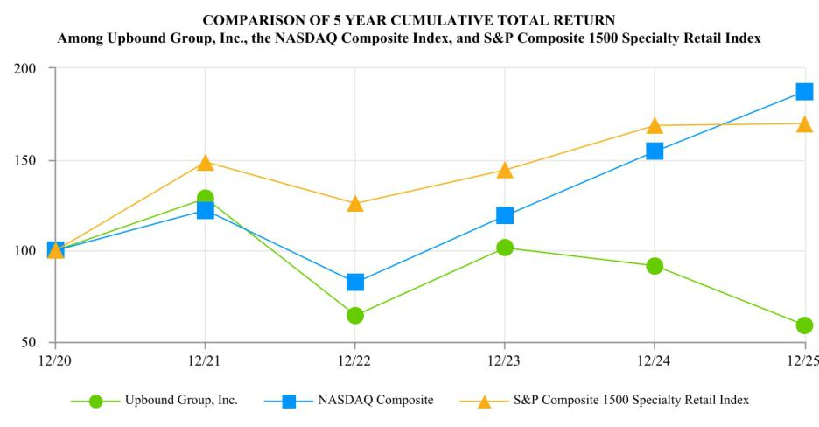

Item 6. Reserved.

41

Item 7. Management’s Discussion and Analysis of Financial Condition and Results of Operations.

Objective

We report financial operations under four operating segments, including our Acima segment, which includes our virtual and staffed business models; our Rent-A-Center segment, which includes our company-owned stores, franchise stores, and e-commerce platform through rentacenter.com; and our Brigit and Mexico segments.

The following discussion focuses on recent developments expected to have current and future impacts on the results of our business, trends and uncertainties within our industry and business model that may impact our financial results, our recent results of operations, and discussion of our liquidity and capital resources. You should read the following discussion in conjunction with the consolidated financial statements and notes thereto included elsewhere in this Annual Report on Form 10-K.

For similar historical operating and financial data and discussion of our year ended December 31, 2024 results compared to our year ended December 31, 2023 results, refer to Part II. Item 7. “Management’s Discussion and Analysis of Financial Condition and Results of Operations” of our Annual Report on Form 10-K, for the year ended December 31, 2024, incorporated herein by reference, which was filed with the SEC on February 25, 2025.

Recent Developments

Brigit Acquisition. On January 31, 2025, we completed the acquisition of Brigit for total consideration of up to $460 million, consisting of approximately $278.7 million in cash consideration and approximately 2.7 million shares of Upbound Group, Inc. common stock at closing, $75 million in deferred consideration, payable in multiple installments, and an earnout of up to $60 million based on the achievement of certain financial performance metrics for the Brigit business in 2026. Brigit is a holistic financial health technology company that has helped millions of Americans improve their financial health and literacy, find ways to earn and save money, access their earned wages before their regularly scheduled payday, build their credit through savings, and protect themselves from identity theft. Its mission is to help everyday Americans build a better financial future.

Operating Segments. On January 31, 2025 we established a new operating segment following the acquisition of Brigit. Please reference Note B in our consolidated financial statements included in this Annual Report on Form 10-K for additional discussion of the acquisition. In addition, effective January 1, 2025, we combined our Franchising segment with our Rent-A-Center segment. Financial information disclosed within this report has been recast for the related prior year period to reflect this change. We report four operating segments: Acima, Rent-A-Center, Brigit and Mexico.

One Big Beautiful Bill Act (“OBBB”). The OBBB was signed into law on July 4, 2025 and contains a broad range of tax reform provisions, including the reinstatement of 100% bonus depreciation and the immediate expensing of domestic R&D under the new § 174A of the Internal Revenue Code. As a result of the new provisions, we expect that OBBB will have a favorable impact on our cash taxes paid in the near term relative to the prior law.

Term Loan Facility Amendment. On August 19, 2025 we entered into a Fourth Amendment to the Term Loan Facility, effective as of August 19, 2025. The amendment, in addition to certain other changes, (i) extended the maturity date for the loans outstanding under the Term Loan Facility to August 19, 2032 (subject to certain springing maturity provisions) and (ii) provided approximately $77 million of incremental commitments under the Term Loan Facility, all of which were drawn at the closing of the amendment, resulting in total aggregate borrowings under the Credit Agreement on such date of $875 million.

Executive Management Changes.

- On June 1, 2025, Mitchell E. Fadel retired from his position as Chief Executive Officer and as a member of the Board of Directors. Fahmi Karam, our former Chief Financial Officer, succeeded Mr. Fadel as Chief Executive Officer and a member of the Board of Directors.
- On September 18, 2025, Rebecca Wooters joined the Company as Executive Vice President, Chief Growth Officer. Ms. Wooters brings more than 30 years of executive leadership in digital transformation, product innovation, technology, and customer engagement. Under the leadership of Ms. Wooters, we have consolidated Upbound’s marketing, data analytics, customer experience, and product development teams into a single integrated group.

- On November 10, 2025, Mr. Hal Khouri joined the Company as Executive Vice President, Chief Financial Officer. Mr. Khouri has over 30 years of experience in consumer-based banking, financial services, leasing, retail, consulting and government service.

42

Dividend. On December 4, 2025, we announced that our Board of Directors approved a quarterly cash dividend of $0.39 per share for the first quarter of 2026. The dividend was paid on January 6, 2026 to our common stockholders of record as of the close of business on December 17, 2025.

Business and Operational Trends

Macroeconomic Conditions. In recent years, we have experienced significant change in business and operational trends driven by macroeconomic conditions, which have directly impacted our customers as well as our operations, including significant changes in the U.S. consumer price index, changes in demand for certain consumer retail categories, changes in consumer payment behaviors, a condensed labor market, which has also contributed to wage inflation, rapid increases in interest rates, changes in tariff and trade policies, and global supply chain disruptions resulting in reduced product availability and rising product costs.

While our businesses have historically remained resilient through various economic cycles, the full extent to which our risk management strategy and these macroeconomic trends (including consumer spending and payment behavior) may impact the Company in future periods is uncertain. The continuation of volatile macroeconomic trends may have a material adverse impact on our financial statements, including our results of operations, operating cash flows, liquidity and capital resources.

See “Risk Factors” in Part I, Item 1A in this Annual Report on Form 10-K, for additional discussion of impacts to our business and additional risks associated with macroeconomic conditions.

Rent-A-Center e-commerce revenue. In recent years, e-commerce revenues have continued to increase as a percentage of total rentals and fees revenue in our Rent-A-Center segment. For the years ended December 31, 2025 and 2024, e-commerce revenues represented approximately 27% and 26% of total lease-to-own revenues, respectively. Due to recent trends in consumer shopping behaviors and expectations, we believe e-commerce solutions are an important part of our lease-to-own offering. However, we are unable to quantify the extent to which e-commerce revenues are incremental compared to what our overall revenues would have been in the absence of those e-commerce transactions. In addition, the profitability of e-commerce transactions can be impacted by different merchandise loss factors compared to traditional store-based transactions in the Rent-A-Center segment. Therefore, we are unable to determine with certainty whether the continuation of this trend toward increased e-commerce transactions will have a significant impact on our financial statements in future periods or be ultimately favorable or unfavorable to our financial results.

Results of Operations

The following discussion focuses on our results of operations and our liquidity and capital resources. You should read this discussion in conjunction with the consolidated financial statements and notes thereto for the year ended December 31, 2025 included in Part II, Item 8 of this Annual Report on Form 10-K.

Key Metrics

Gross Merchandise Volume (“GMV”): The Company defines Gross Merchandise Volume as the retail value in U.S. dollars of merchandise acquired by the Acima segment that is leased to customers through a transaction that occurs within a defined period, net of estimated cancellations as of the measurement date.

Lease Portfolio Value: Represents the aggregate dollar value of the expected monthly rental income associated with current active lease agreements from our Company-owned Rent-A-Center lease-to-own stores and e-commerce platform at the end of any given period.

Same Store Lease Portfolio Value: Represents the aggregate dollar value of the expected monthly rental income associated with current active lease agreements from our Company-owned Rent-A-Center lease-to-own stores that were operated by us for 13 months or more at the end of any given period. The Company excludes from the same store base any store that receives a certain level of customer accounts from closed stores or acquisitions. The receiving store will be eligible for inclusion in the same store base in the 30th full month following account transfer.

Same Store Sales: Same store sales generally represents revenue earned in Company-owned Rent-A-Center stores that were operated by us for 13 months or more and are reported on a constant currency basis as a percentage of total revenue earned in stores of the segment during the indicated period. The Company excludes from the same store sales base any store that receives a certain level of customer accounts from closed stores or acquisitions. The receiving store will be eligible for inclusion in the same store sales base in the 30th full month following account transfer.

Lease Charge-Offs (“LCOs”) (previously referred to as “skip/stolen losses”): Represents charge-offs of the net book value of unrecoverable on-rent merchandise with lease-to-own customers who are past due. This is typically expressed as a percentage

43

of revenues for the applicable period. For the Rent-A-Center segment, LCOs exclude Get It Now, Home Choice and franchise-owned Rent-A-Center locations.

Brigit Net Advance Losses: Represents charge-offs of Brigit uncollectible customer cash advances that are more than 45 days past due. This is typically expressed as a percentage of total cash advances originated in the applicable period.

Overview

The following briefly summarizes certain of our financial information for the year ended December 31, 2025 as compared to the year ended December 31, 2024.

During the year ended December 31, 2025, consolidated revenues and gross profit increased by approximately $374.5 million and $191.3 million, respectively, primarily due to the addition of Brigit segment revenues and an increase in the Acima segment revenues, partially offset by a decrease in Rent-A-Center segment revenues described below. Operating profit decreased by approximately $68.3 million, primarily due to increases in non-labor operating expenses, other gains and charges and general and administrative expenses of $138.3 million, $107.6 million and $19.5 million, respectively, partially offset by the increase in gross profit noted above and a decrease in operating labor expenses of $6.9 million.

The Acima segment revenues increased approximately $251.0 million for the year ended December 31, 2025, due to increases in rentals and fees revenues and merchandise sales of $192.5 million and $59.0 million, respectively, primarily resulting from higher GMV of 8.6%. Growth in GMV was primarily due to an increase in third-party retailer locations and productivity, which resulted in more leases per retailer, and expanded direct-to-consumer offerings. Operating profit increased approximately $39.4 million for the year ended December 31, 2025, primarily due to an increase in gross profit of $60.3 million and decreases in operating labor costs and other gains and charges of $4.4 million and $1.7 million, respectively, partially offset by an increase in non-labor operating expenses of $26.4 million. See “Segment Performance” below for further discussion of Acima segment operating results for the year ended December 31, 2025.

Revenues in our Rent-A-Center segment decreased approximately $83.2 million for the year ended December 31, 2025, due to decreases in same store sales of 2.2% and lower corporate-owned store count as a result of prior year store closures, resulting in decreases in rentals and fees revenues and merchandise sales of $79.9 million and $3.5 million, respectively. Operating profit decreased approximately $47.6 million for the year ended December 31, 2025, primarily due to a decrease in gross profit of approximately $51.1 million driven by lower revenues, in addition to higher general and administrative expenses and other gains and charges of approximately $9.1 million and $6.2 million, respectively, partially offset by decreases in non-labor operating expenses and operating labor expense of approximately $13.2 million and $6.4 million, respectively. See “Segment Performance” below for further discussion of Rent-A-Center segment operating results for the year ended December 31, 2025.

The Brigit segment had revenues and operating profit of $206.0 million and $30.7 million, respectively, during the period beginning on the Closing Date and ending on December 31, 2025. See “Segment Performance” below for further discussion of Brigit segment operating results for the year ended December 31, 2025.

The Mexico segment revenues and gross profit increased by 0.8% and 0.2% for the year ended December 31, 2025, respectively, primarily due to increases in rentals and fees revenue, partially offset by negative impacts of exchange rate fluctuations. Operating profit increased 13.4%, primarily due to an increase in gross profit and a decrease in general and administrative expenses, partially offset by negative impacts of exchange rate fluctuations. See “Segment Performance” below for further discussion of Mexico segment operating results for the year ended December 31, 2025.

Cash flow from operations was $305.6 million for the year ended December 31, 2025. As of December 31, 2025, we held $120.5 million of cash and cash equivalents and had outstanding indebtedness of $1.6 billion.

44

The following table is a reference for the discussion that follows.

 |  | Year Ended December 31, |  |  |  |  |  | 2025-2024 Change
(dollar amounts in thousands) |  | 2025 |  |  | 2024 |  |  | $ |  |  | %
Revenues
Rentals and fees | $ | 3,627,019 |  | $ | 3,513,658 |  | $ | 113,361 |  |  | 3.2 %
Merchandise sales |  | 829,268 |  |  | 773,744 |  |  | 55,524 |  |  | 7.2 %
Subscription and fees |  | 206,024 |  |  | — |  |  | 206,024 |  |  | nm
Other |  | 32,750 |  |  | 33,162 |  |  | (412) |  |  | (1.2)%
Total revenues |  | 4,695,061 |  |  | 4,320,564 |  |  | 374,497 |  |  | 8.7 %
Cost of revenues
Cost of rentals and fees |  | 1,441,758 |  |  | 1,355,539 |  |  | 86,219 |  |  | 6.4 %
Cost of merchandise sold |  | 957,621 |  |  | 884,674 |  |  | 72,947 |  |  | 8.2 %
Cost of subscription and fees |  | 23,973 |  |  | — |  |  | 23,973 |  |  | nm
Total cost of revenues |  | 2,423,352 |  |  | 2,240,213 |  |  | 183,139 |  |  | 8.2 %
Gross profit |  | 2,271,709 |  |  | 2,080,351 |  |  | 191,358 |  |  | 9.2 %
Operating expenses
Operating labor |  | 602,301 |  |  | 609,169 |  |  | (6,868) |  |  | (1.1)%
Non-labor operating expenses |  | 949,918 |  |  | 811,635 |  |  | 138,283 |  |  | 17.0 %
General and administrative expenses |  | 231,963 |  |  | 212,450 |  |  | 19,513 |  |  | 9.2 %
Depreciation and amortization |  | 51,959 |  |  | 50,886 |  |  | 1,073 |  |  | 2.1 %
Other gains and charges |  | 212,221 |  |  | 104,580 |  |  | 107,641 |  |  | 102.9 %
Total operating expenses |  | 2,048,362 |  |  | 1,788,720 |  |  | 259,642 |  |  | 14.5 %
Operating profit |  | 223,347 |  |  | 291,631 |  |  | (68,284) |  |  | (23.4)%
Debt refinancing charges |  | 4,894 |  |  | 6,604 |  |  | (1,710) |  |  | (25.9)%
Interest, net |  | 110,362 |  |  | 107,486 |  |  | 2,876 |  |  | 2.7 %
Earnings before income taxes |  | 108,091 |  |  | 177,541 |  |  | (69,450) |  |  | (39.1)%
Income tax expense |  | 34,849 |  |  | 54,063 |  |  | (19,214) |  |  | (35.5)%
Net earnings | $ | 73,242 |  | $ | 123,478 |  | $ | (50,236) |  |  | (40.7)%

nm - percent change is not meaningful for comparison

Comparison of the Years Ended December 31, 2025 and 2024

Revenue. Total revenue increased by $374.5 million, or 8.7%, to $4,695.1 million for the year ended December 31, 2025, from $4,320.6 million for 2024, primarily due to an increase of approximately $251.0 million in the Acima segment and the addition of the Brigit segment with $206.0 million in revenue, partially offset by a decrease of approximately $83.2 million in the Rent-A-Center segment, as discussed further in the “Segment Performance” section below.

Cost of Rentals and Fees. Cost of rentals and fees consists primarily of depreciation of rental merchandise. Cost of rentals and fees for the year ended December 31, 2025 increased by $86.3 million, or 6.4%, to $1,441.8 million, as compared to $1,355.5 million in 2024. The increase was primarily attributable to an increase of approximately $116.5 million in the Acima segment driven by an increase in rentals and fees revenues, partially offset by a decrease of approximately $30.8 million in the Rent-A-Center segment resulting from a decrease in rentals and fees revenue. Cost of rentals and fees expressed as a percentage of rentals and fees revenue increased to 39.8% for the year ended December 31, 2025, as compared to 38.6% in 2024, primarily due to the continued growth of the Acima segment as a percent of total rentals and fees revenue.

Cost of Merchandise Sold. Cost of merchandise sold represents the net book value of rental merchandise at time of sale. Cost of merchandise sold increased by $72.9 million, or 8.2%, to $957.6 million for the year ended December 31, 2025, from $884.7 million in 2024, primarily attributable to an increase of $74.3 million in the Acima segment primarily driven by higher merchandise sales. The gross margin percent of merchandise sales decreased to (15.5)% for the year ended December 31, 2025, from (14.3)% in 2024 primarily due to the conversion of Acceptance Now locations to the Acima Holdings Lease Management platform.

45

Gross Profit. Gross profit increased by $191.3 million, or 9.2%, to $2,271.7 million for the year ended December 31, 2025, from $2,080.4 million in 2024, primarily due to the addition of the Brigit segment with $182.1 million in gross profit and an increase of $60.3 million in the Acima segment, partially offset by a decrease of approximately $51.1 million in the Rent-A-Center segment, as discussed further in the “Segment Performance” section below. Gross profit as a percentage of total revenue increased to 48.4% in 2025, as compared to 48.1% in 2024.

Operating Labor. Operating labor includes all salaries and wages paid to operational employees and district managers, together with payroll taxes and benefits. Operating labor decreased by $6.9 million, or 1.1%, to $602.3 million for the year ended December 31, 2025, as compared to $609.2 million in 2024, primarily due to decreases of $6.4 million and $4.4 million in the Rent-A-Center and Acima segments, respectively, partially offset by the addition of the Brigit segment with $4.0 million in operating labor. The decrease in Rent-A-Center operating labor was primarily attributable to a decrease in corporate-owned store count, resulting from prior year store closures and refranchising. Operating labor expressed as a percentage of total revenue was 12.8% for the year ended December 31, 2025, as compared to 14.1% in 2024.

Non-Labor Operating Expenses. Non-labor operating expenses include LCOs, occupancy, delivery, advertising, selling, insurance, travel and other operating expenses. Non-labor operating expenses increased by $138.3 million, or 17.0%, to $949.9 million for the year ended December 31, 2025, as compared to $811.6 million in 2024, primarily due to the addition of the Brigit segment with $124.5 million in non-labor operating expenses and an increase of approximately $26.4 million in the Acima segment primarily related to an increase of $27.2 million in lease charge-off expense, partially offset by a decrease of approximately $13.2 million in the Rent-A-Center segment, primarily attributable to decreases of $11.3 million in lease-to-own store merchandise losses. Non-labor operating expenses expressed as a percentage of total revenue was 20.2% for the year ended December 31, 2025, as compared to 18.8% in 2024.

General and Administrative Expenses. General and administrative expenses include all corporate overhead expenses related to our headquarters such as salaries, payroll taxes and benefits, stock-based compensation, occupancy, administrative and other expenses, as well as salaries and labor costs for our regional directors, divisional vice presidents and executive vice presidents. General and administrative expenses increased by $19.5 million, or 9.2%, to $232.0 million for the year ended December 31, 2025, as compared to $212.5 million in 2024, primarily due to an increase in the allowance for doubtful accounts of $9.5 million related to franchising trade receivables, and the addition of the Brigit segment with $7.3 million in general and administrative expenses. General and administrative expenses expressed as a percentage of total revenue were 4.9% for both the years ended December 31, 2025 and 2024.

Other gains and charges. Other gains and charges increased by $107.6 million to $212.2 million in 2025, as compared to $104.6 million in 2024. The increase in other gains and charges was driven primarily by increases of $60.1 million related to the Brigit acquisition, including depreciation and amortization of the fair value of acquired software and intangible assets, stock compensation expense related to the vesting of a portion of the equity consideration, other compensation and transaction costs, $60.7 million in estimated legal accruals and related litigation and defense expenses described further in Note M of our consolidated financial statements and $7.0 million in lease impairment charges and fixed asset disposals, partially offset by decreases of $6.1 million in accelerated software depreciation, $4.9 million in stock compensation expense related to restricted stock issued in connection with the Acima Holdings acquisition, $3.5 million in accelerated stock compensation expense related to our letter agreement with the Company’s former Chief Executive Officer and $1.7 million in depreciation and amortization of acquired software and intangible assets in connection with the Acima Holdings acquisition for the year ended December 31, 2025.

Operating Profit. Operating profit decreased by $68.3 million, or 23.4%, to $223.3 million for the year ended December 31, 2025, as compared to $291.6 million in 2024, primarily due to the increases in non-labor operating expenses, other gains and charges and general and administrative expenses, partially offset by an increase in gross profit and decreases in operating labor, as described above. Operating profit expressed as a percentage of total revenue was 4.8% for the year ended December 31, 2025, compared to 6.7% in 2024.

Income Tax Expense. Income tax expense decreased by $19.3 million to $34.8 million for the year ended December 31, 2025, as compared to $54.1 million in 2024, primarily due to the decrease in earnings before income taxes for the year ended December 31, 2025 compared to 2024, partially offset by a higher effective tax rate for the year ended December 31, 2025 attributable to the tax impact on non-deductible expenses related to the Brigit acquisition. See Note J of our consolidated financial statements included in this Annual Report on Form 10-K for additional information regarding our effective tax rate.

46

Segment Performance

Acima segment.

 |  | Year Ended December 31, |  |  |  |  |  | 2025-2024 Change
(dollar amounts in thousands) | 2025 |  |  | 2024 |  |  | $ |  |  |  | %
Revenues | $ | 2,512,484 |  | $ | 2,261,446 |  | $ | 251,038 |  |  | 11.1 %
Gross profit |  | 762,889 |  |  | 702,620 |  |  | 60,269 |  |  | 8.6 %
Operating profit |  | 294,971 |  |  | 255,549 |  |  | 39,422 |  |  | 15.4 %
Gross merchandise volume⁽¹⁾ |  | 2,010,051 |  |  | 1,851,616 |  |  | 158,435 |  |  | 8.6 %

- See Key Metrics described above for additional information

Revenues. The increase in revenues for the year ended December 31, 2025, as compared to 2024, was primarily due to increases in rentals and fees revenues and merchandise sales revenue of $192.5 million and $59.0 million, respectively, resulting from higher GMV. Growth in GMV was primarily due to an increase in new third-party retailer locations and productivity, which resulted in more leases per retailer, in addition to expanded direct-to-consumer offerings.

Gross Profit. Gross profit increased for the year ended December 31, 2025, as compared to 2024, driven primarily by the increase in revenues described above. Gross profit as a percentage of segment revenues decreased to 30.4% for the year ended December 31, 2025, compared to 31.1% in 2024, primarily due to the conversion of Acceptance Now locations to the Acima Holdings Lease Management platform.

Operating Profit. Operating profit as a percentage of segment revenues increased to 11.7% for the year ended December 31, 2025, compared to 11.3% in 2024. The increase in operating profit margin is primarily due to higher revenues described above, resulting in a decrease of 1.2% in operating expenses as a percentage of total revenue, partially offset by the increase in gross profit margin described above. Merchandise losses in our Acima locations due to LCOs, expressed as a percentage of revenues, were approximately 9.5% in 2025, compared to 9.4% in 2024. Merchandise losses in our Acima locations due to other merchandise losses, expressed as a percentage of revenues, were 0.4% in 2025, as compared to 0.2% in 2024. Other merchandise losses include unrepairable and missing merchandise and loss/damage waiver claims.

Rent-A-Center segment.

 |  | Year Ended December 31, |  |  |  |  |  | 2025-2024 Change
(dollar amounts in thousands) | 2025 |  |  | 2024 |  |  | $ |  |  |  | %
Revenues | $ | 1,897,161 |  | $ | 1,980,392 |  | $ | (83,231) |  |  | (4.2)%
Gross profit |  | 1,270,231 |  |  | 1,321,299 |  |  | (51,068) |  |  | (3.9)%
Operating profit |  | 249,521 |  |  | 297,160 |  |  | (47,639) |  |  | (16.0)%
Lease portfolio value⁽¹⁾ |  | 137,375 |  |  | 136,751 |  |  | 624 |  |  | 0.5 %
Same store lease portfolio value⁽¹⁾ |  | 121,657 |  |  | 120,776 |  |  | 881 |  |  | 0.7 %
Change in same store sales⁽¹⁾ |  |  |  |  |  |  |  |  |  |  | (2.2)%
Stores in same store sales calculation |  |  |  |  |  |  |  |  |  |  | 1,557

- See Key Metrics described above for additional information

Revenues. The decrease in revenue for the year ended December 31, 2025, as compared to 2024, was primarily due to decreases in same store sales of 2.2% generally resulting from certain underwriting adjustments implemented in prior periods. In addition, the decrease in revenue for the year ended December 31, 2025 was also driven by lower corporate-owned store count due to prior year store closures.

Gross Profit. Gross profit decreased in 2025, as compared to 2024, driven primarily by the decrease in revenues described above. Gross profit as a percentage of segment revenues increased to 67.0% in 2025 from 66.7% in 2024, primarily due to mix-shift changes between lease merchandise product categories.

Operating Profit. Operating profit as a percentage of segment revenues was 13.2% for 2025, as compared to 15.0% for 2024. The decrease in operating profit margin for the year ended December 31, 2025 was primarily due to an increase in other gains and charges of $6.2 million, primarily due to impairment charges and shutdown costs related to closure of refranchised locations. The decrease in operating profit margin for the year ended December 31, 2025 was also attributable to an increase in general and administrative expenses of $9.1 million, primarily driven by increase in the allowance for doubtful accounts related

47

to franchising trade receivables. Merchandise losses in our Rent-A-Center lease-to-own stores due to LCOs, expressed as a percentage of Rent-A-Center lease-to-own revenues, were approximately 4.7% for both years ended December 31, 2025 and 2024. Merchandise losses in our Rent-A-Center lease-to-own stores due to other merchandise losses, expressed as a percentage of Rent-A-Center lease-to-own revenues, were approximately 1.0% for the year ended December 31, 2025, compared to 1.3% in 2024. Other merchandise losses include unrepairable and missing merchandise and loss/damage waiver claims.

Brigit segment.

 |  | Year Ended December 31, |  |  |  |  |  | 2025-2024 Change
(dollar amounts in thousands) | 2025 |  |  | 2024 |  |  | $ |  |  |  | %
Revenues | $ | 206,024 |  | $ | — |  | $ | 206,024 |  |  | nm
Gross profit |  | 182,051 |  |  | — |  |  | 182,051 |  |  | nm
Operating profit |  | 30,656 |  |  | — |  |  | 30,656 |  |  | nm

nm - percent change is not meaningful for comparison

Revenues. Revenues for the year ended December 31, 2025 included subscription, transfer fee and marketplace revenues of $143.7 million, $42.0 million, and $20.3 million, respectively.

Gross Profit. Gross profit as a percentage of segment revenues was 88.4% for the year ended December 31, 2025.

Operating Profit. Operating profit as a percentage of segment revenues was 14.9% for the year ended December 31, 2025. Net advance losses expressed as a percentage of total cash advances originated was approximately 3.0% for the year ended December 31, 2025.

Please refer to Note B of our consolidated financial statements included in this Annual Report on Form 10-K for information about the acquisition of Brigit, which was completed on January 31, 2025.

Mexico segment.

 |  | Year Ended December 31, |  |  |  |  |  | 2025-2024 Change
(dollar amounts in thousands) | 2025 |  |  | 2024 |  |  | $ |  |  |  | %
Revenues | $ | 79,392 |  | $ | 78,726 |  | $ | 666 |  |  | 0.8 %
Gross profit |  | 56,538 |  |  | 56,432 |  |  | 106 |  |  | 0.2 %
Operating profit |  | 5,450 |  |  | 4,806 |  |  | 644 |  |  | 13.4 %
Change in same store sales⁽¹⁾ |  |  |  |  |  |  |  |  |  |  | 5.3 %
Stores in same store sales calculation |  |  |  |  |  |  |  |  |  |  | 125

- See Key Metrics described above for additional information

Revenues. Exchange rate fluctuations negatively impacted revenues by approximately $4.2 million for the year ended December 31, 2025, as compared to 2024. On a constant currency basis, revenues for the year ended December 31, 2025 increased approximately $4.9 million, as compared to 2024.

Gross Profit. Exchange rate fluctuations negatively impacted gross profit by approximately $3.1 million for the year ended December 31, 2025, as compared to 2024. On a constant currency basis, gross profit for the year ended December 31, 2025 increased by approximately $3.2 million, as compared to 2024. Gross profit as a percentage of segment revenues was 71.2% for the year ended December 31, 2025, as compared to 71.7% for 2024.

Operating Profit. Exchange rate fluctuations negatively impacted operating profit by approximately $0.4 million for the year ended December 31, 2025, as compared to 2024. On a constant currency basis, operating profit for the year ended December 31, 2025 increased by approximately $1.0 million, as compared to 2024. Operating profit as a percentage of segment revenues increased to 6.9% for the year ended December 31, 2025, as compared to 6.1% for 2024.

Liquidity and Capital Resources

Overview. For the year ended December 31, 2025, we generated $305.6 million in operating cash flow, used cash in the amount of $516.6 million for debt repayments, $278.9 million for acquisitions, $87.9 million for dividends, $66.9 million for capital expenditures, and $58.2 million for customer cash advance originations net of collections, and had cash proceeds from indebtedness of $776.0 million. We ended the year with $120.5 million of cash and cash equivalents and outstanding indebtedness of $1.6 billion.

48

Analysis of Cash Flow. Cash provided by operating activities increased by $200.9 million to $305.6 million in 2025, from $104.7 million in 2024, primarily due to an increase of approximately $180.7 million in cash provided by net earnings (net earnings less adjustments to reconcile net earnings to net cash provided by operating activities), which was benefited by $30.7 million in operating income generated by the Brigit operating segment following the acquisition; a year-over-year decrease of approximately $82.3 million in payments of outstanding inventory and trade payables primarily due to higher payments of outstanding inventory payables made in early 2024; and a year-over-year decrease in income taxes paid, net of refunds, of approximately $32.6 million. . These impacts were partially offset by higher inventory purchases of approximately $165.4 million, net of approximately $47.1 million of customer lease buyouts through early purchase options, lease charge-offs, and other merchandise losses, driven by increased consumer demand.

Cash used in investing activities increased by $362.2 million to $403.7 million in 2025, compared to $41.5 million in 2024, primarily due to payment of cash consideration for the acquisition of Brigit of $275.9 million and $58.2 million for customer cash advance originations net of collections, in addition to higher proceeds from sale of property assets of $18.7 million for the year ended December 31, 2024 resulting from the sale of 55 Rent-A-Center stores in the states of New York and New Jersey to a franchisee.

Cash provided by (used in) financing activities increased by $250.0 million to $156.5 million in 2025, compared to $(93.5) million in 2024, primarily due to an increase in borrowings under the ABL Credit Facility of $456.0 million, partially offset by an increase in debt repayments of $192.8 million for the year ended December 31, 2025.

Liquidity Requirements. Our primary liquidity requirements are for rental merchandise purchases in our Acima and Rent-A-Center segments, which are impacted by consumer demand for our lease-to-own solutions, and customer advances in our Brigit segment. Other capital requirements include expenditures for technology and property assets, and debt service. Our primary source of liquidity has been cash provided by operations.

We generally utilize our ABL Credit Facility for the issuance of letters of credit to manage normal fluctuations in operational cash flow caused by the timing of cash payments relative to cash receipts, and to potentially fund strategic initiatives including acquisitions. In that regard, we may from time to time draw funds under the ABL Credit Facility for general corporate purposes. Amounts are drawn as needed due to the timing of cash flows and are generally paid down as cash is generated by our operating activities. We believe cash flow generated from operations and availability under our ABL Credit Facility will be sufficient to fund our operations during the next twelve months. At February 13, 2026, we had approximately $102.4 million in cash on hand and $216.6 million available under our ABL Credit Facility.

Merchandise Losses. Merchandise losses consist of the following:

 |  |  |  |  | Year Ended December 31,
(in thousands) |  | 2025 |  |  | 2024 |  |  | 2023
Lease charge-offs | $ | 338,999 |  | $ | 316,402 |  | $ | 284,703
Other merchandise losses⁽¹⁾ |  | 27,136 |  |  | 30,670 |  |  | 29,112
Total merchandise losses | $ | 366,135 |  | $ | 347,072 |  | $ | 313,815

- Other merchandise losses include unrepairable and missing merchandise, and loss/damage waiver claims.

Capital Expenditures. We make capital expenditures in order to maintain our existing operations, acquire new capital assets in new and acquired stores and invest in information technology. We spent $66.9 million, $56.3 million and $53.4 million on capital expenditures in the years 2025, 2024 and 2023, respectively. The increase of $10.6 million for the year ended December 31, 2025 is primarily due to higher investment in software development.

New Location Openings and Acquisitions. During 2025, we acquired four lease-to-own store locations and customer accounts for an aggregate purchase price of approximately $2.2 million. One store location was closed upon acquisition and consolidated into existing store operations in our Rent-A-Center segment and three remained open as part of our Rent-A-Center segment.

49

The tables below summarize the location activity for the years ended December 31, 2025, 2024 and 2023 for our Rent-A-Center and Mexico operating segments.

 |  |  |  | Year Ended December 31, 2025
 | Rent-A-Center |  |  |  | Mexico |  |  | Total
Locations at beginning of period |  | 2,176 |  |  | 132 |  |  | 2,308
New location openings |  | 1 |  |  | 4 |  |  | 5
Acquired locations remaining open |  | 3 |  |  | — |  |  | 3
Closed locations
Merged with existing locations |  | (9) |  |  | — |  |  | (9)
Sold or closed with no surviving location⁽¹⁾ |  | (96) |  |  | — |  |  | (96)
Locations at end of period⁽²⁾ |  | 2,075 |  |  | 136 |  |  | 2,211
Acquired locations closed and accounts merged with existing locations |  | 1 |  |  | — |  |  | 1
Total approximate purchase price of acquired stores (in thousands) | $ | 2,219 |  | $ | — $ |  |  | 2,219

- Represents Rent-A-Center franchisee store locations.

- Rent-A-Center includes 1,722 company-owned and 353 franchisee store locations.

 |  |  |  | Year Ended December 31, 2024
 | Rent-A-Center |  |  |  | Mexico |  |  | Total
Locations at beginning of period |  | 2,279 |  |  | 131 |  |  | 2,410
New location openings |  | 4 |  |  | 3 |  |  | 7
Closed locations
Merged with existing locations |  | (62) |  |  | — |  |  | (62)
Sold or closed with no surviving location⁽¹⁾ |  | (45) |  |  | (2) |  |  | (47)
Locations at end of period⁽²⁾ |  | 2,176 |  |  | 132 |  |  | 2,308
Acquired locations closed and accounts merged with existing locations |  | 3 |  |  | — |  |  | 3
Total approximate purchase price of acquired store (in thousands) | $ | 1,463 |  | $ | — $ |  |  | 1,463

- Includes closure of 43 Rent-A-Center franchisee store locations.

- Rent-A-Center includes 1,728 company-owned and 448 franchisee store locations.

 |  |  |  | Year Ended December 31, 2023
 | Rent-A-Center |  |  |  | Mexico |  |  | Total
Locations at beginning of period |  | 2,298 |  |  | 126 |  |  | 2,424
New location openings |  | 9 |  |  | 6 |  |  | 15
Closed locations
Merged with existing locations |  | (12) |  |  | (1) |  |  | (13)
Sold or closed with no surviving location⁽¹⁾ |  | (16) |  |  | — |  |  | (16)
Locations at end of period⁽²⁾ |  | 2,279 |  |  | 131 |  |  | 2,410
Acquired locations closed and accounts merged with existing locations |  | 1 |  |  | — |  |  | 1
Total approximate purchase price of acquired stores (in thousands) | $ | 39 |  | $ | — $ |  |  | 39

- Represents Rent-A-Center franchisee store locations.

- Rent-A-Center includes 1,839 company-owned and 440 franchisee store locations.

Senior Debt. On February 17, 2021, we entered into a credit agreement with JPMorgan Chase Bank, N.A., as administrative agent, and lenders party thereto, that provides for a five-year asset-based revolving credit facility with commitments of $550 million and a letter of credit sublimit of $150 million, which commitments may be increased, at our option and under certain conditions, by up to an additional $125 million in the aggregate (as most recently amended on August 29, 2025, the “ABL Credit Facility”). Under the ABL Credit Facility, we may borrow only up to the lesser of the level of the then-current borrowing base and the aggregate amount of commitments under the ABL Credit Facility. The borrowing base is tied to the amount of eligible installment sales accounts, inventory and eligible lease contracts, reduced by certain reserves. The ABL Credit Facility bears interest at a fluctuating rate determined by reference to an adjusted Term SOFR rate plus an applicable margin of 1.50% to 2.00%, which, as of February 13, 2026, was 5.77%. A commitment fee equal to 0.250% to 0.375% of the unused portion of the ABL Credit Facility fluctuates dependent upon average utilization for the prior month as defined by a

50

pricing grid included in the documentation governing the ABL Credit Facility. Loans under the ABL Credit Facility may be borrowed, repaid and re-borrowed until June 7, 2029 (subject to certain springing maturity provisions), at which time all amounts borrowed must be repaid.

The obligations under the ABL Credit Facility are guaranteed by us and certain of our material wholly owned domestic restricted subsidiaries, subject to certain exceptions. The obligations under the ABL Credit Facility and such guarantees are secured on a first-priority basis by all of our and our subsidiary guarantors’ accounts, inventory, deposit accounts, securities accounts, cash and cash equivalents, rental agreements, general intangibles (other than equity interests in our subsidiaries), chattel paper, instruments, documents, letter of credit rights, commercial tort claims related to the foregoing and other related assets and all proceeds thereof related to the foregoing, subject to permitted liens and certain exceptions (such assets, collectively, the “ABL Priority Collateral”) and a second-priority basis in substantially all other present and future tangible and intangible personal property of ours and the subsidiary guarantors, subject to certain exceptions.

On February 17, 2021, we also entered into a term loan credit agreement with JPMorgan Chase Bank, N.A., as administrative agent, and lenders party thereto, that provides for a seven-year $875 million senior secured term loan facility (as most recently amended on August 19, 2025, the “Term Loan Facility”). Subject in each case to certain restrictions and conditions, we may add up to $625 million (plus additional amounts subject to the satisfaction of certain financial ratios) of incremental term loan facilities to the Term Loan Facility or utilize incremental capacity under the Term Loan Facility at any time by issuing or incurring incremental equivalent term debt. Interest on borrowings under the Term Loan Facility is payable at a fluctuating rate of interest determined by reference to the Term SOFR rate plus an applicable margin of 2.75%, subject to a 0.50% Term SOFR floor, which, as of February 13, 2026, was 6.42%.

Borrowings under the Term Loan Facility amortize in equal quarterly installments in an amount equal to 1.000% per annum of the original aggregate principal amount thereof, with the remaining balance due at final maturity on August 19, 2032 (subject to certain springing maturity provisions). The Term Loan Facility is secured by a first-priority security interest in substantially all of present and future tangible and intangible personal property of us and our subsidiary guarantors, other than the ABL Priority Collateral, and by a second-priority security interest in the ABL Priority Collateral, subject to certain exceptions. The obligations under the Term Loan Facility are guaranteed by us and our material wholly-owned domestic restricted subsidiaries that also guarantee the ABL Credit Facility.

At February 13, 2026, we had outstanding borrowings of $872.8 million under the Term Loan Facility and available commitments of $216.6 million under our ABL Credit Facility, net of letters of credit.

See Note K of our consolidated financial statements included in this Annual Report on Form 10-K for additional information regarding our senior debt.

Senior Notes. On February 17, 2021, we issued $450 million in senior unsecured notes due February 15, 2029, at par value, bearing interest at 6.375% (the “Notes”). Interest on the Notes is payable in arrears on February 15 and August 15 of each year, beginning on August 15, 2021. We may redeem some or all of the Notes at any time for cash at the redemption prices set forth in the indenture governing the Notes, plus accrued and unpaid interest to, but not including, the redemption date. If we experience specific kinds of change in control, we will be required to offer to purchase the Notes at a price equal to 101% of the principal amount thereof plus accrued and unpaid interest. See Note L of our consolidated financial statements included in this Annual Report on Form 10-K for additional information regarding our senior notes.

Operating Leases. We lease space for all of our Rent-A-Center and Mexico stores under operating leases expiring at various times through 2036. In addition we lease space for certain support facilities under operating leases expiring at various times through 2032. Most of our store leases are five-year leases and contain renewal options for additional periods ranging from three to five years at rental rates adjusted according to agreed-upon formulas. As of December 31, 2025, our total remaining obligation for existing store lease contracts was approximately $335.5 million.

We lease vehicles for all of our Rent-A-Center stores under operating leases with lease terms expiring twelve months after the start date of the lease. We classify these leases as short-term and have elected the short-term lease exemption for our vehicle leases, and have therefore excluded them from our operating lease right-of-use assets within our Consolidated Balance Sheets. As of December 31, 2025, our total remaining minimum obligation for existing Rent-A-Center vehicle lease contracts was approximately $3.2 million.

We also lease vehicles for all of our Mexico stores which have terms expiring at various times through 2030 with rental rates adjusted periodically for inflation. As of December 31, 2025, our total remaining obligation for existing Mexico vehicle lease contracts was approximately $3.0 million.

51

Reference Note G of our consolidated financial statements included in this Annual Report on Form 10-K for additional discussion of our store operating leases.

Uncertain Tax Position. As of December 31, 2025, we have recorded $1.0 million in uncertain tax positions. Although these positions represent a potential future cash liability to us, the amounts and timing of such payments are uncertain.

Seasonality. Our revenue mix in our lease-to-own businesses is moderately seasonal, with the first quarter of each fiscal year generally providing higher sales than any other quarter during a fiscal year. Generally, our customers will more frequently exercise the early purchase option on their existing lease purchase agreements in our Acima and Rent-A-Center segments or purchase pre-leased merchandise off the showroom floor in our Rent-A-Center segment during the first quarter of each fiscal year, primarily due to the receipt of federal income tax refunds. In contrast, our cash expenditures for our merchandise purchases for the fiscal year are generally the highest beginning in the latter part of the third quarter through the fourth quarter, primarily as a result of holiday promotions that lead to increased demand for our lease-to-own offerings.

Critical Accounting Estimates, Uncertainties or Assessments in Our Financial Statements

The preparation of our consolidated financial statements in conformity with accounting principles generally accepted in the United States of America requires us to make estimates and assumptions that affect the reported amounts of assets and liabilities, disclosure of contingent losses and liabilities at the date of the consolidated financial statements and the reported amounts of revenues and expenses during the reporting period. In applying accounting principles, we must often make individual estimates and assumptions regarding expected outcomes or uncertainties. Our estimates, judgments and assumptions are continually evaluated based on available information and experience. However, uncertainties, including those related to recent macroeconomic trends or other factors, may affect certain estimates and assumptions inherent in the financial reporting process, which may impact reported amounts of assets and liabilities in future periods and cause actual results to differ from those estimates. We believe the following are areas where the degree of judgment and complexity in determining amounts recorded in our consolidated financial statements make the accounting policies critical.

If we make changes to our reserves in accordance with the policies described below, our earnings would be impacted. Increases to our reserves would reduce earnings and, similarly, reductions to our reserves would increase our earnings. A pre-tax change of approximately $0.9 million in our estimates would result in a corresponding $0.01 change in our diluted earnings per common share as of December 31, 2025.

Self-Insurance Liabilities. We have self-insured retentions with respect to losses under our workers' compensation, general liability and vehicle liability. We establish reserves for our liabilities associated with these losses by obtaining forecasts for the ultimate expected losses and estimating amounts needed to pay losses within our self-insured retentions.

We continually institute procedures to manage our loss exposure and increases in health care costs associated with our insurance claims through our risk management function, including a transitional duty program for injured workers, ongoing safety and accident prevention training, and various other programs designed to minimize losses and improve our loss experience in our store locations. We make assumptions on our liabilities within our self-insured retentions using actuarial loss forecasts, company-specific development factors, general industry loss development factors, and third-party claim administrator loss estimates which are based on known facts surrounding individual claims. These assumptions incorporate expected increases in health care costs. Periodically, we reevaluate our estimate of liability within our self-insured retentions. At that time, we evaluate the adequacy of our reserves by comparing amounts reserved on our balance sheet for anticipated losses to our updated actuarial loss forecasts and third-party claim administrator loss estimates, and make adjustments to our reserves as needed.

As of December 31, 2025, the amount reserved for losses within our self-insured retentions with respect to workers’ compensation, general liability and vehicle liability insurance was $65.9 million, as compared to $61.1 million at December 31, 2024. However, if any of the factors that contribute to the overall cost of insurance claims were to change, the actual amount incurred for our self-insurance liabilities could be more or less than the amounts currently reserved.

Rental Merchandise. Rental merchandise is carried at cost, net of accumulated depreciation. Depreciation for merchandise in Rent-A-Center, certain Acima locations formerly operating under the Acceptance Now brand, and Mexico stores is depreciated using the income forecasting method, which is intended to match as closely as practicable the recognition of depreciation expense with the consumption of the rental merchandise, and assumes no salvage value. The consumption of rental merchandise occurs during periods of rental and directly coincides with the receipt of rental revenue over the rental purchase agreement period. Under the income forecasting method, merchandise held for rent is not depreciated and merchandise on rent is depreciated in the proportion of rents received to total rents provided in the lease contract, which is an activity-based method similar to the units of production method. Depreciation of merchandise for Acima Holdings is recognized using a straight-line

52

method over the term of the lease contract. Depreciation under the straight-line method is recognized each period over the term of the lease-to-own contract irrespective of receipt of revenue payments from the customer. In addition, merchandise that is held for rent for at least 180 consecutive days is depreciated using the straight-line method over a period generally not to exceed 18 months, and smartphones are also depreciated on a straight-line basis over an 18-month period beginning with the earlier of on rent or 90 consecutive days held for rent.

Rental merchandise that is damaged and inoperable is expensed when such impairment occurs. If a customer does not return the merchandise or make payment, the remaining book value of the rental merchandise associated with delinquent accounts is generally charged off on or before the 90th day following the time the account became past due in the Rent-A-Center and Mexico segments, on or before the 120th day in our Acima segment and during the month following the 150th day in certain Acima locations formerly operating under the Acceptance Now brand. Minor repairs made to rental merchandise are expensed at the time of the repair. In addition, we maintain a reserve for these expected losses, which estimates the merchandise losses expected but not yet incurred as of the end of the accounting period based on a combination of historical write-offs and expected future losses. As of December 31, 2025 and 2024, the reserve for merchandise losses was $97.6 million and $83.6 million, respectively.

Valuation of Goodwill. We perform an assessment of goodwill for impairment at the reporting unit level annually as of October 1 or when events or circumstances indicate that impairment may have occurred. Factors which could necessitate an interim impairment assessment include a sustained decline in our stock price, prolonged negative industry or economic trends and significant underperformance relative to historical or projected future operating results.

Based on our assessment, if the fair value of the reporting unit exceeds its carrying value, then the goodwill is not deemed impaired. If the carrying value of the reporting unit exceeds fair value, goodwill is deemed impaired and the impairment is measured as the difference between the carrying value and the fair value of the respective reporting unit. As an alternative to performing a quantitative assessment to measure the fair value of the relevant unit, we may perform a qualitative assessment for impairment if we believe it is not more likely than not that the carrying value of the net assets of the reporting unit exceeds its fair value.

Our reporting units are our reportable operating segments identified in Note T to our consolidated financial statements included in this Annual Report on Form 10-K. Determining the fair value of a reporting unit is judgmental in nature and involves the use of significant estimates and assumptions that we believe are reasonable but inherently uncertain, and actual results may differ from those estimates. These estimates and assumptions include, but are not limited to, future cash flows based on revenue growth rates and operating margins, and future economic and market conditions approximated by a discount rate derived from our weighted average cost of capital. Factors that could affect our ability to achieve the expected growth rates or operating margins include, but are not limited to, the general strength of the economy and other economic conditions that affect consumer preferences and spending and factors that affect the disposable income of our current and potential customers and other factors discussed in “Risk Factors” contained in Item 1A of this Annual Report on Form 10-K. Factors that could affect our weighted average cost of capital include changes in interest rates and changes in our effective tax rate.

During the period from our 2024 goodwill impairment assessment through the third quarter 2025, we periodically analyzed whether any indicators of impairment had occurred, including by comparing the estimated fair value of the Company, as determined based on our consolidated stock price, to its net book value. As the estimated fair value of the Company was higher than its net book value during each of these periods, no additional testing was deemed necessary.

We completed a qualitative assessment for impairment of goodwill as of October 1, 2025, concluding it was not more likely than not that the carrying value of the net assets of our reporting units exceeded their respective fair values.

At December 31, 2025 and 2024, the amount of goodwill allocated to the Acima segment was $288.3 million and $288.3 million. At December 31, 2025 and 2024, the amount of goodwill allocated to the Rent-A-Center segment was $3.0 million and $1.9 million, respectively. At December 31, 2025, the amount of goodwill allocated to the Brigit segment was $196.9 million.

Contingencies. We, along with our subsidiaries, are party to various legal proceedings and governmental inquiries and investigations given the nature of our business. We regularly monitor developments related to these matters to determine whether a potential loss is probable and can be reasonably estimated for purposes of recording a reserve in our financial statements. We review the adequacy of our reserves for such matters on a quarterly basis. As a result, we do not have reserves for all matters with respect to which we may or will have future liability, and no assurance can be given that our reserves, when recorded, will be adequate to cover the full amount of any loss we may ultimately incur. As of December 31, 2025 and 2024, we had estimated legal accruals of $72.0 million and $20.7 million, respectively. Legal reserves are recorded under Accrued Liabilities in our Consolidated Balance Sheet. Please reference Notes I, M and N in the Notes to our consolidated financial statements for additional disclosure related to our outstanding legal matters and related legal reserves.

53

Acquisitions. On January 31, 2025, we completed the acquisition of Brigit. In accordance with the Agreement and Plan of Merger (the “Merger Agreement”) with Fortuna Merger Sub, Inc., a Delaware corporation and wholly owned subsidiary of the Company (“Merger Sub”), Brigit, and Shareholder Representative Services LLC, solely in its capacity as the representative, agent and attorney-in-fact of Brigit’s securityholders, we issued to the security holders of Brigit approximately 2.7 million shares of our common stock and paid to them closing cash consideration of approximately $278.5 million. The total purchase consideration of approximately $395.4 million consisted of stock, cash and other consideration is described further in Note B to our consolidated financial statements included in this Annual Report on Form 10-K.

In accordance with ASC 805, assets acquired and liabilities assumed in connection with the acquisition of Brigit were recorded at their fair values. Carrying value for assets and liabilities assumed as part of the acquisition, including receivables, prepaid expenses and other assets, accounts payable and accrued liabilities were recorded as fair value, as of the date of acquisition, due to the short-term nature of these balances. Operating lease right-of-use assets and liabilities were recorded as the discounted value of future obligations in accordance with ASC Topic 842, “Leases”. The fair value measurements for certain acquired assets, including $152.3 million of identifiable intangible assets and $65.1 million related to developed technology, were determined based on an independent valuation using common industry valuation methods, including the relief-from-royalty, excess earnings and replacement cost methods, using significant unobservable inputs (Level 3) based on the Company's historical financial results, cost estimates and projected future cash flows discounted by an estimated weighted average cost of capital. Changes to these unobservable inputs could impact the estimated fair value measurements of these assets.

Finally, we recorded goodwill of $196.9 million in our Brigit operating segment, which consists of the excess of the net purchase price over the estimated fair value of the acquired net assets described above.

Based on an assessment of our accounting policies and the underlying judgments and uncertainties affecting the application of those policies, we believe our consolidated financial statements fairly present in all material respects the financial condition, results of operations and cash flows of our company as of, and for, the periods presented in this Annual Report on Form 10-K. However, we do not suggest that other general risk factors, such as those discussed elsewhere in this report as well as changes in our growth objectives or performance of new or acquired locations, could not adversely impact our consolidated financial position, results of operations and cash flows in future periods.

Recently Issued Accounting Pronouncements

In November 2024, the FASB issued ASU 2024-03, Income Statement—Reporting Comprehensive Income—Expense Disaggregation Disclosures (Subtopic 220-40): Disaggregation of Income Statement Expenses, which requires new tabular disclosures disaggregating prescribed expense categories within relevant income statement captions. In January 2025, the FASB issued ASU 2025-01, which clarifies the effective date for ASU No. 2024-03. The adoption of ASU 2024-03 will be required for us for annual reporting periods beginning after December 15, 2026 and interim reporting periods beginning after December 15, 2027. We are currently in the preliminary stages of assessing this ASU and the impact it will have on our financial statements following adoption but expect it will result in increased disclosure.

In July 2025, the FASB issued ASU 2025-05, Financial Instruments - Credit Losses (Topic 326), which amends the existing standard that refers to estimating expected credit losses on current accounts receivables and current contract assets arising from transactions under Topic 606. Under the new standard, public business entities may elect a practical expedient that assumes the current conditions as of the balance sheet date do not change for the remaining life of the asset when estimating expected credit losses. The adoption of ASU 2025-05 will be required for us for annual reporting periods beginning after December 15, 2025 and interim reporting periods within those annual reporting periods. We are completing our assessment of this ASU but do not believe it will have a material impact on our financial statements.

In September 2025, the FASB issued ASU 2025-06, Intangibles - Goodwill and Other - Internal-Use Software (Subtopic 350-40), which amends the existing standard that refers to various stages of a software development. Under the new standard, entities will start capitalizing eligible costs when management has authorized and committed to funding the software project, and it is probable that the project will be completed and the software will be used to perform the function intended. The adoption of ASU 2025-06 will be required for us for annual reporting periods beginning after December 15, 2027 and interim reporting periods within those annual reporting periods. We are in the preliminary stages of assessing this ASU and the impact it will have on our financial statements following adoption.

In December 2025, the FASB issued ASU 2025-11, Interim Reporting (Topic 270): Narrow-Scope Improvements, which clarifies interim disclosure requirements and the applicability of Topic 270. The new standard specifies the types of interim reporting and the form and content of interim financial statements, adds a comprehensive list of required interim disclosures and includes a disclosure principle that requires entities to disclose events since the end of the last annual reporting period that have a material impact on the entity. The adoption of ASU 2025-11 will be required for us for annual reporting periods beginning

54

after December 15, 2027 and interim reporting periods within those annual reporting periods. We are in the preliminary stages of assessing this ASU and the impact, if any, it will have on our disclosures within our interim financial statements filed on our Quarterly Reports on Form 10-Q.

From time to time, new accounting pronouncements are issued by the FASB or other standards setting bodies that we adopt as of the specified effective date. As of December 31, 2025, unless otherwise discussed, we believe the impact of any other recently issued standards that are not yet effective are either not applicable to us at this time, or will not have a material impact on our consolidated financial statements upon adoption.

Item 7A. Quantitative and Qualitative Disclosures about Market Risk.

Interest Rate Sensitivity

As of December 31, 2025, we had $450 million in Notes outstanding at a fixed interest rate of 6.375%. We also had $872.8 million outstanding under the Term Loan Facility and $264.0 million outstanding under our ABL Credit Facility, each at interest rates indexed to the Term SOFR rate or the prime rate. Carrying value of the Term Loan Facility and ABL Credit Facility approximates fair value for such indebtedness.

Interest Rate Risk

Our primary market risk exposure is fluctuations in interest rates. Monitoring and managing this risk is a continual process carried out by our senior management. We manage our market risk based on an ongoing assessment of trends in interest rates and economic developments, giving consideration to possible effects on both total return and reported earnings. As a result of such assessment, we may enter into swap contracts or other interest rate protection agreements from time to time to mitigate this risk.

We have outstanding debt with variable interest rates indexed to prime rate or Term SOFR rate that exposes us to the risk of increased interest costs if interest rates rise. As of December 31, 2025, we have not entered into any interest rate swap agreements. Based on our overall interest rate exposure at December 31, 2025, a hypothetical 1.0% increase or decrease in market interest rates would have the effect of causing an additional $11.4 million annualized pre-tax charge or credit to our Consolidated Statements of Operations.

Foreign Currency Translation

We are also exposed to market risk from foreign exchange rate fluctuations of the Mexican peso to the U.S. dollar as the financial position and operating results of our stores in Mexico are translated into U.S. dollars for consolidation. Resulting translation adjustments are recorded as a separate component of stockholders’ equity.

55

Item 8. Financial Statements and Supplementary Data.

 | INDEX TO FINANCIAL STATEMENTS
 |  | Page
Upbound Group, Inc. and Subsidiaries
Reports of Independent Registered Public Accounting Firms | 57
Management's Annual Report on Internal Control over Financial Reporting | 61
Consolidated Financial Statements
Consolidated Statements of Operations | 62
Consolidated Statements of Comprehensive Income | 63
Consolidated Balance Sheets | 64
Consolidated Statements of Stockholders’ Equity | 65
Consolidated Statements of Cash Flows | 66
Notes to Consolidated Financial Statements | 67

56

REPORT OF INDEPENDENT REGISTERED PUBLIC ACCOUNTING FIRM

To the Stockholders and the Board of Directors of Upbound Group, Inc.

Opinion on the Financial Statements

We have audited the accompanying consolidated balance sheet of Upbound Group, Inc. and subsidiaries (the "Company") as of December 31, 2025, the related consolidated statements of operations, comprehensive income, stockholders' equity and cash flows, for the period ended December 31, 2025, and the related notes (collectively referred to as the "financial statements"). In our opinion, the financial statements present fairly, in all material respects, the financial position of the Company as of December 31, 2025, and the results of its operations and its cash flows for the period ended December 31, 2025, in conformity with accounting principles generally accepted in the United States of America.

We have also audited, in accordance with the standards of the Public Company Accounting Oversight Board (United States) (PCAOB), the Company's internal control over financial reporting as of December 31, 2025, based on criteria established in Internal Control — Integrated Framework (2013) issued by the Committee of Sponsoring Organizations of the Treadway Commission and our report dated February 23, 2026, expressed an unqualified opinion on the Company's internal control over financial reporting.

Basis for Opinion

These financial statements are the responsibility of the Company's management. Our responsibility is to express an opinion on the Company's financial statements based on our audit. We are a public accounting firm registered with the PCAOB and are required to be independent with respect to the Company in accordance with the U.S. federal securities laws and the applicable rules and regulations of the Securities and Exchange Commission and the PCAOB.

We conducted our audit in accordance with the standards of the PCAOB. Those standards require that we plan and perform the audit to obtain reasonable assurance about whether the financial statements are free of material misstatement, whether due to error or fraud. Our audit included performing procedures to assess the risks of material misstatement of the financial statements, whether due to error or fraud, and performing procedures that respond to those risks. Such procedures included examining, on a test basis, evidence regarding the amounts and disclosures in the financial statements. Our audit also included evaluating the accounting principles used and significant estimates made by management, as well as evaluating the overall presentation of the financial statements. We believe that our audit provides a reasonable basis for our opinion.

Critical Audit Matter

The critical audit matter communicated below is a matter arising from the current-period audit of the financial statements that was communicated or required to be communicated to the audit committee and that (1) relates to accounts or disclosures that are material to the financial statements and (2) involved our especially challenging, subjective, or complex judgments. The communication of critical audit matters does not alter in any way our opinion on the financial statements, taken as a whole, and we are not, by communicating the critical audit matter below, providing a separate opinion on the critical audit matter or on the accounts or disclosures to which it relates.

Rental Merchandise, Net – Reserve for Merchandise Losses for Rent-A-Center and Acima Reporting Units – Refer to Note A to the financial statements Critical Audit Matter Description

The Company maintains a reserve for expected merchandise losses from unreturned merchandise, which estimates the merchandise losses expected but not yet incurred as of the end of the accounting period based on a combination of historical write-offs and expected future losses.

We identified the reserve for merchandise losses for the Rent-a-Center and Acima segments as a critical audit matter because of the significant amount of judgment required by management when estimating the amount of merchandise not expected to be returned due to delinquent accounts. This required a high degree of auditor judgment and an increased extent of effort in evaluating whether the audit evidence supports management’s estimate.

57

How the Critical Audit Matter Was Addressed in the Audit

Our audit procedures related to the Reserve for merchandise losses included the following, among others:

- We tested the design and effectiveness of the controls related to the reserve for merchandise losses, including management's review of the significant inputs underlying the reserve estimate, which include those mentioned above.

- We tested management's estimate by:

  - Tested the accuracy and completeness of the underlying data used in the reserve calculation and evaluated the Company's methodology for estimating future losses.

  - Performed a look back analysis for the reserve each quarter by comparing the reserve balance to the actual charge offs recorded the following quarter.

  - Performed sensitivity analyses over significant assumptions to evaluate the changes in the estimated reserve for merchandise losses resulting from changes in the Company's significant inputs and assumptions.

/s/ DELOITTE & TOUCHE LLP

Dallas, Texas

February 23, 2026

We have served as the Company's auditor since 2025.

58

Report of Independent Registered Public Accounting Firm To the Stockholders and the Board of Directors of Upbound Group, Inc. Opinion on the Financial Statements

We have audited the accompanying consolidated balance sheets of Upbound Group, Inc. and subsidiaries (the Company) as of December 31, 2024, the related consolidated statements of operations, comprehensive income, stockholders' equity and cash flows for each of the two years in the period ended December 31, 2024, and the related notes (collectively referred to as the “consolidated financial statements”). In our opinion, the consolidated financial statements present fairly, in all material respects, the financial position of the Company at December 31, 2024, and the results of its operations and its cash flows for each of the two years in the period ended December 31, 2024, in conformity with U.S. generally accepted accounting principles.

Basis for Opinion

These financial statements are the responsibility of the Company's management. Our responsibility is to express an opinion on the Company’s financial statements based on our audits. We are a public accounting firm registered with the Public Company Accounting Oversight Board (United States) (PCAOB) and are required to be independent with respect to the Company in accordance with the U.S. federal securities laws and the applicable rules and regulations of the Securities and Exchange Commission and the PCAOB.

We conducted our audits in accordance with the standards of the PCAOB. Those standards require that we plan and perform the audit to obtain reasonable assurance about whether the financial statements are free of material misstatement, whether due to error or fraud. Our audits included performing procedures to assess the risks of material misstatement of the financial statements, whether due to error or fraud, and performing procedures that respond to those risks. Such procedures included examining, on a test basis, evidence regarding the amounts and disclosures in the financial statements. Our audits also included evaluating the accounting principles used and significant estimates made by management, as well as evaluating the overall presentation of the financial statements. We believe that our audits provide a reasonable basis for our opinion.

/s/ Ernst & Young LLP

We served as the Company’s auditor from 2019 to 2025.

Dallas, Texas

February 25, 2025

59

REPORT OF INDEPENDENT REGISTERED PUBLIC ACCOUNTING FIRM

To the stockholders and the Board of Directors of Upbound Group, Inc.

Opinion on Internal Control over Financial Reporting

We have audited the internal control over financial reporting of Upbound Group, Inc. and subsidiaries (the "Company") as of December 31, 2025, based on criteria established in Internal Control — Integrated Framework (2013) issued by the Committee of Sponsoring Organizations of the Treadway Commission (COSO). In our opinion, the Company maintained, in all material respects, effective internal control over financial reporting as of December 31, 2025, based on criteria established in Internal Control — Integrated Framework (2013) issued by COSO.

We have also audited, in accordance with the standards of the Public Company Accounting Oversight Board (United States) (PCAOB), the consolidated financial statements as of and for the year ended December 31, 2025, of the Company and our report dated February 23, 2026, expressed an unqualified opinion on those financial statements.

As described in the Management's Annual Report on Internal Control over Financial Reporting of the Company Form 10-K, management excluded from its assessment the internal control over financial reporting at Brigit, which was acquired on January 31, 2025, and whose financial statements constitute 4% of revenues of the consolidated financial statement amounts as of and for the year ended December 31, 2025. Accordingly, our audit did not include the internal control over financial reporting at Brigit.

Basis for Opinion

The Company's management is responsible for maintaining effective internal control over financial reporting and for its assessment of the effectiveness of internal control over financial reporting, included in the accompanying Management's Annual Report on Internal Control Over Financial Reporting. Our responsibility is to express an opinion on the Company's internal control over financial reporting based on our audit. We are a public accounting firm registered with the PCAOB and are required to be independent with respect to the Company in accordance with the U.S. federal securities laws and the applicable rules and regulations of the Securities and Exchange Commission and the PCAOB.

We conducted our audit in accordance with the standards of the PCAOB. Those standards require that we plan and perform the audit to obtain reasonable assurance about whether effective internal control over financial reporting was maintained in all material respects. Our audit included obtaining an understanding of internal control over financial reporting, assessing the risk that a material weakness exists, testing and evaluating the design and operating effectiveness of internal control based on the assessed risk, and performing such other procedures as we considered necessary in the circumstances. We believe that our audit provides a reasonable basis for our opinion.

Definition and Limitations of Internal Control over Financial Reporting

A company's internal control over financial reporting is a process designed to provide reasonable assurance regarding the reliability of financial reporting and the preparation of financial statements for external purposes in accordance with generally accepted accounting principles. A company's internal control over financial reporting includes those policies and procedures that (1) pertain to the maintenance of records that, in reasonable detail, accurately and fairly reflect the transactions and dispositions of the assets of the company;
- provide reasonable assurance that transactions are recorded as necessary to permit preparation of financial statements in accordance with generally accepted accounting principles, and that receipts and expenditures of the company are being made only in accordance with authorizations of management and directors of the company; and (3) provide reasonable assurance regarding prevention or timely detection of unauthorized acquisition, use, or disposition of the company's assets that could have a material effect on the financial statements.

Because of its inherent limitations, internal control over financial reporting may not prevent or detect misstatements. Also, projections of any evaluation of effectiveness to future periods are subject to the risk that controls may become inadequate because of changes in conditions, or that the degree of compliance with the policies or procedures may deteriorate.

/s/ DELOITTE & TOUCHE LLP

Dallas, Texas

February 23, 2026

60

MANAGEMENT’S ANNUAL REPORT ON INTERNAL CONTROL

OVER FINANCIAL REPORTING

Management of the Company, including the Chief Executive Officer and Chief Financial Officer, is responsible for establishing and maintaining adequate internal control over financial reporting as defined in Rule 13a-15(f) under the Securities Exchange Act of 1934, as amended. The Company’s internal control system was designed to provide reasonable assurance to management and the Company’s Board of Directors regarding the reliability of financial reporting and the preparation of financial statements for external purposes in accordance with generally accepted accounting principles.

All internal control systems, no matter how well designed, have inherent limitations. A system of internal control may become inadequate over time because of changes in conditions, or deterioration in the degree of compliance with the policies or procedures. Therefore, even those systems determined to be effective can provide only reasonable assurance with respect to financial statement preparation and presentation.

Management assessed the effectiveness of the Company’s internal control over financial reporting as of December 31, 2025, using the criteria set forth by the Committee of Sponsoring Organizations of the Treadway Commission in Internal Control - Integrated Framework (2013).

In January 2025, we acquired Brigit. Management's assessment and conclusions on the effectiveness of internal control over financial reporting as of December 31, 2025 excludes an assessment of the internal control over financial reporting of Brigit. Brigit represents approximately 4% of the Company's total revenues for the 12 months ended December 31, 2025.

Excluding the above, Management's assessment concluded that, as of December 31, 2025, the Company’s internal control over financial reporting was effective.

Deloitte and Touche LLP, the Company’s independent registered public accounting firm, has issued an audit report on the effectiveness of the Company’s internal control over financial reporting, which is included elsewhere in this Annual Report on Form 10-K.

61

UPBOUND GROUP, INC. AND SUBSIDIARIES

CONSOLIDATED STATEMENTS OF OPERATIONS

 |  |  |  |  | Year Ended December 31,
(in thousands, except per share data) |  | 2025 |  |  | 2024 |  |  | 2023
Revenues
Rentals and fees | $ | 3,627,019 |  | $ | 3,513,658 |  | $ | 3,261,678
Merchandise sales |  | 829,268 |  |  | 773,744 |  |  | 700,450
Subscriptions and fees |  | 206,024 |  |  | — |  |  | —
Other |  | 32,750 |  |  | 33,162 |  |  | 30,285
Total revenues |  | 4,695,061 |  |  | 4,320,564 |  |  | 3,992,413
Cost of revenues
Cost of rentals and fees |  | 1,441,758 |  |  | 1,355,539 |  |  | 1,199,161
Cost of merchandise sold |  | 957,621 |  |  | 884,674 |  |  | 770,994
Cost of subscriptions and fees |  | 23,973 |  |  | — |  |  | —
Total cost of revenues |  | 2,423,352 |  |  | 2,240,213 |  |  | 1,970,155
Gross profit |  | 2,271,709 |  |  | 2,080,351 |  |  | 2,022,258
Operating expenses
Operating labor |  | 602,301 |  |  | 609,169 |  |  | 613,538
Non-labor operating expenses |  | 949,918 |  |  | 811,635 |  |  | 775,919
General and administrative expenses |  | 231,963 |  |  | 212,450 |  |  | 201,706
Depreciation and amortization |  | 51,959 |  |  | 50,886 |  |  | 51,321
Other gains and charges |  | 212,221 |  |  | 104,580 |  |  | 216,909
Total operating expenses |  | 2,048,362 |  |  | 1,788,720 |  |  | 1,859,393
Operating profit |  | 223,347 |  |  | 291,631 |  |  | 162,865
Debt refinancing charges |  | 4,894 |  |  | 6,604 |  |  | —
Interest expense |  | 112,980 |  |  | 110,585 |  |  | 113,418
Interest income |  | (2,618) |  |  | (3,099) |  |  | (3,420)
Earnings before income taxes |  | 108,091 |  |  | 177,541 |  |  | 52,867
Income tax expense |  | 34,849 |  |  | 54,063 |  |  | 58,046
Net earnings (loss) | $ | 73,242 |  | $ | 123,478 |  | $ | (5,179)
Basic earnings (loss) per common share | $ | 1.30 |  | $ | 2.26 |  | $ | (0.09)
Diluted earnings (loss) per common share | $ | 1.25 |  | $ | 2.21 |  | $ | (0.09)

See accompanying notes to consolidated financial statements.

62

UPBOUND GROUP, INC. AND SUBSIDIARIES

CONSOLIDATED STATEMENTS OF COMPREHENSIVE INCOME

 |  |  |  |  | Year Ended December 31,
(in thousands) |  | 2025 |  |  | 2024 |  |  | 2023
Net earnings (loss) | $ | 73,242 |  | $ | 123,478 |  | $ | (5,179)
Other comprehensive income (loss):
Foreign currency translation adjustments, net of tax of $1,127, $(1,821), and $1,665 for 2025, 2024, and 2023, respectively |  | 4,238 |  |  | (6,849) |  |  | 6,263
Total other comprehensive income (loss) |  | 4,238 |  |  | (6,849) |  |  | 6,263
Comprehensive income | $ | 77,480 |  | $ | 116,629 |  | $ | 1,084

See accompanying notes to consolidated financial statements.

63

UPBOUND GROUP, INC. AND SUBSIDIARIES
CONSOLIDATED BALANCE SHEETS
 |  | December 31,
(in thousands, except share and par value data) |  | 2025 |  |  | 2024
ASSETS
Cash and cash equivalents | $ | 120,528 |  | $ | 60,860
Receivables, net of allowance for doubtful accounts of $29,661 and $13,290 in 2025 and 2024, respectively |  | 203,194 |  |  | 156,438
Prepaid expenses and other assets |  | 153,010 |  |  | 54,205
Rental merchandise, net
On rent |  | 1,202,282 |  |  | 1,134,860
Held for rent |  | 114,525 |  |  | 113,922
Merchandise held for installment sale |  | 5,205 |  |  | 5,522
Property assets, net of accumulated depreciation of $556,812 and $548,708 in 2025 and 2024, respectively |  | 310,126 |  |  | 254,151
Operating lease right-of-use assets |  | 272,692 |  |  | 265,537
Deferred tax asset |  | 56,767 |  |  | 58,732
Goodwill |  | 488,158 |  |  | 290,189
Other intangible assets, net |  | 349,594 |  |  | 255,246
Total assets | $ | 3,276,081 |  | $ | 2,649,662
LIABILITIES
Accounts payable — trade | $ | 154,042 |  | $ | 115,479
Accrued liabilities |  | 461,026 |  |  | 304,212
Operating lease liabilities |  | 286,798 |  |  | 272,983
Deferred tax liability |  | 108,591 |  |  | 18,388
Senior debt, net |  | 1,126,030 |  |  | 867,726
Senior notes, net |  | 443,854 |  |  | 441,890
Total liabilities |  | 2,580,341 |  |  | 2,020,678
STOCKHOLDERS’ EQUITY
Common stock, $0.01 par value; 250,000,000 shares authorized; 128,996,814 and 125,796,878 shares issued in 2025 and 2024, respectively |  | 1,127 |  |  | 1,108
Additional paid-in capital |  | 1,573,895 |  |  | 1,493,885
Retained earnings |  | 1,018,658 |  |  | 1,036,169
Treasury stock at cost, 71,060,928 shares in 2025 and 2024 |  | (1,890,966) |  |  | (1,890,966)
Accumulated other comprehensive loss |  | (6,974) |  |  | (11,212)
Total stockholders' equity |  | 695,740 |  |  | 628,984
Total liabilities and stockholders' equity | $ | 3,276,081 |  | $ | 2,649,662

See accompanying notes to consolidated financial statements.

64

UPBOUND GROUP, INC. AND SUBSIDIARIES

CONSOLIDATED STATEMENTS OF STOCKHOLDERS’ EQUITY

 | Common Stock |  |  |  |  |  | Additional |  |  |  |  |  |  |  |  | Accumulated Other
 |  |  |  |  |  |  | Paid-In |  |  | Retained |  |  | Treasury |  |  | Comprehensive (Loss)
(in thousands) | Shares |  |  | Amount |  |  |  |  |  |  |  |  |  |  |  |  |  |  | Total
(in thousands) |  |  |  |  |  |  | Capital |  |  | Earnings |  |  | Stock |  |  | Income |  |  | Total
Balance at January 1, 2023 | 125,028 |  | $ | 1,080 |  | $ | 1,298,094 |  | $ | 1,077,189 |  | $ | (1,840,591) |  | $ | (10,626) |  | $ | 525,146
Net loss | — |  |  | — |  |  | — |  |  | (5,179) |  |  | — |  |  | — |  |  | (5,179)
Other comprehensive income | — |  |  | — |  |  | — |  |  | — |  |  | — |  |  | 6,263 |  |  | 6,263
Purchase of treasury stock | — |  |  | (17) |  |  | — |  |  | — |  |  | (50,375) |  |  | — |  |  | (50,392)
Exercise of stock options | 138 |  |  | 1 |  |  | 2,385 |  |  | — |  |  | — |  |  | — |  |  | 2,386
Vesting of restricted share units | 249 |  |  | 36 |  |  | (36) |  |  | — |  |  | — |  |  | — |  |  | —
Tax effect of stock awards vested and options exercised | — |  |  | — |  |  | (2,850) |  |  | — |  |  | — |  |  | — |  |  | (2,850)
Stock-based compensation | — |  |  | — |  |  | 162,116 |  |  | — |  |  | — |  |  | — |  |  | 162,116
Dividends declared(1) | — |  |  | — |  |  | — |  |  | (77,118) |  |  | — |  |  | — |  |  | (77,118)
Balance at December 31, 2023 | 125,415 |  | $ | 1,100 |  | $ | 1,459,709 |  | $ | 994,892 |  | $ | (1,890,966) |  | $ | (4,363) |  | $ | 560,372
Net earnings | — |  |  | — |  |  | — |  |  | 123,478 |  |  | — |  |  | — |  |  | 123,478
Other comprehensive loss | — |  |  | — |  |  | — |  |  | — |  |  | — |  |  | (6,849) |  |  | (6,849)
Exercise of stock options | 73 |  |  | 1 |  |  | 1,798 |  |  | — |  |  | — |  |  | — |  |  | 1,799
Vesting of restricted share units | 309 |  |  | 7 |  |  | (7) |  |  | — |  |  | — |  |  | — |  |  | —
Tax effect of stock awards vested and options exercised | — |  |  | — |  |  | (3,689) |  |  | — |  |  | — |  |  | — |  |  | (3,689)
Stock-based compensation | — |  |  | — |  |  | 36,074 |  |  | — |  |  | — |  |  | — |  |  | 36,074
Dividends declared(1) | — |  |  | — |  |  | — |  |  | (82,201) |  |  | — |  |  | — |  |  | (82,201)
Balance at December 31, 2024 | 125,797 |  | $ | 1,108 |  | $ | 1,493,885 |  | $ | 1,036,169 |  | $ | (1,890,966) |  | $ | (11,212) |  | $ | 628,984
Net earnings | — |  |  | — |  |  | — |  |  | 73,242 |  |  | — |  |  | — |  |  | 73,242
Other comprehensive income | — |  |  | — |  |  | — |  |  | — |  |  | — |  |  | 4,238 |  |  | 4,238
Exercise of stock options | 65 |  |  | 1 |  |  | 565 |  |  | — |  |  | — |  |  | — |  |  | 566
Vesting of restricted share units | 443 |  |  | 4 |  |  | (4) |  |  | — |  |  | — |  |  | — |  |  | —
Tax effect of stock awards vested and options exercised | — |  |  | — |  |  | (7,178) |  |  | — |  |  | — |  |  | — |  |  | (7,178)
Stock-based compensation | — |  |  | — |  |  | 45,368 |  |  | — |  |  | — |  |  | — |  |  | 45,368
Dividends declared(1) | — |  |  | — |  |  | 253 |  |  | (90,753) |  |  | — |  |  | — |  |  | (90,500)
Brigit acquisition equity consideration | 2,692 |  |  | 14 |  |  | 41,006 |  |  | — |  |  | — |  |  | — |  |  | 41,020
Balance at December 31, 2025 | 128,997 |  | $ | 1,127 |  | $ | 1,573,895 |  | $ | 1,018,658 |  | $ | (1,890,966) |  | $ | (6,974) |  | $ | 695,740

- Cash dividends declared for the years ended December 31, 2025, 2024 and 2023 were $1.56, $1.50 and $1.39 per common share, respectively. Cash dividends are paid in the quarter subsequent to declaration.

See accompanying notes to consolidated financial statements.

65

UPBOUND GROUP, INC. AND SUBSIDIARIES

CONSOLIDATED STATEMENTS OF CASH FLOWS

 |  |  | Year Ended December 31,
(in thousands) |  | 2025 |  |  | 2024 |  |  | 2023
Cash flows from operating activities
Net earnings (loss) | $ | 73,242 | $ |  | 123,478 |  | $ | (5,179)
Adjustments to reconcile net earnings (loss) to net cash provided by operating activities
Depreciation of rental merchandise |  | 1,380,425 |  |  | 1,302,571 |  |  | 1,160,579
Bad debt expense |  | 75,136 |  |  | 19,350 |  |  | 25,869
Stock-based compensation expense |  | 45,368 |  |  | 36,074 |  |  | 162,116
Depreciation of property assets |  | 75,300 |  |  | 71,995 |  |  | 75,450
Loss (gain) on sale or disposal of property assets |  | 838 |  |  | (2,158) |  |  | 568
Amortization of intangibles |  | 59,052 |  |  | 46,382 |  |  | 58,022
Amortization of financing fees |  | 4,426 |  |  | 5,322 |  |  | 6,374
Write-off of debt financing fees |  | 958 |  |  | 4,817 |  |  | —
Deferred income taxes |  | 46,668 |  |  | (27,147) |  |  | (17,944)
Changes in operating assets and liabilities, net of effects of acquisitions
Rental merchandise⁽¹⁾ |  | (1,447,207) |  |  | (1,328,899) |  |  | (1,272,043)
Receivables |  | (19,450) |  |  | (62,283) |  |  | (25,009)
Prepaid expenses and other assets |  | (96,108) |  |  | (3,946) |  |  | (4,188)
Operating lease right-of-use assets and lease liabilities |  | 6,660 |  |  | 3,713 |  |  | 487
Accounts payable — trade |  | 20,574 |  |  | (61,770) |  |  | 21,800
Accrued liabilities |  | 79,689 |  |  | (22,778) |  |  | 13,388
Net cash provided by operating activities |  | 305,571 |  |  | 104,721 |  |  | 200,290
Cash flows from investing activities
Net originations and collections of customer cash advances |  | (58,227) |  |  | — |  |  | —
Purchase of property assets |  | (66,863) |  |  | (56,275) |  |  | (53,402)
Proceeds from sale of assets |  | 61 |  |  | 18,683 |  |  | 2,484
Promissory loan issuance |  | — |  |  | (2,500) |  |  | —
Promissory loan collection |  | 240 |  |  | — |  |  | —
Acquisitions of businesses, net of cash acquired |  | (278,942) |  |  | (1,413) |  |  | (39)
Net cash used in investing activities |  | (403,731) |  |  | (41,505) |  |  | (50,957)
Cash flows from financing activities
Share repurchases |  | — |  |  | — |  |  | (50,000)
Excise tax related to share repurchases⁽²⁾ |  | — |  |  | (392) |  |  | —
Exercise of stock options |  | 566 |  |  | 1,799 |  |  | 2,386
Shares withheld for payment of employee tax withholdings |  | (7,178) |  |  | (3,689) |  |  | (2,850)
Debt issuance costs |  | (8,531) |  |  | (5,186) |  |  | —
Proceeds from debt |  | 776,042 |  |  | 320,000 |  |  | 70,000
Repayments of debt |  | (516,563) |  |  | (323,750) |  |  | (138,604)
Dividends paid |  | (87,865) |  |  | (82,299) |  |  | (83,056)
Net cash provided by (used in) financing activities |  | 156,471 |  |  | (93,517) |  |  | (202,124)
Effect of exchange rate changes on cash |  | 1,357 |  |  | (2,544) |  |  | 2,355
Net increase (decrease) in cash and cash equivalents |  | 59,668 |  |  | (32,845) |  |  | (50,436)
Cash and cash equivalents at beginning of year |  | 60,860 |  |  | 93,705 |  |  | 144,141
Cash and cash equivalents at end of year | $ | 120,528 |  | $ | 60,860 |  | $ | 93,705
Supplemental cash flow information:
Cash paid during the year for:
Interest | $ | 105,290 | $ |  | 108,509 |  | $ | 106,161
Income taxes (excludes $49, $751, and $20,714 of income taxes refunded in 2025, 2024, and 2023, respectively) | $ | 69,826 | $ |  | 103,110 |  | $ | 89,241

- The change in Rental merchandise includes lease charge-offs and other merchandise losses.

- Excise tax cash payment of $0.4 million during the year ended December 31, 2024 is related to share repurchases of $50.0 million during the year ended December 31, 2023.

See accompanying notes to consolidated financial statements.

66

UPBOUND GROUP, INC. AND SUBSIDIARIES

NOTES TO CONSOLIDATED FINANCIAL STATEMENTS

Note A — Nature of Operations and Summary of Accounting Policies

A summary of the significant accounting policies consistently applied in the preparation of the accompanying consolidated financial statements follows:

Principles of Consolidation and Nature of Operations

The financial statements included herein include the accounts of Upbound Group, Inc., and its direct and indirect subsidiaries. All intercompany accounts and transactions have been eliminated. Unless the context indicates otherwise, references to “Upbound Group, Inc.” refer only to Upbound Group, Inc., the parent, and references to the “Company,” “we,” “us” and “our” refer to the consolidated business operations of Upbound Group, Inc. and any or all of its direct and indirect subsidiaries. We currently report four operating segments: Acima, Rent-A-Center, Brigit and Mexico.

On January 31 2025, we established a new operating segment following the acquisition of Bridge IT, Inc. (“Brigit”). Please reference Note B for additional discussion of the acquisition. In addition, effective January 1, 2025, we combined our Franchising segment with our Rent-A-Center segment. Financial information disclosed within this report has been recast for the related prior year period to reflect this change. Brigit’s results of operations are reflected in our Consolidated Statements of Operations from January 31, 2025.

Our Acima segment, which primarily operates in the United States and Puerto Rico, generally offers the lease-to-own transaction to consumers who do not qualify for traditional financing through staffed or unstaffed kiosks located within third-party retailer locations or other virtual options. In virtual locations, customers, either directly or with the assistance of a representative of the third-party retailer, initiate the lease-to-own transaction online in the retailers’ locations using our virtual solutions.

Our Rent-A-Center segment primarily consists of company-owned lease-to-own stores in the United States and Puerto Rico that lease durable goods to customers on a lease-to-own basis. In addition, we offer merchandise on an installment sales basis in certain of our stores operating under the names “Get It Now” and “Home Choice” in the states of Minnesota and Wisconsin. The Rent-A-Center segment also includes franchising operations that offer the sale of rental merchandise to our franchisees, who in turn offer the merchandise to the general public for rent or purchase under lease-to-own agreements consistent with our company-owned lease-to-own stores. We also receive royalties based on a percent of the franchisees' monthly gross revenues. Our Rent-A-Center segment operates through our company-owned and franchise stores, and e-commerce platforms through rentacenter.com, getitnowstores.com and homechoicestores.com. At December 31, 2025, we operated 2,075 company-owned and franchise stores nationwide and in Puerto Rico, including 50 retail installment sales stores.

Our Brigit segment, which operates in the United States, includes the operations of Bridge IT Inc., which was acquired on January 31, 2025. The Brigit segment, through mobile and web applications, offers various financial health products and tools to help users improve their financial health, such as Finance Helper, Deals & Offers, Instant Cash, Credit Builder, Identity Theft Protection and more. These products and tools help customers improve their financial health and literacy, find ways to earn and save money, access their earned wages before their regularly scheduled payday, build their credit through savings and protect themselves from identity theft.

Our Mexico segment consists of our company-owned stores in Mexico that lease durable goods to customers on a lease-to-own basis. At December 31, 2025, we operated 136 stores in Mexico. Rental Merchandise
Rental merchandise is carried at cost, net of accumulated depreciation. Depreciation for merchandise in Rent-A-Center, certain Acima locations formerly operating under our Acceptance Now brand, and Mexico stores is depreciated using the income forecasting method, which is intended to match as closely as practicable the recognition of depreciation expense with the consumption of the rental merchandise, and assumes no salvage value. The consumption of rental merchandise occurs during periods of rental and directly coincides with the receipt of rental revenue over the rental purchase agreement period. Under the income forecasting method, merchandise held for rent is not depreciated and merchandise on rent is depreciated in the proportion of rents received to total rents provided in the lease contract, which is an activity-based method similar to the units of production method. Lease merchandise under Acima Holdings is depreciated over the lease term using a straight-line depreciation method. Depreciation under the straight-line method is recognized each period over the term of the lease-to-own contract irrespective of receipt of revenue payments from the customer. In addition, we depreciate merchandise that is held for rent for at least 180 consecutive days using the straight-line method over a period generally not to exceed 18 months. Smartphones are depreciated over an 18-month straight-line basis beginning with the earlier of on rent or 90 consecutive days held for rent.

67

UPBOUND GROUP, INC. AND SUBSIDIARIES

NOTES TO CONSOLIDATED FINANCIAL STATEMENTS — (Continued)

Rental merchandise that is damaged and inoperable is expensed when such impairment occurs. If a customer does not return the merchandise or make payment, the remaining book value of the rental merchandise associated with delinquent accounts is generally charged off on or before the 90th day following the time the account became past due in the Rent-A-Center and Mexico segments, on or before the 120th day in our Acima segment and during the month following the 150th day in certain Acima locations formerly operating under the Acceptance Now brand. Minor repairs made to rental merchandise are expensed at the time of the repair. In addition, we maintain a reserve for these expected losses, which estimates the merchandise losses incurred but not yet identified by management as of the end of the accounting period based on a combination of historical write-offs and expected future losses. As of December 31, 2025 and 2024, the reserve for merchandise losses was $97.6 million and $83.6 million, respectively. Expenses related to merchandise losses, damaged merchandise, or merchandise repairs are recorded to non-labor operating expenses in our Consolidated Statements of Operations and were $366.1 million, $347.1 million, and $313.8 million for the years ended December 31, 2025, 2024, and 2023, respectively.

Cash Equivalents

Cash equivalents include all highly liquid investments with an original maturity of three months or less, in addition to in-transit customer payments. We maintain cash and cash equivalents at several financial institutions, which at times may not be federally insured or may exceed federally insured limits. We have not experienced any losses in such accounts and believe we are not exposed to any significant credit risks on such accounts.

Revenues

Rental merchandise is leased to customers pursuant to lease-to-own agreements which provide for weekly, bi-weekly, semi-monthly or monthly terms with non-refundable lease payments. At the expiration of each lease term, customers may renew the lease-to-own agreement for the next lease term. The customer has the right to acquire title of the merchandise either through an early purchase option or through payment of all optional lease renewal terms. Rental revenue and fees are recognized over the lease term and merchandise sales revenue is recognized when the customer exercises the purchase option and pays the cash price due. Cash received prior to the period in which it should be recognized is deferred and recognized according to the lease term. Revenue is accrued for uncollected amounts due based on historical collection experience. However, the total potential amount of the lease-to-own agreement is not accrued because the customer can elect not to renew the lease-to-own agreement at any time and, in that case would not owe future lease payments.

Revenues from the sale of merchandise in our retail installment stores are recognized when the installment note is signed, the customer has taken possession of the merchandise and collectability is reasonably assured. Revenue from the sale of rental merchandise to franchise stores is recognized upon shipment of the merchandise to the franchisee.

Subscription payments are received on a monthly basis from customers and we continually fulfill obligations to each customer over the subscription term. We recognize revenue ratably as the customer receives and consumes the benefits of the platform throughout the monthly contract period. Expedited transfer fee payments from customers are recognized as revenue over the expected term of the associated customer cash advance.

Revenues from our marketplace partners, who are featured in our Deals & Offers section in our mobile application, are based on contractual terms, generally on the basis of customer traffic or conversions brought to such products or services. Marketplace revenues are recognized as customer traffic is added and conversions to the marketplace partners’ products and services occur.

Other revenue primarily consists of franchise royalty income and fee revenue, which is recognized upon completion of substantially all services and satisfaction of all material conditions required under the terms of the franchise agreement. Initial franchise fees charged to franchisees for new or converted franchise stores are recognized on a straight-line basis over the term of the franchise agreement.

Receivables and Allowance for Doubtful Accounts

The installment sales receivable associated with the sale of merchandise at our Get It Now and Home Choice stores generally consists of the sales price of the merchandise purchased and any additional fees for services the customer has chosen, less the customer’s down payment. No interest is accrued and interest income is recognized each time a customer makes a payment, generally on a monthly basis.

68

UPBOUND GROUP, INC. AND SUBSIDIARIES

NOTES TO CONSOLIDATED FINANCIAL STATEMENTS — (Continued)

We have established an allowance for doubtful accounts for our installment notes receivable. Our policy for determining the allowance is primarily based on historical loss experience, as well as the results of management’s review and analysis of the payment and collection of the installment notes receivable within the previous year. We believe our allowance is adequate to absorb all expected losses. Our policy is to charge off installment notes receivable that are 120 days or more past due. Charge-offs are applied as a reduction to the allowance for doubtful accounts and any recoveries of previously charged off balances are recognized as contra-bad debt expense recorded to non-labor operating expenses in our Consolidated Statements of Operations.

Our trade and notes receivables consist of amounts due from our lease-to-own customers for lease renewal payments and past due uncollected lease payments, adjusted for the probability of collection based on our assessment of historical collection rates and length of time the receivable is past due; amounts owed from our franchisees for inventory purchases, earned royalties and other obligations; and other corporate related receivables. The majority of our franchising trade and notes receivables relate to amounts due from franchisees for inventory purchases, earned royalties and other obligations. Credit is extended to franchisees based on an evaluation of each franchisee’s financial condition and collateral is generally not required. Trade receivables are generally due within 30 days and are reported as amounts due from franchisees, net of an allowance for doubtful accounts. Accounts that are outstanding longer than the contractual payment terms are considered past due. Franchising determines its allowance by considering a number of factors, including the length of time receivables are past due, previous loss history, the franchisee’s current ability to pay its obligation, and the condition of the general economy and the industry as a whole. Franchising writes off trade receivables that are 90 or more days past due and payments subsequently received on such receivables are recognized as contra-bad debt expense recorded to non-labor operating expenses in our Consolidated Statements of Operations.

Customer cash advances consist of EWA advances provided to Brigit customers when requested and are treated as financial receivables in accordance with ASC Topic 310, “Receivables”. Generally customers repay cash advances on or shortly after they receive their next paycheck. Customer cash advances are not interest bearing. We recognize these financial receivables at the origination amount and we do not use discounting techniques to determine present value of the originations due to their short-term nature. We estimate the allowance for customer cash advance losses based on a number of factors, including the length of time receivables are past due, previous loss history and current economic conditions. The allowance for credit losses is recognized upon origination of customer cash advances. Customer cash advances are charged-off 45 days past their due date as a reduction to the allowance for doubtful accounts and any recoveries of previously charged off balances are recognized as contra-bad debt expense in our Consolidated Statements of Operations.

Credit Builder loans are originated and held by Brigit’s third-party bank partner, and are not included on our Consolidated Balance Sheets.

Property Assets and Related Depreciation

Furniture, equipment and vehicles are stated at cost less accumulated depreciation. Depreciation is provided over the estimated useful lives of the respective assets (generally 5 years) on the straight-line method. Leasehold improvements are amortized over the useful life of the asset or the initial term of the applicable leases on the straight-line method, whichever is shorter.

We have incurred costs to develop computer software for internal use. We capitalize the costs incurred during the application development stage, which includes designing the software configuration and interfaces, coding, installation, and testing. Costs incurred during the preliminary stages along with post-implementation stages of internally developed software are expensed as incurred. Internally developed software costs, once placed in service, are amortized over various periods up to 10 years.

We incur repair and maintenance expenses on our vehicles and equipment. These amounts are recognized when incurred, unless such repairs significantly extend the life of the asset, in which case we amortize the cost of the repairs for the remaining useful life of the asset utilizing the straight-line method.

Goodwill and Other Intangible Assets

We record goodwill when the consideration paid for an acquisition exceeds the fair value of the identifiable net tangible and identifiable intangible assets acquired. Goodwill is not subject to amortization but must be periodically evaluated for impairment for each reporting unit. Impairment occurs when the carrying value of goodwill is not recoverable from future cash flows. We perform an assessment of goodwill for impairment at the reporting unit level annually as of October 1 or when events or circumstances indicate that impairment may have occurred.

Our reporting units are our reportable operating segments. Factors which could necessitate an interim impairment assessment include a sustained decline in our stock price, prolonged negative industry or economic trends and significant underperformance relative to historical or projected future operating results.

69

UPBOUND GROUP, INC. AND SUBSIDIARIES

NOTES TO CONSOLIDATED FINANCIAL STATEMENTS — (Continued)

Based on our assessment, if the fair value of the reporting unit exceeds its carrying value, then the goodwill is not deemed impaired. If the carrying value of the reporting unit exceeds fair value, goodwill is deemed impaired and the impairment is measured as the difference between the carrying value and the fair value of the respective reporting unit. We determine the fair value of each reporting unit using methodologies which include the present value of estimated future cash flows. The analysis is based upon available information regarding expected future cash flows and discount rates. Discount rates are generally based upon our weighted average cost of capital.

As an alternative to performing a quantitative assessment to measure the fair value of the reporting unit, the Company may perform a qualitative assessment for impairment if it believes it is not more likely than not that the carrying value of the net assets of the reporting unit exceeds its fair value.

At December 31, 2025, the amount of goodwill attributable to the Acima, Brigit and Rent-A-Center segments was approximately $288.3 million, $196.9 million and $3.0 million, respectively. We currently do not have goodwill balances attributable to our Mexico segment.

Acquired intangible assets are recorded at their estimated fair value as of the date of acquisition and generally include customer relationships, merchant relationships, non-compete agreements and trade names. Customer relationships are generally amortized over a 21-month period, excluding relationships with existing subscribers acquired from Brigit which are being amortized over 10 years. Non-compete agreements are amortized over the contractual life of the agreements, merchant relationships are amortized over a 7 to 15 year period, and trade names and other intangible assets are amortized over the estimated life of the asset. Intangible assets are amortized using methods that we believe reflect the pattern in which the economic benefits of the related asset are consumed unless such pattern cannot be reliably determined, in which case we amortize using a straight-line method.

Accounting for Impairment of Long-Lived Assets

We evaluate all long-lived assets, including intangible assets, excluding goodwill, for impairment whenever events or changes in circumstances indicate that the carrying amounts of the related assets may not be recoverable by the undiscounted net cash flows they will generate. Impairment is recognized when the carrying amounts of such assets exceed their fair value. We determine the fair value of our long-lived assets using methodologies which include the present value of estimated future cash flows of the asset, or related fair market values for similar assets.

Self-Insurance Liabilities

We have self-insured retentions with respect to losses under our workers’ compensation, general liability, vehicle liability and health insurance programs. We establish reserves for our liabilities associated with these losses by obtaining forecasts for the ultimate expected losses and estimating amounts needed to pay losses within our self-insured retentions. We make assumptions on our liabilities within our self-insured retentions using actuarial loss forecasts, company-specific development factors, general industry loss development factors, and third-party claim administrator loss estimates which are based on known facts surrounding individual claims. These assumptions incorporate expected increases in health care costs. Periodically, we reevaluate our estimate of liability within our self-insured retentions. At that time, we evaluate the adequacy of our reserves by comparing amounts reserved on our balance sheet for anticipated losses to our updated actuarial loss forecasts and third-party claim administrator loss estimates, and make adjustments to our reserves as needed.

Foreign Currency Translation

The functional currency of our foreign operations is the applicable local currency. Assets and liabilities denominated in a foreign currency are translated into U.S. dollars at the current rate of exchange on the last day of the reporting period. Revenues and expenses are generally translated at an average rate of exchange during the period.

Other Comprehensive Income (Loss)

Other comprehensive income (loss) is comprised exclusively of our foreign currency translation adjustment and the related tax impact of that adjustment.

70

UPBOUND GROUP, INC. AND SUBSIDIARIES

NOTES TO CONSOLIDATED FINANCIAL STATEMENTS — (Continued)

Income Taxes

We record deferred taxes for temporary differences between the tax and financial reporting bases of assets and liabilities at the enacted tax rate expected to be in effect when those temporary differences are expected to be recovered or settled. Income tax accounting requires management to make estimates and apply judgments to events that will be recognized in one period under rules that apply to financial reporting in a different period in our tax returns. In particular, judgment is required when estimating the value of future tax deductions, tax credits and net operating loss carryforwards (NOLs), as represented by deferred tax assets. We evaluate the recoverability of these future tax deductions and credits by assessing the future expected taxable income from all sources, including reversal of taxable temporary differences, forecasted operating earnings and available tax planning strategies. These sources of income rely heavily on estimates. We use our historical experience and our short- and long-range business forecasts to provide insight and assist us in determining recoverability. When it is determined the recovery of all or a portion of a deferred tax asset is not likely, a valuation allowance is established. We include NOLs in the calculation of deferred tax assets. NOLs are utilized to the extent allowable due to the provisions of the Internal Revenue Code of 1986, as amended, and relevant state statutes.

We recognize the financial statement benefit of a tax position only after determining that the relevant tax authority would more likely than not sustain the position following an audit. For tax positions meeting the more likely-than-not threshold, the amount recognized in the financial statements is the largest benefit that has a greater than 50 percent likelihood of being realized upon the ultimate settlement with the relevant tax authority. A number of years may elapse before a particular matter, for which we have recorded a liability, is audited and effectively settled. We review our tax positions quarterly and adjust our liability for unrecognized tax benefits in the period in which we determine the issue is effectively settled with the tax authorities, the statute of limitations expires for the relevant taxing authority to examine the tax position, or when more information becomes available. We classify accrued interest and penalties related to unrecognized tax benefits as interest expense and general & administrative expense, respectively.

Sales Taxes

We record revenue net of related sales taxes imposed on our goods and services in our Consolidated Statements of Operations. We are required by the applicable governmental authorities to collect and remit sales taxes. Accordingly, such amounts are charged to the customer, collected and remitted directly to the appropriate jurisdictional entity.

Earnings (Loss) Per Common Share

Basic earnings (loss) per common share are based upon the weighted average number of common shares outstanding during each period presented. Diluted earnings (loss) per common share are based upon the weighted average number of common shares outstanding during the period, plus, if dilutive, the assumed exercise of stock options and vesting of stock awards at the beginning of the year, or for the period outstanding during the year for current year issuances.

Advertising Costs

Costs incurred for producing and communicating advertising are expensed when incurred. Advertising expense was $132.4 million, $65.0 million, and $63.1 million, for the years ended December 31, 2025, 2024, and 2023, respectively. Advertising expense is net of vendor allowances of $25.6 million, $23.2 million, and $21.7 million for the years ended December 31, 2025, 2024, and 2023, respectively.

Stock-Based Compensation

We maintain long-term incentive plans for the benefit of certain employees and directors, which are described more fully in Note O. We recognize expense for our share-based payment awards issued to our employees and directors based on the estimated fair value on the grant date. Stock-based compensation expense is recorded net of an estimated forfeiture rate. The forfeiture rate is based upon historical activity and is analyzed at least annually as actual forfeitures occur. Compensation costs are recognized net of estimated forfeitures over the requisite service period on a straight-line basis. We issue new shares to settle our stock awards. Time-vesting restricted stock units are valued using the closing price on the Nasdaq Stock Market on the day prior to the grant date. Performance-based restricted stock units will vest in accordance with a total shareholder return formula relative to a market index, and are valued by a third-party valuation firm using Monte Carlo simulations.

71

UPBOUND GROUP, INC. AND SUBSIDIARIES

NOTES TO CONSOLIDATED FINANCIAL STATEMENTS — (Continued)

Reclassifications

Certain reclassifications have been made to the reported amounts for prior periods to conform to the current period presentation. These reclassifications have no impact on net earnings or earnings per share in any period. See Note C and Note T for further information.

Use of Estimates

In preparing financial statements in conformity with U.S. generally accepted accounting principles, we are required to make estimates and assumptions that affect the reported amounts of assets and liabilities, the disclosure of contingent losses and liabilities at the date of the consolidated financial statements, and the reported amounts of revenues and expenses during the reporting period. In applying accounting principles, we must often make individual estimates and assumptions regarding expected outcomes or uncertainties. Our estimates, judgments and assumptions are continually evaluated based on available information and experience. However, uncertainties, including those related to recent macroeconomic trends or other factors, may affect certain estimates and assumptions inherent in the financial reporting process, which may impact reported amounts of assets and liabilities in future periods and cause actual results to differ from those estimates.

Newly Adopted Accounting Pronouncements

In December 2023, the FASB issued ASU 2023-09, Income Taxes (Topic 740): Improvements to Income Tax Disclosures, which is intended to improve the transparency of the annual income tax disclosures by requiring specific categories in the income tax rate reconciliation and disaggregation of income taxes paid by jurisdiction. It also includes certain other amendments to improve the effectiveness of income tax disclosures. Adoption of ASU 2023-09 was required for us beginning January 1, 2025 for our fiscal year end December 31, 2025. We have included required disclosure updates in our Annual Report on Form 10-K for the year ended December 31, 2025, using a prospective approach.

Note B — Acquisitions and Divestitures

Brigit Acquisition

On December 12, 2024, we entered into the Merger Agreement, pursuant to which Merger Sub merged with and into Brigit (the “Merger”), with Brigit surviving the Merger as a wholly owned subsidiary of the Company. The Merger with Brigit, a leading holistic financial health technology company, is intended to accelerate Upbound’s strategy to provide technology-driven financial solutions to customers underserved by the traditional financial system. The Merger was completed on January 31, 2025 for total purchase consideration of approximately $395.4 million comprised of stock, cash and other consideration described further below.

In accordance with the Merger Agreement, we issued to the security holders of Brigit (the “Brigit Securityholders”) approximately 2.7 million shares of our common stock, par value $0.01 per share (the “Closing Stock Consideration”), with a value of $29.75 per share based on the volume-weighted average price of our common stock over the ten consecutive trading days ending on (and including) the trading day immediately prior to the Closing Date, and paid to them closing cash consideration of approximately $278.5 million (“Closing Cash Consideration”), excluding approximately $63.7 million in debt settlement payments and other transaction expenses.

We also entered into deferred cash award agreements with certain Brigit employees to replace their unvested Brigit stock options or unvested phantom awards, as applicable (“Replacement Awards”), each entitling the holder to receive an amount in cash upon vesting equal to the excess of the merger consideration per common shares over the exercise price of the original award. The maximum amount payable pursuant to the Replacement Awards, approximately $7.8 million, which is included in the Closing Cash Consideration described above, was escrowed on the Closing Date and recorded to Prepaid and other assets in our Consolidated Balance Sheet. The Replacement Awards are subject to vesting conditions that are substantially similar to those of the original awards. They will be amortized over the remaining award vesting periods as compensation expense and recorded to other gains and charges in our Consolidated Statements of Operations.

Pursuant to the terms of the Merger Agreement, we will also pay the Brigit Securityholders $75 million, payable in multiple installments (the “Deferred Consideration”), $37.5 million of which will be payable 30 days following the first anniversary of the Closing Date and the remainder of which will be payable no later than 30 days following the second anniversary of the Closing Date. The payment of the Deferred Consideration is subject to acceleration if certain acceleration events specified in the Merger Agreement occur prior to the payment of the Deferred Consideration. The estimated fair value of the Deferred Consideration at the Closing Date was approximately $66.1 million, discounted to estimate the present value of the installment payments that will be made over a 2-year period as described above. The Brigit Securityholders may also receive up to $60 million in earnout payments based on the achievement of certain financial performance metrics for the Brigit business in

72

UPBOUND GROUP, INC. AND SUBSIDIARIES

NOTES TO CONSOLIDATED FINANCIAL STATEMENTS — (Continued)

2026. The estimated fair value of the earnout payments at the Closing Date was approximately $10.6 million. The fair value of the earnout payments was estimated using a Monte Carlo simulation model based on our estimated long range cash flow projections for the Brigit business.

The portion of Closing Stock Consideration issued to Brigit’s co-founders and certain of their respective affiliates (collectively, the “Co-Founders”) included approximately 1.3 million shares, valued at $39.1 million, which are subject to certain vesting restrictions over a two-year period from the Closing Date and other limitations set forth in a restricted stock agreement entered into with each such Co-Founder. These shares are being recognized as stock-based compensation expense subject to ASC Topic 718, “Stock-based Compensation”, over the required vesting period, and recorded to other gains and charges in our Consolidated Statements of Operations.

Assets acquired and liabilities assumed in connection with the acquisition have been recorded at their fair values. The following table provides the estimated fair values of the identifiable assets acquired and liabilities assumed as of the acquisition date:

(in thousands) |  |  | January 31, 2025
Aggregate cash consideration⁽¹⁾ |  | $ | 277,668
Aggregate stock consideration⁽²⁾ |  |  | 41,019
Other consideration⁽³⁾ |  |  | 76,691
Total purchase consideration |  | $ | 395,378
 | ASSETS ACQUIRED
Receivables, net⁽⁴⁾ | $ |  | 44,470
Prepaid expenses and other assets |  |  | 2,672
Property assets |  |  | 65,311
Operating lease right-of-use assets |  |  | 850
Goodwill |  |  | 196,866
Other intangible assets |  |  | 152,300
Total assets acquired |  | $ | 462,469
 | LIABILITIES ASSUMED
Accounts payable - trade | $ |  | 17,989
Accrued liabilities |  |  | 3,877
Operating lease liabilities |  |  | 850
Deferred income taxes |  |  | 44,375
Total liabilities assumed |  |  | 67,091
Net assets acquired |  | $ | 395,378

- Aggregate cash consideration excludes $7.8 million in Replacement Awards described above and $58.6 million in cash acquired and includes cash paid to settle Brigit's outstanding debt and loan balances and other transaction expenses of $63.7 million, and post-closing net working capital adjustments of $1.7 million.
- Aggregate stock consideration excludes approximately 1.3 million shares valued at approximately $39.1 million subject to certain vesting restrictions, as described further above.
- Includes the fair value of Deferred Consideration and earnout payments described above, which were not included in Closing Cash Consideration paid at the time of closing but will be paid out in future periods pursuant to the terms of the Merger Agreement.
- Includes gross contractual receivables of $43.8 million related to customer cash advances, of which $4.5 million were estimated to be uncollectible as of the Closing Date.

The carrying values for certain assets and liabilities assumed as part of the acquisition, including receivables, prepaid expenses and other assets, accounts payable and accrued liabilities were considered equivalent to and recorded as fair value, as of the date of acquisition, due to the short-term nature of these balances. Operating lease right-of-use assets and liabilities were recorded as the discounted value of future obligations in accordance with ASC Topic 842, “Leases”. The fair value measurements for acquired intangible assets and developed technology were primarily based on significant unobservable inputs (Level 3) developed using company-specific information. Certain fair values were determined based on an independent valuation of the net assets acquired, including $152.3 million of identifiable intangible assets with an estimated weighted average useful life of nine years, as follows:

Asset Class |  | Estimated Fair Value | Estimated Remaining Useful Life (in
Asset Class |  | (in thousands) | years)
Customer contracts | $ | 144,500 | 10
Trade name |  | 7,800 | 7
 | 73

UPBOUND GROUP, INC. AND SUBSIDIARIES

NOTES TO CONSOLIDATED FINANCIAL STATEMENTS — (Continued)

Developed technology, included in Property assets, net, in line with our accounting policies, was also acquired with a value of $65.1 million and an estimated remaining useful life of seven years. The fair value for these intangibles and developed technology were estimated using common industry valuation methods for similar asset types, including the relief-from-royalty, excess earnings and replacement cost methods using significant unobservable inputs (Level 3) based on the Company's historical financial results, cost estimates and projected future cash flows discounted by an estimated weighted average cost of capital.

In addition, we recorded goodwill of $196.9 million in our Brigit operating segment, which consists of the excess of the net purchase price over the fair value of the net assets acquired. Goodwill represents expected cost and revenue synergies and other benefits expected to result within our financial health business from the acquisition of Brigit.

Brigit’s results of operations are reflected in our Consolidated Statements of Operations from the Closing Date.

In the second quarter of 2025, we recorded adjustments to certain assets acquired and liabilities assumed related to post-closing updates in net working capital and adjustments to deferred income taxes resulting in an overall decrease to goodwill of approximately $1.3 million. The purchase price allocation for the Brigit acquisition was complete as of December 31, 2025.

In connection with this acquisition, we have incurred approximately $10.3 million in acquisition-related expenses including expenses related to legal, professional, and banking transaction fees, of which $6.7 million was recognized during the year ended December 31, 2025. These costs were included in other gains and charges in our Consolidated Statements of Operations.

The following unaudited pro forma combined results of operations present our financial results as if the acquisition of Brigit had been completed on January 1, 2024. These unaudited pro forma results may not necessarily reflect the actual results of operations that would have been achieved, nor are they necessarily indicative of future results of operations. The unaudited pro forma information reflects step-up and step-down adjustments for depreciation and amortization of $1.8 million and $22.7 million for the fair value of the assets acquired, compensation expense of $(4.3) million and $25.3 million as a result of Closing Stock Consideration and Replacement Awards subject to vesting provisions, interest expense of $1.4 million and $16.7 million due to the elimination of historical debt, accreted interest of $0.3 million and $3.7 million related to the Deferred Consideration, and adjustments to income tax expense (benefit) of $4.4 million and $(18.7) million, for the years ended December 31, 2025 and 2024, respectively. In addition, pro forma net income for the years ended December 31, 2025 and 2024 has been adjusted to reflect transaction expenses incurred of $22.0 million as of January 1, 2024. The unaudited pro forma financial information is as follows:

 |  | Year Ended December 31,
(in thousands) |  | 2025 |  |  | 2024
 |  | (unaudited) |  |  | (unaudited)
Pro Forma total revenues | $ | 4,711,115 |  | $ | 4,479,295
Pro Forma net earnings⁽¹⁾ |  | 79,480 |  |  | 74,355

- Total pro forma adjustments to net earnings represented an increase of $6.2 million, and decrease of $49.1 million for the years ended December 31, 2025 and 2024, respectively.

The amounts of revenue and earnings of Brigit included in our Consolidated Statements of Operations from the acquisition date of January 31, 2025 are as follows:

(in thousands) |  | January 31, 2025 -
(in thousands) |  | December 31, 2025
 |  | (audited)
Total revenues | $ | 206,024
Net earnings⁽¹⁾ |  | 12,976
⁽¹⁾Net earnings for the period includes amortization and depreciation of intangible assets and developed technology acquired upon closing of the Brigit acquisition.
74

UPBOUND GROUP, INC. AND SUBSIDIARIES

NOTES TO CONSOLIDATED FINANCIAL STATEMENTS — (Continued)

Other Acquisitions

The following table provides information concerning other store acquisitions completed during the years ended December 31, 2025, 2024 and 2023.

 |  |  |  |  | Year Ended December 31,
(dollar amounts in thousands) |  | 2025 |  |  | 2024 |  |  | 2023
Number of stores acquired remaining open |  | 3 |  |  | 3 |  |  | —
Number of stores acquired that were merged with existing stores |  | 1 |  |  | 3 |  |  | 1
Number of transactions |  | 4 |  |  | 6 |  |  | 1
Total purchase price | $ | 2,219 |  | $ | 1,463 |  | $ | 39
Amounts allocated to:
Goodwill | $ | 1,109 |  | $ | 439 |  | $ | —
Customer relationships |  | 199 |  |  | 230 |  |  | 11
Rental merchandise |  | 911 |  |  | 794 |  |  | 28

Operating results of the acquired stores and accounts have been included in the consolidated financial statements since their date of acquisition.

Refranchise Sale

On September 9, 2024, we sold 55 Rent-A-Center stores in the states of New York and New Jersey to a franchisee. We received cash consideration of approximately $19.1 million, including approximately $0.6 million related to franchise fees. The sale included on rent and held for rent inventory of approximately $13.0 million, property assets of approximately $2.0 million, and prorated rent and other miscellaneous expenses of $0.4 million, resulting in a net gain on sale of approximately $3.1 million. The gain on sale was recorded to non-labor operating expenses in our Consolidated Statements of Operations.

Note C — Revenues

The following tables disaggregate our revenue:

 |  |  |  |  |  |  | Year Ended December 31, 2025
(in thousands) |  | Acima |  |  |  | Rent-A-Center |  |  |  |  |  | Brigit |  |  |  | Mexico |  |  |  |  |  | Consolidated
Rentals and fees | $ | 1,952,558 |  | $ |  | 1,599,459 |  |  | $ |  |  | — |  |  | $ |  | 75,002 |  |  | $ |  | 3,627,019
Merchandise sales |  | 558,373 |  |  |  | 267,381 |  |  |  |  |  | — |  |  |  |  | 3,514 |  |  |  |  | 829,268
Subscription and fees |  | — |  |  |  | — |  |  |  |  |  | 206,024 |  |  |  |  | — |  |  |  |  | 206,024
Other |  | 1,553 |  |  |  | 30,321 |  |  |  |  |  | — |  |  |  |  | 876 |  |  |  |  | 32,750
Total revenues | $ | 2,512,484 |  | $ |  | 1,897,161 |  |  | $ |  |  | 206,024 |  |  | $ |  | 79,392 |  |  | $ |  | 4,695,061
 |  |  |  |  |  |  |  |  |  |  |  | Year Ended December 31, 2024
(in thousands) |  |  |  |  |  | Acima |  |  |  |  |  | Rent-A-Center |  |  |  | Mexico |  |  |  |  |  | Consolidated
Rentals and fees |  |  |  |  | $ | 1,760,086 |  |  |  |  | $ | 1,679,385 |  |  |  | $ | 74,187 |  |  |  | $ | 3,513,658
Merchandise sales |  |  |  |  |  | 499,407 |  |  |  |  |  | 270,908 |  |  |  |  | 3,429 |  |  |  |  | 773,744
Other |  |  |  |  |  | 1,953 |  |  |  |  |  | 30,099 |  |  |  |  | 1,110 |  |  |  |  | 33,162
Total revenues |  |  |  |  | $ | 2,261,446 |  |  |  |  | $ | 1,980,392 |  |  |  | $ | 78,726 |  |  |  | $ | 4,320,564
 |  |  |  |  |  |  |  |  |  |  |  | Year Ended December 31, 2023
(in thousands) |  |  |  |  |  | Acima |  |  |  |  |  | Rent-A-Center |  |  |  | Mexico |  |  |  |  |  | Consolidated
Rentals and fees |  |  |  |  | $ | 1,515,189 |  |  |  | $ |  | 1,676,238 |  |  |  | $ | 70,251 |  |  |  | $ | 3,261,678
Merchandise sales |  |  |  |  |  | 415,306 |  |  |  |  |  | 281,599 |  |  |  |  | 3,545 |  |  |  |  | 700,450
Other |  |  |  |  |  | 830 |  |  |  |  |  | 28,626 |  |  |  |  | 829 |  |  |  |  | 30,285
Total revenues |  |  |  |  | $ | 1,931,325 |  |  |  | $ |  | 1,986,463 |  |  |  | $ | 74,625 |  |  |  | $ | 3,992,413

75

UPBOUND GROUP, INC. AND SUBSIDIARIES

NOTES TO CONSOLIDATED FINANCIAL STATEMENTS — (Continued)

Lease Purchase Agreements

Rentals and Fees. Rental merchandise is leased to customers pursuant to lease-to-own agreements, which provide for weekly, bi-weekly, semi-monthly or monthly terms with non-refundable lease payments. At the expiration of each lease term, customers may renew the lease-to-own agreement for the next lease term. The customer has the right to acquire title of the merchandise either through an early purchase option or through payment of all optional lease renewal terms. Customers can terminate the lease-to-own agreement and return the product at the end of any lease term without penalty. Therefore, lease-to-own agreements are accounted for as operating leases.

Lease payments received at our company-owned Rent-A-Center stores, certain Acima locations formerly operating under the Acceptance Now brand, and Mexico stores must be prepaid in advance of the next lease renewal term. Under the Acima Holdings business model, in certain cases revenues may be earned prior to the lease payment due date, in which case revenue is accrued prior to receipt of the lease payment, net of estimated returns and uncollectible renewal payments. Under both models, rental revenue is recognized over the lease term. See Note D for additional information regarding accrued lease revenue.

Cash received for rental payments, including fees, prior to the period in which it should be recognized, is deferred and recognized according to the lease term. At December 31, 2025 and 2024, we had $62.1 million and $61.6 million, respectively, in deferred revenue included in accrued liabilities related to our lease-to-own agreements. Revenues related to various payments, reinstatement or late fees are recognized when paid by the customer at the point service is provided. Rental merchandise in our company-owned Rent-A-Center stores, certain Acima locations formerly operating under the Acceptance Now brand, and Mexico stores is depreciated using the income forecasting method and recognized in cost of rentals and fees in our Consolidated Statements of Operations over the lease term. Lease merchandise under Acima Holdings is depreciated over the lease term using a straight-line depreciation method. Under the income forecasting method, the consumption of lease merchandise occurs during periods of rental and depreciation directly coincides with the receipt of rental revenue over the lease-to-own contract period. Depreciation under the straight-line method is recognized each period over the term of the lease-to-own contract irrespective of receipt of revenue payments from the customer.

We also offer additional optional product plans along with our lease-to-own agreements which provide customers with liability protection against significant damage or loss of a product, and club membership benefits, including various discount programs and product service and replacement benefits in the event merchandise is damaged or lost, and payment waivers in the event eligible customers become unemployed. Customers renew product plans in conjunction with their lease term renewals, and can cancel the plans at any time. We do not separate the lease and non-lease components for lease purchase agreements so revenue for product plans is recognized over the term of the current term of the lease. Costs incurred related to product plans are primarily recognized in cost of revenues.

Revenue from contracts with customers

Merchandise Sales. Revenue for merchandise sales is recognized when payment is received and ownership of the merchandise passes to the customer. Merchandise sales include payments received for the exercise of the early purchase options offered through our lease-to-own agreements or merchandise sold through point-of-sale transactions. The remaining net value of lease merchandise sold is recorded to cost of merchandise sold at the time of the transaction. Revenue from the sale of lease merchandise to our franchisees is recognized upon shipment of the merchandise to the franchisee (previously reported in franchise merchandise sales in prior periods).

Revenue from the sale of merchandise in our retail installment stores is recognized when the installment note is signed and control of the merchandise has passed to the customer (previously reported in installment sales revenue in prior periods). The cost of merchandise sold through installment agreements is recognized at the time of the transaction. We offer optional extended service plans with our installment agreements which are administered by third parties and provide customers with product maintenance beyond the term of the installment agreement. Payments received for extended service plans are deferred and recognized, net of related costs, when the installment payment plan is complete and the service plan goes into effect. Customers can cancel extended service plans at any time during the installment agreement period and receive a refund for payments previously made towards the plan. At December 31, 2025 and December 31, 2024, the amount of deferred revenue included in accrued liabilities related to extended service plans was inconsequential to our financial statements.

Subscriptions and fees. Subscription payments in our Brigit segment are received on a monthly basis from customers who upgrade to a Plus or Premium subscription tier via the Brigit mobile application and/or web browser. Depending on the optional subscription tier, the customer gains access to some or all of the following services: Credit Monitoring, Credit Builder, Identity Theft Protection, and more. This payment can range based on a variety of factors and higher cost tiers generally offer additional services. Brigit continually fulfills obligations to each customer over the subscription term. The series of distinct services represent a single performance obligation that is satisfied over time. Revenue for the Plus and Premium subscription tiers are

76

UPBOUND GROUP, INC. AND SUBSIDIARIES

NOTES TO CONSOLIDATED FINANCIAL STATEMENTS — (Continued)

recognized over the subscription term. Customers pay subscriptions at the end of the term. Price concessions are granted to customers who have insufficient funds and are unable to make subscription payments when they are due.

We also receive payments from customers who request their cash advance be delivered faster for an optional expedited transfer fee. Such expedited transfer fee payments from customers are recognized as revenue over the expected term of the associated customer cash advance. We also serve offers from our marketplace partners’ products and services in our Deals & Offers section of our mobile application. We receive a payment from our partners based on contractual terms, generally on the basis of customer traffic or conversions brought to such products or services. Marketplace revenues are recognized as customer traffic is added and conversions to the marketplace partners’ products and services occur.

Other. Other revenue primarily consists of franchise royalties, including franchisee contributions to corporate advertising funds, which represent sales-based royalties calculated as a percentage of gross rental payments and sales (previously reported in royalty income and fees in prior periods). Royalty revenue is accrued and recognized as lease payments and merchandise sales occur. Franchise fees are initial fees charged to franchisees for new or converted franchise stores. Franchise fee revenue is recognized on a straight-line basis over the term of the franchise agreement. At December 31, 2025 and 2024, we had $1.4 million and $2.7 million, respectively, in deferred revenue included in accrued liabilities related to franchise fees.

Other revenue also includes revenues generated by other miscellaneous product plans offered to our lease-to-own and installment customers. Revenue for other product plans is recognized in accordance with the terms of the applicable plan agreement.

Note D — Receivables and Allowance for Doubtful Accounts

Trade and notes receivables consist of amounts due from our lease-to-own customers for lease renewal payments and past due uncollected lease payments, adjusted for the probability of collection based on our assessment of historical collection rates and length of time the receivable is past due; amounts owed from our franchisees for inventory purchases, earned royalties and other obligations; and other miscellaneous and corporate related receivables. Credit is extended to franchisees based on an evaluation of each franchisee’s financial condition and collateral is generally not required. Trade receivables are generally due within 30 days.

Installment sales receivables consist primarily of receivables due from customers for the sale of merchandise in our retail installment stores. Installment sales receivables associated with the sale of merchandise at our Get It Now and Home Choice stores generally consist of the sales price of the merchandise purchased and any additional fees for optional services the customer has chosen, less the customer’s down payment. No interest is accrued and interest income is recognized each time a customer makes a payment, generally on a monthly basis. Interest payments received on installment agreements for the years ended December 31, 2025, 2024 and 2023 was $9.7 million, $10.3 million, and $11.4 million, respectively, included in our merchandise sales revenues in our Consolidated Statements of Operations.

Customer cash advances consist of EWA advances provided to Brigit customers when requested. By leveraging cash flow information from the customer’s bank account as well as customer verified income information, Brigit’s algorithm assesses their earned income and ability to repay, with no FICO or credit check needed and no impact on credit scores. Generally, customers repay cash advances on or shortly after they receive their next paycheck.

Receivables consist of the following:

 |  | December 31,
(in thousands) |  | 2025 |  |  | 2024
Trade and notes receivables⁽¹⁾ | $ | 112,490 |  | $ | 109,486
Installment sales receivable |  | 61,389 |  |  | 60,242
Customer cash advances |  | 58,976 |  |  | —
Total receivables |  | 232,855 |  |  | 169,728
Less allowance for doubtful accounts⁽²⁾ |  | (29,661) |  |  | (13,290)
Total receivables, net of allowance for doubtful accounts | $ | 203,194 |  | $ | 156,438

- Trade and notes receivables includes accrued revenue, adjusted for the probability of collection, related to our lease-to-own agreements of $55.9 million and $51.1 million at December 31, 2025 and 2024, respectively, including $51.9 million and $46.6 million related to lease-to-own agreements for Acima Holdings at December 31, 2025 and 2024, respectively, and $3.6 million related to lease-to-own agreements for Rent-A-Center at both December 31, 2025 and 2024.
- Lease receivables are accrued on a net basis, adjusted for the probability of collection based on our assessment of historical collection rates, as described above. Therefore, we do not maintain a separate allowance for doubtful accounts related to our lease receivables.

77

UPBOUND GROUP, INC. AND SUBSIDIARIES

NOTES TO CONSOLIDATED FINANCIAL STATEMENTS — (Continued)

The allowance for our franchising trade and notes receivables is determined by considering a number of factors, including the length of time receivables are past due, previous loss history, the franchisee’s current ability to pay its obligation, and the condition of the general economy and the industry as a whole. Trade receivables that are more than 90 days past due are either written-off or fully reserved in our allowance for doubtful accounts. Payments subsequently received on such receivables are recognized as contra-bad debt expense in our Consolidated Statements of Operations.

We have established an allowance for doubtful accounts for our installment notes receivable. Our policy for determining the allowance is primarily based on historical loss experience, as well as the results of management’s review and analysis of the payment and collection of the installment notes receivable within the previous year. Our allowance is adequate to absorb all expected losses. Our policy is to charge off installment notes receivable that are 120 days or more past due. Charge-offs are applied as a reduction to the allowance for doubtful accounts and any recoveries of previously charged off balances are recognized as contra-bad debt expense in our Consolidated Statements of Operations.

We estimate the allowance for customer cash advance losses based on a number of factors, including the length of time receivables are past due, previous loss history, and current economic conditions. The allowance for credit losses is recognized upon origination of customer cash advances. Customer cash advances are charged-off 45 days past their due date as a reduction to the allowance for doubtful accounts and any recoveries of previously charged off balances are recognized as contra-bad debt expense in our Consolidated Statements of Operations.

The allowance for doubtful accounts related to franchising trade and notes receivables was $12.7 million and $2.2 million at December 31, 2025 and 2024, respectively, the allowance for doubtful accounts related to installment sales receivables was $11.1 million at both December 31, 2025 and 2024, and the allowance for doubtful accounts related to Brigit customer cash advances was $5.9 million at December 31, 2025.

Changes in our allowance for doubtful accounts are as follows:

 |  |  |  |  | Year Ended December 31,
(in thousands) |  | 2025 |  |  | 2024 |  |  | 2023
Beginning allowance for doubtful accounts | $ | 13,290 |  | $ | 14,254 |  | $ | 13,214
Estimated uncollectible payments and returns⁽¹⁾ |  | 75,136 |  |  | 19,350 |  |  | 25,869
Accounts written off, net of recoveries |  | (58,765) |  |  | (20,314) |  |  | (24,829)
Ending allowance for doubtful accounts | $ | 29,661 |  | $ | 13,290 |  | $ | 14,254

- Uncollectible installment payments, franchisee obligations, customer cash advances and other corporate receivables are recognized in non-labor operating expenses in our consolidated financial statements.

The details of Brigit customer cash advances aging are as follows:

 |  | December 31, 2025
($ in thousands) |  | Amount | Percent
0-15 days | $ | 44,077 | 75 %
16-30 days |  | 9,844 | 17 %
31-45 days |  | 3,731 | 6 %
45+ days |  | 1,324 | 2 %
Customer cash advances before allowance for doubtful accounts⁽¹⁾ | $ | 58,976 | 100.0 %

- Brigit was acquired in January 2025.

78

UPBOUND GROUP, INC. AND SUBSIDIARIES

NOTES TO CONSOLIDATED FINANCIAL STATEMENTS — (Continued)

Note E — Rental Merchandise

 |  | December 31,
(in thousands) |  | 2025 |  |  | 2024
On rent
Cost | $ | 1,915,861 |  | $ | 1,842,222
Less accumulated depreciation |  | (713,579) |  |  | (707,362)
Net book value, on rent | $ | 1,202,282 |  | $ | 1,134,860
Held for rent
Cost | $ | 133,269 |  | $ | 134,875
Less accumulated depreciation |  | (18,744) |  |  | (20,953)
Net book value, held for rent | $ | 114,525 |  | $ | 113,922

Note F — Property Assets

 |  | December 31,
(in thousands) |  | 2025 |  |  | 2024
Software | $ | 544,062 |  | $ | 438,607
Building and leasehold improvements |  | 160,632 |  |  | 205,162
Furniture and equipment |  | 145,640 |  |  | 140,621
Transportation equipment |  | 2,375 |  |  | 1,765
Construction in progress |  | 14,229 |  |  | 16,704
Total property assets |  | 866,938 |  |  | 802,859
Less accumulated depreciation |  | (556,812) |  |  | (548,708)
Total property assets, net of accumulated depreciation | $ | 310,126 |  | $ | 254,151

We had $11.9 million and $12.8 million of capitalized software costs included in construction in progress at December 31, 2025 and 2024, respectively. For the years ended December 31, 2025, 2024, and 2023, we placed in service internally developed software of approximately $47.4 million, $44.0 million, and $15.9 million, respectively.

Note G — Leases

We lease space for all of our Rent-A-Center and Mexico stores under operating leases expiring at various times through 2036. In addition, we lease space for certain support facilities under operating leases expiring at various times through 2032. Most of our store leases are five-year leases and contain renewal options for additional periods ranging from three years to five years at rental rates adjusted according to agreed upon formulas. We evaluate all leases to determine if it is likely that we will exercise future renewal options and in most cases we are not reasonably certain of exercise due to competing market rental rates and lack of significant penalty, or business disruption incurred by not exercising the renewal options.

In certain situations involving the sale of a Rent-A-Center corporate store to a franchisee, we enter into a lease assignment agreement with the buyer, but we remain the primary obligor under the original lease for the remaining active term. These assignments are therefore classified as subleases and the original lease is included in our operating lease right-of-use assets and operating lease liabilities in our Consolidated Balance Sheets.

We lease vehicles for all of our Rent-A-Center stores under operating leases with lease terms expiring twelve months after the start date of the lease. We classify these leases as short-term and have elected the short-term lease exemption for our vehicle leases, and have therefore excluded them from our operating lease right-of-use assets within our Consolidated Balance Sheets. We also lease vehicles for all of our Mexico stores which have terms expiring at various times through 2030 with rental rates adjusted periodically for inflation, which are included in our operating lease right-of-use assets and operating lease liabilities in our Consolidated Balance Sheets. Finally, we have a minimal number of equipment leases, primarily related to temporary storage containers and certain back office technology hardware assets, which are included in our operating lease right-of-use assets and operating lease liabilities in our Consolidated Balance Sheets, or classified as short-term leases and excluded under the short term lease exemption.

79

UPBOUND GROUP, INC. AND SUBSIDIARIES

NOTES TO CONSOLIDATED FINANCIAL STATEMENTS — (Continued)

In our calculation of operating lease right-of-use assets and operating lease liabilities we do not separate the lease and non-lease components. Furthermore, operating lease right-of-use assets and operating lease liabilities are discounted using our incremental borrowing rate, since the implicit rate is not readily determinable. We do not currently have any financing leases.

Operating lease costs are recorded on a straight-line basis within non-labor operating expenses in our Consolidated Statements of Operations.

Total operating lease costs by expense type:

 |  |  |  |  |  |  |  |  |  |  | Year Ended
(in thousands) |  |  |  | December 31, 2025 |  |  |  |  |  | December 31, 2024 |  |  |  |  | December 31, 2023
Operating lease cost included in non-labor operating expenses⁽¹⁾ |  |  | $ | 133,150 |  |  |  |  | $ | 129,667 |  |  |  | $ | 124,593
Operating lease cost included in general and administrative expenses |  |  |  | 5,520 |  |  |  |  |  | 5,567 |  |  |  |  | 5,725
Operating lease cost included in other gains and charges |  |  |  | 12,465 |  |  |  |  |  | 5,308 |  |  |  |  | —
Variable lease expense |  |  |  | 35,482 |  |  |  |  |  | 37,540 |  |  |  |  | 37,660
Sublease receipts |  |  |  | (3,917) |  |  |  |  |  | (6,637) |  |  |  |  | (3,913)
Total operating lease charges |  |  | $ | 182,700 |  |  |  |  | $ | 171,445 |  |  |  | $ | 164,065
⁽¹⁾ Includes short-term lease costs, which are not significant.
Supplemental cash flow information related to leases:
 |  |  |  |  |  |  |  |  |  |  | Year Ended
(in thousands) |  |  |  | December 31, 2025 |  |  |  |  |  | December 31, 2024 |  |  |  |  | December 31, 2023
Cash paid for amounts included in measurement of operating lease liabilities |  |  | $ | 99,797 |  |  |  |  | $ | 102,013 |  |  |  | $ | 105,438
Cash paid for short-term operating leases not included in operating lease liabilities |  |  |  | 36,159 |  |  |  |  |  | 25,105 |  |  |  |  | 19,306
Right-of-use assets obtained in exchange for new operating lease liabilities |  |  |  | 101,251 |  |  |  |  |  | 63,874 |  |  |  |  | 68,707
Weighted-average discount rate and weighted-average remaining lease term:
 |  |  |  | December 31, 2025 |  |  |  |  |  | December 31, 2024 |  |  |  |  | December 31, 2023
Weighted-average discount rate⁽¹⁾ |  |  |  | 8.1 % |  |  |  |  |  | 8.0 % |  |  |  |  | 7.8 %
Weighted-average remaining lease term (in years) |  |  |  | 4 |  |  |  |  |  | 4 |  |  |  |  | 4
⁽¹⁾ January 1, 2019 incremental borrowing rate was used for leases in existence at the time of adoption of ASU 2016-02.
Reconciliation of undiscounted operating lease liabilities to the present value operating lease liabilities at December 31, 2025:
(in thousands) |  |  |  |  |  |  |  |  |  |  | Operating Leases
2026 |  |  |  |  |  |  |  |  |  |  | $ |  |  |  | 100,065
2027 |  |  |  |  |  |  |  |  |  |  |  |  |  |  | 81,759
2028 |  |  |  |  |  |  |  |  |  |  |  |  |  |  | 59,809
2029 |  |  |  |  |  |  |  |  |  |  |  |  |  |  | 45,136
2030 |  |  |  |  |  |  |  |  |  |  |  |  |  |  | 30,787
Thereafter |  |  |  |  |  |  |  |  |  |  |  |  |  |  | 20,956
Total undiscounted operating lease liabilities |  |  |  |  |  |  |  |  |  |  |  |  |  |  | 338,512
Less: Interest |  |  |  |  |  |  |  |  |  |  |  |  |  |  | (51,714)
Total present value of operating lease liabilities |  |  |  |  |  |  |  |  |  |  | $ |  |  |  | 286,798

Note H — Goodwill and Other Intangible Assets

Goodwill

In the fourth quarter of 2025, we completed a qualitative assessment for impairment of goodwill as of October 1, 2025, concluding it was not more likely than not that the carrying value of the net assets of our reporting units exceeded their respective fair values. Therefore, no impairment of goodwill existed as of December 31, 2025.

80

UPBOUND GROUP, INC. AND SUBSIDIARIES

NOTES TO CONSOLIDATED FINANCIAL STATEMENTS — (Continued)

At both December 31, 2025 and 2024, the amount of goodwill attributable to the Acima segment was approximately $288.3 million. At December 31, 2025 and 2024, the amount of goodwill attributable to the Rent-A-Center segment was approximately $3.0 million and $1.9 million, respectively. At December 31, 2025, the amount of goodwill attributable to the Brigit segment was approximately $196.9 million.

A summary of the changes in recorded goodwill follows:

 |  | Year Ended December 31,
(in thousands) |  | 2025 |  |  | 2024
Beginning goodwill balance | $ | 290,189 |  | $ | 289,750
Additions from acquisitions |  | 197,969 |  |  | 439
Ending goodwill balance | $ | 488,158 |  | $ | 290,189

Other Intangible Assets

Amortizable intangible assets consist of the following:

 |  |  |  | December 31, 2025 |  |  |  |  |  | December 31, 2024
 | Avg. |  |  | Gross |  |  | Accumulated |  |  | Gross |  |  | Accumulated
(Dollar amounts in thousands) | Life |  |  | Carrying |  |  |  |  |  | Carrying |  |  | Accumulated
(Dollar amounts in thousands) | (years) |  |  | Amount |  |  | Amortization |  |  | Amount |  |  | Amortization
Customer relationships | 2 |  | $ | 285,122 |  | $ | 153,624 |  | $ | 140,417 |  | $ | 140,193
Merchant relationships | 10 |  |  | 389,760 |  |  | 191,520 |  |  | 389,760 |  |  | 152,630
Trade name | 7 |  |  | 47,800 |  |  | 28,844 |  |  | 40,000 |  |  | 22,108
Non-compete agreements | 3 |  |  | 46,719 |  |  | 46,719 |  |  | 46,719 |  |  | 46,719
Total other intangible assets |  |  | $ | 769,401 |  | $ | 420,707 |  | $ | 616,896 |  | $ | 361,650

Aggregate amortization expense (in thousands):

Year Ended December 31, 2025 | $ | 59,052
Year Ended December 31, 2024 | $ | 46,382
Year Ended December 31, 2023 | $ | 58,022

Estimated amortization expense for each of the years ending December 31, is as follows:

(in thousands) |  | Estimated
(in thousands) |  | Amortization Expense
2026 | $ | 60,283
2027 |  | 60,205
2028 |  | 55,203
2029 |  | 54,158
2030 |  | 53,564
Thereafter |  | 66,181
Total amortization expense | $ | 349,594

In December 2025, we acquired a patent license with a fair value of $0.9 million.

81

UPBOUND GROUP, INC. AND SUBSIDIARIES

NOTES TO CONSOLIDATED FINANCIAL STATEMENTS — (Continued)

Note I — Accrued Liabilities

 |  | December 31,
(in thousands) |  | 2025 |  |  | 2024
Accrued compensation⁽¹⁾ | $ | 125,044 |  | $ | 37,606
Estimated legal accrual⁽²⁾ |  | 72,000 |  |  | 20,700
Accrued insurance costs |  | 70,209 |  |  | 66,586
Deferred revenue |  | 63,457 |  |  | 64,952
Taxes other than income |  | 34,228 |  |  | 31,633
Accrued interest payable |  | 25,101 |  |  | 21,907
Accrued dividends |  | 24,028 |  |  | 21,393
Deferred compensation |  | 12,355 |  |  | 10,742
Accrued other |  | 34,604 |  |  | 28,693
Total Accrued liabilities | $ | 461,026 |  | $ | 304,212

- Includes Deferred Consideration and potential earnout payments included in the proceeds of the Brigit acquisition. See Note B for additional information.

- See Note M for additional information.

Note J — Income Taxes

For financial statement purposes, earnings before income taxes by source was comprised of the following:

 |  | Year Ended December 31,
(in thousands) | 2025 | 2024 | 2023

Domestic | $ | 93,639 |  | $ | 165,020 |  | $ | 38,375
Foreign |  | 14,452 |  |  | 12,521 |  |  | 14,492
Earnings before income taxes | $ | 108,091 |  | $ | 177,541 |  | $ | 52,867

Cash paid for income taxes, net of refunds received, by source was comprised of the following:

 |  | Year Ended December 31,
(in thousands) |  | 2025
Federal | $ | 57,986
State and Local |  | 9,229
Foreign |  | 2,562
Cash paid for income taxes, net of refunds received | $ | 69,777

82

UPBOUND GROUP, INC. AND SUBSIDIARIES

NOTES TO CONSOLIDATED FINANCIAL STATEMENTS — (Continued)

Reconciliations of the federal statutory rate of 21% to the effective rate follows:

 |  | Year Ended December 31, 2025
(dollar amounts in thousands) |  | Amount |  | Percent
Federal statutory tax rate | $ | 22,699 |  | 21.0 %
State and local income taxes, net of federal income tax effect⁽¹⁾ |  | 4,237 |  | 3.9 %
Foreign tax effects
Puerto Rico
Statutory tax rate difference between Puerto Rico and United States |  | 1,568 |  | 1.5 %
Other |  | 353 |  | 0.3 %
Other |  | 130 |  | 0.1 %
Effect of cross-border tax laws, net |  | (464) |  | (0.4)%
Tax credits
Research and development tax credits |  | (3,477) |  | (3.2)%
Other |  | (1,019) |  | (0.9)%
Changes in valuation allowances |  | 1,382 |  | 1.3 %
Nontaxable or nondeductible items
Non-deductible compensation |  | 7,194 |  | 6.7 %
Other |  | 1,927 |  | 1.8 %
Changes in unrecognized tax benefits |  | 483 |  | 0.4 %
Other adjustments |  | (164) |  | (0.3)%
Effective income tax rate | $ | 34,849 |  | 32.2 %

- State taxes in California, Illinois, Indiana, New York, Texas and Wisconsin made up the majority (greater than 50 percent) of the tax effect in this category.

Year Ended December 31,

 | 2024 |  |  | 2023
U.S. federal statutory tax rate |  | 21.0 % |  | 21.0 %
Non-deductible compensation |  | 3.2 % |  | 57.1 %
State income taxes |  | 5.7 % |  | 16.5 %
Effect of foreign operations |  | 1.6 % |  | 19.5 %
Effect of current year credits |  | (2.5)% |  | (9.9)%
Change in unrecognized tax benefits |  | (0.1)% |  | (6.9)%
Other permanent differences |  | 0.9 % |  | 1.7 %
Prior year return to provision adjustments |  | 0.2 % |  | 0.3 %
Changes in valuation allowances |  | (0.3)% |  | 11.4 %
Other adjustments |  | 0.8 % |  | (0.9)%
Effective income tax rate |  | 30.5 % |  | 109.8 %

83

UPBOUND GROUP, INC. AND SUBSIDIARIES

NOTES TO CONSOLIDATED FINANCIAL STATEMENTS — (Continued)

The components of income tax expense (benefit) are as follows:

 |  |  |  |  | Year Ended December 31,
(in thousands) |  | 2025 |  |  | 2024 |  |  | 2023
Current expense (benefit)
Federal | $ | (24,583) |  | $ | 79,751 |  | $ | 58,480
State |  | 7,358 |  |  | 2,451 |  |  | 9,644
Foreign |  | 3,841 |  |  | 1,537 |  |  | 4,385
Total current |  | (13,384) |  |  | 83,739 |  |  | 72,509
Deferred (benefit) expense
Federal |  | 48,143 |  |  | (39,712) |  |  | (28,084)
State |  | (1,154) |  |  | 11,462 |  |  | 1,316
Foreign |  | 1,244 |  |  | (1,426) |  |  | 12,305
Total deferred |  | 48,233 |  |  | (29,676) |  |  | (14,463)
Total income tax expense | $ | 34,849 |  | $ | 54,063 |  | $ | 58,046

Deferred tax assets (liabilities) consist of the following:

 |  | December 31,
(in thousands) |  | 2025 |  |  | 2024
Deferred tax assets
Net operating loss carryforwards | $ | 74,402 |  | $ | 12,814
Accrued liabilities |  | 76,264 |  |  | 63,258
Intangible assets |  | 73,083 |  |  | 133,235
Property assets |  | — |  |  | 9,641
Lease obligations |  | 77,243 |  |  | 72,790
Other assets |  | 7,744 |  |  | 3,892
Foreign tax credit carryforwards |  | 6,181 |  |  | 2,348
Total deferred tax assets |  | 314,917 |  |  | 297,978
Valuation allowance |  | (6,148) |  |  | (8,599)
Deferred tax assets, net |  | 308,769 |  |  | 289,379
Deferred tax liabilities
Rental merchandise |  | (273,457) |  |  | (176,375)
Property assets |  | (9,706) |  |  | —
Lease assets |  | (73,550) |  |  | (70,786)
Other liabilities |  | (3,880) |  |  | (1,874)
Total deferred tax liabilities |  | (360,593) |  |  | (249,035)
Net deferred taxes | $ | (51,824) |  | $ | 40,344

On July 4, 2025, the One Big Beautiful Bill Act ("OBBB") was signed into law. The OBBB contains a broad range of tax reform provisions, including the reinstatement of 100% bonus depreciation and the immediate expensing of domestic R&D under the new § 174A of the Internal Revenue Code. As a result of the enactment of OBBB, the acceleration of certain expenses for tax purposes resulted in an increase to the deferred tax liability with a corresponding increase to income tax receivable as of December 31, 2025. The provisions of OBBB did not have a material impact on our tax expenses for the year ended December 31, 2025, but are expected to have a favorable impact on our cash taxes in 2026.

As of each reporting date, our management considers new evidence, both positive and negative, that could impact management’s view with regard to future realization of deferred tax assets. At December 31, 2025, we had net operating loss carryforwards of approximately $276 million for state, $293 million for federal and $8 million for foreign jurisdictions.

84

UPBOUND GROUP, INC. AND SUBSIDIARIES

NOTES TO CONSOLIDATED FINANCIAL STATEMENTS — (Continued)

After review of all available evidence, we have determined that a valuation allowance is required against certain state net operating loss carryforwards due to inability to project sufficient taxable income to utilize these losses prior to expiration. We also had federal, state and foreign tax credit carryforwards of approximately $9.9 million of which a portion has been offset by a valuation allowance. The net operating losses and credits will expire in various years between 2026 and 2044.

We file income tax returns in the U.S. and multiple foreign jurisdictions with varying statutes of limitations. In the normal course of business, we are subject to examination by various taxing authorities. We are currently under examination by certain state revenue authorities for the fiscal years 2013 through 2022. The following is a summary of all tax years that are open to examination.

- U.S. Federal - 2022 and forward

- U.S. States - 2013 and forward

- Foreign - 2021 and forward

We do not anticipate that adjustments as a result of these audits, if any, will have a material impact on our Consolidated Statements of Operations, Consolidated Balance Sheets, and statement of cash flows or earnings per share.

A reconciliation of the beginning and ending amount of unrecognized tax benefits follows:

 |  |  |  |  | Year Ended December 31,
(in thousands) |  | 2025 |  |  | 2024 |  |  | 2023
Beginning unrecognized tax benefit balance | $ | 368 |  | $ | 1,221 |  | $ | 5,100
Additions based on tax positions related to current year |  | — |  |  | — |  |  | 97
Additions for tax positions of prior years |  | 922 |  |  | — |  |  | 759
Reductions for tax positions of prior years |  | (262) |  |  | (653) |  |  | (4,735)
Settlements |  | — |  |  | (200) |  |  | —
Ending unrecognized tax benefit balance | $ | 1,028 |  | $ | 368 |  | $ | 1,221

Included in the balance of unrecognized tax benefits at December 31, 2025, is $0.8 million, net of federal benefit, which, if ultimately recognized, will affect our annual effective tax rate.

During the year ended December 31, 2025, we recorded $3.5 million of interest income primarily related to the reversal of the accrual of interest for matters settled during the year in our favor, partially offset by interest expense of $0.1 million for remaining uncertain tax positions both of which are excluded from the reconciliation of unrecognized tax benefits presented above.

Note K— Senior Debt

On February 17, 2021, we entered into a credit agreement with JPMorgan Chase Bank, N.A., as administrative agent, and lenders party thereto, providing for a seven-year $875 million senior secured term loan facility (the “Term Loan Facility”), as amended on September 21, 2021, June 15, 2023, May 28, 2024 and August 19, 2025, and an Asset Based Loan Credit Facility (the “ABL Credit Facility”), as amended August 10, 2022, June 7, 2024 and August 29, 2025, providing for a five-year asset-based revolving credit facility with commitments of $550 million and a letter of credit sublimit of $150 million. Commitments under the ABL Credit Facility may be increased, at our option and under certain conditions, by up to an additional $125 million in the aggregate.

On August 10, 2022, we entered into a First Amendment to the ABL Credit Facility, effective as of August 10, 2022. The amendment effected the replacement of LIBOR with Term Secured Overnight Financing Rate (“Term SOFR”) as the benchmark rate of interest thereunder.

On June 15, 2023, we entered into a Second Amendment to the Term Loan Facility, effective as of June 15, 2023. The amendment effected the replacement of LIBOR with Term SOFR as the benchmark rate of interest.

On May 28, 2024, we entered into a Third Amendment to the Term Loan Facility, effective as of May 28, 2024. The amendment, in addition to certain other changes, effected a repricing of the applicable margin under the Term Loan Facility by reducing the applicable margin, with respect to any initial term loans, by 50 basis points from 3.25% to 2.75% and removing the credit spread adjustment that was previously included in the calculation of the adjusted Term SOFR rate for term benchmark loans.

85

UPBOUND GROUP, INC. AND SUBSIDIARIES

NOTES TO CONSOLIDATED FINANCIAL STATEMENTS — (Continued)

On June 7, 2024, we entered into a Second Amendment to the ABL Credit Facility, effective as of June 7, 2024. The amendment, in addition to certain other changes, extended the maturity date for loans outstanding under the ABL Credit Facility to June 7, 2029 (subject to certain springing maturity provisions).

On August 19, 2025 we entered into a Fourth Amendment to the Term Loan Facility, effective as of August 19, 2025. The amendment, in addition to certain other changes, (i) extended the maturity date for the loans outstanding under the Term Loan Facility to August 19, 2032 (subject to certain springing maturity provisions) and (ii) provided approximately $77 million of incremental commitments under the Term Loan Facility, all of which were drawn on August 19, 2025, resulting in total aggregate borrowings under the Term Loan Facility on such date of $875 million. Proceeds from the Term Loan Facility were net of original issue discount of $4.4 million upon issuance from the lenders.

On August 29, 2025 we entered into a Third Amendment to the ABL Credit Facility, effective as of August 29, 2025. The amendment provided for certain changes to the covenants applicable to the ABL Credit Facility.

In connection with the execution of the Second Amendment to the ABL Credit Facility, we incurred approximately $3.2 million in debt issuance costs, including third-party arrangement and other professional fees, which were capitalized and recorded as a reduction to our outstanding senior debt in our Consolidated Balance Sheets. In addition, in accordance with ASC Topic 470, “Debt”, we recorded approximately $0.4 million in write-offs of unamortized debt issuance costs previously capitalized upon the issuance of the ABL Credit Facility on February 17, 2021. The write-offs were recorded as debt refinance charges in our Consolidated Statements of Operations.

In connection with the execution of the Fourth Amendment to the Term Loan Facility and Third Amendment to the ABL Credit Facility, we incurred approximately $4.2 million in debt issuance costs, including third-party arrangement and other professional fees, of which approximately $4.0 million were expensed as debt refinance charges in our Consolidated Statements of Operations, and approximately $0.2 million were capitalized and recorded as a reduction to our outstanding senior debt in our Consolidated Balance Sheets. In addition, in accordance with ASC Topic 470, “Debt”, we recorded approximately $0.9 million in write-offs of unamortized debt issuance costs and original issue discount previously capitalized upon the Third Amendment to the Term Loan Facility on May 28, 2024. The write-offs were recorded as debt refinance charges in our Consolidated Statements of Operations.

As of December 31, 2025, the total remaining balances of unamortized debt issuance costs and original issue discount related to our senior debt reported in the Consolidated Balance Sheets were approximately $6.2 million and $4.6 million, respectively. Remaining unamortized debt issuance costs and original issue discount will be amortized to interest expense over the remaining terms of the ABL Credit Facility and Term Loan Facility.

We had $264.0 million outstanding borrowings under our ABL Credit Facility at December 31, 2025 and borrowing capacity of $237.6 million, net of issued letters of credit of approximately $48.4 million. The amount outstanding under the Term Loan Facility was $872.8 million at December 31, 2025.

The senior debt facilities as of December 31, 2025 and 2024 are as follows:

 |  |  |  |  | December 31, 2025 |  |  |  |  |  |  |  |  | December 31, 2024
(in thousands) | Facility |  | Maximum |  |  | Amount |  |  | Amount |  |  | Maximum |  |  | Amount |  |  | Amount
(in thousands) | Maturity |  | Facility |  |  | Outstanding |  |  | Available |  |  | Facility |  |  | Outstanding |  |  | Available
Senior Debt:
ABL Credit Facility⁽¹⁾ | June 7, 2029 | $ | 550,000 |  | $ | 264,000 | $ |  | 237,648 |  | $ | 550,000 |  | $ | 75,000 | $ |  | 428,306
Term Loan Facility | August 19, 2032 |  | 875,000 |  |  | 872,813 |  |  | — |  |  | 875,000 |  |  | 802,333 |  |  | —
Total |  | $ | 1,425,000 |  |  | 1,136,813 |  | $ | 237,648 |  | $ | 1,425,000 |  |  | 877,333 |  | $ | 428,306
Unamortized debt issuance costs |  |  |  |  |  | (10,783) |  |  |  |  |  |  |  |  | (9,607)
Total senior debt, net |  |  |  |  | $ | 1,126,030 |  |  |  |  |  |  |  | $ | 867,726

- Borrowing availability is net of issued letters of credit of approximately $48.4 million and $46.7 million for the years ended December 31, 2025 and 2024, respectively

ABL Credit Facility

The ABL Credit Facility will mature on June 7, 2029 (subject to certain springing maturity provisions). We may borrow only up to the lesser of the level of the then-current borrowing base and the aggregate amount of commitments under the ABL Credit Facility. The borrowing base is tied to the amount of eligible installment sales accounts, inventory and eligible lease contracts, reduced by certain reserves.

86

UPBOUND GROUP, INC. AND SUBSIDIARIES

NOTES TO CONSOLIDATED FINANCIAL STATEMENTS — (Continued)

The ABL Credit Facility bears interest at a fluctuating rate determined by reference to an adjusted Term SOFR rate plus an applicable margin of 1.50% to 2.00%. The total interest rate on the ABL Credit Facility at December 31, 2025 was 5.87%, including an applicable margin of 2.00%. A commitment fee equal to 0.250% to 0.375% of the unused portion of the ABL Credit Facility fluctuates dependent upon average utilization for the prior month as defined by a pricing grid included in the governing documents of the ABL Credit Facility. The commitment fee at December 31, 2025 was 0.250%.

Loans under the ABL Credit Facility may be borrowed, repaid and re-borrowed until June 7, 2029 (subject to certain springing maturity provision), at which time all amounts borrowed must be repaid. The obligations under the ABL Credit Facility are guaranteed by us and certain of our material wholly owned domestic restricted subsidiaries, subject to certain exceptions. The obligations under the ABL Credit Facility and such guarantees are secured on a first-priority basis by all of our and our subsidiary guarantors’ accounts, inventory, deposit accounts, securities accounts, cash and cash equivalents, rental agreements, general intangibles (other than equity interests in our subsidiaries), chattel paper, instruments, documents, letter of credit rights, commercial tort claims related to the foregoing and other related assets and all proceeds thereof related to the foregoing, subject to permitted liens and certain exceptions (such assets, collectively, the “ABL Priority Collateral”) and a second-priority basis in substantially all other present and future tangible and intangible personal property of ours and the subsidiary guarantors, subject to certain exceptions.

The ABL Credit Facility contains covenants that are usual and customary for similar facilities and transactions and that, among other things, restrict our ability and our restricted subsidiaries' ability to create certain liens and enter into certain sale and lease-back transactions; create, assume, incur or guarantee certain indebtedness; consolidate or merge with, or convey, transfer or lease all or substantially all of our and our restricted subsidiaries’ assets, to another person; pay dividends or make other distributions on, or repurchase or redeem, our capital stock or certain other debt; and make other restricted payments.

The governing documents of the ABL Credit Facility provide for customary events of default, including, but not limited to, failure to pay principal and interest, failure to comply with covenants, agreements or conditions, and certain events of bankruptcy or insolvency involving us and our significant subsidiaries. As of December 31, 2025, we were in compliance with all requirements and conditions set forth in our ABL Credit Facility governing documents.

Term Loan Facility

The Term Loan Facility, which matures on August 19, 2032, (subject to certain springing maturity provisions), amortizes in equal quarterly installments at a rate of 1.00% per annum of the original principal amount thereof, with the remaining balance due at final maturity. Subject in each case to certain restrictions and conditions, we may add up to $625 million (plus additional amounts subject to the satisfaction of certain financial ratios) of incremental term loan facilities to the Term Loan Facility or utilize incremental capacity under the Term Loan Facility at any time by issuing or incurring incremental equivalent term debt.

Interest on borrowings under the Term Loan Facility is payable at a fluctuating rate of interest determined by reference to the Term SOFR rate plus an applicable margin of 2.75%, subject to a 0.50% Term SOFR floor. The total interest rate on the Term Loan Facility was 6.63% at December 31, 2025.

The Term Loan Facility is secured by a first-priority security interest in substantially all of our present and future tangible and intangible personal property, including our subsidiary guarantors, other than the ABL Priority Collateral (as defined below), and by a second-priority security interest in the ABL Priority Collateral, subject to certain exceptions. The obligations under the Term Loan Facility are guaranteed by us and our material wholly-owned domestic restricted subsidiaries that also guarantee the ABL Credit Facility.

The Term Loan Facility contains covenants that are usual and customary for similar facilities and transactions and that, among other things, restrict our ability and our restricted subsidiaries' ability to create certain liens and enter into certain sale and lease-back transactions; create, assume, incur or guarantee certain indebtedness; consolidate or merge with, or convey, transfer or lease all or substantially all of our and our restricted subsidiaries’ assets, to another person; pay dividends or make other distributions on, or repurchase or redeem, our capital stock or certain other debt; and make other restricted payments. The Term Loan Facility also includes mandatory prepayment requirements related to asset sales (subject to reinvestment), debt incurrence (other than permitted debt) and, commencing with the fiscal year ending December 31, 2026, excess cash flow, in each case, subject to certain limitations described therein. These covenants are subject to a number of limitations and exceptions set forth in the governing documents of the Term Loan Facility.

The Term Loan Facility provides for customary events of default, including, but not limited to, failure to pay principal and interest, failure to comply with covenants, agreements or conditions, and certain events of bankruptcy or insolvency involving us and our significant subsidiaries.

87

UPBOUND GROUP, INC. AND SUBSIDIARIES

NOTES TO CONSOLIDATED FINANCIAL STATEMENTS — (Continued)

The table below shows the scheduled maturity dates of our outstanding senior debt at December 31, 2025 for each of the years ending December 31:

(in thousands) |  | ABL Credit Facility |  |  | Term Loan Facility ⁽¹⁾ |  |  | Total
2026 | $ | — |  | $ | — |  | $ | —
2027 |  | — |  |  | — |  |  | —
2028 |  | — |  |  | — |  |  | —
2029 |  | 264,000 |  |  | — |  |  | 264,000
2030 |  | — |  |  | — |  |  | —
Thereafter |  | — |  |  | 872,813 |  |  | 872,813
Total senior debt | $ | 264,000 |  | $ | 872,813 |  | $ | 1,136,813

- Annual installment requirements were reduced by the amount of the excess cash flow payments made in 2023, in accordance with the terms of the credit agreement governing the Term Loan Facility.

Note L — Senior Notes

On February 17, 2021, we issued $450 million in senior unsecured notes all of which are due February 15, 2029, at par value, bearing interest at 6.375% (the “Notes”), the proceeds of which were used to fund a portion of the consideration upon closing of the Acima Holdings acquisition. Interest on the Notes is payable in arrears on February 15 and August 15 of each year. In connection with the issuance of the Notes, we incurred approximately $15.7 million in debt issuance costs, including bank financing fees and third-party legal and other professional fees, which were capitalized in accordance with ASC Topic 470, “Debt” and recorded as a reduction of our outstanding Notes in our Consolidated Balance Sheets. Debt issuance costs are amortized as interest expense over the term of the Notes. As of December 31, 2025, the total remaining balance of unamortized debt issuance costs related to our Notes reported in the Consolidated Balance Sheets was approximately $6.1 million.

We may redeem some or all of the Notes at any time for cash at the redemption prices set forth in the indenture governing the Notes, plus accrued and unpaid interest to, but not including, the redemption date. If we experience specific kinds of change in control, we will be required to offer to purchase the Notes at a price equal to 101% of the principal amount thereof plus accrued and unpaid interest.

The Notes are our general unsecured senior obligations, and are effectively subordinated to all of our existing and future secured indebtedness to the extent of the value of the collateral securing such indebtedness, structurally subordinated to all existing and future indebtedness and other liabilities of our non-guarantor subsidiaries, equal in right of payment to all of our and our guarantor subsidiaries’ existing and future senior unsecured indebtedness and senior in right of payment to all of our future subordinated indebtedness, if any. The Notes are jointly and severally guaranteed on a senior unsecured basis by certain of our domestic subsidiaries that have outstanding indebtedness or guarantee other specified indebtedness, including the ABL Credit Facility and the Term Loan Facility.

The indenture governing the Notes contains covenants that limit, among other things, our ability and the ability of some of our restricted subsidiaries to create liens, transfer or sell assets, incur indebtedness or issue certain preferred stock, pay dividends, redeem stock or make other distributions, make other restricted payments or investments, create restrictions on payment of dividends or other amounts to us by our restricted subsidiaries, merge or consolidate with other entities, engage in certain transactions with affiliates and designate our subsidiaries as unrestricted subsidiaries. These covenants are subject to a number of exceptions and qualifications. The covenants limiting restricted payments, restrictions on payment of dividends or other amounts to us by our restricted subsidiaries, the ability to incur indebtedness, asset dispositions and transactions with affiliates will be suspended if and while the Notes have investment grade ratings from any two of Standard & Poor’s Ratings Services, Moody’s Investors Service, Inc. and Fitch, Inc.

The indenture governing the Notes also provides for events of default, which, if any of them occurs, would permit or require the principal, premium, if any, and interest on all the then outstanding Notes to be due and payable.

88

UPBOUND GROUP, INC. AND SUBSIDIARIES

NOTES TO CONSOLIDATED FINANCIAL STATEMENTS — (Continued)

Note M — Contingencies

Given the nature of our businesses and the heavily regulated industries in which we operate, we, along with our subsidiaries, are party to various legal proceedings and governmental inquiries and investigations. Certain legal proceedings and governmental inquiries and investigations involving us or our subsidiaries are described below. In addition to the matters described below, we are also party to other legal proceedings and governmental inquiries and investigations involving us or our subsidiaries that we believe, based on our current knowledge, will not have a material adverse effect on our business or our consolidated results of operations, financial condition or liquidity, including arbitrations, litigation, putative class actions and other matters alleging various types of claims, including those based on consumer regulatory, contract, labor and employment and other alleged claims. However, in light of the uncertainties involved in such matters, including the fact that some pending legal proceedings are at preliminary stages or seek an indeterminate amount of damages, penalties, fines or other relief, it is possible that the outcome of one or more legal proceedings could have a material adverse impact on our results of operations.

We regularly monitor developments related to our legal proceedings and governmental inquiries and investigations, determine whether a reserve is appropriate if the loss is both probable and reasonably estimable, and review the adequacy of our reserves for such matters on a quarterly basis. As a result, we do not have reserves for all matters with respect to which we may or will have future liability, and no assurance can be given that our reserves, when recorded, will be adequate to cover the full amount of any loss we may ultimately incur. In addition, certain of these matters involve demands for monetary relief and changes to our business practices that could materially and adversely impact our business, financial condition and results of operations were we to agree to them as part of a settlement or be subject to them following an adverse result in litigation.

At December 31, 2025 and 2024, we had estimated legal accruals of $72.0 million and $20.7 million, respectively, included in accrued liabilities in our Consolidated Balance Sheet for pending legal and regulatory matters for which we believe losses are probable and the amount of the loss can be reasonably estimated. Included in the $72.0 million estimated legal accrual at December 31, 2025 are (1) the previously agreed, pending McBurnie litigation settlement payment, as described below, and (2) the ultimate cash amounts that we currently expect to pay as part of the potential settlements of the Multistate and District of Columbia Attorneys’ General matters described further below if we are able to enter final, binding settlement agreements with the Multistate and the District of Columbia Attorneys’ General, which cannot be assured. However, as of the date of this Annual Report on Form 10-K, other than as stated in the immediately preceding sentence with respect to the McBurnie litigation and the Multistate and District of Columbia Attorneys’ General matters, we cannot reasonably predict the ultimate resolution of our pending legal proceedings, governmental inquiries and investigations (which include, but are not limited to, the matters discussed below) and, therefore, are unable to estimate a range of losses related to these matters that may be reasonably possible to occur. In addition to our estimated legal accruals, as of December 31, 2025 we have incurred legal and other related expenses, and expect to incur substantial additional legal and related expenses, associated with the litigation and investigations discussed below and other pending legal matters.

Unclaimed Property. We are subject to unclaimed property audits by states in the ordinary course of business. The property subject to review in the audit process includes unclaimed wages, vendor payments and customer refunds. State escheat laws generally require entities to report and remit abandoned and unclaimed property to the state. Failure to timely report and remit the property can result in assessments that could include interest and penalties, in addition to the payment of the escheat liability itself. We routinely remit escheat payments to states and believe we are in compliance with applicable escheat laws.

Multistate and District of Columbia Attorneys’ General Investigations. In November 2021, Acima received a letter from the Nebraska Attorney General’s office stating that the Attorney General of Nebraska, along with a coalition of thirty-eight state Attorneys General, initiated a multistate investigation into the business acts and practices of Acima and that a civil investigative demand(s) and/or subpoena(s) pursuant to respective state consumer protection laws will be forthcoming. Since receiving the letter, we have held multiple discussions and attended meetings with officials at many of the applicable attorneys’ general offices, including members of the Executive Committee, which is leading the negotiations on behalf of the multistate group (the “Multistate”). Based on our engagement with the Multistate, it is our understanding that the investigation involves 43 states. The District of Columbia was formerly a member of the Multistate and part of the Executive Committee, but withdrew from the Multistate and presented a separate settlement demand, and we are engaging in discussions with the District of Columbia Attorney General’s office in addition to the Multistate.

In the second quarter 2024, Acima received an initial settlement proposal from the Multistate. Since then, the parties have continued to engage in conversations regarding a potential resolution and Acima has responded to the Multistate’s and District of Columbia’s settlement proposals and monetary demands. In September 2025, we reached a non-binding agreement in principle with the District of Columbia’s Attorney General’s office regarding the primary monetary and injunctive terms of a potential settlement, although any final binding settlement remains subject to negotiation and execution of a definitive settlement agreement. We also believe we are nearing a non-binding agreement in principle with the Executive Committee of

89

UPBOUND GROUP, INC. AND SUBSIDIARIES

NOTES TO CONSOLIDATED FINANCIAL STATEMENTS — (Continued)

the Multistate matter regarding the primary monetary and injunctive terms of a potential settlement, although any final binding settlement remains subject to negotiation and execution of definitive settlement agreements with each of the states in the Multistate, which we cannot assure you will be achieved. As of the date of this Annual Report on Form 10-K, we are continuing to actively discuss the potential resolution of these matters with the Multistate and the District of Columbia with the objective of finalizing settlement agreements in the near term. We are unable to provide assurance that we will be able to reach final binding settlement agreements with the Multistate and the District of Columbia. If we are able to reach final binding settlement agreements in the Multistate and District of Columbia Attorneys’ General matters, we expect that any potential settlement of such matters would include monetary relief, reporting and other provisions, including a release of claims by the Attorneys’ General offices and injunctive relief regarding various aspects of Acima’s business. If, however, we are unable to reach final binding settlement agreements, some or all of such states may commence legal proceedings against Acima. We cannot provide any assurance that any adverse result in litigation will not require a monetary payment and/or changes to Acima’s business practices or operations that could materially and adversely affect our business, financial condition, results of operations or reputation.

New York Attorney General Litigation. The New York Attorney General (the “NYAG”) issued a subpoena to our Acima subsidiary in January 2020, prior to our acquisition of Acima, seeking information with respect to various business practices in connection with Acima’s lease-to-own transactions. Acima received additional subpoenas from the NYAG in August 2021 and July 2023. Acima cooperated with the NYAG throughout its investigation. In March 2023, the NYAG provided Acima with a proposed assurance of discontinuance alleging violations of certain consumer laws, seeking injunctive relief regarding certain business practices, and seeking payment of unspecified amounts for restitution and civil penalties. In April 2023, Acima submitted its response to the NYAG’s proposed assurance of discontinuance. In February 2024, Acima provided a settlement proposal to the NYAG. In March 2024, the NYAG presented Acima with an initial monetary demand for settlement purposes. On August 14, 2024, despite Acima’s cooperation with the investigation and its active engagement in settlement discussions with the NYAG, the NYAG filed a lawsuit against Acima in the Supreme Court of the State of New York, County of New York. The lawsuit alleges violations of various consumer financial protection laws and regulations similar to those set forth in the NYAG’s March 2023 proposed assurance of discontinuance. The lawsuit seeks injunctive relief, unspecified monetary relief and civil penalties and other relief. Acima filed a motion to dismiss the NYAG’s lawsuit. As of the date of filing this Annual Report on Form 10-K, the trial court has not yet ruled on Acima’s motion to dismiss. Acima will continue to vigorously defend itself against the NYAG’s lawsuit. We cannot provide any assurance that Acima will be successful in defending against the NYAG’s litigation or that an adverse result in litigation will not require a monetary payment and/or changes to Acima’s business practices or operations that could materially and adversely affect our business, financial condition, results of operations or reputation.

McBurnie Litigation Pending Settlement. We are a defendant in a certified class action entitled McBurnie, et al. v. Acceptance Now, LLC, brought on behalf of individuals who entered into a rental purchase agreement with the Company’s former Acceptance Now business in California and were charged a processing fee and/or an expedited fee. Plaintiffs alleged that the fees they were charged were neither “reasonable” nor “actually incurred” in violation of the Karnette Rental-Purchase Act and other California state consumer protection laws. The action is pending in the United States District Court for the Northern District of California. In June 2025, the District Court certified a class of consumers who were charged a processing fee in California within the class period and scheduled a trial date for January 2026. In late July 2025, the parties reached an agreement in principle to settle the class action. We denied the allegations in the case and we did not admit to any violations of law or any wrongdoing. In addition, there has not been any adjudication regarding the claims and allegations in the lawsuit. However, to avoid additional expense, risk and distractions associated with further protracted litigation, the parties agreed to settle the litigation. In August 2025, the parties executed a definitive class-wide settlement agreement, which provides a cash payment by the Company of $14.0 million, which was fully reserved for as of December 31, 2025, as an estimated loss contingency in our consolidated financial statements. The agreement remains subject to final approval by the District Court of the class settlement, which cannot be assured. If the settlement is not finalized for any reason, we intend to continue to vigorously defend the litigation.

FlexShopper Settlement. On September 30, 2024, FlexShopper, Inc. (“FlexShopper”) filed a patent infringement lawsuit against Upbound Group, Inc, Acima Holdings, LLC and Acima Digital, LLC in the United States District Court for the Eastern District of Texas. On October 1, 2024, FlexShopper issued a press release announcing the lawsuit and a similar lawsuit it filed against another lease-to-own company, Katapult Holdings, Inc. The lawsuit filed against our Company sought damages and an injunction for alleged infringement of five patents assigned to FlexShopper. FlexShopper’s claims related to certain technology allegedly used in connection with Acima’s e-commerce third-party retailer lease-to-own business. In December 2025, FlexShopper and Upbound Group, Inc., Acima Holdings, LLC and Acima Digital, LLC entered into a confidential settlement agreement fully resolving the litigation without admission of any liability, and the District Court dismissed all claims and

90

UPBOUND GROUP, INC. AND SUBSIDIARIES

NOTES TO CONSOLIDATED FINANCIAL STATEMENTS — (Continued)

counterclaims asserted by the parties in the litigation with prejudice. The settlement included a cash payment by the Company, which was made in December 2025 and is therefore not included in the December 31, 2025 estimated legal accrual.

Note N — Other Gains and Charges

Acima Holdings Acquisition. On February 17, 2021, we completed the acquisition of Acima Holdings, a leading provider of virtual lease-to-own solutions. Included in the aggregate consideration issued to the former owners of Acima Holdings were 8,096,595 common shares, valued at $414.1 million, subject to 36-month vesting conditions under restricted stock agreements, which were recognized over the vesting term as stock compensation expense, in accordance with ASC Topic 718, “Stock-based Compensation”. During the year ended December 31, 2024, we recognized approximately $4.9 million in stock compensation expense related to these restricted stock agreements. See Note O for additional information. These restricted stock agreements were fully vested as of March 31, 2024. Stock-based compensation expense is reported under our Corporate segment.

The fair value of assets acquired as part of the transaction included $520 million in intangible assets and $170 million in developed technology. During the years ended December 31, 2025 and 2024, we recognized approximately $43.7 million and $45.5 million in amortization expense, respectively, related to acquired intangible assets. We also recognized approximately $15.9 million in incremental depreciation expense related to acquired technology assets during both the years ended December 31, 2025 and 2024. Depreciation expense for technology assets is reported under our Corporate segment.

Brigit Acquisition. As described in Note B, on January 31, 2025, we completed the acquisition of Brigit, a leading holistic financial health technology company. Included in the aggregate consideration issued to the former owners of Brigit were 1,313,331 shares, valued at $39.1 million, issued under restricted stock agreements and subject to vesting conditions, which will be recognized as stock compensation expense over the vesting term, in accordance with ASC Topic 718, “Stock-based Compensation”. During the year ended December 31, 2025, we recognized approximately $20.0 million in stock compensation expense related to these restricted stock agreements, in addition to $14.3 million related to Brigit's Replacement Awards and other agreement compensation. Stock-based and other acquisition-related compensation expense associated with the Brigit acquisition is reported under our Corporate segment. See Note B and Note O for additional information.

The fair value of assets acquired as part of the transaction included $152.3 million in intangible assets and $65.1 million in developed technology. During the year ended December 31, 2025, we recognized approximately $14.3 million in amortization expense related to acquired intangible assets. We also recognized approximately $8.5 million in incremental depreciation expense related to acquired technology assets during the year ended December 31, 2025. Depreciation expense for technology assets is reported under our Corporate segment.

For the year ended December 31, 2025 and 2024, we recognized approximately $6.7 million and $3.7 million, respectively, in transaction costs associated with the closing of the transaction, reported under our Corporate segment.

Legal Matters. As disclosed further in Note M in this Annual Report on Form 10-K and as previously disclosed, we are currently party to a filed regulatory lawsuit with the New York Attorney General, as well as a multistate and District of Columbia regulatory investigation by attorneys’ general offices, none of which we believe are representative of historical regulatory matters that arise in the ordinary course of our business. These matters relate to lease-to-own transactions for our Acima subsidiary, which was acquired in 2021. We are also party to a certified class action brought on behalf of certain individuals who entered into rental purchase agreements and paid certain fees with the Company’s former Acceptance Now business in the state of California, and we were party to a recently settled patent infringement lawsuit. During the years ended December 31, 2025 and 2024, we recorded estimated legal accruals of $70.3 million and $10.7 million, respectively, based on the then-current status of our legal matters, including the foregoing matters, and incurred related litigation and defense expenses of $6.1 million and $5.1 million for the years ended December 31, 2025 and 2024, respectively. Legal accruals for litigation matters and related defense expenses are reported under our Corporate segment. We will continue to evaluate and modify our estimated legal accruals as appropriate in future periods based on future developments.

Stock Award Letter Agreement. On April 3, 2024, we entered into a letter agreement with the Company’s former Chief Executive Officer as disclosed in our Current Report on Form 8-K dated as of April 5, 2024. The terms of the letter agreement included special provisions for his outstanding restricted stock awards vesting at various times through February 2027, which resulted in the acceleration of stock compensation expense for those awards in accordance with ASC Topic 718, “Stock-based Compensation”. Accelerated stock compensation expense recognized for the years ended December 31, 2025 and 2024 due to this letter agreement was approximately $1.6 million and $5.1 million, respectively. Stock-based compensation expense is reported under our Corporate segment.

91

UPBOUND GROUP, INC. AND SUBSIDIARIES

NOTES TO CONSOLIDATED FINANCIAL STATEMENTS — (Continued)

Refranchised Store Closures. During the third quarter of 2025, certain refranchised stores for which we remained liable under the existing store and vehicle lease agreements were closed resulting in pre-tax lease impairment charges to write-off the remaining right-of-use asset of $12.4 million and $1.5 million in other miscellaneous shutdown and holding costs during the year ended December 31, 2025. Impairment charges and other expenses for these refranchised store closures are reported under our Rent-A-Center segment.

Store Consolidations. During the first half of 2024, we closed 55 Rent-A-Center stores, resulting in pre-tax charges of $5.3 million in lease impairment charges and $0.6 million in disposal of fixed assets for the year ended December 31, 2024. Other miscellaneous shutdown and holding costs incurred were $0.7 million and $1.4 million for the years ended December 31, 2025 and 2024, respectively. Impairment and other shutdown and holding charges for these store closures are reported under our Rent-A-Center segment.

Internally Developed Software Depreciation. During the third quarter of 2023, we completed initial development and began pilot testing a new internally developed point-of-sale system for our Rent-A-Center lease-to-own stores. Deployment of the new
system across our lease-to-own store network began in the second quarter of 2024 and was completed in the third quarter of 2024, at which time our existing point-of-sale software was retired. Therefore, in the third quarter of 2023, we accelerated the remaining useful lives of our existing point-of-sale software assets to align with the deployment timeline of our new point-of-sale system, which resulted in the recognition of additional depreciation expense of $6.1 million for the year ended December 31, 2024. Depreciation expense for internally developed software is reported under our Corporate segment.

Activity with respect to Other gains and charges for the years ended December 31, 2025, 2024 and 2023 is summarized in the below table:

 |  |  |  |  | Year Ended December 31,
(in thousands) |  | 2025 |  |  | 2024 |  |  | 2023
Legal matters | $ | 76,439 |  | $ | 15,764 |  | $ | 318
Acima acquired assets depreciation and amortization |  | 59,600 |  |  | 61,347 |  |  | 72,935
Brigit acquired assets depreciation and amortization |  | 22,792 |  |  | — |  |  | —
Brigit equity consideration vesting |  | 19,997 |  |  | — |  |  | —
Brigit replacement awards and other compensation |  | 14,313 |  |  | — |  |  | —
Asset impairments |  | 12,963 |  |  | 5,944 |  |  | —
Brigit transaction costs |  | 6,685 |  |  | 3,656 |  |  | —
Accelerated stock compensation |  | 1,599 |  |  | 5,073 |  |  | —
Accelerated software depreciation |  | — |  |  | 6,145 |  |  | 9,218
Acima equity consideration vesting |  | — |  |  | 4,893 |  |  | 137,507
Other⁽¹⁾ |  | (2,167) |  |  | 1,758 |  |  | (3,069)
Total other gains and charges | $ | 212,221 |  | $ | 104,580 |  | $ | 216,909

- Primarily represents interest income on tax refunds for prior years recognized in 2025 offset by shutdown and holding costs related to refranchising recognized during the year ended December 31, 2025, shutdown and holding costs related to store closures for the year ended December 31, 2024 and interest income on tax refunds for prior years received in 2023 for the year ended December 31, 2023.

Note O — Stock-Based Compensation

We maintain long-term incentive plans for the benefit of certain employees and directors. Our current and former plans consist of the 2021 Long-Term Incentive Plan (the “2021 Plan”), the 2016 Long-Term Incentive Plan (the “2016 Plan”), the 2006 Long-Term Incentive Plan (the “2006 Plan”), and the 2006 Equity Incentive Plan (the “Equity Incentive Plan”), which are collectively referred to as the “Plans.” All Plans prior to the 2021 Plan were previously expired upon approval of the superseding Plan, and any shares available for grant under the respective plans were canceled at the time of expiration.

92

UPBOUND GROUP, INC. AND SUBSIDIARIES

NOTES TO CONSOLIDATED FINANCIAL STATEMENTS — (Continued)

On June 8, 2021, at the 2021 Annual Meeting of Stockholders, the stockholders approved the 2021 Plan. The 2021 Plan authorizes the issuance of a total of 5,000,000 shares of common stock. Any shares of common stock granted in connection with 2021 Plan awards will be counted against this limit as one share. No shares of common stock will be deemed to have been issued if (1) such shares covered by the unexercised portion of an option that terminates, expires, or is cancelled or settled in cash or (2) such shares are forfeited or subject to awards that are forfeited, canceled, terminated or settled in cash. In any calendar year, (1) no employee will be granted options and/or stock appreciation rights for more than 800,000 shares of common stock; (2) no employee will be granted performance-based equity awards under the 2021 Plan (other than options and stock appreciation rights), covering more than 800,000 shares of common stock. On June 6, 2023, at the 2023 Annual Meeting of Stockholders, our stockholders approved an amendment to the 2021 plan (the “Amended 2021 Plan”). The Amended 2021 Plan authorized the issuance of an additional 4,287,000 shares of common stock for a total of 9,287,000 shares of common stock. Excluding the increase in shares of common stock issuable pursuant to the Amended 2021 Plan, the terms of the Amended 2021 Plan are substantially identical to those of the 2021 Plan. As of December 31, 2025 and 2024, there were 2,420,939 and 2,072,822 shares allocated to equity awards outstanding in the Amended 2021 Plan, respectively.

Under the previously expired 2016 Plan, there were 424,205 and 539,203 shares, respectively, allocated to equity awards outstanding as of December 31, 2025 and 2024, respectively, in the 2016 Plan. The 2016 Plan expired on June 8, 2021 upon approval of the 2021 Plan.

Under the previously expired 2006 Plan and Equity Incentive Plan (formerly known as the Rent-Way, Inc. 2006 Equity Incentive Plan) there were 500 and 15,291 shares as of December 31, 2025 and 2024, respectively, allocated to outstanding equity awards under the 2006 Plan, and 0 and 8,500 shares as of December 31, 2025 and 2024, respectively, allocated to outstanding equity awards under the Equity Incentive Plan. The 2006 Plan and Equity Incentive Plan previously expired in 2016. Outstanding equity awards under these plans represent vested options that will expire at various times through 2026, unless exercised or canceled prior to the expiration date.

Options granted to our employees generally become exercisable over a period of 1 to 4 years from the date of grant and may be exercised up to a maximum of 10 years from the date of grant. Options granted to directors are immediately exercisable.

We grant time-vesting restricted stock units to certain employees that vest ratably over a three-year service period. We recognize expense for these awards using the straight-line method over the requisite service period based on the number of awards expected to vest. We also grant performance-based restricted stock units that vest between 0% and 200% based on our stock price performance relative to a market index using a total shareholder return formula established at the date of grant for the subsequent three-year period. We record expense for these awards over the requisite service period, net of the expected forfeiture rate, because the employee must maintain employment to vest in the award.

Stock-based compensation expense for the years ended December 31, 2025, 2024 and 2023 is as follows:

 |  |  |  |  | Year Ended December 31,
(in thousands) |  | 2025 |  |  | 2024 |  |  | 2023
Stock options | $ | 19 |  | $ | 340 |  | $ | 900
Restricted share units⁽¹⁾⁽²⁾⁽³⁾ |  | 45,349 |  |  | 35,734 |  |  | 161,216
Total stock-based compensation expense |  | 45,368 |  |  | 36,074 |  |  | 162,116
Tax benefit recognized in the Consolidated Statements of Operations |  | 4,992 |  |  | 5,483 |  |  | 5,168
Stock-based compensation expense, net of tax | $ | 40,376 |  | $ | 30,591 |  | $ | 156,948

- Includes expense of $20.0 million recognized for the year ended December 31, 2025 in stock compensation expense related to 1,313,331 common shares issued to the former owners of Brigit as part of the Closing Stock Consideration subject to restricted stock agreements as described in Note B, and recorded to Other gains and charges in our Consolidated Statements of Operations. Shares issued as part of the Closing Stock Consideration for the acquisition of Brigit were not issued under the authorization of the 2021 Plan or any prior approved long-term incentive plan described above. See Note N for additional information.
- Includes expense of $4.9 million and $137.5 million for the years ended December 31, 2024 and 2023, respectively, in stock compensation expense related to 8,096,595 common shares issued to the former owners of Acima, as part of the Closing Stock Consideration subject to restricted stock agreements, and recorded to Other gains and charges in our Consolidated Statements of Operations. Shares issued as part of the Closing Stock Consideration for the acquisition of Acima Holdings were not issued under the authorization of the 2021 Plan or any prior approved long-term incentive plan described above. See Note N for additional information.
- Includes expense of $1.6 million and $5.1 million for the years ended December 31, 2025 and 2024, respectively, in stock compensation expense related to accelerated stock compensation due to the letter agreement entered into with the Company's former Chief Executive Officer and recorded to Other gains and charges in our Consolidated Statements of Operations. See Note N for additional information.

We issue new shares of stock to satisfy option exercises and the vesting of restricted stock units.

93

UPBOUND GROUP, INC. AND SUBSIDIARIES

NOTES TO CONSOLIDATED FINANCIAL STATEMENTS — (Continued)

Information with respect to stock option activity related to the Plans for the year ended December 31, 2025 follows:

 | Equity Awards |  |  | Weighted Average |  | Weighted Average |  |  | Aggregate Intrinsic
 | Equity Awards |  |  |  |  |  |  |  | Value
 | Outstanding |  |  | Exercise Price |  | Remaining Contractual Life |  |  | (in thousands)
Balance outstanding at January 1, 2025 | 562,994 |  | $ | 21.54
Granted⁽¹⁾ | — |  |  | —
Exercised | (113,604) |  |  | 10.78
Forfeited | (24,685) |  |  | 32.33
Balance outstanding at December 31, 2025 | 424,705 | $ |  | 23.79 |  | 3.63 |  | $ | 592
Exercisable at December 31, 2025 | 424,705 | $ |  | 23.79 |  | 3.63 |  | $ | 592

- There were no options granted in 2025, 2024 or 2023.

The intrinsic value of options exercised during the years ended December 31, 2025, 2024, and 2023 was $1.4 million, $0.6 million, and $1.5 million, respectively, resulting in tax benefits of $0.5 million, $0.2 million, and $0.5 million, respectively, which are reflected as an outflow from operating activities and an inflow from financing activities in the Consolidated Statements of Cash Flows.

Information with respect to non-vested restricted stock unit activity follows:

 | Restricted Awards |  |  | Weighted Average
 | Outstanding |  |  | Grant Date Fair Value
Balance outstanding at January 1, 2025 | 2,072,822 |  | $ | 30.91
Granted⁽¹⁾ | 3,000,791 |  |  | 27.76
Vested⁽²⁾ | (878,816) |  |  | 26.17
Forfeited | (591,860) |  |  | 27.63
Balance outstanding at December 31, 2025 | 3,602,937 | $ |  | 29.98

- Includes 1,313,331 shares issued during 2025 as part of the Closing Stock Consideration for the acquisition of Brigit, as described above.
- Includes 131,333 shares vested during 2025 as part of the Closing Stock Consideration for the acquisition of Brigit, as described above.

Restricted stock units are valued using the closing price reported by the Nasdaq Stock Market on the trading day immediately preceding the day of the grant. Unrecognized compensation expense for unvested restricted stock units at December 31, 2025, including unrecognized compensation for Closing Stock Consideration for the acquisition of Brigit, as described above, was approximately $35.2 million expected to be recognized over a weighted average period of 1.54 years.

Performance-based restricted stock units are valued by a third-party valuation firm using Monte Carlo simulations. Unrecognized compensation expense for unvested performance-based restricted stock units at December 31, 2025, was approximately $16.6 million expected to be recognized over a weighted average period of 1.79 years.

Note P — Deferred Compensation Plan

The Deferred Compensation Plan is an unfunded, nonqualified deferred compensation plan for a select group of our key management personnel and highly compensated employees. The Deferred Compensation Plan first became available to eligible employees in July 2007, with deferral elections taking effect as of August 3, 2007.

The Deferred Compensation Plan allows participants to defer up to 50% of their base compensation and up to 100% of any bonus compensation. Participants may invest the amounts deferred in measurement funds that are the same funds offered as the investment options in their 401(k) Retirement Savings Plan (the “401(k) Plan”). We may make discretionary contributions to the Deferred Compensation Plan, which are subject to a two-year vesting schedule based on the participant’s years of service with us. We are obligated to pay the deferred compensation amounts in the future in accordance with the terms of the Deferred Compensation Plan. Assets and associated liabilities of the Deferred Compensation Plan are included in prepaid and other assets and accrued liabilities in our Consolidated Balance Sheets. For the years ended December 31, 2025, 2024 and 2023, we made matching cash contributions of approximately $110 thousand, $160 thousand, and $70 thousand, respectively, which represents 50% of the employees’ contributions to the Deferred Compensation Plan up to an amount not to exceed 6% of each employee's respective compensation. No other discretionary contributions were made for the years ended December 31, 2025, 2024 and 2023. The deferred compensation plan assets and liabilities were approximately $12.3 million and $10.7 million as of December 31, 2025 and 2024, respectively.

94

UPBOUND GROUP, INC. AND SUBSIDIARIES

NOTES TO CONSOLIDATED FINANCIAL STATEMENTS — (Continued)

Note Q — 401(k) Plan

We sponsor a defined contribution plan under Section 401(k) of the Internal Revenue Code for certain employees who have completed at least three months of service. Employees may elect to contribute up to 50% of their eligible compensation on a pre-tax basis, subject to limitations. We may make discretionary contributions to the 401(k) Plan. Employer matching contributions are subject to a two-year vesting schedule based on the participant's years of service with us. For the years ended December 31, 2025, 2024 and 2023, we made matching cash contributions of $5.4 million, $5.7 million, and $5.3 million, respectively, which represents 50% of the employees’ contributions to the 401(k) Plan up to an amount not to exceed 6% of each employee's respective compensation. Employees are permitted to elect to purchase our common stock as part of their 401(k) Plan, up to specified limitations and in accordance with applicable law. As of December 31, 2025 and 2024, 2.0% and 3.5%, respectively, of the total plan assets consisted of our common stock.

Note R — Fair Value

We follow a three-tier fair value hierarchy, which classifies the inputs used in measuring fair values, in determining the fair value of our non-financial assets and non-financial liabilities, which consist primarily of goodwill. These tiers include: Level 1, defined as observable inputs such as quoted prices for identical instruments in active markets; Level 2, defined as inputs other than quoted prices in active markets that are either directly or indirectly observable; and Level 3, defined as unobservable inputs in which little or no market data exists, therefore requiring an entity to develop its own assumptions.

Our financial instruments include cash and cash equivalents, receivables, payables, borrowings against our ABL Credit Facility and Term Loan Facility, and outstanding Notes. The carrying amount of cash and cash equivalents, receivables and payables approximates fair value at December 31, 2025 and December 31, 2024, because of the short maturities of these instruments. In addition, the interest rates on our Term Loan Facility and ABL Credit Facility are variable and, therefore, we believe the carrying value of outstanding borrowings approximates their fair value.

The fair value of our Notes is based on Level 1 inputs and was as follows at December 31, 2025:

 |  |  |  |  | December 31, 2025
(in thousands) |  | Carrying Value |  |  | Fair Value |  | Difference
Senior notes | $ | 450,000 |  | $ | 443,070 | $ | (6,930)

Note S — Stock Repurchase Plan

In early December 2021, our Board of Directors authorized a stock repurchase program for up to $500 million (the “December 2021 Program”), which superseded our previous stock repurchase program. Under the December 2021 Program, we may purchase shares of our common stock from time to time in the open market or privately negotiated transactions. We are not obligated to acquire any shares under the program, and the program may be suspended or discontinued at any time. There were no repurchases of our common stock during the years ended December 31, 2025 and 2024. During 2023 we repurchased 1,706,277 shares of our common stock, under the December 2021 Program for an aggregate purchase price of approximately $50.0 million. At December 31, 2023, in accordance with Section 4501 of the Internal Revenue Code of 1986, as amended, we accrued $0.4 million in excise tax related to the share repurchases in 2023, which was subsequently paid in the year ended December 31, 2024. As of December 31, 2025, under the December 2021 Program, approximately $235.0 million remains available for repurchases.

Note T — Segment Information

The operating segments reported below are the segments for which separate financial information is available and for which segment results are evaluated by our Chief Operating Decision Makers (“CODMs”). Our CODMs include Upbound's Chief Executive Officer and Chief Financial Officer. Our CODMs regularly review the revenues and operating profit for each operating segment in comparison to Company projections and previously reported periods, in addition to other factors, including the Company’s strategic initiatives, as well as industry, macroeconomic, and market trends, in determining the appropriate allocation of resources to support our business operations. Our operating segments are organized based on factors including, but not limited to, type of business transaction, geographic location and store ownership.

On January 31, 2025, we established a new operating segment following the acquisition of Brigit. Please reference Note B for additional discussion of the acquisition. In addition, effective January 1, 2025, we combined our Franchising segment with our Rent-A-Center segment. Financial information disclosed within this report has been recast for the related prior year period to reflect this change. We report financial operating performance under four operating segments: Acima, Rent-A-Center, Brigit and Mexico. Reportable segments and their respective operations are defined as follows.

95

UPBOUND GROUP, INC. AND SUBSIDIARIES

NOTES TO CONSOLIDATED FINANCIAL STATEMENTS — (Continued)

Our Acima segment, which primarily operates in the United States and Puerto Rico, includes the operations of Acima Holdings acquired in February 2021 and locations previously operating under our Acceptance Now brand, which completed the transition to the Acima platform in 2024. The Acima segment generally offers the lease-to-own transaction to consumers who do not qualify for traditional financing through staffed or unstaffed kiosks located third-party retailer locations, or other virtual options. In virtual locations, customers, either directly or with the assistance of a representative of the third-party retailer, initiate the lease-to-own transaction online in the retailers’ locations using our virtual solutions.

Our Rent-A-Center segment primarily consists of company-owned lease-to-own stores in the United States and Puerto Rico whose customers enter into weekly, bi-weekly, semi-monthly or monthly rental purchase agreements, which renew automatically upon receipt of each payment. We retain the title to the merchandise during the term of the rental purchase agreement and ownership passes to the customer through an early purchase option or payment of all optional lease renewal terms. This segment also includes 50 stores operating in two states that utilize a retail model which offers installment credit sales through a retail sale transaction. Segment assets include cash, receivables, rental merchandise, property assets and other intangible assets. Our Rent-A-Center segment also includes franchising operations with franchise locations that use the Rent-A-Center’s or RimTyme’s trade names, service marks, trademarks and logos, and operate under distinctive operating procedures and standards. The revenue from franchise stores include the sale of rental merchandise to its franchisees who, in turn, offer the merchandise to the general public for rent or purchase under a lease-to-own program, royalties based on a percent of the franchisees' monthly gross revenue and initial fees for new locations. Segment assets include cash, trade receivables, property assets and intangible assets.

Our Brigit segment, which operates in the United States, includes the operations of Bridge IT Inc., which was acquired on January 31, 2025. The Brigit segment, through its mobile and web applications, offers a suite of financial health products and tools designed to help users improve their financial well-being. These include Finance Helper, Deals & Offers, Instant Cash, Credit Builder, Identity Theft Protection and more. Together, these offerings help customers budget more effectively, build financial literacy, discover ways to earn and save, access earned wages ahead of payday, strengthen credit through savings-based programs and protect themselves from identity theft.

Our Mexico segment consists of our company-owned lease-to-own stores in Mexico. The nature of this segment's operations and assets are the same as our Rent-A-Center segment.

Segment information as of and for the years ended December 31, 2025, 2024, and 2023 is as follows:

 |  |  |  |  |  | Year Ended December 31, 2025
(in thousands) |  | Acima |  |  | Rent-A-Center |  |  |  | Brigit |  |  | Mexico |  |  | Total
Revenues | $ | 2,512,484 |  | $ | 1,897,161 |  |  | $ | 206,024 |  | $ | 79,392 |  | $ | 4,695,061
Cost of revenues |  | 1,749,595 |  |  | 626,930 |  |  |  | 23,973 |  |  | 22,854 |  |  | 2,423,352
Gross profit |  | 762,889 |  |  | 1,270,231 |  |  |  | 182,051 |  |  | 56,538 |  |  | 2,271,709
Operating expenses
Operating labor |  | 98,631 |  |  | 481,403 |  |  |  | 4,046 |  |  | 18,221 |  |  | 602,301
Non-labor operating expenses⁽¹⁾ |  | 322,002 |  |  | 479,878 |  |  |  | 124,536 |  |  | 23,502 |  |  | 949,918
Depreciation and amortization |  | 1,456 |  |  | 21,304 |  |  |  | 75 |  |  | 2,051 |  |  | 24,886
Other segment expenses⁽²⁾ |  | 45,829 |  |  | 38,125 |  |  |  | 22,738 |  |  | 7,314 |  |  | 114,006
Segment operating profit |  | 294,971 |  |  | 249,521 |  |  |  | 30,656 |  |  | 5,450 |  |  | 580,598
Corporate |  |  |  |  |  |  |  |  |  |  |  |  |  |  | (357,251)
Operating profit |  |  |  |  |  |  |  |  |  |  |  |  |  |  | 223,347
Debt refinancing charges |  |  |  |  |  |  |  |  |  |  |  |  |  |  | 4,894
Interest expense |  |  |  |  |  |  |  |  |  |  |  |  |  |  | 112,980
Interest income |  |  |  |  |  |  |  |  |  |  |  |  |  |  | (2,618)
Earnings before income taxes |  |  |  |  |  |  |  |  |  |  |  |  |  | $ | 108,091

- Includes Lease Charge-Offs of $238.9 million and $80.8 million in the Acima and Rent-A-Center segments, respectively, and net advance losses of $44.5 million in the Brigit segment for the year ended December 31, 2025.
- Includes certain general and administrative expenses and other gains and charges. See Note N for additional information regarding other gains and charges.

96

UPBOUND GROUP, INC. AND SUBSIDIARIES

NOTES TO CONSOLIDATED FINANCIAL STATEMENTS — (Continued)

 |  |  |  | Year Ended December 31, 2024
(in thousands) | Acima |  |  | Rent-A-Center |  |  | Mexico |  |  | Total
Revenues | 2,261,446 |  | $ | 1,980,392 |  | $ | 78,726 |  | $ | 4,320,564
Cost of revenues | 1,558,826 |  |  | 659,093 |  |  | 22,294 |  |  | 2,240,213
Gross profit | 702,620 |  |  | 1,321,299 |  |  | 56,432 |  |  | 2,080,351
Operating expenses
Operating labor | 102,981 |  |  | 487,772 |  |  | 18,416 |  |  | 609,169
Non-labor operating expenses⁽¹⁾ | 295,588 |  |  | 493,083 |  |  | 22,964 |  |  | 811,635
Depreciation and amortization | 1,376 |  |  | 20,508 |  |  | 1,566 |  |  | 23,450
Other segment expenses⁽²⁾ | 47,126 |  |  | 22,776 |  |  | 8,680 |  |  | 78,582
Segment operating profit | 255,549 |  |  | 297,160 |  |  | 4,806 |  |  | 557,515
Corporate |  |  |  |  |  |  |  |  |  | (265,884)
Operating profit |  |  |  |  |  |  |  |  |  | 291,631
Debt refinancing charges |  |  |  |  |  |  |  |  |  | 6,604
Interest expense |  |  |  |  |  |  |  |  |  | 110,585
Interest income |  |  |  |  |  |  |  |  |  | (3,099)
Earnings before income taxes |  |  |  |  |  |  |  |  | $ | 177,541

- Includes Lease Charge-Offs of $211.8 million and $84.8 million in the Acima and Rent-A-Center segments, respectively, and for the year ended December 31, 2024.
- Includes certain general and administrative expenses and other gains and charges. See Note 9 for additional information regarding other gains and charges.

 |  |  |  |  | Year Ended December 31, 2023
(in thousands) |  | Acima |  |  | Rent-A-Center |  |  | Mexico |  |  | Total
Revenues | $ | 1,931,325 |  | $ | 1,986,463 |  | $ | 74,625 |  | $ | 3,992,413
Cost of revenues |  | 1,286,878 |  |  | 661,521 |  |  | 21,756 |  |  | 1,970,155
Gross profit |  | 644,447 |  |  | 1,324,942 |  |  | 52,869 |  |  | 2,022,258
Operating expenses
Operating labor |  | 102,910 |  |  | 493,447 |  |  | 17,181 |  |  | 613,538
Non-labor operating expenses⁽¹⁾ |  | 246,344 |  |  | 506,058 |  |  | 23,517 |  |  | 775,919
Depreciation and amortization |  | 1,661 |  |  | 18,962 |  |  | 1,206 |  |  | 21,829
Other segment expenses⁽²⁾ |  | 58,052 |  |  | 15,870 |  |  | 6,119 |  |  | 80,041
Segment operating profit |  | 235,480 |  |  | 290,605 |  |  | 4,846 |  |  | 530,931
Corporate |  |  |  |  |  |  |  |  |  |  | (368,066)
Operating profit |  |  |  |  |  |  |  |  |  |  | 162,865
Interest expense |  |  |  |  |  |  |  |  |  |  | 113,418
Interest income |  |  |  |  |  |  |  |  |  |  | (3,420)
Earnings before income taxes |  |  |  |  |  |  |  |  |  | $ | 52,867

- Includes Lease Charge-Offs of $179.6 million and $79.9 million in the Acima and Rent-A-Center segments, respectively, for the year ended December 31, 2023.
- Includes certain general and administrative expenses and other gains and charges. See Note 9 for additional information regarding other gains and charges.

97

UPBOUND GROUP, INC. AND SUBSIDIARIES

NOTES TO CONSOLIDATED FINANCIAL STATEMENTS — (Continued)

 |  |  |  |  |  |  | Year Ended December 31,
 | (in thousands) |  | 2025 |  |  |  | 2024 |  |  |  |  | 2023
 | Capital expenditures
 | Acima | $ | 434 |  | $ |  | 1,560 |  |  | $ |  | 512
 | Rent-A-Center |  | 17,986 |  |  |  | 24,209 |  |  |  |  | 22,924
 | Brigit |  | 466 |  |  |  | — |  |  |  |  | —
 | Mexico |  | 3,703 |  |  |  | 2,199 |  |  |  |  | 2,153
 | Total operating segments |  | 22,589 |  |  |  | 27,968 |  |  |  |  | 25,589
 | Corporate |  | 44,274 |  |  |  | 28,307 |  |  |  |  | 27,813
 | Total capital expenditures | $ | 66,863 |  | $ |  | 56,275 |  |  | $ |  | 53,402
 |  |  |  |  |  |  | December 31,
 | (in thousands) |  |  |  |  |  | 2025 |  |  |  |  | 2024
 | On rent rental merchandise, net
 | Acima |  |  |  | $ |  | 710,844 |  |  | $ |  | 693,095
 | Rent-A-Center |  |  |  |  |  | 465,076 |  |  |  |  | 420,382
 | Mexico |  |  |  |  |  | 26,362 |  |  |  |  | 21,383
 | Total on rent rental merchandise, net |  |  |  | $ |  | 1,202,282 |  |  | $ |  | 1,134,860
 |  |  |  |  |  |  | December 31,
 | (in thousands) |  |  |  |  |  | 2025 |  |  |  |  | 2024
 | Held for rent rental merchandise, net
 | Acima |  |  |  | $ |  | 164 |  |  | $ |  | 261
 | Rent-A-Center |  |  |  |  |  | 100,893 |  |  |  |  | 104,302
 | Mexico |  |  |  |  |  | 13,468 |  |  |  |  | 9,359
 | Total held for rent rental merchandise, net |  |  |  | $ |  | 114,525 |  |  | $ |  | 113,922
 |  |  |  |  |  |  | December 31,
 | (in thousands) |  |  |  |  |  | 2025 |  |  |  |  | 2024
 | Assets by segment
 | Acima |  |  |  | $ |  | 1,280,771 |  |  | $ |  | 1,301,657
 | Rent-A-Center |  |  |  |  |  | 1,016,293 |  |  |  |  | 977,787
 | Mexico |  |  |  |  |  | 62,602 |  |  |  |  | 47,608
 | Brigit |  |  |  |  |  | 430,232 |  |  |  |  | —
 | Total operating segments |  |  |  |  |  | 2,789,898 |  |  |  |  | 2,327,052
 | Corporate |  |  |  |  |  | 486,183 |  |  |  |  | 322,610
 | Total assets |  |  |  |  | $ | 3,276,081 |  |  |  | $ | 2,649,662
 |  |  |  |  |  |  | December 31,
 | (in thousands) |  |  |  |  |  | 2025 |  |  |  |  | 2024
 | Assets by country
 | United States |  |  |  | $ |  | 3,213,479 |  |  | $ |  | 2,602,054
 | Mexico |  |  |  |  |  | 62,602 |  |  |  |  | 47,608
 | Total assets |  |  |  | $ |  | 3,276,081 |  |  | $ |  | 2,649,662

98

UPBOUND GROUP, INC. AND SUBSIDIARIES

NOTES TO CONSOLIDATED FINANCIAL STATEMENTS — (Continued)

 |  |  |  |  | Year Ended December 31,
(in thousands) |  | 2025 |  |  | 2024 |  |  | 2023
Rentals and fees by category
Furniture and accessories | $ | 1,356,656 |  | $ | 1,337,917 |  | $ | 1,179,919
Consumer electronics |  | 454,016 |  |  | 426,078 |  |  | 486,571
Appliances |  | 412,236 |  |  | 411,720 |  |  | 404,241
Wheels and tires |  | 449,765 |  |  | 447,008 |  |  | 341,174
Jewelry |  | 372,327 |  |  | 302,035 |  |  | 228,081
Personal Electronics |  | 169,573 |  |  | 177,714 |  |  | 181,217
Other products and services |  | 412,446 |  |  | 411,186 |  |  | 440,475
Total rentals and fees | $ | 3,627,019 |  | $ | 3,513,658 |  | $ | 3,261,678
 |  |  |  |  | Year Ended December 31,
(in thousands) |  | 2025 |  |  | 2024 |  |  | 2023
Revenue by country
United States | $ | 4,615,669 |  | $ | 4,241,838 |  | $ | 3,917,788
Mexico |  | 79,392 |  |  | 78,726 |  |  | 74,625
Total revenues | $ | 4,695,061 |  | $ | 4,320,564 |  | $ | 3,992,413

Note U — Earnings (Loss) Per Common Share

Summarized basic and diluted earnings (loss) per common share were calculated as follows:

 |  |  |  |  | Year Ended December 31,
(in thousands, except per share data) |  | 2025 |  |  | 2024 |  |  | 2023
Numerator:
Net earnings (loss) | $ | 73,242 |  | $ | 123,478 |  | $ | (5,179)
Denominator:
Weighted-average shares outstanding |  | 56,479 |  |  | 54,654 |  |  | 54,978
Effect of dilutive stock awards ⁽¹⁾ ⁽²⁾ |  | 2,133 |  |  | 1,279 |  |  | —
Weighted-average dilutive shares |  | 58,612 |  |  | 55,933 |  |  | 54,978
Basic earnings (loss) per common share | $ | 1.30 |  | $ | 2.26 |  | $ | (0.09)
Diluted earnings (loss) per common share | $ | 1.25 |  | $ | 2.21 |  | $ | (0.09)
Anti-dilutive securities excluded from diluted earnings (loss) per common share:
Anti-dilutive time-vesting restricted share units ⁽³⁾ |  | 652 |  |  | — |  |  | 1,163
Anti-dilutive performance share units |  | — |  |  | 475 |  |  | 1,292
Anti-dilutive stock options |  | 264 |  |  | 53 |  |  | 656

- There was no dilutive effect to the loss per common share for the year ended December 31, 2023 due to the net loss incurred for the period.
- Weighted-average dilutive shares outstanding for the year ended December 31, 2025, includes approximately 1.2 million common shares, issued in connection with the acquisition of Brigit and subject to vesting conditions under restricted stock agreements.
- Anti-dilutive time-vesting restricted share units for the year ended December 31, 2023 includes approximately 0.4 million common shares issued in connection with the acquisition of Acima Holdings and subject to vesting conditions under restricted stock agreements.

Item 9. Changes in and Disagreements with Accountants on Accounting and Financial Disclosure.

None.

99

Item 9A. Controls and Procedures.

Disclosure Controls and Procedures

In accordance with Rule 13a-15(b) under the Securities Exchange Act of 1934, an evaluation was performed under the supervision and with the participation of our management, including our Chief Executive Officer and Chief Financial Officer, of the effectiveness of the design and operation of our disclosure controls and procedures (as defined in Rules 13a-15(e) and 15d-15(e) under the Securities Exchange Act of 1934) as of the end of the period covered by this Annual Report on Form 10-K. Based on this evaluation, our management, including our Chief Executive Officer and our Chief Financial Officer, concluded that, as of December 31, 2025, our disclosure controls and procedures (as defined in Rules 13a-15(e) and 15d-15(e) under the Securities Exchange Act of 1934) were effective.

On January 31, 2025, we acquired Brigit. We are currently in the process of integrating Brigit into our assessment of our internal control over financial reporting. Management’s assessment and conclusions on the effectiveness of our disclosure controls and procedures as of December 31, 2025 excludes an assessment of the internal control over financial reporting of Brigit. Brigit represents approximately 4% of the Company’s total revenues for the year ended December 31, 2025.

Management’s Annual Report on Internal Control over Financial Reporting

Please refer to Management’s Annual Report on Internal Control over Financial Reporting in Part II, Item 8, of this Annual Report on Form 10-K.

Auditor's Report Relating to Effectiveness of Internal Control over Financial Reporting

Please refer to the Report of Independent Registered Public Accounting Firm in Part II, Item 8, of this Annual Report on Form 10-K.

Changes in Internal Control over Financial Reporting

For the quarter ended December 31, 2025, there have been no changes in our internal control over financial reporting (as defined in Rule 13a-15(f) under the Securities Exchange Act of 1934) that, in the aggregate, have materially affected, or are reasonably likely to materially affect, our internal control over financial reporting.

Item 9B. Other Information.

Certain of our officers have made, or may make, elections to participate in, or are participating in, the Company’s stock investment option and dividend reinvestment available through the Company’s 401(k) plan. In addition, certain of our officers and directors may from time to time make elections to have shares withheld to cover withholding taxes owed in connection with long-term incentive plan awards or to pay the exercise price of options or make standing elections to reinvest dividends received on our shares or long-term incentive plan awards held by them, which may be intended to satisfy the affirmative defense conditions of Rule 10b5-1 under the Exchange Act, or may constitute “non-Rule 10b5–1 trading arrangements” as defined in Item 408(c) of Regulation S-K.

Item 9C. Disclosure Regarding Foreign Jurisdictions that Prevent Inspections.

None.

PART III

Item 10. Directors, Executive Officers and Corporate Governance.(*)

Item 11. Executive Compensation.(*)

Item 12. Security Ownership of Certain Beneficial Owners and Management and Related Stockholder Matters.(*)

Item 13. Certain Relationships and Related Transactions, and Director Independence.(*)

100

Item 14. Principal Accountant Fees and Services.(*)

Our independent registered public accounting firm is Deloitte & Touche LLP, Dallas, TX, Auditor Firm ID: 34.

- The information required by Items 10, 11, 12, 13 and 14 is or will be set forth in the definitive proxy statement relating to the 2026 Annual Meeting of Stockholders of Upbound Group, Inc., which is to be filed with the SEC pursuant to Regulation 14A under the Securities Exchange Act of 1934, as amended. This definitive proxy statement relates to a meeting of stockholders involving the election of directors and the portions therefrom required to be set forth in this Form 10-K by Items 10, 11, 12, 13 and 14 are incorporated herein by reference pursuant to General Instruction G(3) to Form 10-K.

101

PART IV

Item 15. Exhibits and Financial Statement Schedules.

1. Financial Statements

The financial statements included in this report are listed in the Index to Financial Statements in Part II, Item 8, of this Annual Report on Form 10-K.

2. Financial Statement Schedules

Schedules for which provision is made in the applicable accounting regulations of the SEC are either not required under the related instructions or inapplicable.

3. Exhibits

Exhibit No.

Description

Plan of acquisition, reorganization, arrangement, liquidation or succession

2.1 Agreement and Plan of Merger, dated as of December 12, 2024, by and among Upbound Group Inc., Fortuna Merger Sub Inc., Bridge IT Inc. and Shareholder Representative Services LLC, solely in its capacity as the Representative (incorporated herein by reference to Exhibit 2.1 to the registrant’s Current Report on Form 8-K

dated as of December 12, 2024.)

Articles of Incorporation and Bylaws

3.1 | Restated Certificate of Incorporation of the registrant, dated as of December 5, 2024 (incorporated herein by reference to Exhibit 3.1 to the registrant’s Registration
 | Statement on Form S-3 dated as of February 20, 2025.)
3.2 | Amended and Restated Bylaws of the registrant (incorporated herein by reference to Exhibit 10.3 to the registrant’s Current Report on Form 8-K dated as of June 4, 2024.)
3.3 | Certificate of Correction to the Certificate of Elimination of the Series A Preferred Stock of the registrant, dated as of June 4, 2024 (incorporated herein by reference to
 | Exhibit 10.2 to the registrant’s Current Report on Form 8-K dated as of June 5, 2024.)

Instruments Defining the Rights of Security Holders, Including Indentures

4.1 | Description of the registrant's Common Stock (incorporated herein by reference to Exhibit 4.1 to the registrant’s Registration Statement on Form S-3 dated as of February
 | 20, 2025.)
4.2 | Form of Certificate evidencing Common Stock (incorporated herein by reference to Exhibit 4.6 to the registrant's Registration Statement on Form S-8 dated as of June 7,
 | 2023.)
4.3 | Indenture, dated as of February 17, 2021, by and between Radiant Funding SPV, LLC and Truist Bank (incorporated herein by reference to Exhibit 4.1 to the registrant's
 | Current Report on Form 8-K dated as of February 17, 2021.)
Material Contracts
 | Credit Agreements
10.1 | Term Loan Guarantee and Collateral Agreement, dated as of August 5, 2019, between Rent-A-Center, Inc., its subsidiaries named as guarantors therein and JPMorgan Chase
 | Bank, N.A., as administrative agent (incorporated herein by reference to Exhibit 10.44 to the registrant's Current Report on Form 10-Q for the quarter ended June 30, 2019.)
10.2 | ABL Guarantee and Collateral Agreement, dated as of August 5, 2019, between Rent-A-Center, Inc., its subsidiaries named as guarantors therein and JPMorgan Chase Bank,
 | N.A., as administrative agent (incorporated herein by reference to Exhibit 10.45 to the registrant's Quarterly Report on Form 10-Q for the quarter ended June 30, 2019.)
 | 102

10.3 | Term Loan Credit Agreement dated as of February 17, 2021, among Rent-A-Center, Inc., as Borrower, the several lenders from time to time party thereto and JPMorgan
 | Chase Bank, N.A., as Administrative Agent (incorporated herein by reference to Exhibit 10.3 to the registrant's Current Report on Form 8-K dated as of February 17, 2021.)
10.4 | First Amendment to Term Loan Credit Agreement, dated as of September 21, 2021, by and among Rent-A-Center, Inc., the other Loan Parties party thereto, the Lenders
 | party thereto and JPMorgan Chase Bank, N.A., as administrative agent (incorporated herein by reference to Exhibit 10.1 to the registrant's Current Report on Form 8-K dated
 | as of September 21, 2021.)
10.5 | Second Amendment to Term Loan Credit Agreement, dated as of June 15, 2023, by and among Upbound Group, Inc. and JPMorgan Chase Bank, N.A., as administrative
 | agent (incorporated herein by reference to Exhibit 10.2 to the registrant's Quarterly Report on Form 10-Q for the quarter ended June 30, 2023.)
10.6 | Third Amendment to Term Loan Credit Agreement, dated as of May 28, 2024, by and among Upbound Group, Inc., the other Loan Parties party thereto, the Lenders party
 | thereto and JPMorgan Chase Bank, N.A., as administrative agent (incorporated herein by reference to Exhibit 10.1 to the registrant’s Current Report on Form 8-K dated as of
 | May 29, 2024.)
10.7 | Fourth Amendment to Term Loan Credit Agreement, dated as of August 19, 2025, by and among Upbound Group, Inc., the other Loan Parties party thereto, the Lenders
 | party thereto and JPMorgan Chase Bank, N.A., as administrative agent (incorporated herein by reference to Exhibit 10.1 to the registrant’s Current Report on Form 8-K
 | dated as of August 19, 2025.)
10.8 | ABL Credit Agreement dated as of February 17, 2021, among Rent-A-Center, Inc., as Borrower, the several lenders from time to time party thereto and JPMorgan Chase
 | Bank, N.A., as Administrative Agent (incorporated herein by reference to Exhibit 10.2 to the registrant's Current Report on Form 8-K dated as of February 17, 2021.)
10.9 | First Amendment to ABL Credit Agreement, dated as of August 10, 2022, by and among Rent-A-Center, Inc., the Lenders party thereto and JPMorgan Chase Bank, N.A., as
 | administrative agent (incorporated herein by reference to Exhibit 10.1 to the registrant's Quarterly Report on Form 10-Q for the quarter ended September 30, 2022.)
10.10 | Second Amendment to ABL Credit Agreement, dated as of June 7, 2024, by and among Upbound Group, Inc., the other Loan Parties party thereto, JPMorgan Chase Bank,
 | N.A., as administrative agent, and the Lenders party thereto (incorporated herein by reference to Exhibit 10.1 to the registrant’s Current Report on Form 8-K dated as of June
 | 10, 2024.)
10.11 | Third Amendment to ABL Credit Agreement, dated as of August 29, 2025, by and among Upbound Group, Inc., the other Loan Parties party thereto, JPMorgan Chase Bank,
 | N.A., as administrative agent, and the Lenders party thereto (incorporated herein by reference to Exhibit 10.2 to the registrant's Quarterly Report on Form 10-Q for the
 | quarter ended September 30, 2025.)
 | Certain Other Agreements
10.12 | Master Confirmation Agreement, dated as of May 2, 2013, between Rent-A-Center, Inc. and Goldman Sachs & Co. (incorporated herein by reference to Exhibit 10.1 to the
 | registrant's Current Report on Form 8-K dated as of May 2, 2013.)
10.13 | Agreement Containing Consent Order, dated as of February 21, 2020, by and between the Bureau of Competition and Rent-A-Center, Inc. (incorporated herein by reference
 | to Exhibit 10.1 to the registrant's Current Report on Form 8-K dated as of February 21, 2020.)
10.14 | Registration Rights Agreement, dated as of January 31, 2025, by and among Upbound Group, Inc. and the Brigit Securityholders party thereto (incorporated herein by
 | reference to Exhibit 10.1 to the registrant's Current Report on Form 8-K dated as of February 5, 2025.)
 | Management Contracts and Director Compensation
10.15 | Form of Loyalty and Confidentiality Agreement entered into with management (incorporated herein by reference to Exhibit 10.13 to the registrant's Annual Report on Form
 | 10-K for the year ended December 31, 2023.)
 | 103

10.16 | Amended and Restated Employment Agreement, entered into as of April 16, 2019, between Rent-A-Center, Inc. and Mitchell E. Fadel (incorporated herein by reference to
 | Exhibit 10.1 to the registrant's Current Report on Form 8-K dated as of April 16, 2019.)
10.17 | Summary of Director Compensation (incorporated herein by reference to Exhibit 10.18 to the registrant's Annual Report on Form 10-K for the year ended December 31,
 | 2024.)
10.18 | Form of EVP Executive Transition Agreement (incorporated herein by reference to Exhibit 10.1 to the registrant's Quarterly Report on Form 10-Q for the quarter ended
 | March 31, 2024.)
10.19 | Letter Agreement, dated as of April 3, 2024, between Upbound Group, Inc. and Mitchell E. Fadel (incorporated herein by reference to Exhibit 10.1 to the registrant's Current
 | Report on Form 8-K dated as of April 5, 2024.)
10.20 | Employment Agreement, by and between the Company and Mr. Fahmi Karam, dated as of February 19, 2025 (incorporated herein by reference to Exhibit 10.1 to the
 | registrant's Current Report on Form 8-K dated as of February 20, 2025.)
 | Long-Term Incentive Plan
10.21 | Amended and Restated Rent-A-Center, Inc. Long-Term Incentive Plan (incorporated herein by reference to Exhibit 10.1 to the registrant's Quarterly Report on Form 10-Q
 | for the quarter ended September 30, 2003.)
10.22 | Form of Stock Option Agreement issuable to Directors pursuant to the Amended and Restated Rent-A-Center, Inc. Long-Term Incentive Plan (incorporated herein by
 | reference to Exhibit 10.20 to the registrant's Annual Report on Form 10-K for the year ended December 31, 2004.)
10.23 | Form of Stock Compensation Agreement issuable to management pursuant to the Amended and Restated Rent-A-Center, Inc. Long-Term Incentive Plan (incorporated herein
 | by reference to Exhibit 10.15 to the registrant's Annual Report on Form 10-K for the year ended December 31, 2005.)
10.24 | Form of Long-Term Incentive Cash Award issuable to management pursuant to the Amended and Restated Rent-A-Center, Inc. Long-Term Incentive Plan (incorporated
 | herein by reference to Exhibit 10.16 to the registrant's Annual Report on Form 10-K for the year ended December 31, 2005.)
 | 2006 Long-Term Incentive Plan
10.25 | Rent-A-Center, Inc. 2006 Long-Term Incentive Plan (incorporated herein by reference to Exhibit 10.17 to the registrant's Quarterly Report on Form 10-Q for the quarter
 | ended June 30, 2006.)
10.26 | Form of Stock Option Agreement issuable to management pursuant to the Rent-A-Center, Inc. 2006 Long-Term Incentive Plan (incorporated herein by reference to
 | Exhibit 10.18 to the registrant's Quarterly Report on Form 10-Q for the quarter ended June 30, 2006.)
10.27 | Form of Long-Term Incentive Cash Award issuable to management pursuant to the Rent-A-Center, Inc. 2006 Long-Term Incentive Plan (incorporated herein by reference to
 | Exhibit 10.20 to the registrant's Annual Report on Form 10-K for the year ended December 31, 2006.)
10.28 | Form of Stock Compensation Agreement issuable to management pursuant to the Rent-A-Center, Inc. 2006 Long-Term Incentive Plan (incorporated herein by reference to
 | Exhibit 10.23 to the registrant's Annual Report on Form 10-K for the year ended December 31, 2006.)
10.29 | Form of Stock Option Agreement issuable to Directors pursuant to the Rent-A-Center, Inc. 2006 Long-Term Incentive Plan (incorporated herein by reference to Exhibit
 | 10.24 to the registrant's Annual Report on Form 10-K for the year ended December 31, 2006.)
10.30 | Form of Deferred Stock Unit Award Agreement issuable to Directors pursuant to the Rent-A-Center, Inc. 2006 Long-Term Incentive Plan (incorporated herein by reference
 | to Exhibit 10.23 to the registrant's Annual Report on Form 10-K for the year ended December 31, 2010.)
 | 2006 Equity Incentive Plan
10.31 | Form of Stock Compensation Agreement issuable to management pursuant to the Rent-A-Center, Inc. 2006 Equity Incentive Plan (incorporated herein by reference to
 | Exhibit 10.19 to the registrant's Annual Report on Form 10-K for the year ended December 31, 2006.)
 | 104

10.32 | Form of Stock Option Agreement issuable to management pursuant to the Rent-A-Center, Inc. 2006 Equity Incentive Plan (incorporated herein by reference to Exhibit 10.22
 | to the registrant's Annual Report on Form 10-K for the year ended December 31, 2006.)
10.33 | Rent-A-Center, Inc. 2006 Equity Incentive Plan and Amendment (incorporated herein by reference to Exhibit 4.5 to the registrant's Registration Statement on Form S-8
 | dated as of January 4, 2007.)
 | 2016 Long-Term Incentive Plan
10.34 | Rent-A-Center, Inc. 2016 Long-Term Incentive Plan (incorporated herein by reference to Exhibit 10.36 to the registrant's Quarterly Report on Form 10-Q for the quarter
 | ended March 31, 2016.)
10.35 | Form of Stock Option Agreement issuable to management pursuant to the Rent-A-Center, Inc. 2016 Long-Term Incentive Plan (incorporated herein by reference to Exhibit
 | 10.37 to the registrant's Quarterly Report on Form 10-Q for the quarter ended March 31, 2016.)
10.36 | Form of Stock Compensation Agreement (RSU) issuable to management pursuant to the Rent-A-Center, Inc. 2016 Long-Term Incentive Plan (incorporated herein by
 | reference to Exhibit 10.38 to the registrant's Quarterly Report on Form 10-Q for the quarter ended March 31, 2016.)
10.37 | Form of Stock Compensation Agreement (PSU) issuable to management pursuant to the Rent-A-Center, Inc. 2016 Long-Term Incentive Plan (incorporated herein by
 | reference to Exhibit 10.39 to the registrant's Quarterly Report on Form 10-Q for the quarter ended March 31, 2016.)
 | 2021 Long-Term Incentive Plan
10.38 | Form of Rent-A-Center, Inc. 2021 Long-Term Incentive Plan Restricted Stock Unit Award Agreement (incorporated herein by reference to Exhibit 10.2 to the registrant's
 | Current Report on Form 8-K dated as of June 8, 2021.)
10.39 | Form of Rent-A-Center, Inc. 2021 Long-Term Incentive Plan Performance Stock Unit Award Agreement (incorporated herein by reference to Exhibit 10.3 to the registrant's
 | Current Report on Form 8-K dated as of June 8, 2021.)
10.40 | Form of Rent-A-Center, Inc. 2021 Long-Term Incentive Plan Stock Option Award Agreement (incorporated herein by reference to Exhibit 10.4 to the registrant's Current
 | Report on Form 8-K dated as of June 8, 2021.)
10.41 | Form of Rent-A-Center, Inc. 2021 Long-Term Incentive Plan Deferred Stock Unit Award Agreement (incorporated herein by reference to Exhibit 10.5 to the registrant's
 | Current Report on Form 8-K dated as of June 8, 2021.)
10.42 | Upbound Group, Inc. Amended 2021 Long Term Incentive Plan (incorporated herein by reference to Annex A of the registrant’s Proxy Statement on Schedule 14A dated as
 | of April 25, 2023.)
10.43* | Form of Upbound Group, Inc. Amended 2021 Long-Term Incentive Plan Restricted Stock Unit Award Agreement
10.44* | Form of Upbound Group, Inc. Amended 2021 Long-Term Incentive Plan Performance Stock Unit Award Agreement
 | Deferred Compensation and 401(k) Plans
10.45 | Rent-A-Center, Inc. Non-Qualified Deferred Compensation Plan (incorporated herein by reference to Exhibit 10.28 to the registrant's Quarterly Report on Form 10-Q for the
 | quarter ended June 30, 2007.)
10.46 | Rent-A-Center, Inc. 401(k) Plan (incorporated herein by reference to Exhibit 10.30 to the registrant's Annual Report on Form 10-K for the year ended December 31, 2008.)
10.47 | Rent-A-Center East, Inc. Retirement Savings Plan for Puerto Rico Employees (incorporated herein by reference to Exhibit 99.1 to the registrant's Registration Statement on
 | Form S-8 dated as of January 28, 2011.)

105

Other Exhibits and Certifications

16.1 | Letter from Ernst & Young LLP to the Securities and Exchange Commission dated as of February 28, 2025 (incorporated herein by reference to Exhibit 16.1 to the
 | registrant’s Current Report on Form 8-K dated as of February 28, 2025.)
19* | Upbound Group, Inc. Insider Trading Policy, dated as of September 17, 2025
21.1* | Subsidiaries of Upbound Group, Inc.
23.1* | Consent of Deloitte & Touche LLP
23.2* | Consent of Ernst & Young LLP
31.1* | Certification pursuant to Rule 13a-14(a) of the Securities Exchange Act of 1934 implementing Section 302 of the Sarbanes-Oxley Act of 2002 by Fahmi Karam
31.2* | Certification pursuant to Rule 13a-14(a) of the Securities Exchange Act of 1934 implementing Section 302 of the Sarbanes-Oxley Act of 2002 by Hal Khouri
32.1* | Certification pursuant to 18 U.S.C. Section 1350 as adopted pursuant to Section 906 of the Sarbanes-Oxley Act of 2002 by Fahmi Karam
32.2* | Certification pursuant to 18 U.S.C. Section 1350 as adopted pursuant to Section 906 of the Sarbanes-Oxley Act of 2002 by Hal Khouri

- Clawback Policy for Recovery of Erroneously Awarded Incentive Base Compensation (incorporated herein by reference to Exhibit 97 to the registrant's Annual Report on Form 10-K for the year ended December 31, 2023.)

101.INS* | XBRL Instance Document - The instance document does not appear in the interactive data files because its XBRL tags are embedded within the inline XBRL document
101.SCH* | XBRL Taxonomy Extension Schema Document
101.CAL* | XBRL Taxonomy Extension Calculation Linkbase Document
101.DEF* | XBRL Taxonomy Extension Definition Linkbase Document
101.LAB* | XBRL Taxonomy Extension Label Linkbase Document
101.PRE* | XBRL Taxonomy Extension Presentation Linkbase Document
104* | Cover page Interactive Data File (embedded within the inline XBRL document contained in Exhibit 101)

- Filed herewith.

Item 16. Form 10-K Summary.

None.

106

SIGNATURES

Pursuant to the requirements of Section 13 or 15(d) of the Securities Exchange Act of 1934, the registrant has duly caused this report to be signed on its behalf by the undersigned, thereunto duly authorized.

UPBOUND GROUP, INC.
By: |  | /s/ FAHMI KARAM
 |  | Fahmi Karam
 |  | Chief Executive Officer

Date: February 23, 2026

Pursuant to the requirements of the Securities Exchange Act of 1934, this report has been signed by the following persons on behalf of the registrant and in the capacities and on the date indicated.

Signature

/s/ FAHMI KARAM

Fahmi Karam

/s/ HAL KHOURI

Hal Khouri

/s/ JEFFREY BROWN

Jeffrey Brown

/s/ CHARU JAIN

Charu Jain

/s/ MOLLY LANGENSTEIN

Molly Langenstein

/s/ HAROLD LEWIS

Harold Lewis

/s/ GLENN MARINO

Glenn Marino

/s/ CAROL MCFATE

Carol McFate

Title | Date
Chief Executive Officer and Director | February 23, 2026
(Principal Executive Officer)
EVP, Chief Financial Officer (Principal Financial and | February 23, 2026
Accounting Officer)
Director | February 23, 2026
Director | February 23, 2026
Director | February 23, 2026
Director | February 23, 2026
Director | February 23, 2026
Director | February 23, 2026

107

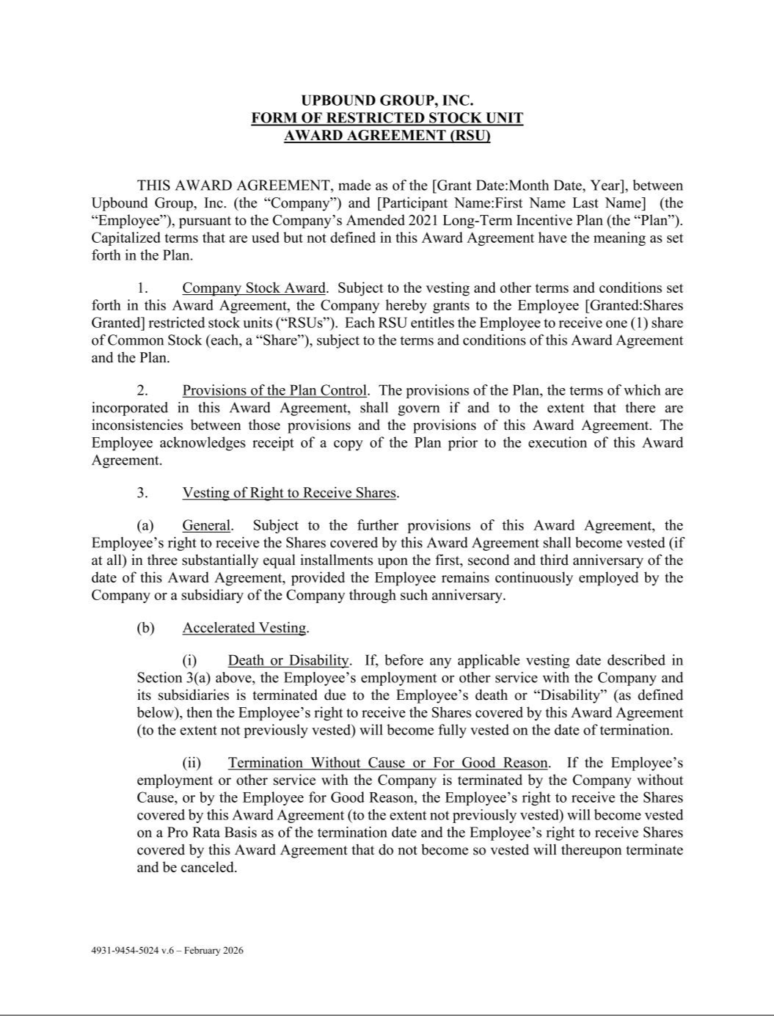

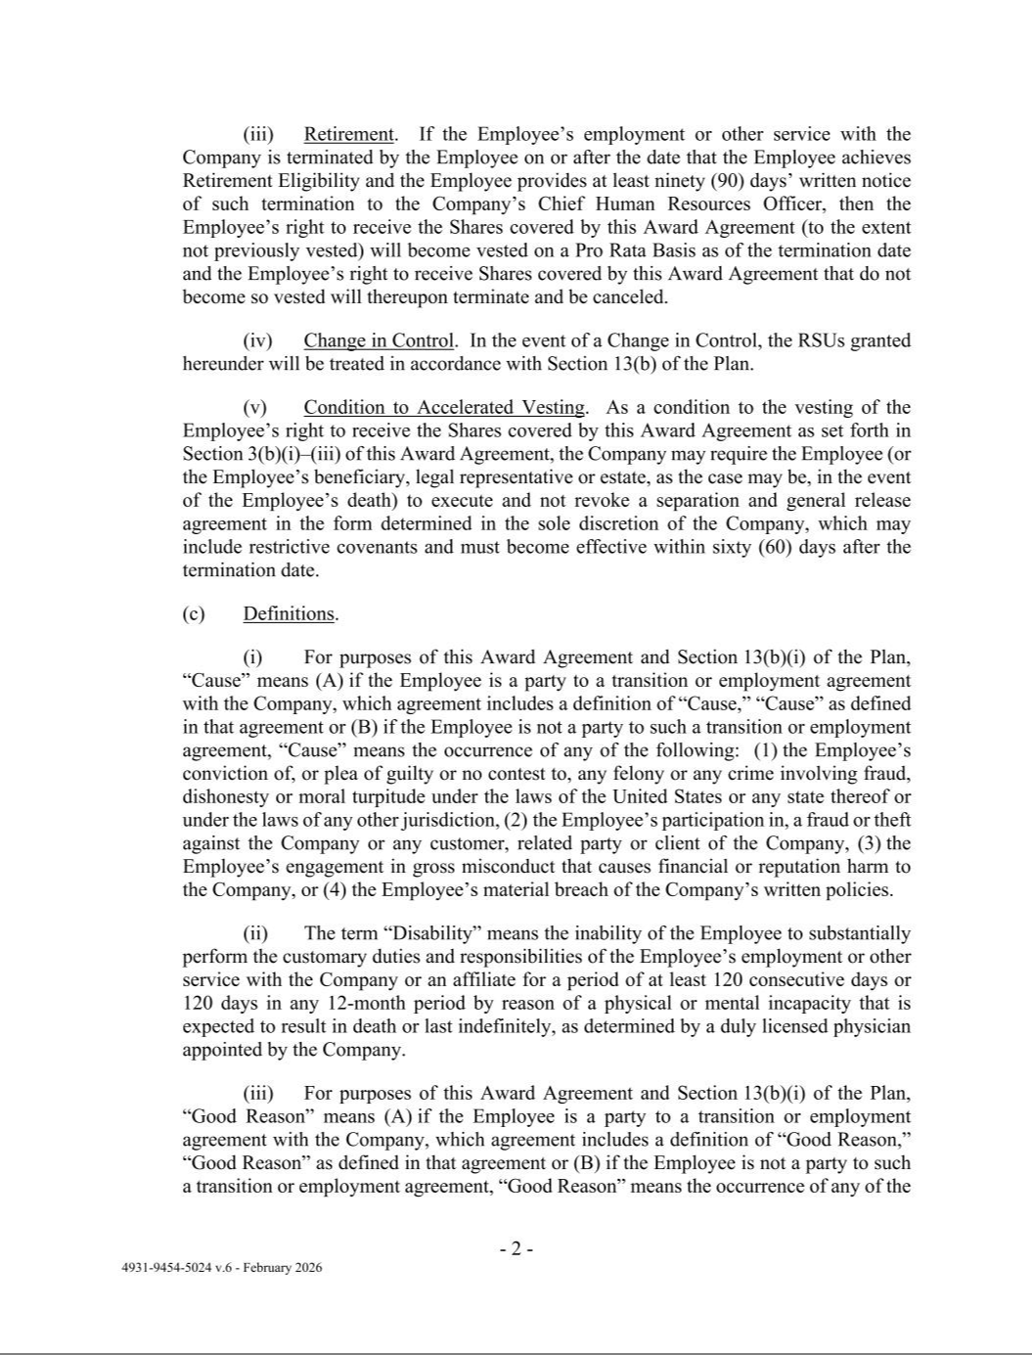

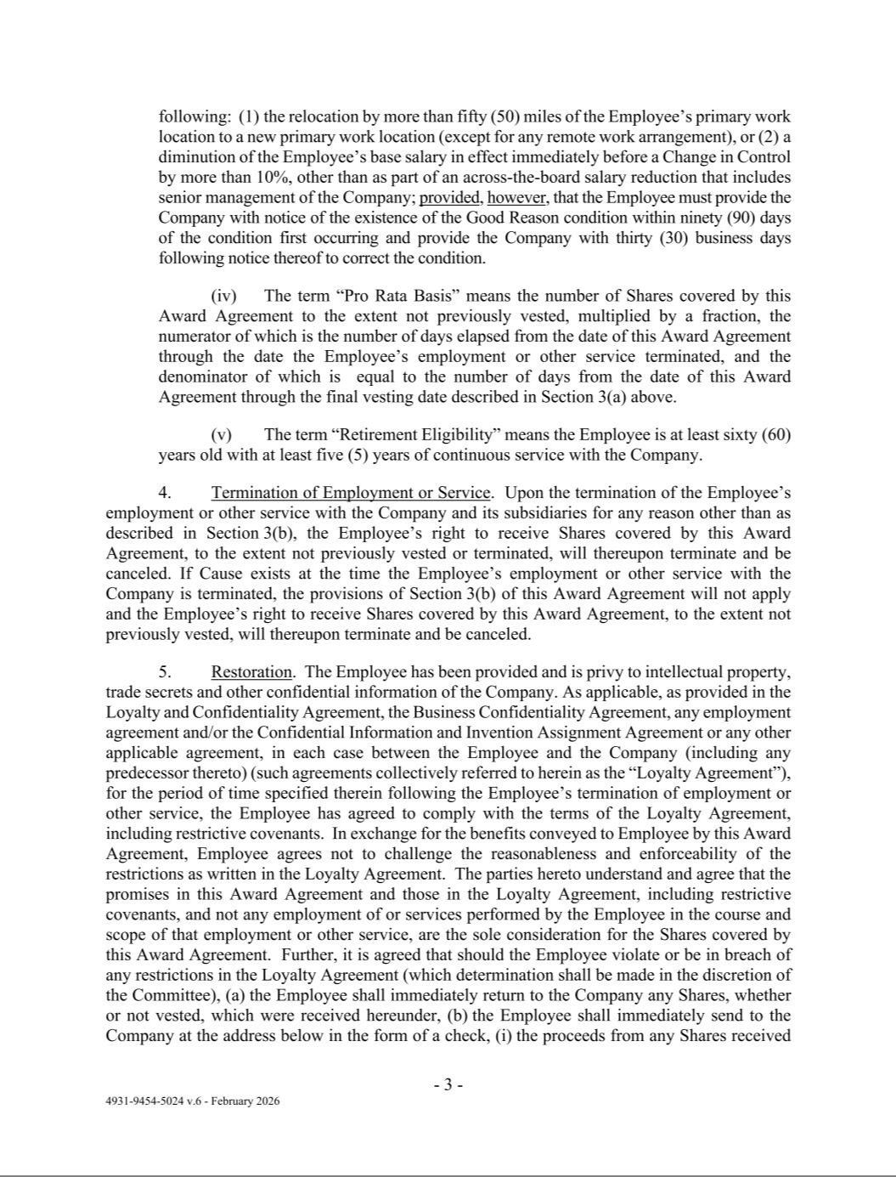

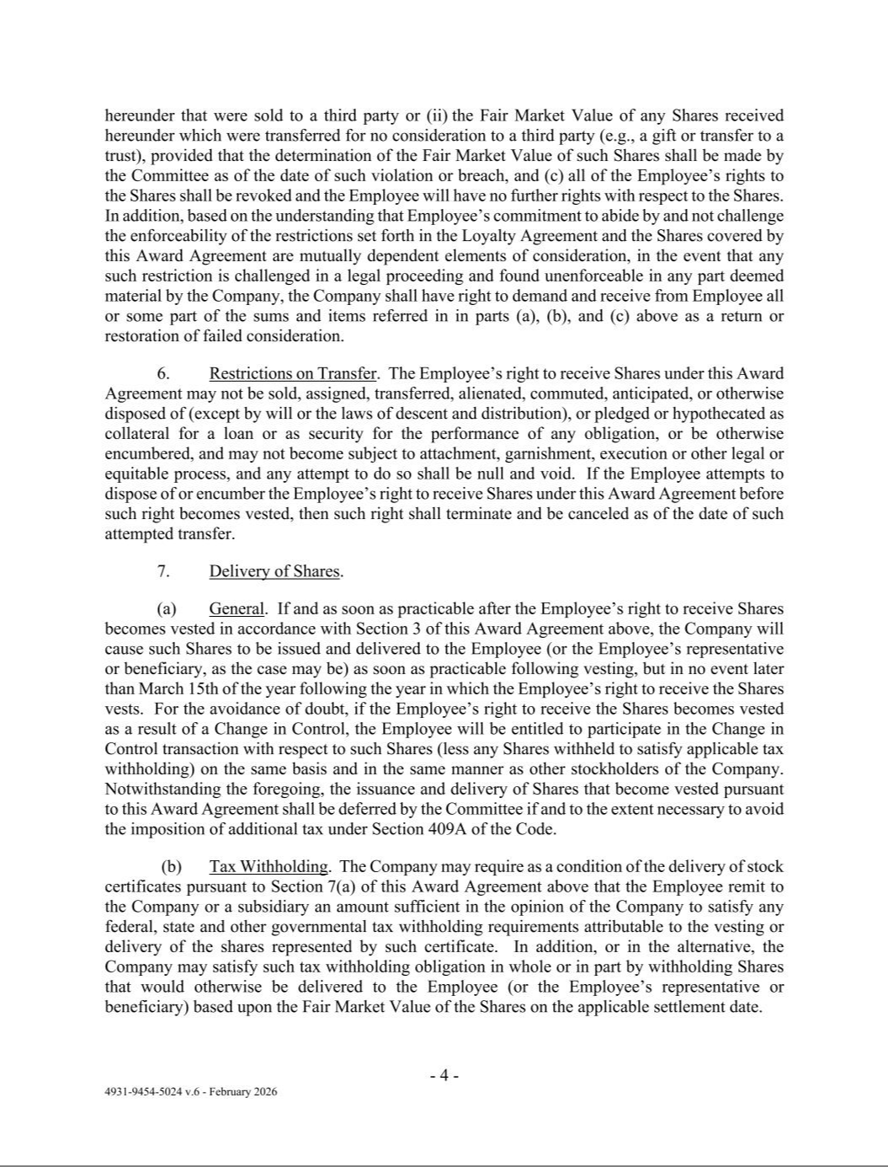

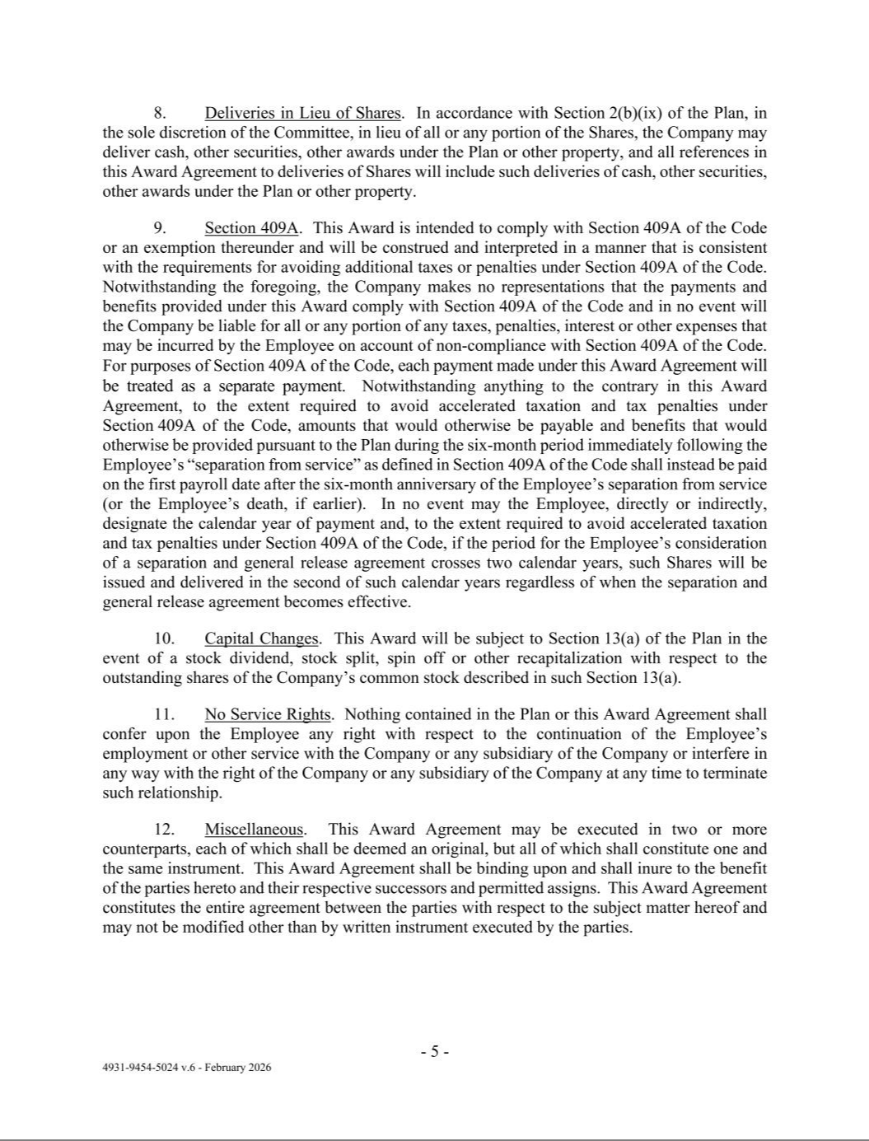

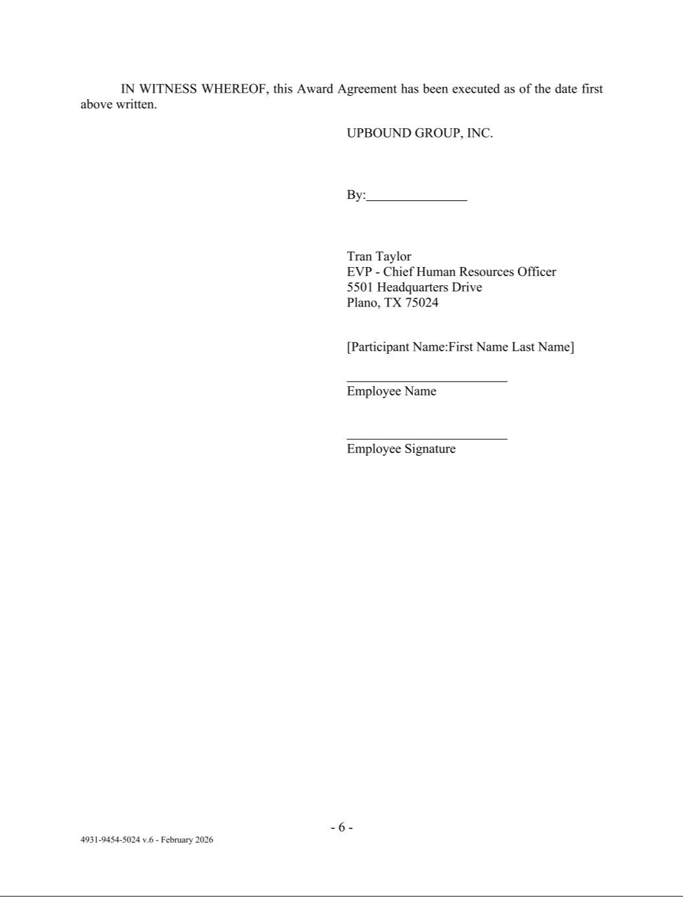

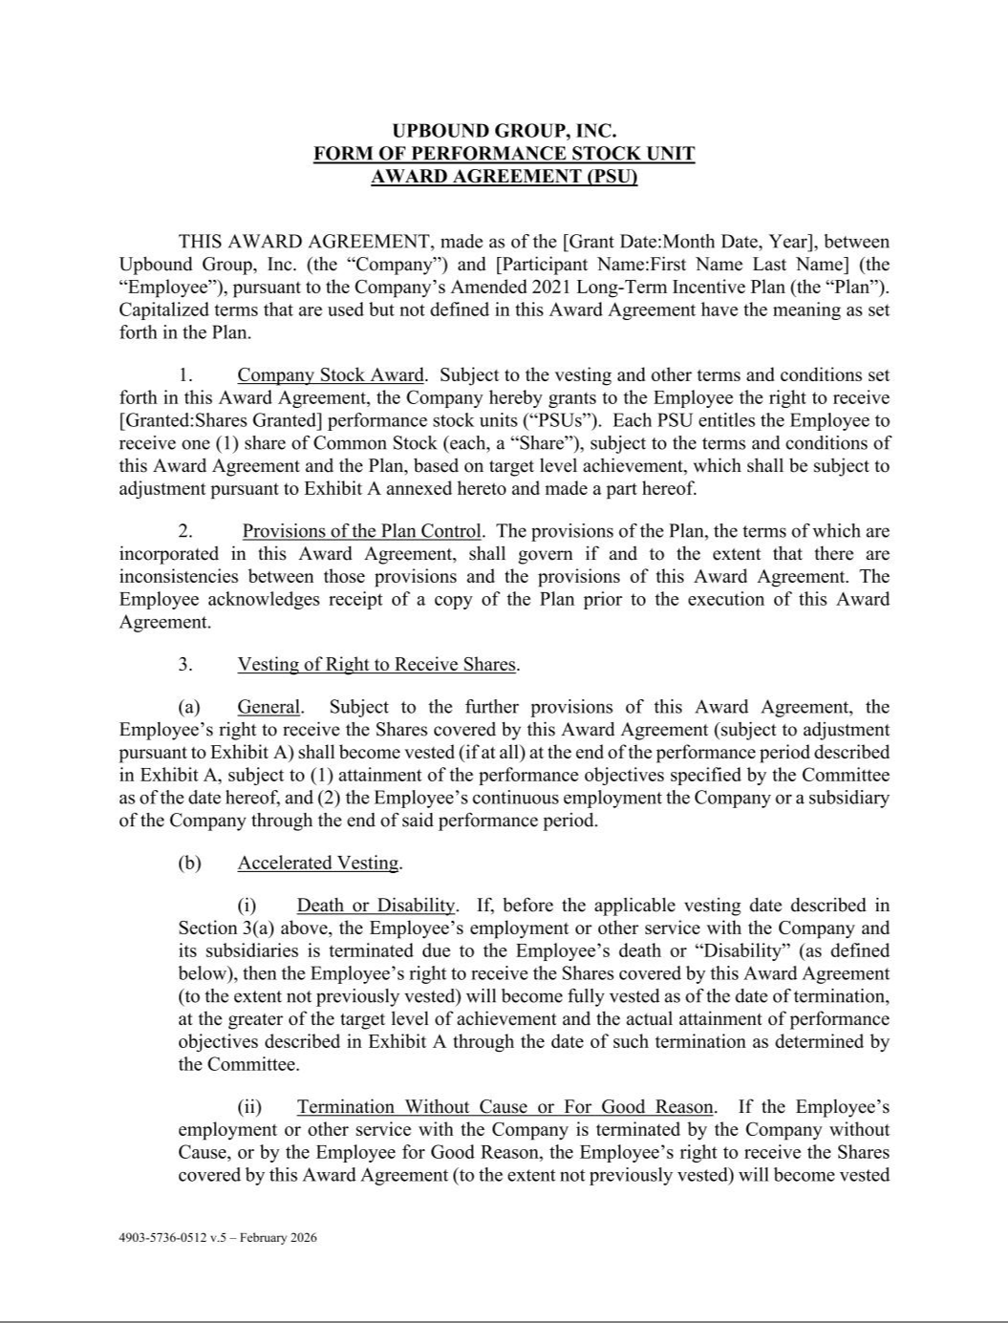

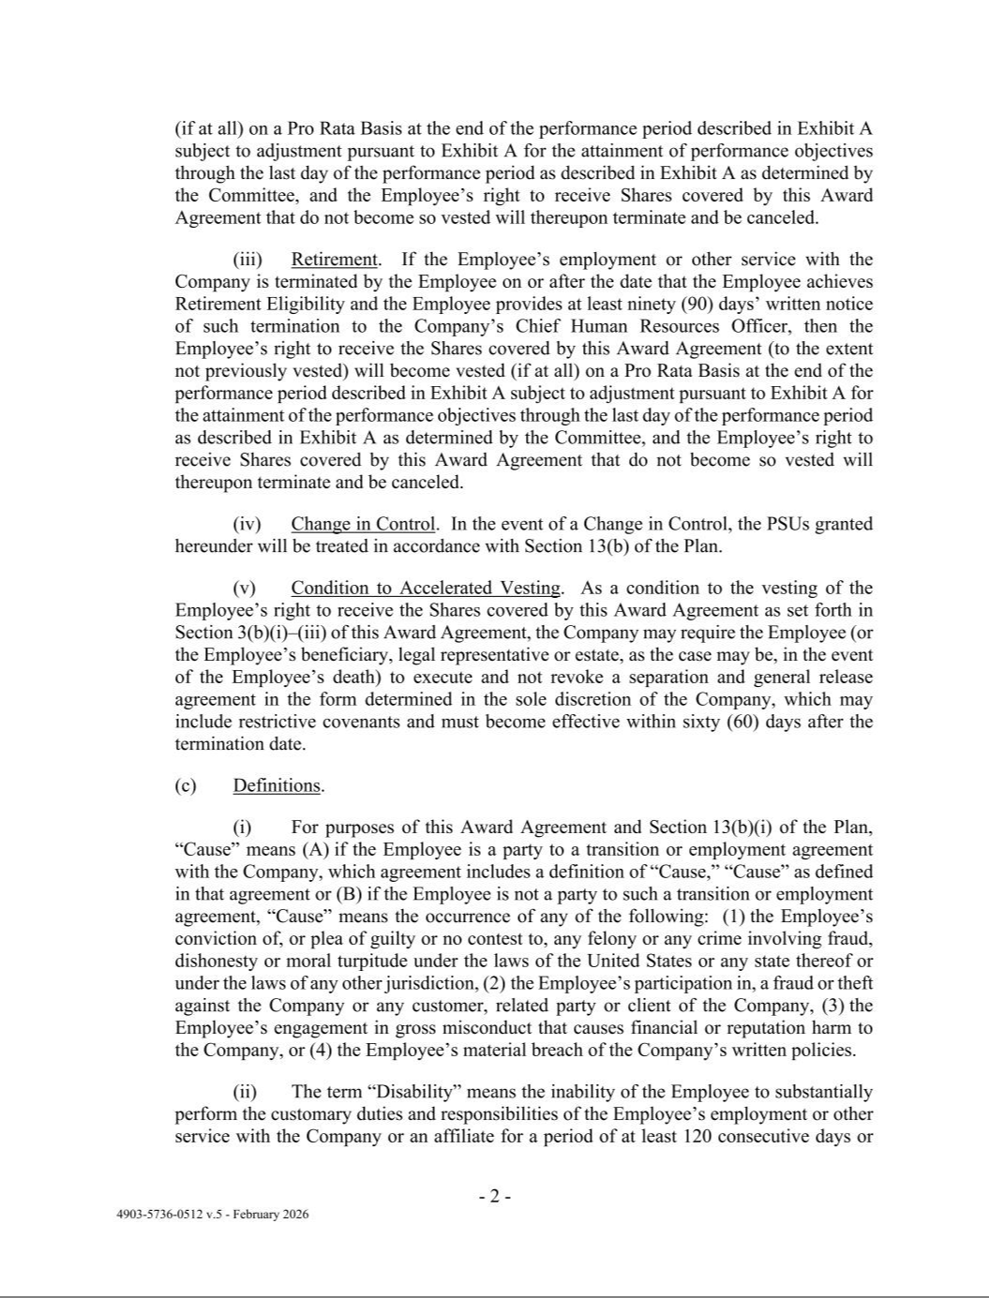

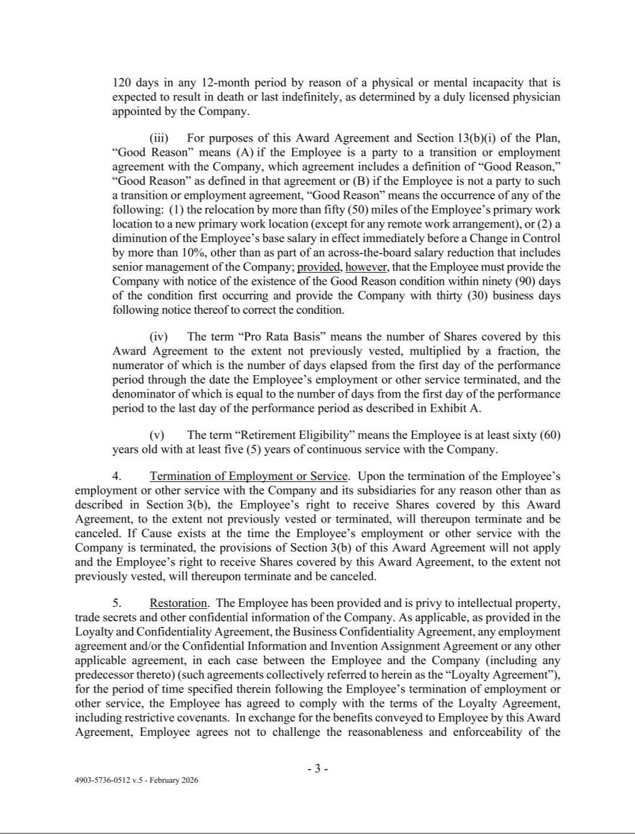

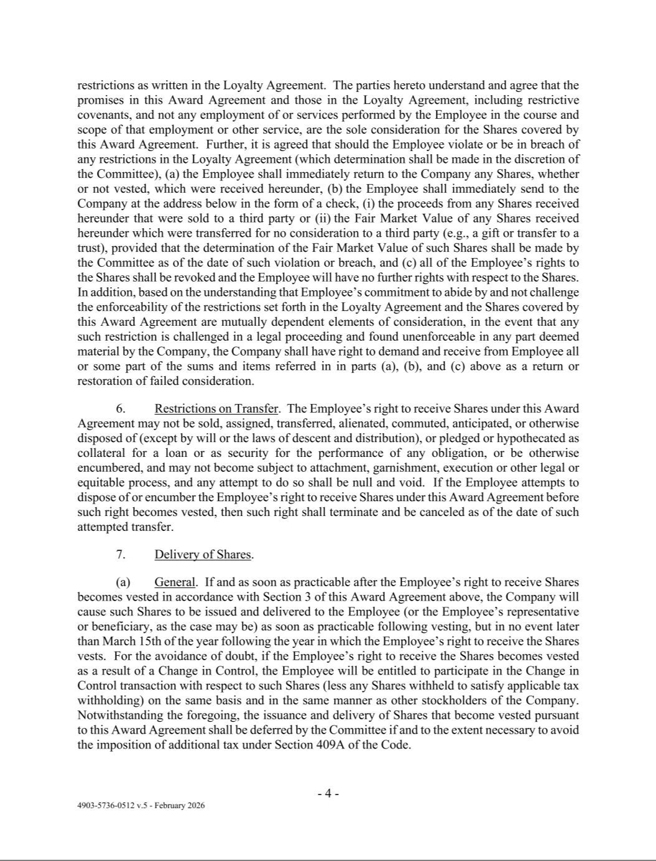

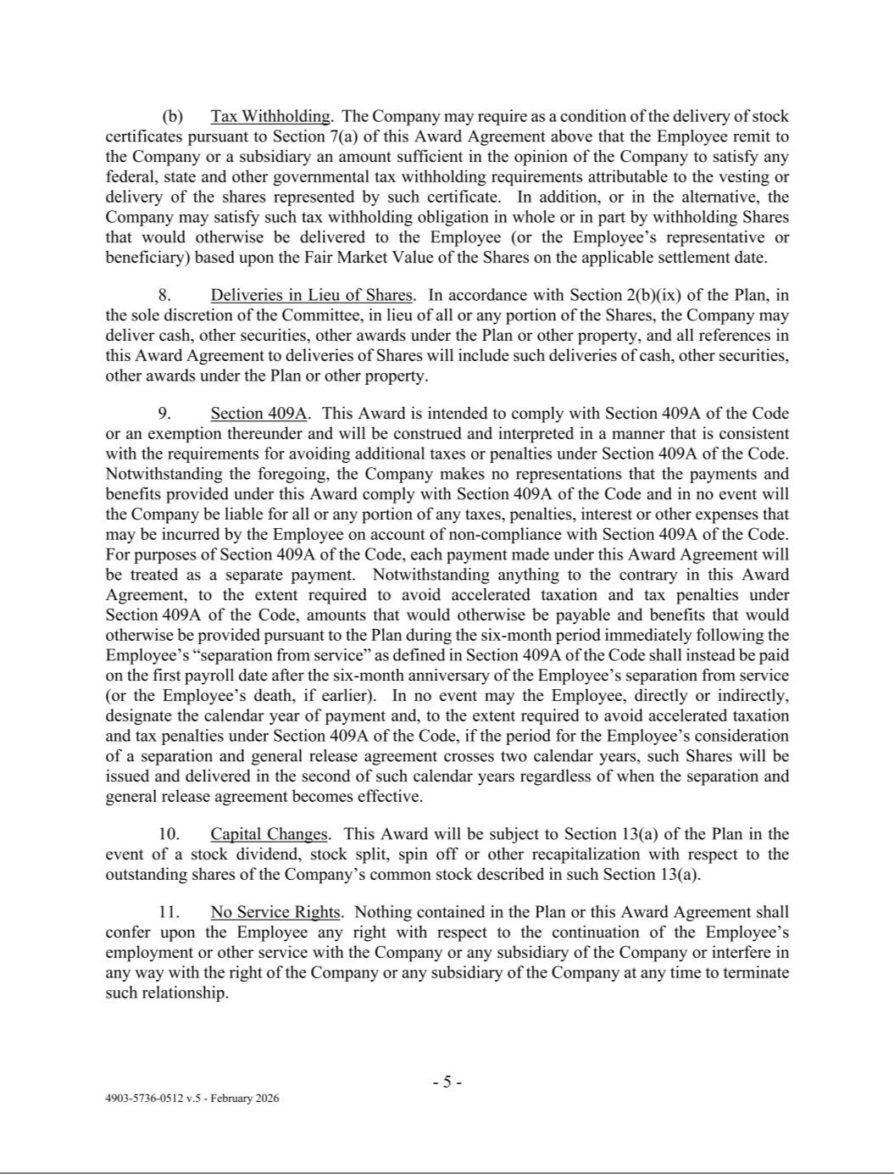



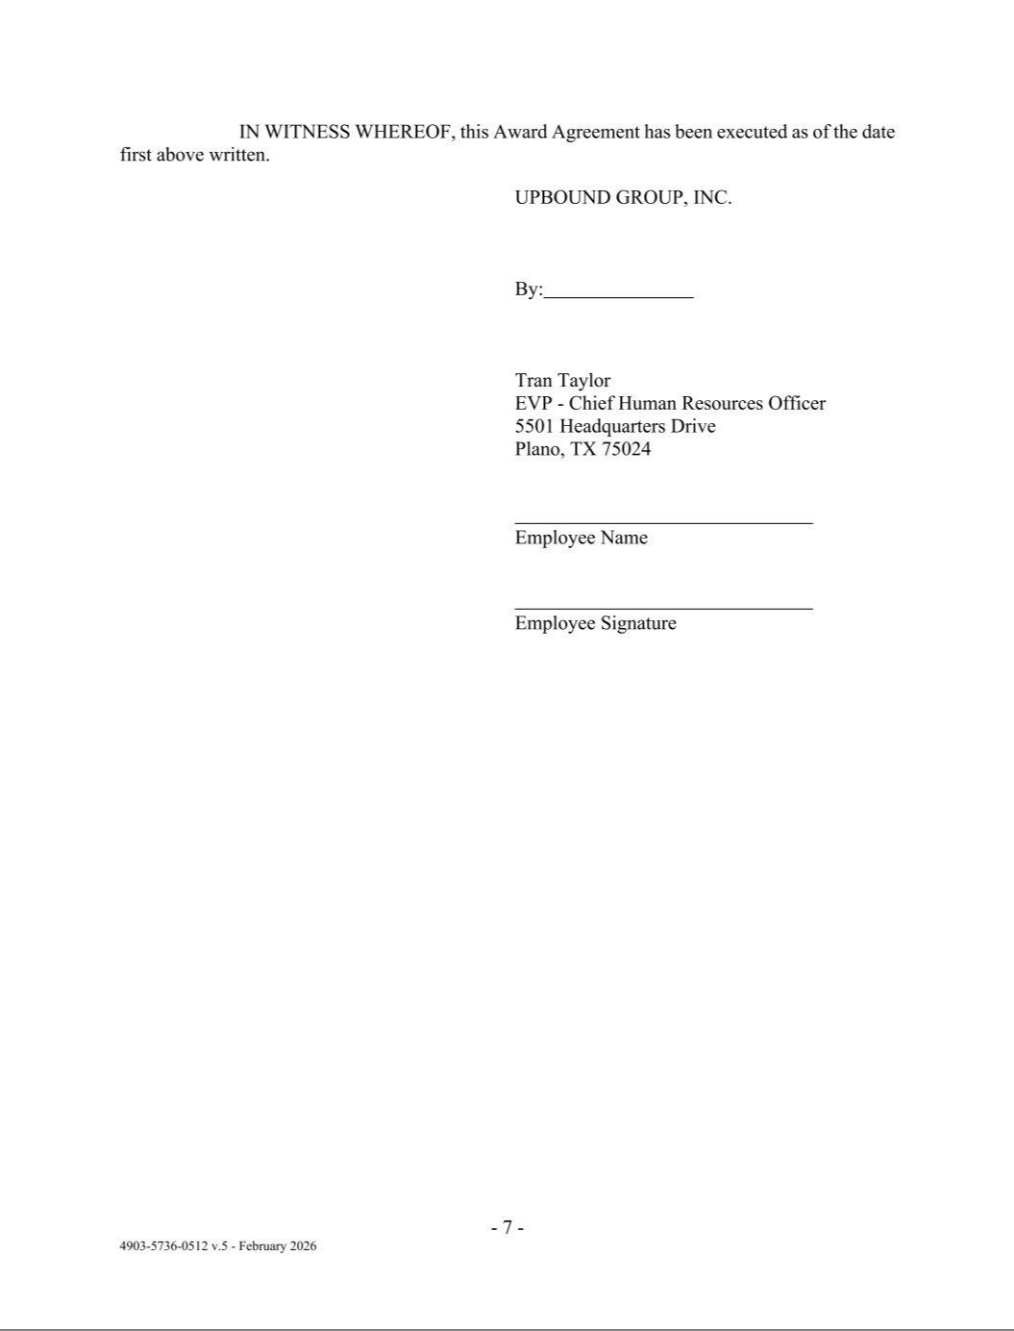

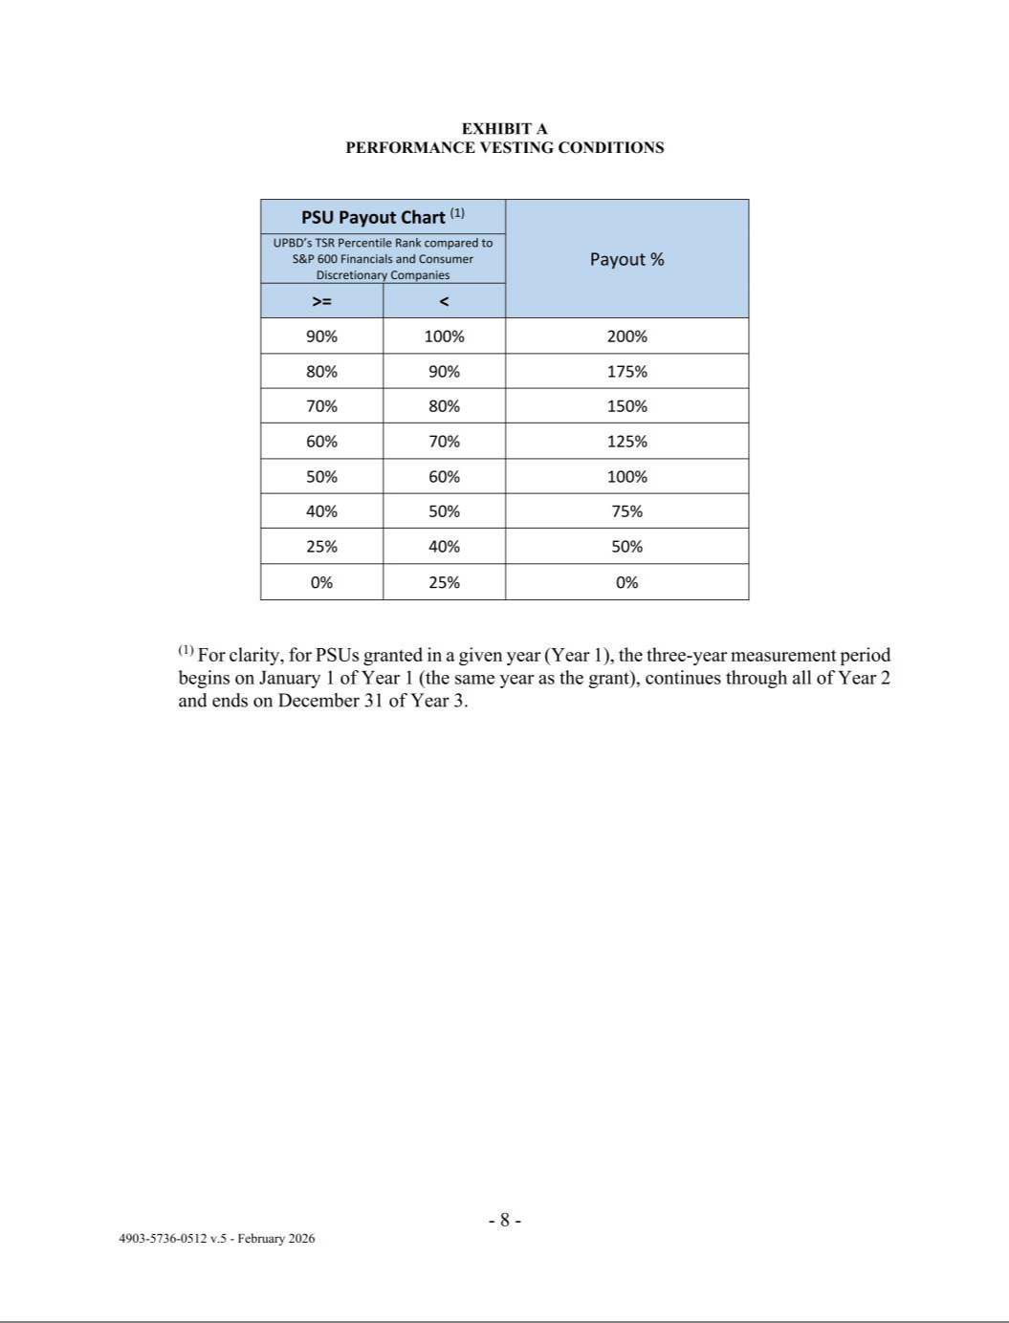

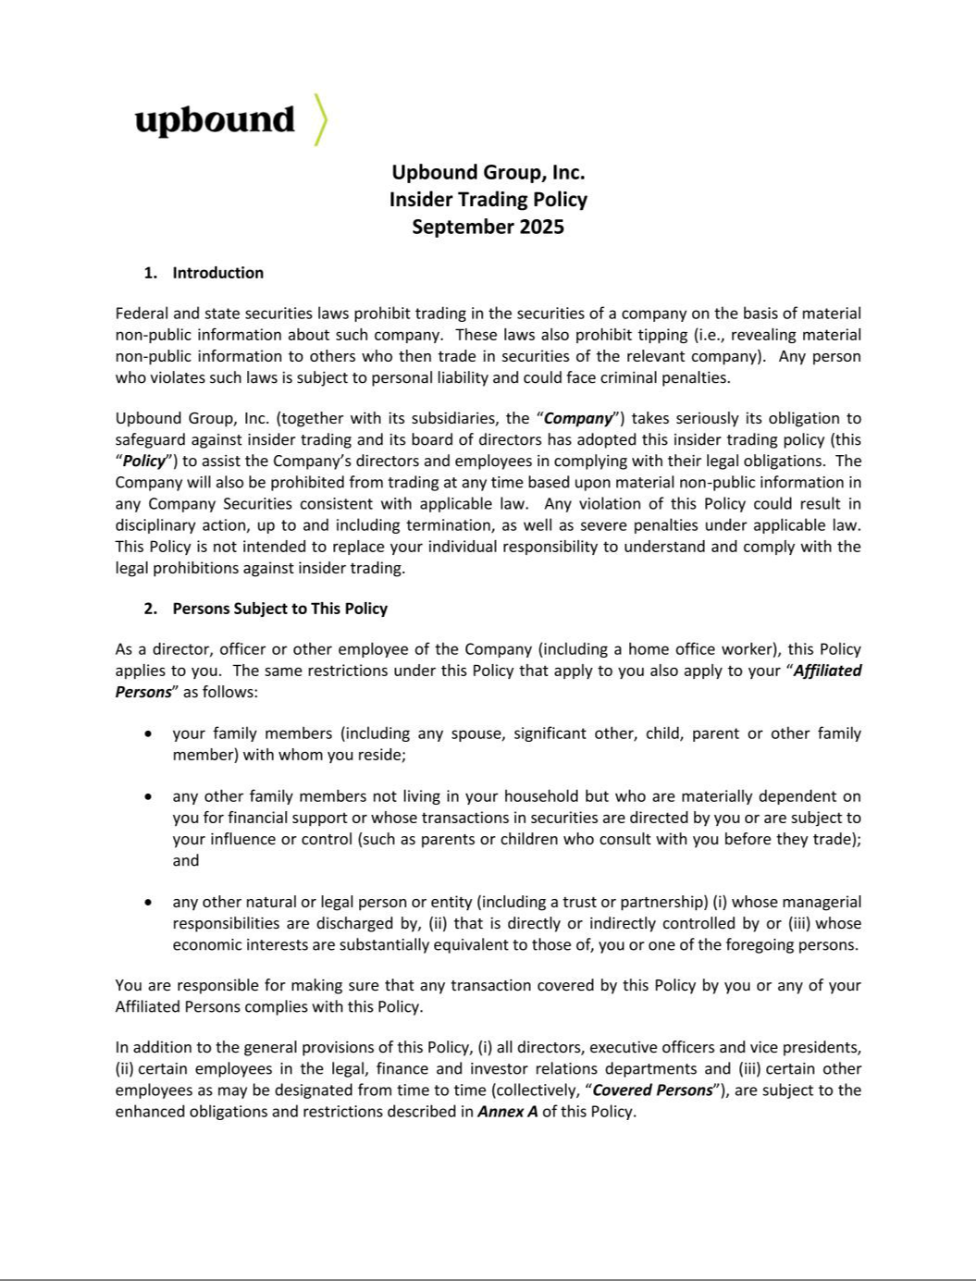

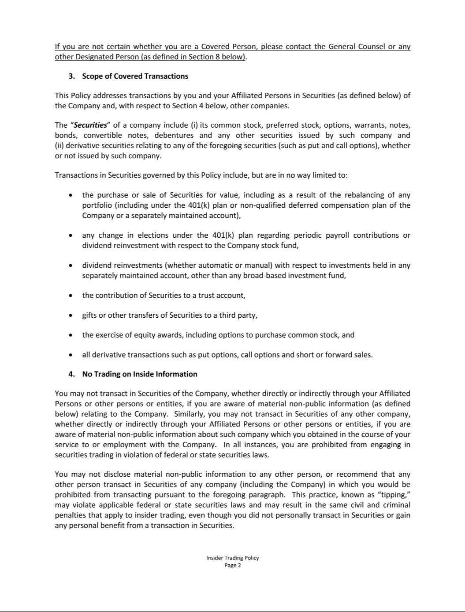

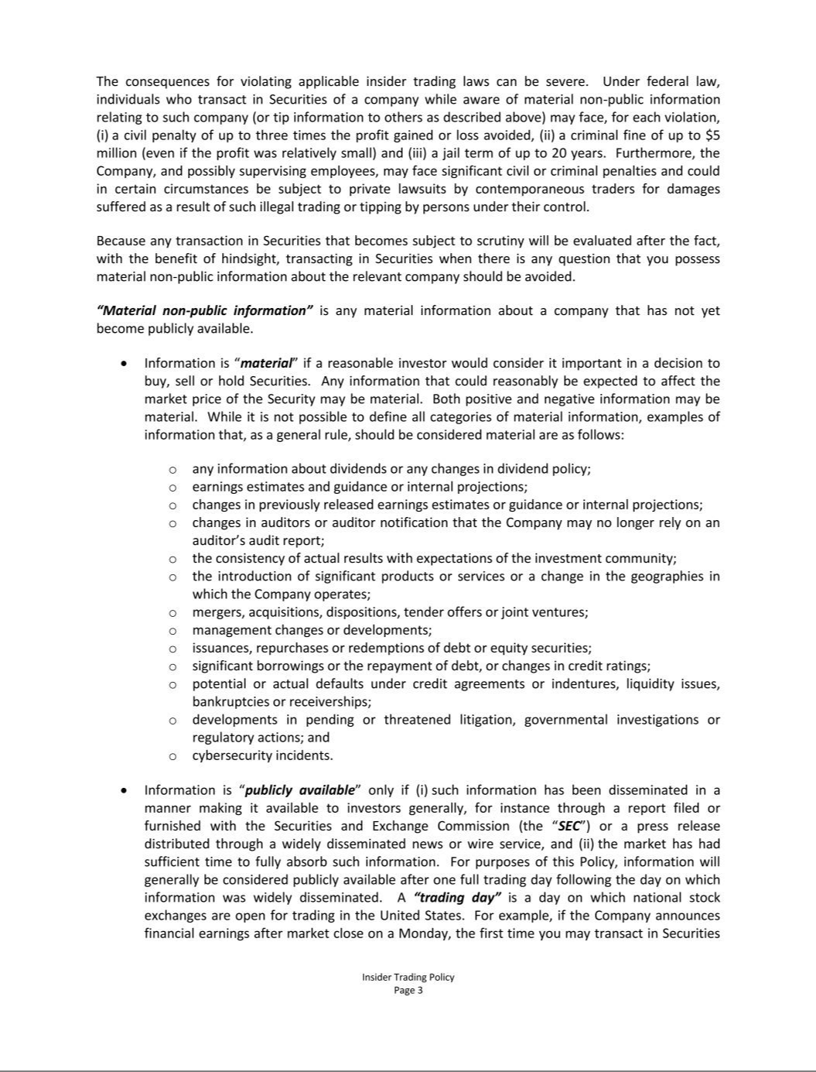

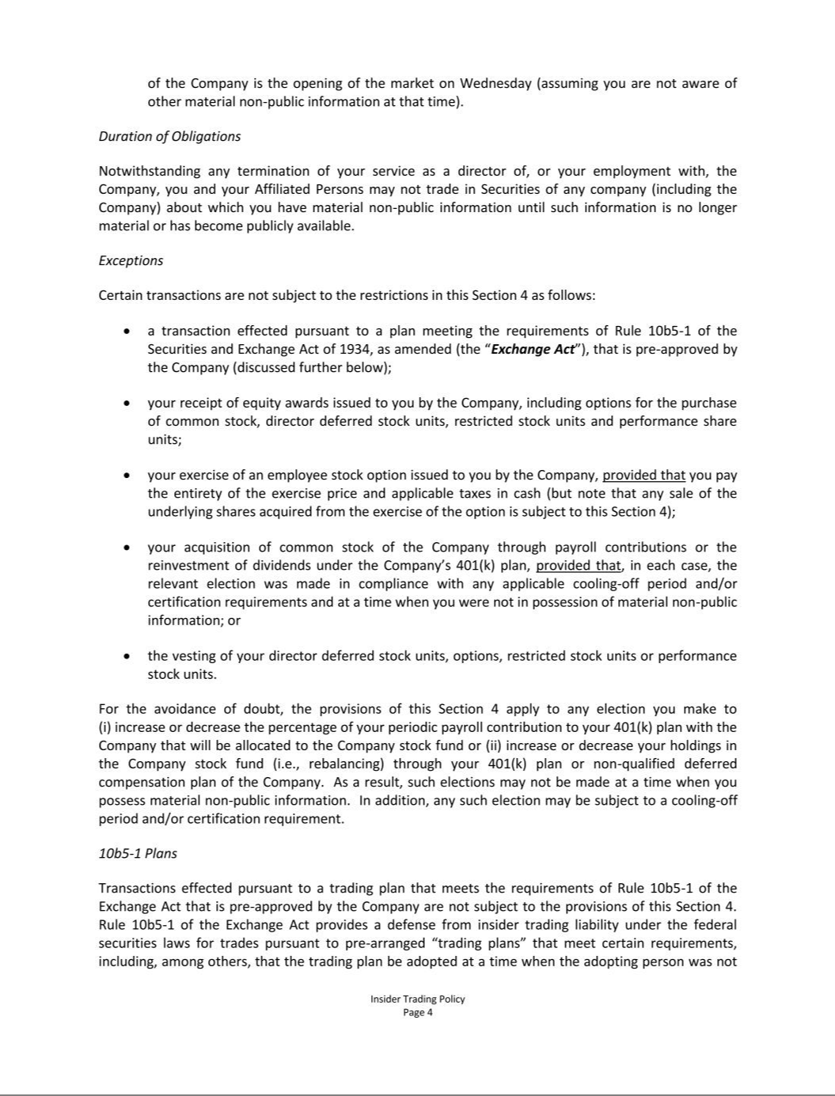

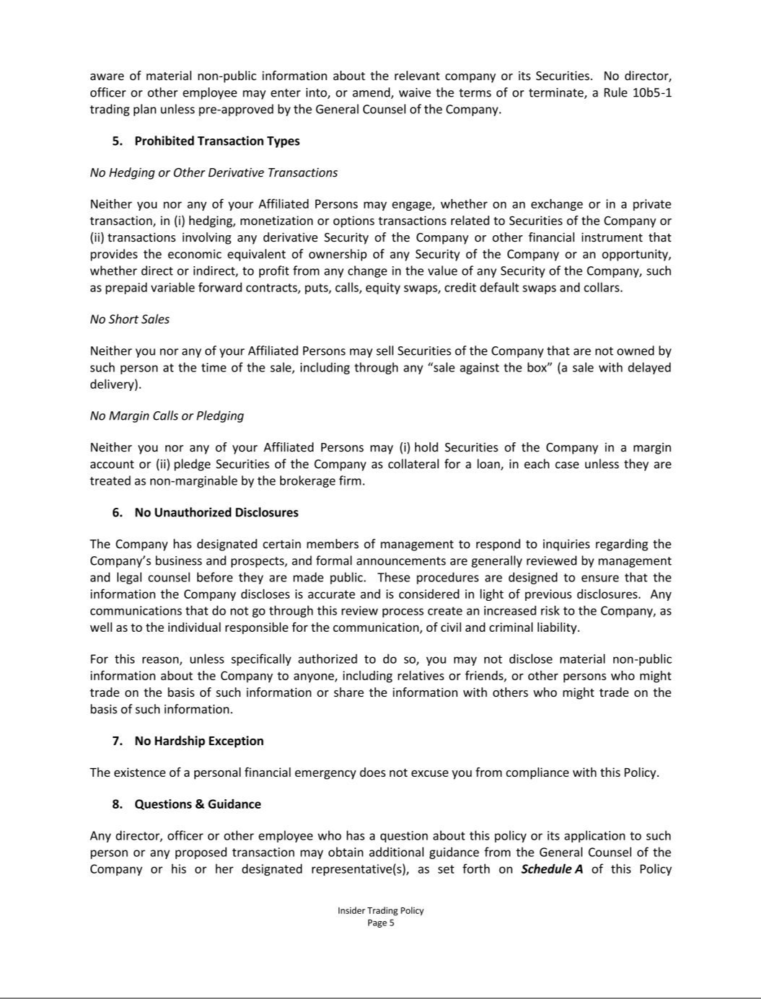

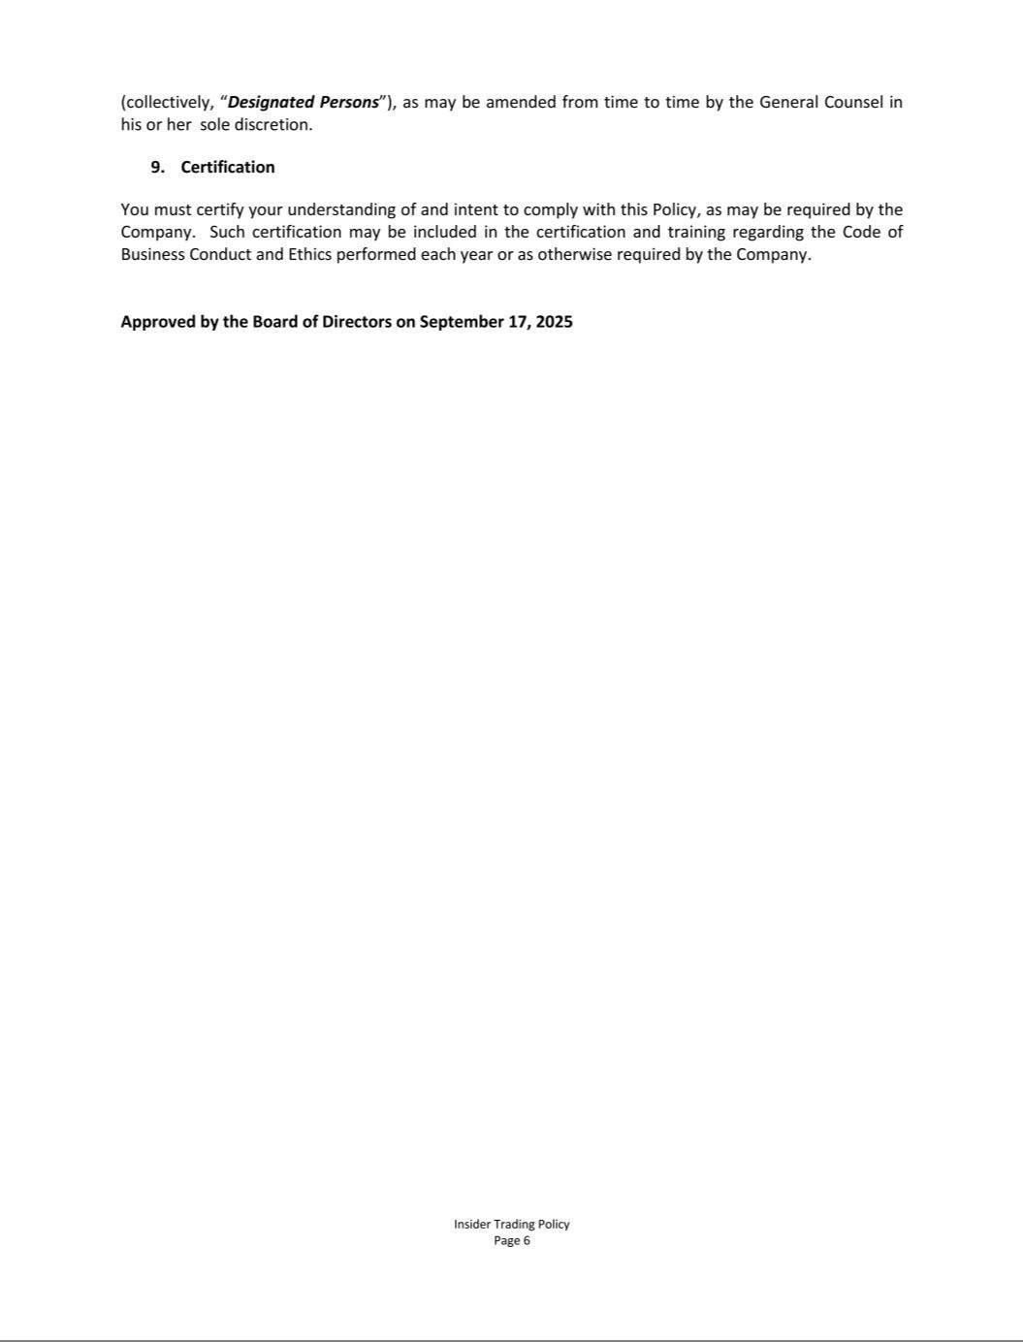

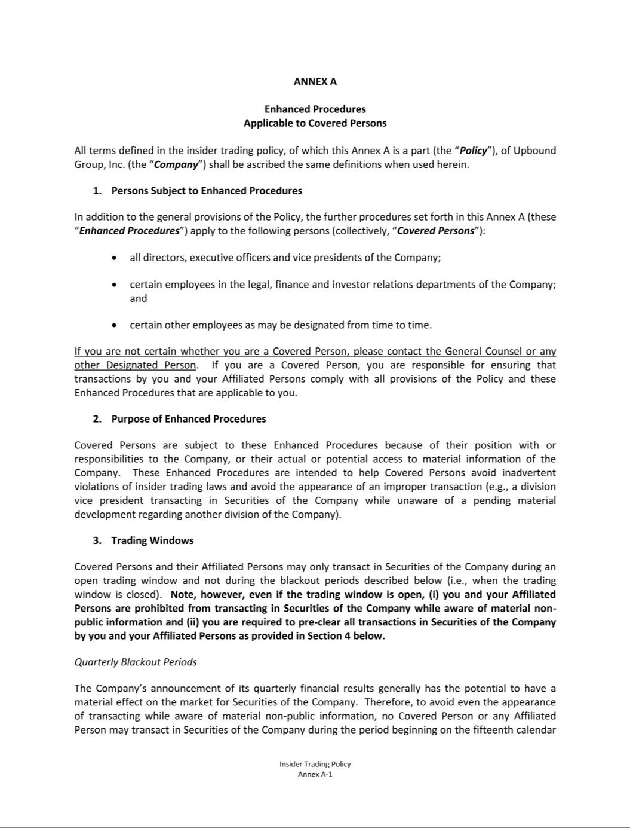

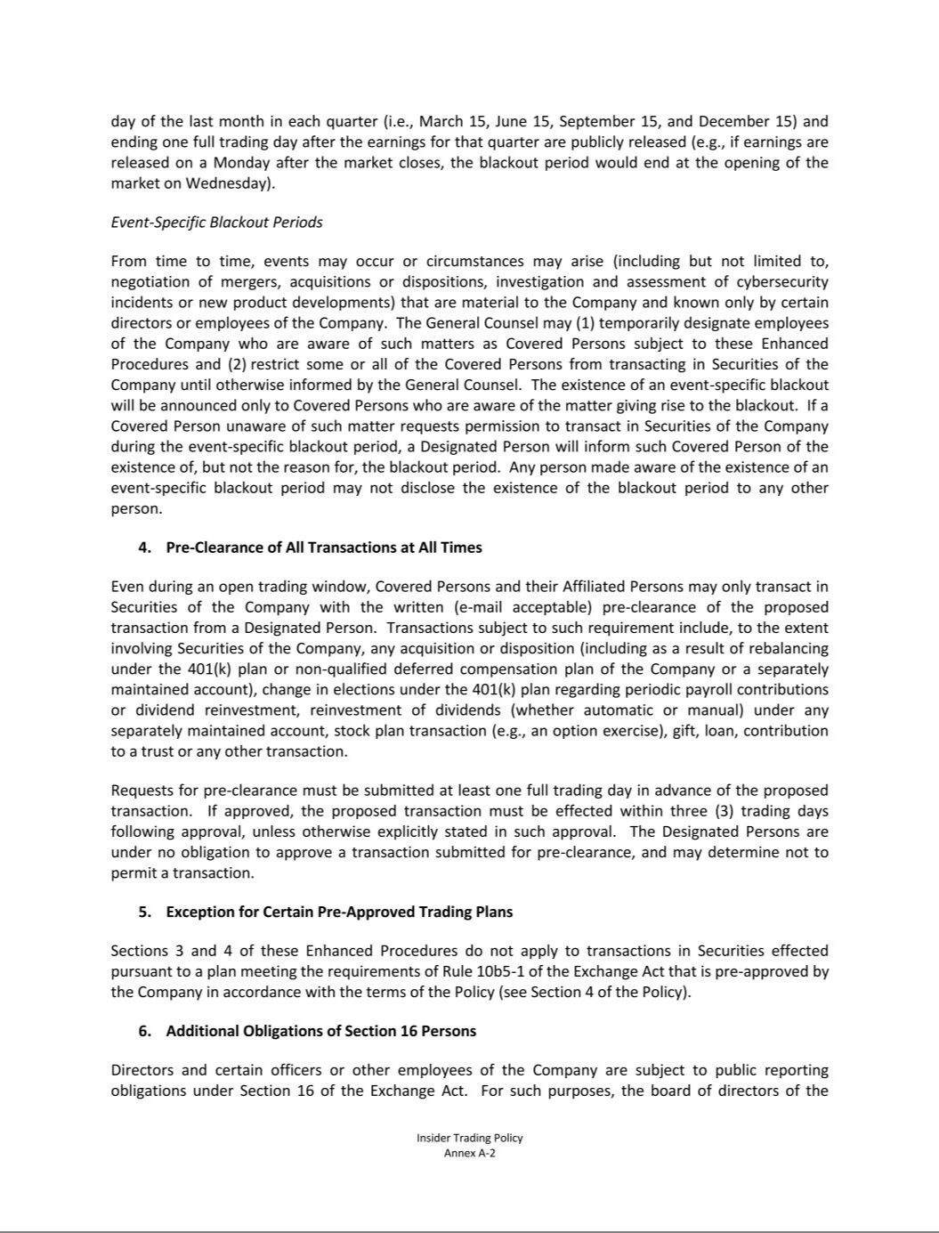

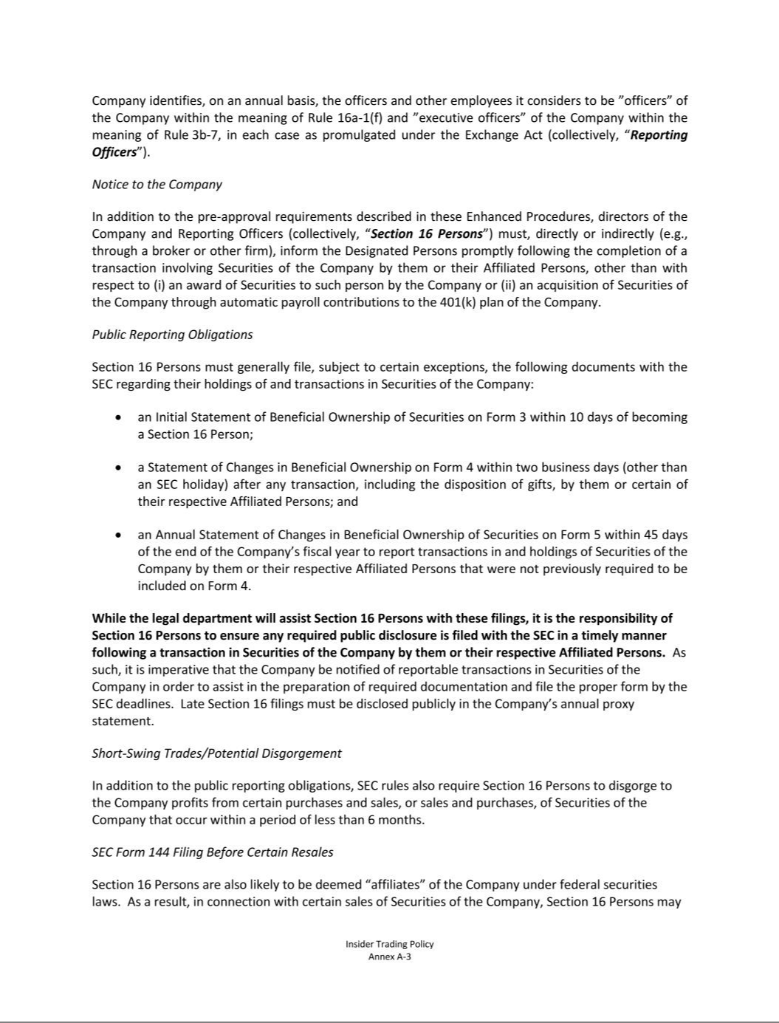





EXHIBIT 21.1

SUBSIDIARIES OF UPBOUND GROUP, INC.

AS OF DECEMBER 31, 2025

Acima Credit Solutions HoldCo, LLC, a Delaware limited liability company

Acima Credit Solutions, LLC, a Delaware limited liability company

Acima Digital, LLC, a Utah limited liability company

Acima Holdings, LLC, a Utah limited liability company

Acima Leasing Canada, Ltd., an Ontario Canada corporation

Acima Operaciones Mexico S. de R.L. de C.V., a México S. de R.L. de C.V.

Braveheart Acquisition, LLC, a Delaware limited liability company

Bridge IT, Inc., a Delaware corporation

Get It Now, LLC, a Delaware limited liability company

Legacy Insurance Co., Ltd., a Bermuda limited company

RAC Acceptance East, LLC, a Delaware limited liability company

RAC Mexico Holdings I, LLC, a Delaware limited liability company

RAC Mexico Holdings II, LLC, a Delaware limited liability company

Rent-A-Center, LLC, a Delaware limited liability company

Rent-A-Center East, Inc., a Delaware corporation

Rent-A-Center Franchising International, Inc., a Texas corporation

Rent-A-Center International, Inc., a Delaware corporation

Rent-A-Center Texas, L.L.C., a Nevada limited liability company

Rent-A-Center Texas, L.P., a Texas limited partnership

Rent-A-Center West, Inc., a Delaware corporation

Upbound Mexico, S. de R.L. de C.V., a México S. de R.L. de C.V.

Upbound Mexico Operaciones S. de R.L. de C.V., a México S. de R.L. de C.V.

Exhibit 23.1

CONSENT OF INDEPENDENT REGISTERED PUBLIC ACCOUNTING FIRM

We consent to the incorporation by reference in Registration Statement Nos. 333-32296, 333-40958, 333-62582, 333-136615, 333-139792, 333-145121, 333-171926, 333-211859, 333-256927 and 333-272494 on Form S-8 of our reports dated February 23, 2026, relating to the financial statements of Upbound Group, Inc. and the effectiveness of Upbound Group Inc.’s internal control over financial reporting, appearing in the Annual Report on Form 10-K for the year ended December 31, 2025.

/s/ DELOITTE & TOUCHE LLP

Dallas, Texas

February 23, 2026

Exhibit 23.2

Consent of Independent Registered Public Accounting Firm

We consent to the incorporation by reference in the following Registration Statements:

- Registration Statement (Form S-8 No. 333-32296) pertaining to the Rent-A-Center, Inc. 401(k) Retirement Savings Plan,

- Registration Statement (Form S-8 No. 333-40958) pertaining to Amended and Restated Rent-A-Center, Inc. Long-Term Incentive Plan,

- Registration Statement (Form S-8 No. 333-62582) pertaining to Amended and Restated Rent-A-Center, Inc. Long-Term Incentive Plan,

- Registration Statement (Form S-8 No. 333-136615) pertaining to Rent-A-Center, Inc. 2006 Long-Term Incentive Plan,

- Registration Statement (Form S-8 No. 333-139792) pertaining to Rent-A-Center, Inc. 2006 Equity Incentive Plan,

- Registration Statement (Form S-8 No. 333-145121) pertaining to Rent-A-Center, Inc. Deferred Compensation Plan,

- Registration Statement (Form S-8 No. 333-171926) pertaining to Rent-A-Center East, Inc. Retirement Savings Plan for Puerto Rico Employees,

- Registration Statement (Form S-8 No. 333-211859) pertaining to Rent-A-Center, Inc. 2016 Long-Term Incentive Plan,

- Registration Statement (Form S-8 No.333-256927) pertaining to Rent-A-Center, Inc. 2021 Long-Term Incentive Plan

- Registration Statement (Form S-8 No. 333-272494) pertaining to Upbound Group, Inc. Amended 2021 Long-Term Incentive Plan; and

of our report dated February 25, 2025, with respect to the consolidated financial statements of Upbound Group, Inc. included in this Annual Report (Form 10-K) of Upbound Group, Inc. for the year ended December 31, 2025.

/s/ Ernst & Young LLP

Dallas, Texas

February 23, 2026

Exhibit 31.1

I, Fahmi Karam, certify that:

- I have reviewed this Annual Report on Form 10-K of Upbound Group, Inc.;

- Based on my knowledge, this report does not contain any untrue statement of a material fact or omit to state a material fact necessary to make the statements made, in light of the circumstances under which such statements were made, not misleading with respect to the period covered by this report;

- Based on my knowledge, the financial statements, and other financial information included in this report, fairly present in all material respects the financial condition, results of operations and cash flows of the registrant as of, and for, the periods presented in this report;

- The registrant's other certifying officer(s) and I are responsible for establishing and maintaining disclosure controls and procedures (as defined in Exchange Act Rules 13a-15(e) and

15d-15(e)) and internal control over financial reporting (as defined in Exchange Act Rules 13a-15(f) and 15d-15(f)) for the registrant and have:

- Designed such disclosure controls and procedures, or caused such disclosure controls and procedures to be designed under our supervision, to ensure that material information relating to the registrant, including its consolidated subsidiaries, is made known to us by others within those entities, particularly during the period in which this report is being prepared;

- Designed such internal control over financial reporting, or caused such internal control over financial reporting to be designed under our supervision, to provide reasonable assurance regarding the reliability of financial reporting and the preparation of financial statements for external purposes in accordance with generally accepted accounting principles;

- Evaluated the effectiveness of the registrant's disclosure controls and procedures and presented in this report our conclusions about the effectiveness of the disclosure controls and procedures, as of the end of the period covered by this report based on such evaluation; and

- Disclosed in this report any change in the registrant's internal control over financial reporting that occurred during the registrant's most recent fiscal quarter (the registrant's fourth fiscal quarter in the case of an annual report) that has materially affected, or is reasonably likely to materially affect, the registrant's internal control over financial reporting; and

- The registrant's other certifying officer(s) and I have disclosed, based on our most recent evaluation of internal control over financial reporting, to the registrant's auditors and the audit committee of the registrant's board of directors (or persons performing the equivalent functions):

- All significant deficiencies and material weaknesses in the design or operation of internal control over financial reporting which are reasonably likely to adversely affect the registrant's ability to record, process, summarize and report financial information; and

- Any fraud, whether or not material, that involves management or other employees who have a significant role in the registrant's internal control over financial reporting.

Date: February 23, 2026

/s/ Fahmi Karam

Fahmi Karam

Chief Executive Officer and Director

(Principal Executive Officer)

Exhibit 31.2

I, Hal Khouri, certify that:

- I have reviewed this Annual Report on Form 10-K of Upbound Group, Inc.;

- Based on my knowledge, this report does not contain any untrue statement of a material fact or omit to state a material fact necessary to make the statements made, in light of the circumstances under which such statements were made, not misleading with respect to the period covered by this report;

- Based on my knowledge, the financial statements, and other financial information included in this report, fairly present in all material respects the financial condition, results of operations and cash flows of the registrant as of, and for, the periods presented in this report;

- The registrant's other certifying officer(s) and I are responsible for establishing and maintaining disclosure controls and procedures (as defined in Exchange Act Rules 13a-15(e) and

15d-15(e)) and internal control over financial reporting (as defined in Exchange Act Rules 13a-15(f) and 15d-15(f)) for the registrant and have:

- Designed such disclosure controls and procedures, or caused such disclosure controls and procedures to be designed under our supervision, to ensure that material information relating to the registrant, including its consolidated subsidiaries, is made known to us by others within those entities, particularly during the period in which this report is being prepared;

- Designed such internal control over financial reporting, or caused such internal control over financial reporting to be designed under our supervision, to provide reasonable assurance regarding the reliability of financial reporting and the preparation of financial statements for external purposes in accordance with generally accepted accounting principles;

- Evaluated the effectiveness of the registrant's disclosure controls and procedures and presented in this report our conclusions about the effectiveness of the disclosure controls and procedures, as of the end of the period covered by this report based on such evaluation; and

- Disclosed in this report any change in the registrant's internal control over financial reporting that occurred during the registrant's most recent fiscal quarter (the registrant's fourth fiscal quarter in the case of an annual report) that has materially affected, or is reasonably likely to materially affect, the registrant's internal control over financial reporting; and

- The registrant's other certifying officer(s) and I have disclosed, based on our most recent evaluation of internal control over financial reporting, to the registrant's auditors and the audit committee of the registrant's board of directors (or persons performing the equivalent functions):

- All significant deficiencies and material weaknesses in the design or operation of internal control over financial reporting which are reasonably likely to adversely affect the registrant's ability to record, process, summarize and report financial information; and

- Any fraud, whether or not material, that involves management or other employees who have a significant role in the registrant's internal control over financial reporting.

Date: February 23, 2026

/s/ Hal Khouri

Hal Khouri

EVP, Chief Financial Officer

(Principal Financial and Accounting Officer)

Exhibit 32.1

CERTIFICATION PURSUANT TO

18 U.S.C. SECTION 1350,

AS ADOPTED PURSUANT TO

SECTION 906 OF THE SARBANES-OXLEY ACT OF 2002

In connection with the Annual Report on Form 10-K of Upbound Group, Inc. (the "Company") for the period ended December 31, 2025, as filed with the Securities and Exchange Commission on the date hereof (the "Report"), I, Fahmi Karam, Chief Executive Officer and Director of the Company, hereby certify, pursuant to 18 U.S.C. Section 1350, as adopted pursuant to Section 906 of the Sarbanes-Oxley Act of 2002, that, to the best of my knowledge:

- The Report fully complies with the requirements of Section 13(a) or 15(d) of the Securities Exchange Act of 1934; and

- The information contained in the Report fairly presents, in all material respects, the financial condition and results of operations of the Company.

/s/ Fahmi Karam

Fahmi Karam

Chief Executive Officer and Director

Dated: February 23, 2026

A signed original of this written statement required by Section 906 has been provided to Upbound Group, Inc. and will be retained by Upbound Group, Inc. and furnished to the Securities and Exchange Commission or its staff upon request. The foregoing certification is being furnished solely pursuant to 18 U.S.C. Section 1350 and is not being filed as part of the Report or as a separate disclosure document.

Exhibit 32.2

CERTIFICATION PURSUANT TO

18 U.S.C. SECTION 1350,

AS ADOPTED PURSUANT TO

SECTION 906 OF THE SARBANES-OXLEY ACT OF 2002

In connection with the Annual Report on Form 10-K of Upbound Group, Inc. (the "Company") for the period ended December 31, 2025, as filed with the Securities and Exchange Commission on the date hereof (the "Report"), I, Hal Khouri, Chief Financial Officer of the Company, hereby certify, pursuant to 18 U.S.C. Section 1350, as adopted pursuant to Section 906 of the Sarbanes-Oxley Act of 2002, that, to the best of my knowledge:

- The Report fully complies with the requirements of Section 13(a) or 15(d) of the Securities Exchange Act of 1934; and

- The information contained in the Report fairly presents, in all material respects, the financial condition and results of operations of the Company.

/s/ Hal Khouri

Hal Khouri

EVP, Chief Financial Officer

Dated: February 23, 2026

A signed original of this written statement required by Section 906 has been provided to Upbound Group, Inc. and will be retained by Upbound Group, Inc. and furnished to the Securities and Exchange Commission or its staff upon request. The foregoing certification is being furnished solely pursuant to 18 U.S.C. Section 1350 and is not being filed as part of the Report or as a separate disclosure document.

